Supplementary Materials for: “Mutational signature analysis predicts bacterial hypermutation and multidrug resistance”

Authors: Kalen M. Hall,^{1,2,3} Leonard G. Williams,^{2,3,4} Richard D. Smith,⁵ Erin A. Kuang,¹ Robert K. Ernst,⁵ Christine M. Bojanowski,⁶ William C. Wimley,² Lisa A. Morici,¹* and Zachary F. Pursell^{2,7}**†
Corresponding authors: zpursell@tulane.edu, lmorici@tulane.edu

This document contains:
Supplementary Fig. 1-5
Supplementary Table 1
Legends for Supplementary Data 1-6

Supplementary Fig. 1: Characterization of mutagenesis and resistance acquisition of MMR-deficient P. aeruginosa. (a) Measurement of mutant frequency via rifampicin reversion (rifampicin resistant colonies per 10⁸ viable cells) using MPAO1 and MPAO1-ΔmutS strains. Hypermutators are defined as those with mutant frequency at least 20-fold higher than wild-type or parent strain (threshold shown as a black dotted line). (b) MICs of all antimicrobials used for resistance testing on all strains, along with susceptibility denotation according to the CLSI. No susceptibility denotation is reported for investigational peptides D-CONGA and D-CONGA-Q7. (c) Proportions of unique indels and SNVs called relative to PAO1 in clones of MPAO1-ΔmutS and MPAO1. (d) Trinucleotide mutation spectra showing unique SNVs of individual independently evolved clones of MPAO1-ΔmutS grouped by treatment. (e) Compilation of all five MMR-deficiency associated COSMIC mutational signatures (SBS6, SBS15, SBS21, SBS26, SBS44) from human tumor genomes. The mutation probabilities of the composite signature were normalized by dividing the summed probabilities by the number of signatures combined (n=5). (f, g) In vitro adaptive evolution of MPAO1-ΔmutL with repeated exposure to (f) AZ or (g) COL resulted in rapid resistance acquisition compared to wild-type MPAO1. All data is shown as mean ± SD of independent biological triplicates. ****p<0.0001, unpaired t-tests of slopes from linear regression analysis of log-transformed datasets for comparison of ΔmutL + treatment vs WT + same treatment.

Supplementary Fig. 2: Cross-resistance acquisition acquired by MMR-deficient P. aeruginosa. (a) In vitro adaptive evolution of MPAO1-ΔmutS with repeated exposure to antibiotics (e.g. Chl) rapidly acquired resistance to AZ (pink line), but MPAO1-ΔmutS exposed to peptides did not (blue lines). (b, c) In vitro adaptive evolution of MPAO1-ΔmutS showed (b) rapid resistance acquisition to polymyxin B with repeated exposure to peptides (COL, D-CONGA, D-CONGA-Q7), but (c) no resistance acquisition with repeated exposure to antibiotics. (d) In vitro adaptive evolution of MPAO1-ΔmutL with repeated exposure to antibiotics rapidly acquired levels of resistance to AZ above CLSI clinical breakpoints (pink line). Black dashed lines denote clinical breakpoint determined by CLSI for tested drug. All data is shown as mean ± SD of independent biological triplicates. ****p<0.0001, ordinary one-way ANOVA of slopes from linear regression analysis of log-transformed datasets for comparison of ΔmutS/L + treatment vs ΔmutS/L – treatment vs WT + same treatment. In all graphs, pink denotes drugs that are substrates of efflux pumps and blue denotes peptides.

Supplementary Fig. 3: Effect of rational combination therapy on MMR-deficient and wild type P. aeruginosa. (a, b) In vitro adaptive evolution of MPAO1-ΔmutS in (a) AZ + D-CONGA or (b) AZ + D-CONGA-Q7 showed minimal resistance acquisition (purple compared to pink and blue lines). (c) In vitro adaptive evolution of MPAO1-ΔmutL in AZ + COL demonstrated minimal resistance acquisition compared to monotherapies, similar to what was seen with MPAO1-ΔmutS (purple compared to pink and blue lines). (d-f) In vitro adaptive evolution of wild type (WT) MPAO1 with repeated exposure to combination therapies, (d) AZ + COL, (e) AZ + D-CONGA, or (f) AZ + D-CONGA-Q7 resulted in resistance acquisition like monotherapies. All data is shown as mean ± SD of independent biological triplicates. ****p<0.0001, unpaired t-tests of slopes from linear regression analysis of log-transformed datasets for comparison of ΔmutS/L + combination therapy vs ΔmutS/L + monotherapy.

Supplementary Fig. 4: MMR-deficient P. aeruginosa treated with combination therapy shows eliminated cross-resistance acquisition despite persistently elevated mutation rates. (a-c) WGS of mid- and endpoint clones of MPAO1-ΔmutS following adaptive evolution with AZ + D-CONGA or AZ + D-CONGA-Q7 revealed no significant change in (a) mutation rate, (b) no significant shift in mutation spectra, or (c) shift in trinucleotide mutation spectra. (d, e) Resistance acquisition of MPAO1-ΔmutS to (d) D-CONGA and (e) D-CONGA-Q7, previously shown to be induced by peptide monotherapy, is not observed with evolution with repeated exposure to combination therapy. (f-h) Resistance acquisition to monotherapies after repeated exposure to combination therapies, (f) AZ + COL, (g) AZ + D-CONGA, (h) AZ + D-CONGA-Q7, in MPAO1-ΔmutS. All data is shown as mean ± SD of independent biological triplicates. **p<0.01, ****p<0.0001, ordinary one-way ANOVA with multiple comparisons of slopes from linear regression analysis of log-transformed datasets for comparison of ΔmutS + combination therapy vs ΔmutS + monotherapy.

Supplementary Fig. 5: Mutational signature analysis predicts MMR-deficiency and future resistance acquisition in CF isolates. (a) Trinucleotide mutation spectra of all those sample isolates predicted as WT. (b) Unique SNVs and indels per isolate following deduplication of variants across all samples, with predicted MMR-deficient isolates colored in blue/green. (c-e) Resistance acquisition to monotherapies (AZ, COL) compared to combination therapy (AZ + COL) in vitro of all predicted MMR-deficient isolates not shown in Figure 4. (f-n) Resistance acquisition to monotherapies (AZ, COL) compared to combination therapy (AZ + COL) in vitro of all predicted WT isolates. All data is shown as mean ± SD of independent biological triplicates. ****p<0.0001, ordinary one-way ANOVA with multiple comparisons of slopes from linear regression analysis of log-transformed datasets for comparison of isolate + combination therapy vs isolate + monotherapy.

Supplementary table 1: Summary of observed treatment-induced multidrug resistance across tested strains. Average MICs (independent biological triplicates) of respective drug at end points following evolution of MPAO1-ΔmutS, MPAO1-ΔmutL, or MPAO1 in AZ, Chl, COL, D-CONGA, D-CONGA-Q7, or no antibiotic treatment. Values are expressed as absolute MIC (fold-change relative to starting MIC before treatment). MICs of AZ, ciprofloxacin, COL, and polymyxin B are expressed in μg/mL, and are compared to reference clinical breakpoints designated by CLSI (red = resistant). MICs of D-CONGA and D-CONGA-Q7 are expressed in μM and do not have standard reference breakpoints, as they are investigational.
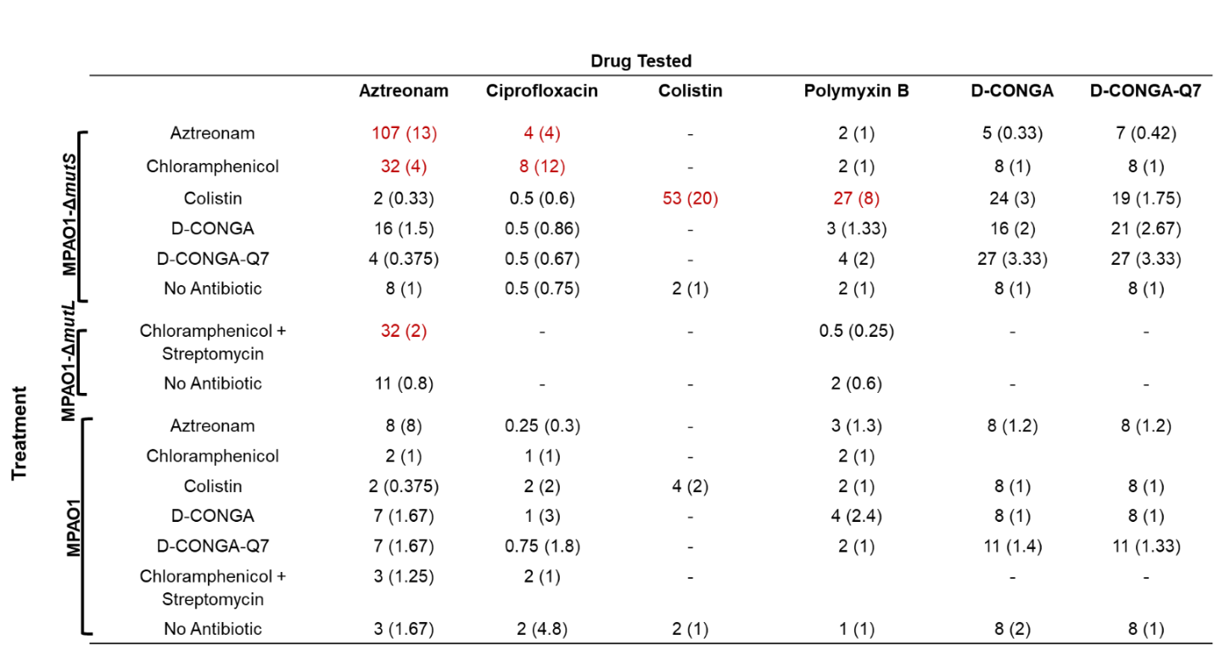

Supplementary Data 1: De novo mutations identified in lab evolved lineages.

Supplementary Data 2: Extended information on prospectively collected P. aeruginosa subject isolates. Mucoidy was determined morphologically after pure-culturing isolates. Mutator denotes determination of hypermutator phenotype via rifampicin reversion frequency. Nonsynonymous mutations called to PAO1, prior to deduplication, in key genes of interest are listed.

Supplementary Data 3: Cosine similarities of retrospective isolates of P. aeruginosa from pwCF to MMR-deficiency signatures. Isolates are listed in the order of appearance on heat map presented in Figure 5B, going from left to right.

Supplementary Data 4: Predictions of MMR-status for all retrospective isolates from pwCF. Isolates from Lopez-Causape et al. are listed with corresponding predicted MMR status resulting from mutational signature analysis, as well as respective mutator and resistance phenotypes (reported by Lopez-Causape et al.) used in analyses. PIP/TAZ = piperacillin/tazobactam, CAZ = ceftazidime, MER = meropenem, CIP = ciprofloxacin, COL = colistin, TOL/TAZ = ceftolozane/tazobactam, CAZ/AVI = ceftazidime/avibactam, MER/VAB = meropenem/vaborbactam, IMI/REL = imipenem/relebactam, FDC = cefiderocol.

Supplementary Data 5: Cosine similarities of retrospective isolates of P. aeruginosa from additional disease contexts to MMR-deficiency signatures. Isolates are listed in the order of appearance on heat map presented in Figure 6B.

Supplementary Data 6: Predictions of MMR-status for all retrospective isolates from additional disease contexts. Isolates from Kos et al. are listed with corresponding predicted MMR status resulting from mutational signature analysis, as well as resistance phenotypes (reported by Kos et al.) used in analyses.

