Appendix A – Additional recent cod environment-recruitment results
All graphs below are examinations of patterns of poor recruitment for the remaining recent cod stocks and season combinations previously examined in NEFSC (2023) including the Western Gulf of Maine (WGOM, fall season only, for spring season see main text Figure 3), Eastern Gulf of Maine (EGOM, spring and fall seasons), and Georges Bank (GBK, spring and fall seasons).
For all graphs, the vertical dashed line divides the data into extreme and non-extreme conditions for the given environmental variable. Labels for extreme (red) and non-extreme (blue) conditions are also listed below each individual graph. The horizontal dashed line divides the recruitment into below- and above-median recruitment, while the horizontal red and blue lines indicate median recruitment for extreme and normal conditions, respectively.
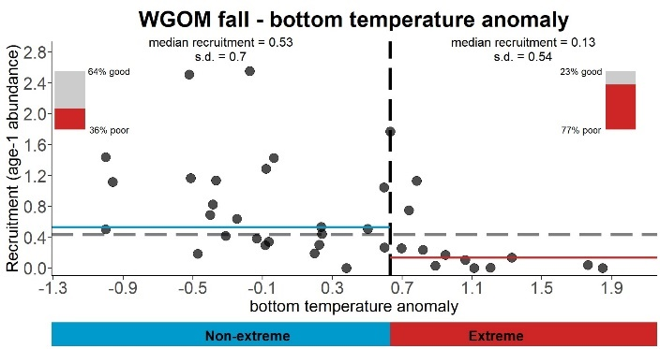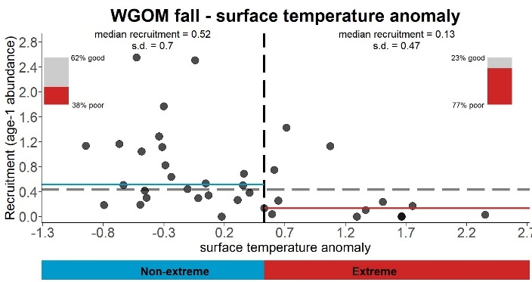
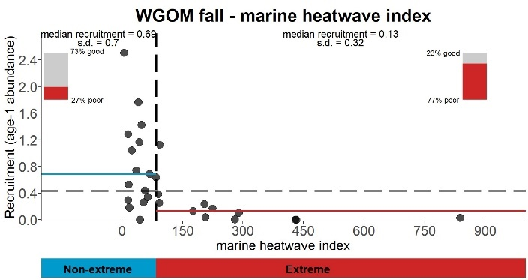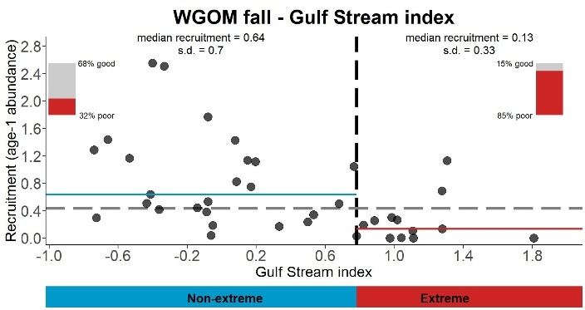
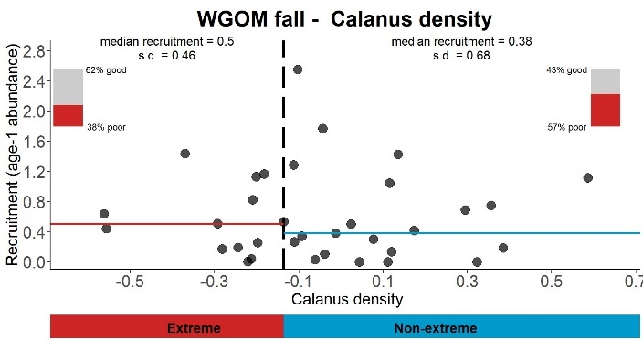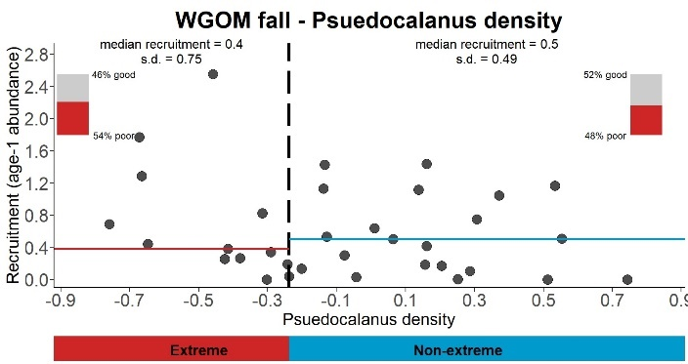
Figure 5. Results for the Western Gulf of Maine cod stock during the fall season.
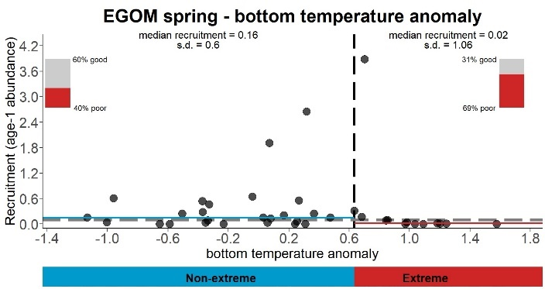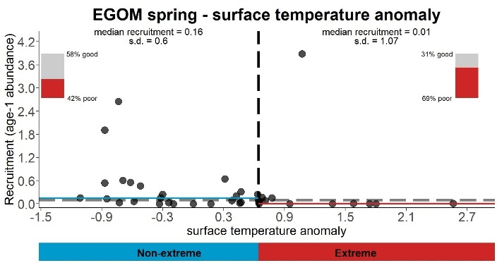
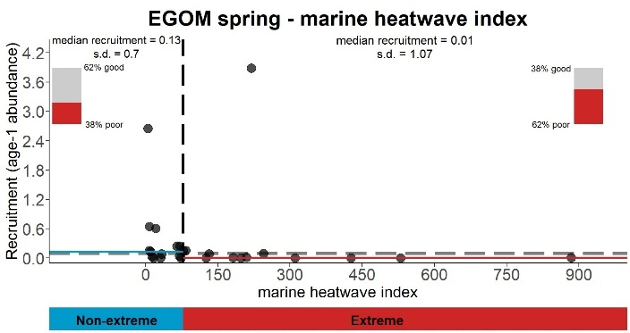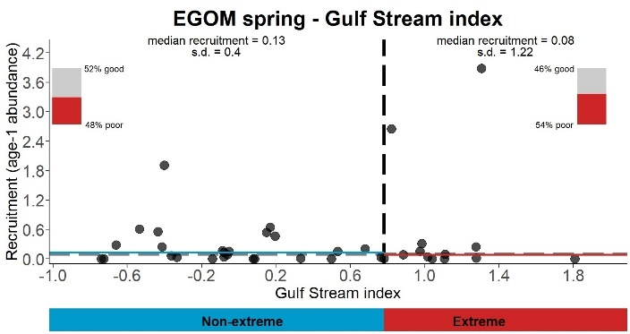
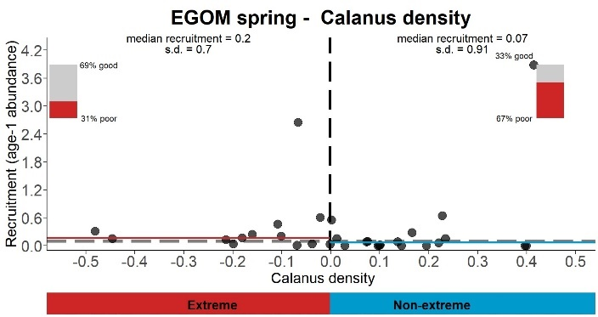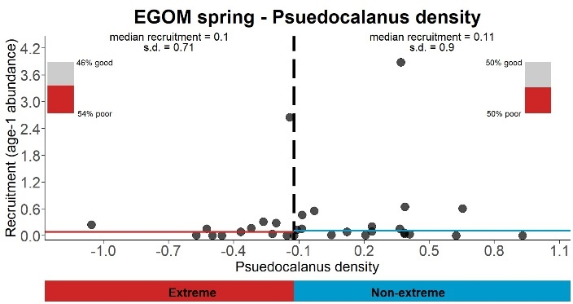
Figure 6. Results for the Eastern Gulf of Maine cod stock during the spring season.

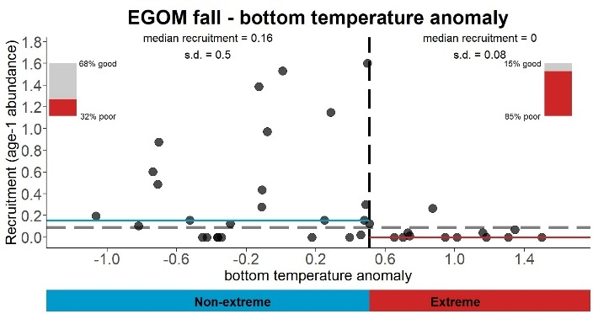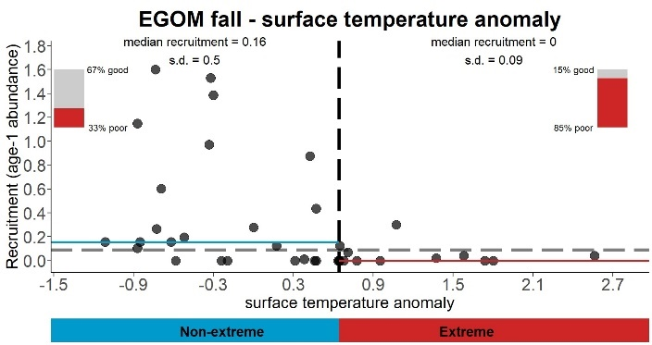
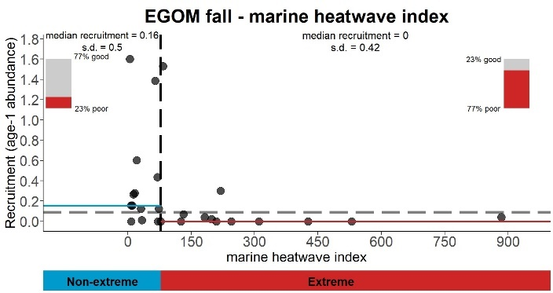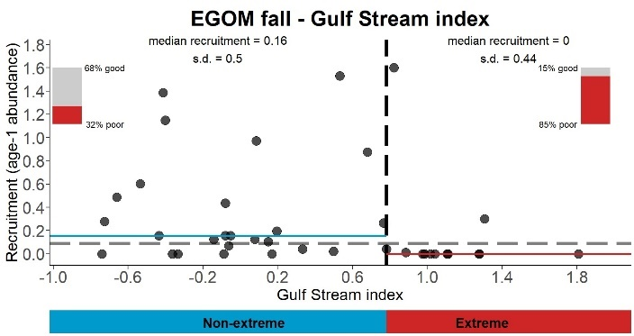
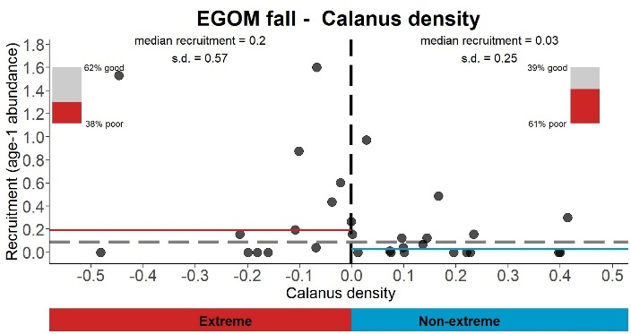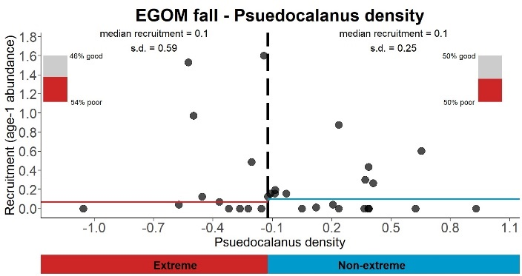
Figure 7. Results for the Eastern Gulf of Maine cod stock during the fall season.

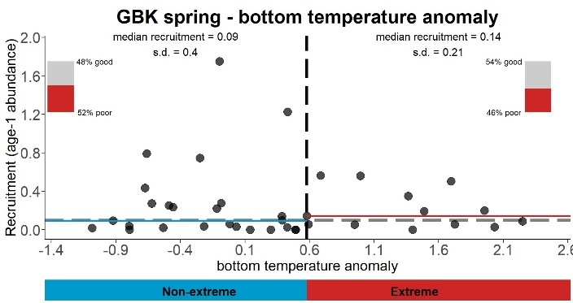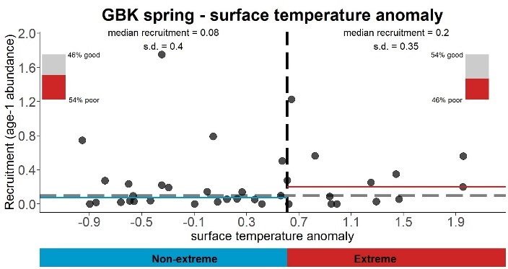
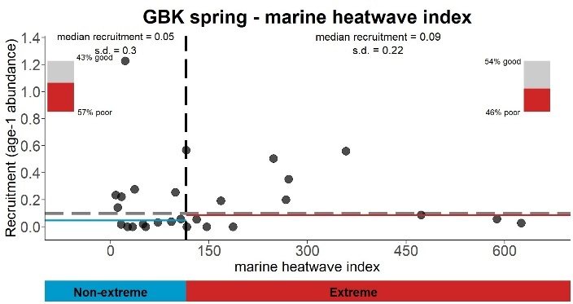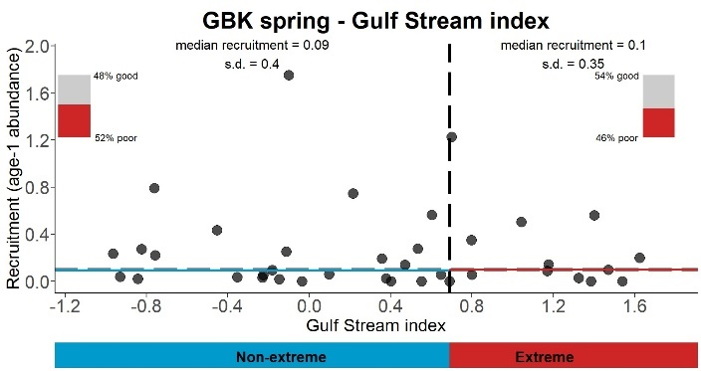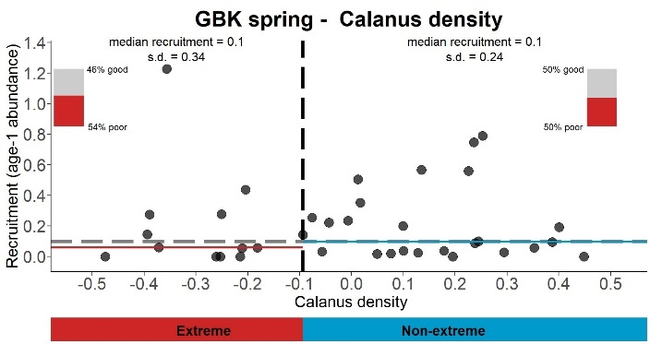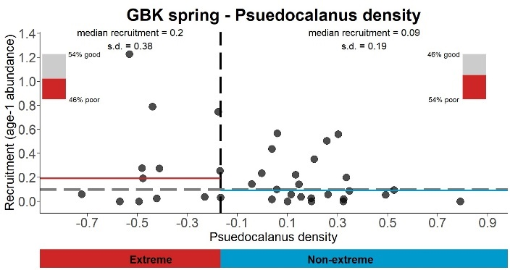
Figure 8. Results for the Georges Bank cod stock during the spring season.

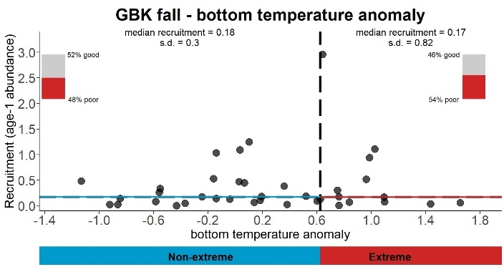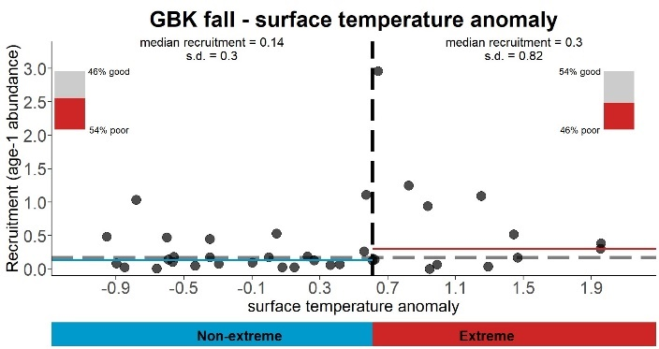
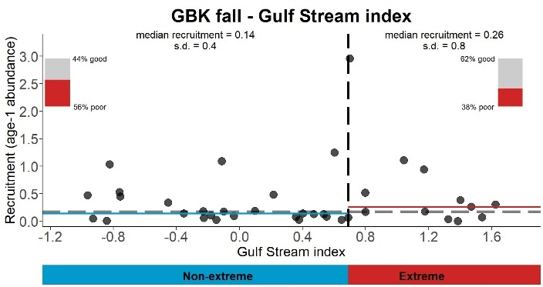
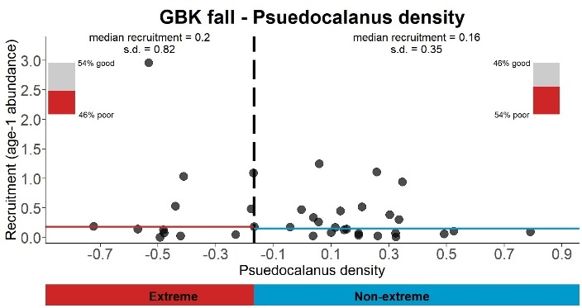
Figure 9. Results for the Georges Bank cod stock during the fall season.

