Original gel/blot images

Original Western-Blot image of Additional file 1-Actin

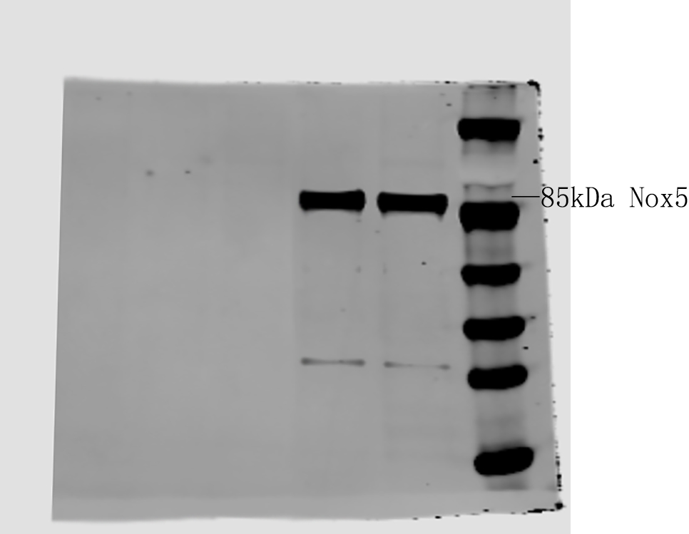
Original Western-Blot image of Additional file 1-Nox5

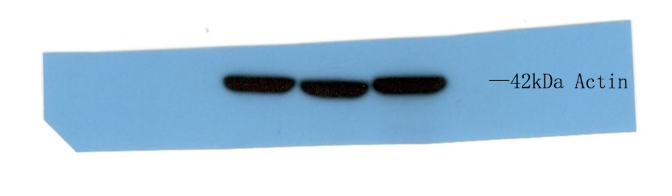
Original Western-Blot image of Fig 1-Actin

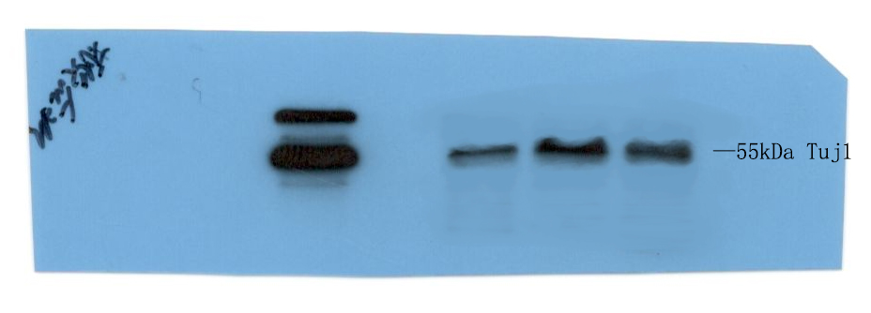
Original Western-Blot image of Fig 1-Tuj1

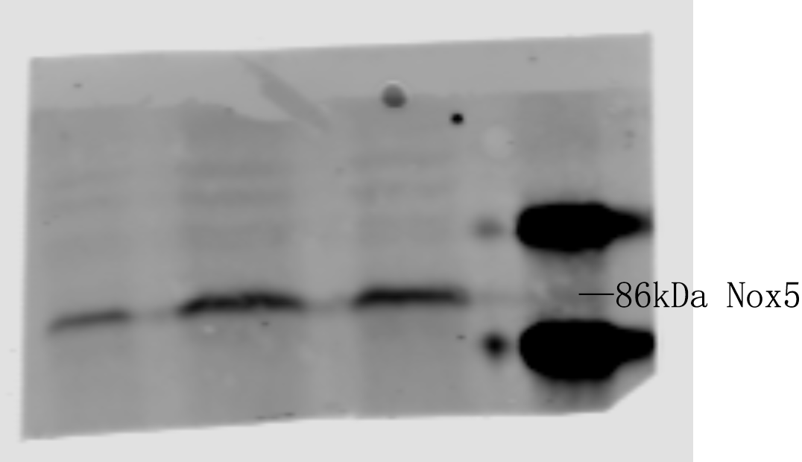
Original Western-Blot image of Fig 1-Nox5

