Supplemental Figures

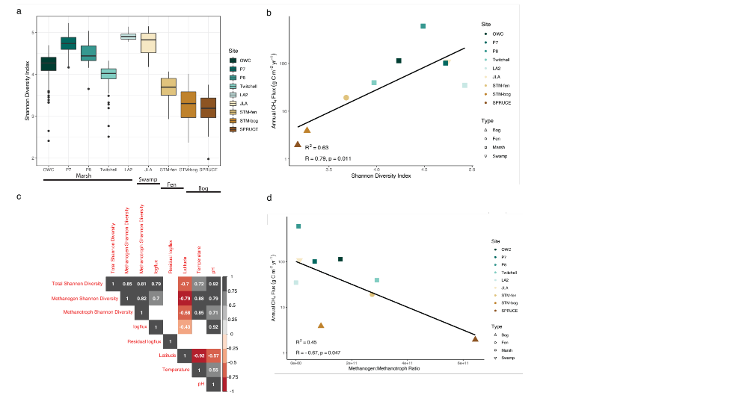
Figure S1. (A) Alpha diversity measured using the Shannon diversity index of the total community was significantly higher in swamps and marshes compared to bog and fen (p<0.001). (B) Total community alpha diversity was significantly correlated with annual CH₄ flux.

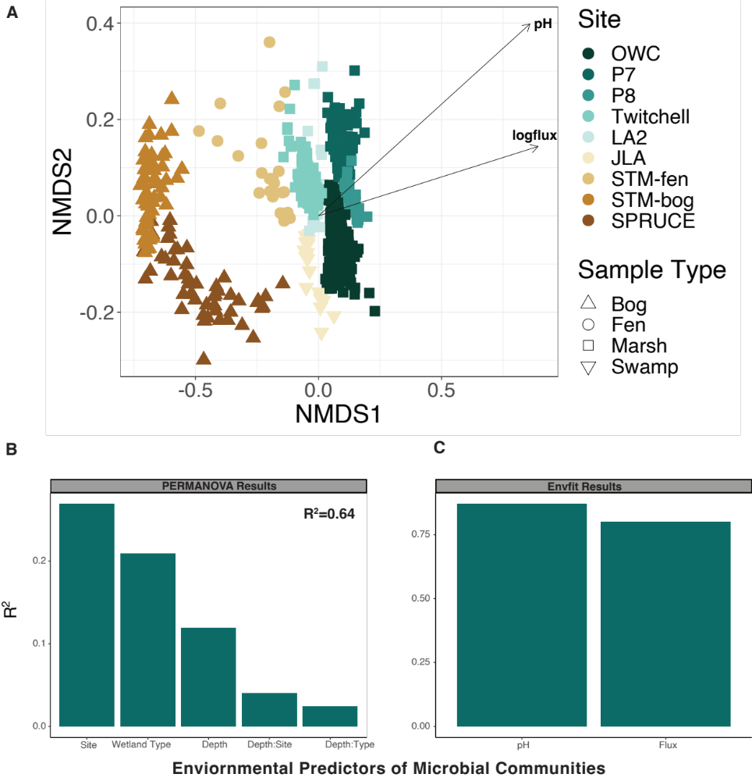Figure S2. Wetland type and pH are dominant drivers of microbial communities. (A) Nonmetric multidimensional scaling (NMDS) oridination of wetland communities was overlayed with significant environmental variables using envfit. (B) Barplot visualizing the relative importance of environmental factors that explain variation in the microbial communities. (C) Higher pH and CH₄ flux were correlated with microbial communities from marsh sites.

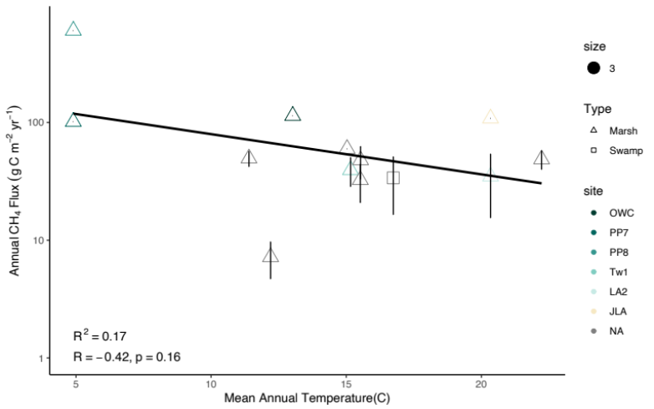
A.
B.
C.
Figure S3. (A) Temperature alone has relatively low predictive power of CH₄ flux in marshes and swamps. Mean annual temperature of all marsh and swamp found in Delwiche et al. (2021) and in our dataset were compared annual CH₄ flux. (B) Correlation plot comparing environmental variables to CH₄ flux and Shannon diversity. White boxes with no value indicates no significant correlation between variables. (C) The ratio of methanogen to methanotroph relative abundance is significantly correlated to CH₄ flux.

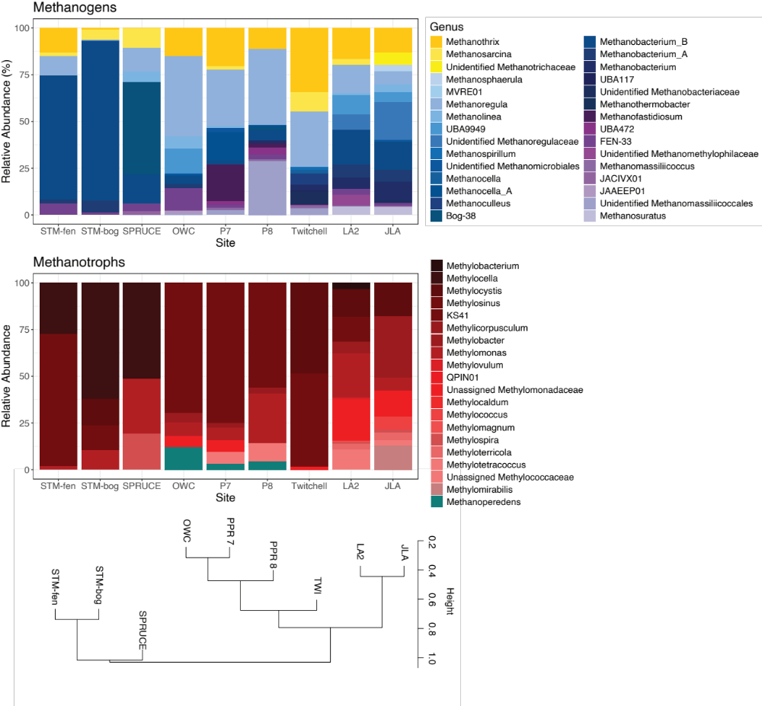
Figure S4. Across 9 wetlands, the highest methane emitting wetlands (PPR P7, OWC) shared similar methane microbial communities despite differences in geography. Amplicon taxonomic data were mined for known methanogen or methanotroph membership and relative abundance. Dominant and prevalent methanogen genera include Methanoregula and Methanothrix. Methanogens are colored by pathway where acetoclastic methanogens are given in yellow, hydrogenotrophic methanogens in blue and methylotrophic methanogens in purple. Aerobic methanotrophs are given in red while anaerobic methanotrophs are given in teal.

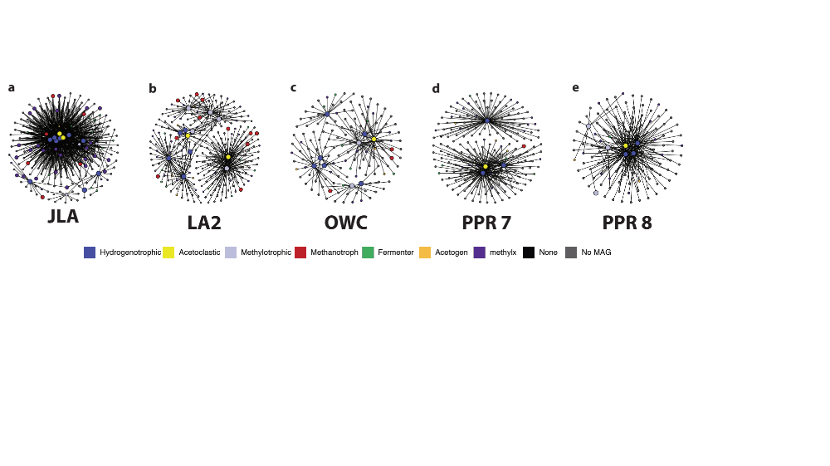
Figure S5. 16S rRNA gene co-occurrence networks at each site were built for the methanogen community. Networks were constructed to comprise all significant co-occurrences that included a methanogen.

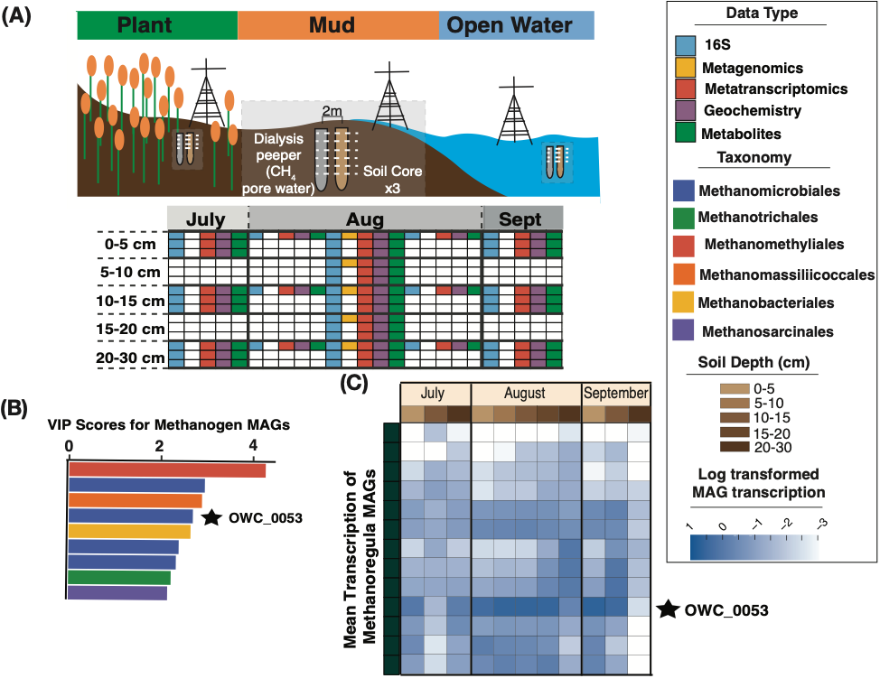
Figure S6. (A) Illustration representing our 2018 sampling campaign in OWC, here used as a case study for exploring the significance of Methanoregula in a single wetland. (B) Significant VIP scores (>2) for methanogen MAGs found predictive of CH₄ fluxes in OWC, including a member of the Methanoregula (starred, OWC_0053). (B) Mean transcription of Methanoregula MAGs across time and depth in OWC in the mud site type. Members of the genus are active across the site, with the most active MAG representing the sole one found to be significantly predictive of CH₄ fluxes.

Captions for Supplemental Tables The bolded pre-fix relates to the spreadsheet worksheet
name.
Supplemental Table 1. Overview of all metagenomics, metranscriptomic, and 16S rRNA samples included in the Multiomics for Understanding Climate Change (MUCC) v2.0.0 and sequencing information for every metagenome sampled.
Supplemental Table 2. The 16S rRNA sequencing data table includes unique amplicon sequences variants (ASV) and their corresponding GTDB-Tk assignment for all 1,112 samples.
Supplemental Table 3. Data including the database ID, taxonimc assignment, and quality scores for the 4,746 medium and high-quality metagenome assembled genomes (MAGs) included in the MUCC v2.0.0 database.
Supplemental Table 4. Metabolic rules created to assign the following functional categories to MAGs: methanogen, methanotroph, homoacetogen, obligate fermenter, and demethylation metabolism.
Supplemental Table 5. MAGs linked to the 16S rRNA cooccurrence networks were assigned functional categories based on the rules outlined in Supplemental Table $.
Supplemental Table 6. Methanogen and methanotroph MAGs and their corresponding taxonomic identification and methanogenic pathway.
Supplemental Table 7. Library preparation and sequencing information for al 16S rRNA samples.

Supplemental References
1. Oliverio, A. M. et al. Rendering the metabolic wiring powering wetland soil methane production. 2024.02.06.579222 Preprint at https://doi.org/10.1101/2024.02.06.579222 (2024).
2. Angle, J. C. et al. Methanogenesis in oxygenated soils is a substantial fraction of wetland methane emissions. Nat Commun 8, 1567 (2017).
3. Narrowe, A. B. et al. Uncovering the Diversity and Activity of Methylotrophic Methanogens in Freshwater Wetland Soils. mSystems 4, e00320-19 (2019).
4. Narrowe, A. B. et al. Complex Evolutionary History of Translation Elongation Factor 2 and Diphthamide Biosynthesis in Archaea and Parabasalids. Genome Biol Evol 10, 2380–2393 (2018).
5. Dalcin Martins, P., Frank, J., Mitchell, H., Markillie, L. M. & Wilkins, M. J. Wetland Sediments Host Diverse Microbial Taxa Capable of Cycling Alcohols. Appl Environ Microbiol 85, (2019).
6. He, S. et al. Patterns in wetland microbial community composition and functional gene repertoire associated with methane emissions. mBio 6, e00066-00015 (2015).
7. Woodcroft, B. J. et al. Genome-centric view of carbon processing in thawing permafrost. Nature 560, 49–54 (2018).
8. Dalcin Martins, P. et al. Abundant carbon substrates drive extremely high sulfate reduction rates and methane fluxes in Prairie Pothole Wetlands. Glob Change Biol 23, 3107–3120 (2017).
9. Wilson, R. M. et al. Soil metabolome response to whole-ecosystem warming at the Spruce and Peatland Responses under Changing Environments experiment. Proceedings of the National Academy of Sciences 118, e2004192118 (2021).
10. Ellenbogen, J. B. et al. Methylotrophy in the Mire: direct and indirect routes for methane production in thawing permafrost. mSystems 0, e00698-23 (2023).
11. Guerrero-Cruz, S. et al. Methanotrophs: Discoveries, Environmental Relevance, and a Perspective on Current and Future Applications. Frontiers in Microbiology 12, (2021).
12. Shin, J., Song, Y., Jeong, Y. & Cho, B.-K. Analysis of the Core Genome and Pan-Genome of Autotrophic Acetogenic Bacteria. Front Microbiol 7, 1531 (2016).
13. Andreesen, J. R. Glycine reductase mechanism. Current Opinion in Chemical Biology 8, 454–461 (2004).
14. Rajakovich, L. J., Fu, B., Bollenbach, M. & Balskus, E. P. Elucidation of an anaerobic pathway for metabolism of l-carnitine–derived γ-butyrobetaine to trimethylamine in human gut bacteria. Proceedings of the National Academy of Sciences 118, e2101498118 (2021).
15. Massmig, M. et al. Carnitine metabolism in the human gut: characterization of the two-component carnitine monooxygenase CntAB from Acinetobacter baumannii. J Biol Chem 295, 13065–13078 (2020).
16. Koeth, R. A. et al. γ-Butyrobetaine Is a Proatherogenic Intermediate in Gut Microbial Metabolism of L-Carnitine to TMAO. Cell Metabolism 20, 799–812 (2014).
17. Craciun, S. & Balskus, E. P. Microbial conversion of choline to trimethylamine requires a glycyl radical enzyme. Proc Natl Acad Sci U S A 109, 21307–21312 (2012).
18. Bazire, P. et al. Characterization of l-Carnitine Metabolism in Sinorhizobium meliloti. Journal of Bacteriology 201, 10.1128/jb.00772-18 (2019).
19. Wargo, M. J. & Meadows, J. A. Carnitine in bacterial physiology and metabolism. Microbiology 161, 1161–1174 (2015).
20. Wargo, M. J., Szwergold, B. S. & Hogan, D. A. Identification of Two Gene Clusters and a Transcriptional Regulator Required for Pseudomonas aeruginosa Glycine Betaine Catabolism. Journal of Bacteriology 190, 2690–2699 (2008).
21. Kumar, R. et al. Prediction and Biochemical Demonstration of a Catabolic Pathway for the Osmoprotectant Proline Betaine. mBio 5, 10.1128/mbio.00933-13 (2014).
22. Cronin, D. & Institute, N. E. B. I. Metagenome-assembled genomes (MAGs) from Stordalen Mire, Sweden. Zenodo https://doi.org/10.5281/zenodo.7596016 (2023).
23. Kurth, J. M., Op den Camp, H. J. M. & Welte, C. U. Several ways one goal—methanogenesis from unconventional substrates. Appl Microbiol Biotechnol 104, 6839–6854 (2020).
24. Lü, Z. & Lu, Y. Complete Genome Sequence of a Thermophilic Methanogen, Methanocella conradii HZ254, Isolated from Chinese Rice Field Soil. Journal of Bacteriology 194, 2398–2399 (2012).
25. Borrel, G. et al. Methanomethylophilus alvi gen. nov., sp. nov., a Novel Hydrogenotrophic Methyl-Reducing Methanogenic Archaea of the Order Methanomassiliicoccales Isolated from the Human Gut and Proposal of the Novel Family Methanomethylophilaceae fam. nov. Microorganisms 11, 2794 (2023).
26. Theisen, A. R. & Murrell, J. C. Facultative Methanotrophs Revisited. Journal of Bacteriology 187, 4303–4305 (2005).
27. Cozannet, M. et al. New Insights into the Ecology and Physiology of Methanomassiliicoccales from Terrestrial and Aquatic Environments. Microorganisms 9, 30 (2020).
28. Liu, Y.-F. et al. Anaerobic Degradation of Paraffins by Thermophilic Actinobacteria under Methanogenic Conditions. Environ. Sci. Technol. 54, 10610–10620 (2020).

