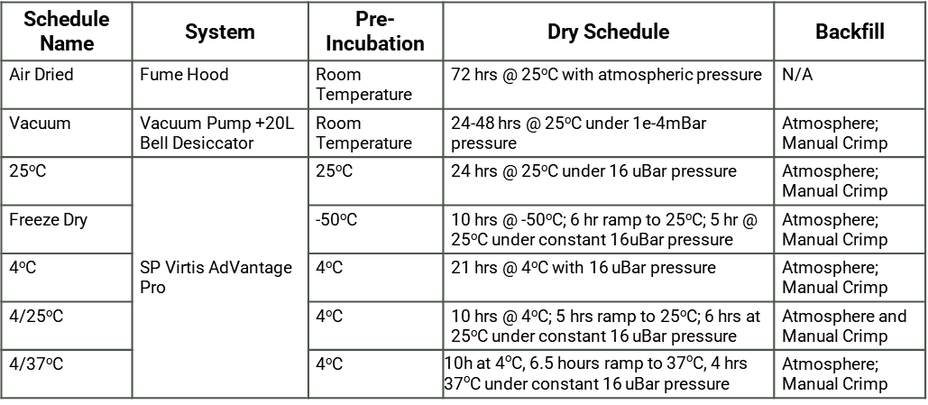
Table S1. Summary of drying schedules.

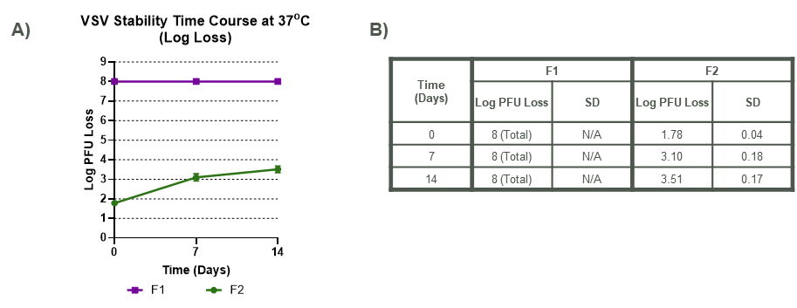
Figure S1. VSV stability with air drying methodology. A) VSV stability for process loss and thermal challenge over 14 days. B) Calculated means and standard deviation for each data point of accumulated Log PFU loss for each condition.

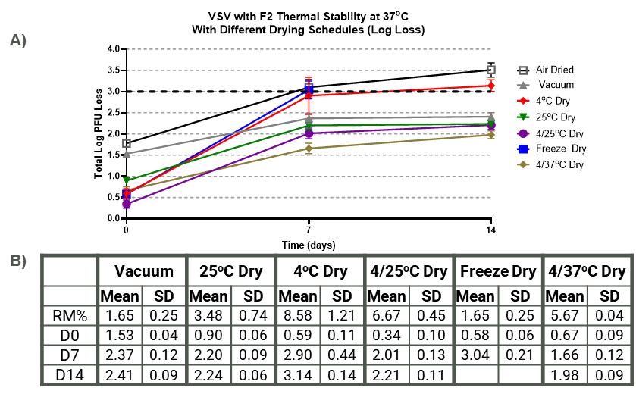
Figure S2. Comparison of different dry schedules for VSV process and thermal stability loss over 14 days. A) VSV stability for process loss and thermal challenge over 14 days. B) Calculated means and standard deviation for each data point of accumulated Log PFU loss for each condition.

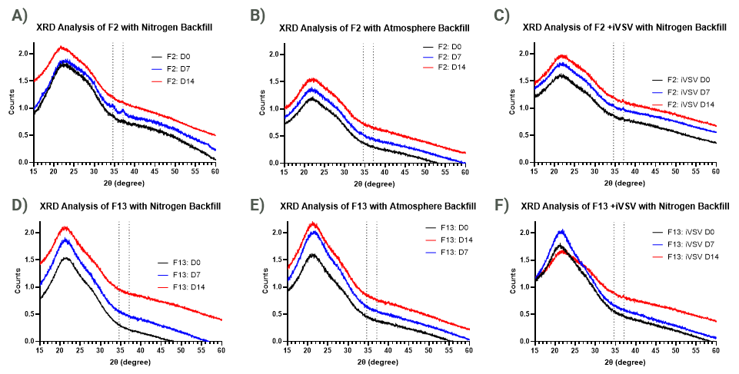
Fig S3. XRD traces of formulations over 14-day time course at 37ºC. A) Formulation F2 in vials backfilled with dried nitrogen. B) Formulation F2 in vials backfilled with atmosphere. C) Formulation F2 with inactivated VSV backfilled with dried nitrogen. D) Formulation F13 in vials backfilled with dried nitrogen. B) Formulation F13 in vials backfilled with atmosphere. C) Formulation F13 with inactivated VSV backfilled with dried nitrogen

