Step2B-epilepsy-metabolites-reverse MR results-IVW
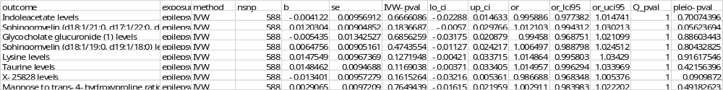

1. Indoleacetate levels—epilepsy

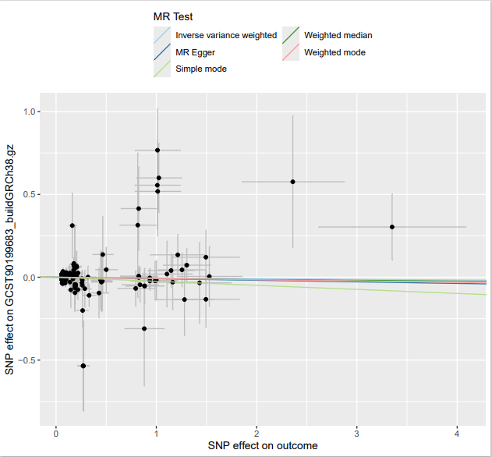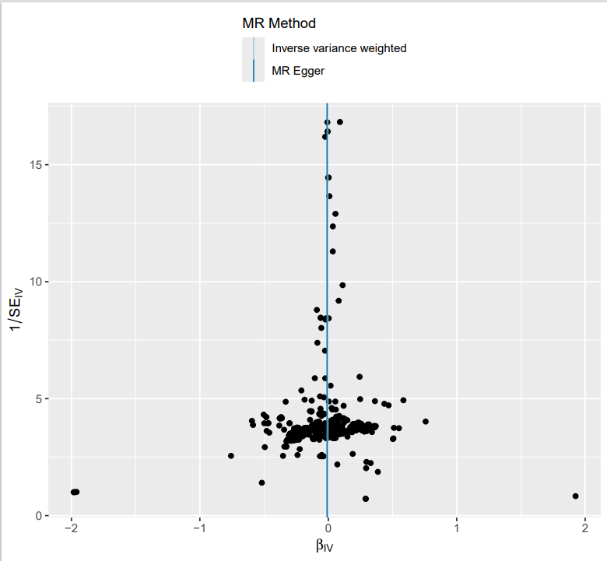

Results of heterogeneity analysis
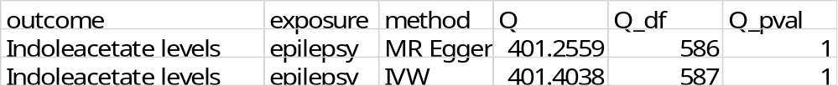
Results of horizontal pleiotropic effects analysis

2. Sphingomyelin (d18:1/21:0, d17:1/22:0, d16:1/23:0) levels —epilepsy

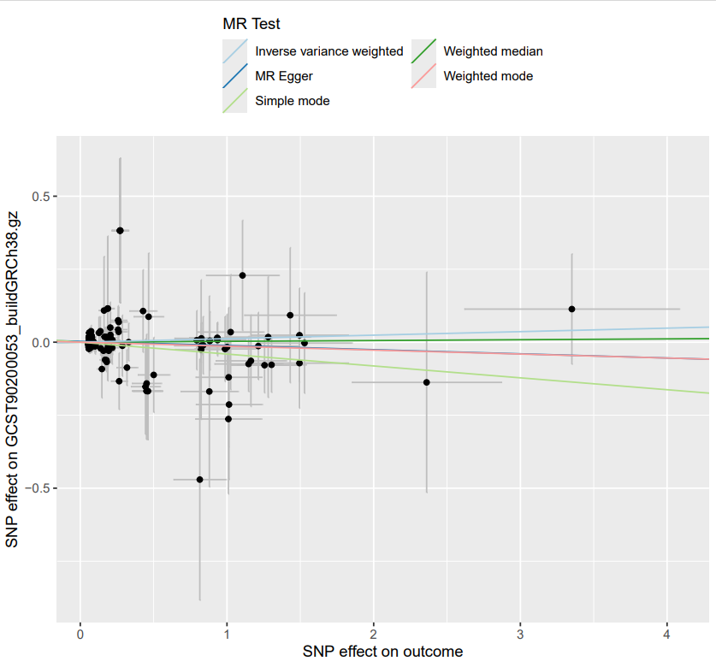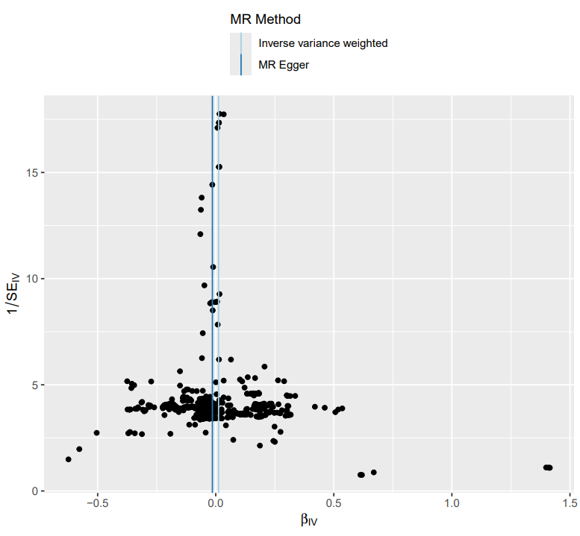
Results of heterogeneity analysis
Results of horizontal pleiotropic effects analysis

3. Glycocholate glucuronide (1) levels-- epilepsy

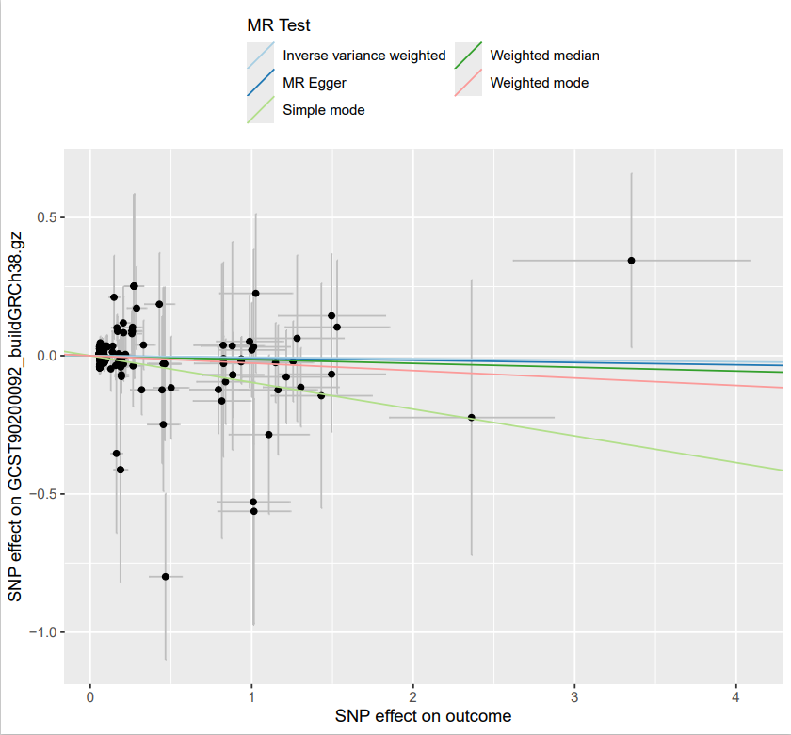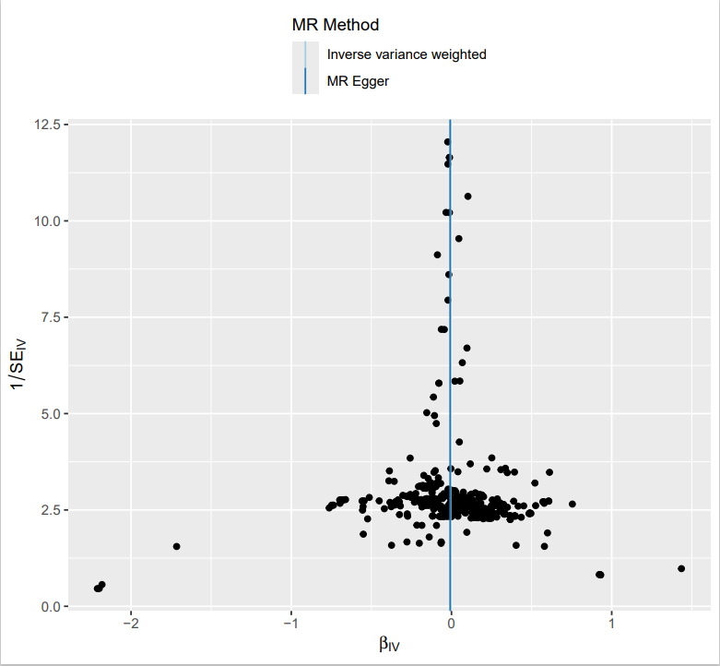

Results of heterogeneity analysis
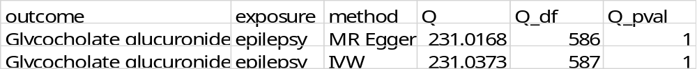
Results of horizontal pleiotropic effects analysis

4. Sphingomyelin (d18:1/19:0, d19:1/18:0) levels—epilepsy
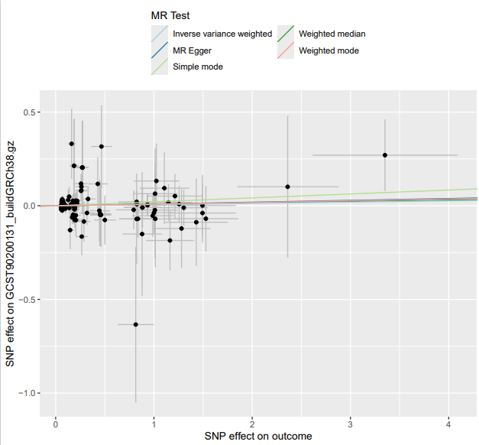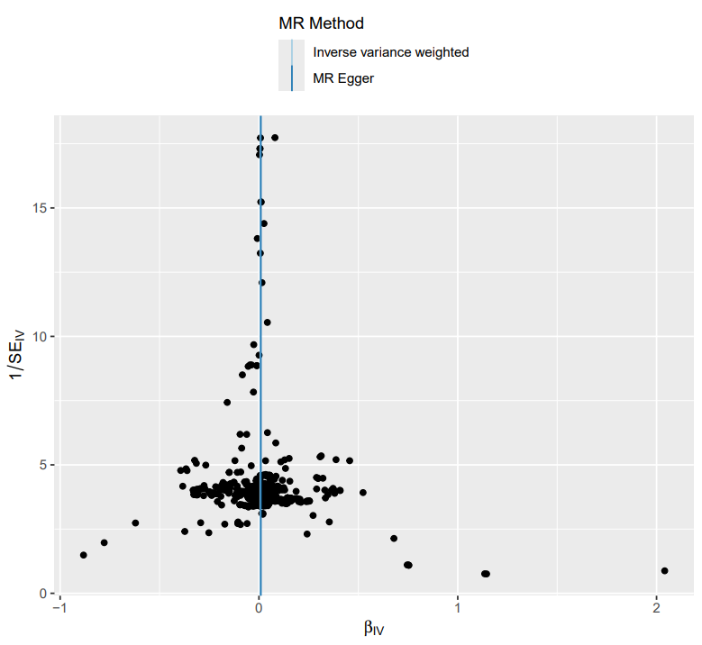

Results of heterogeneity analysis
Results of horizontal pleiotropic effects analysis

5. Lysine levels—epilepsy
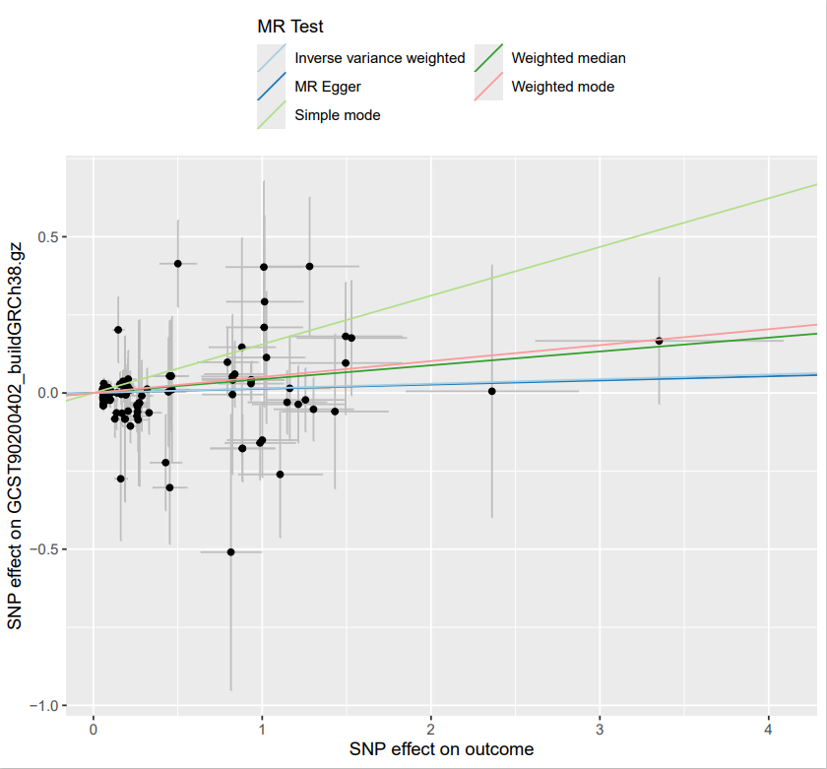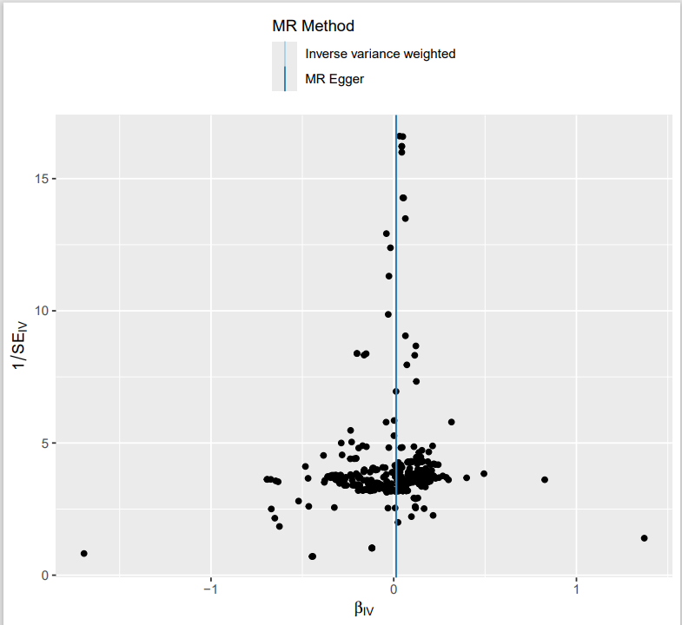
Results of heterogeneity analysis
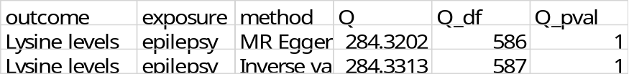

Results of horizontal pleiotropic effects analysis
6. Taurine levels—epilepsy
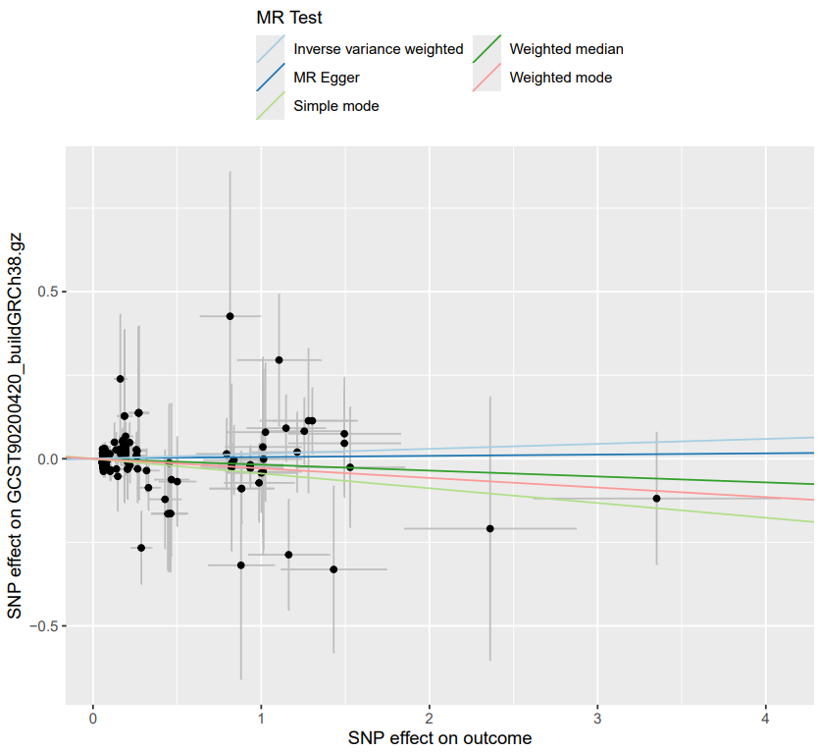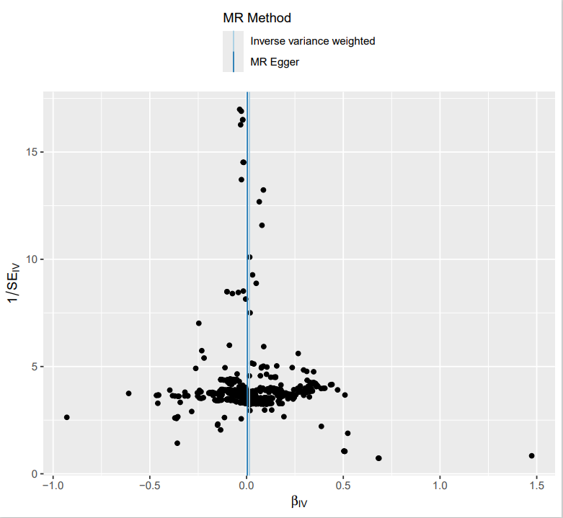
Results of heterogeneity analysis
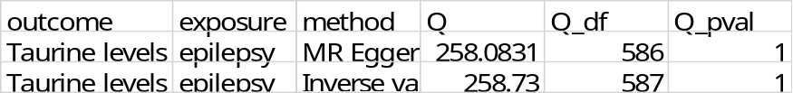
Results of horizontal pleiotropic effects analysis

7. X-25828 levels—epilepsy

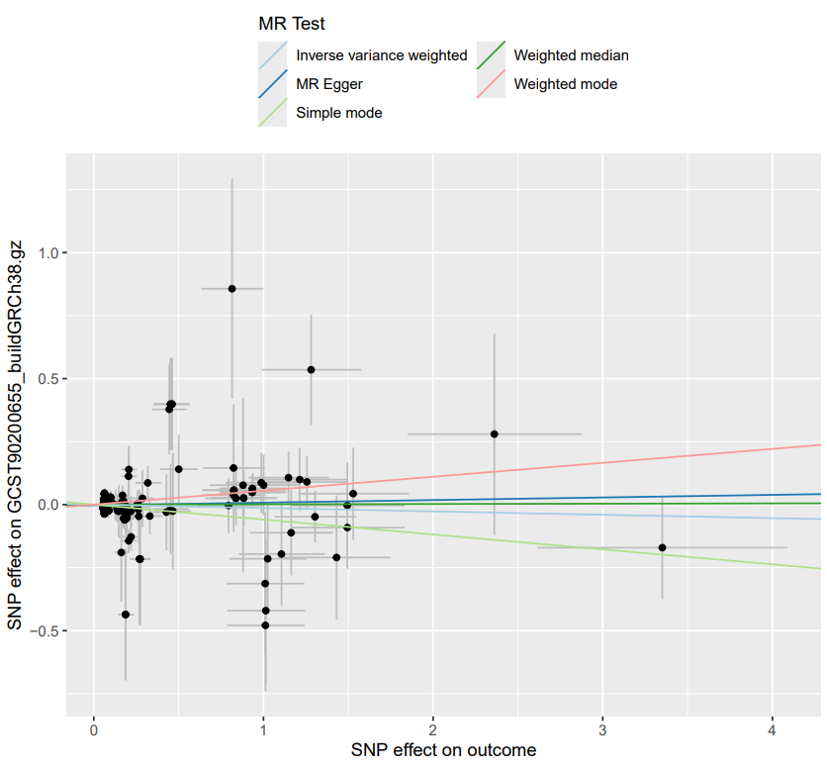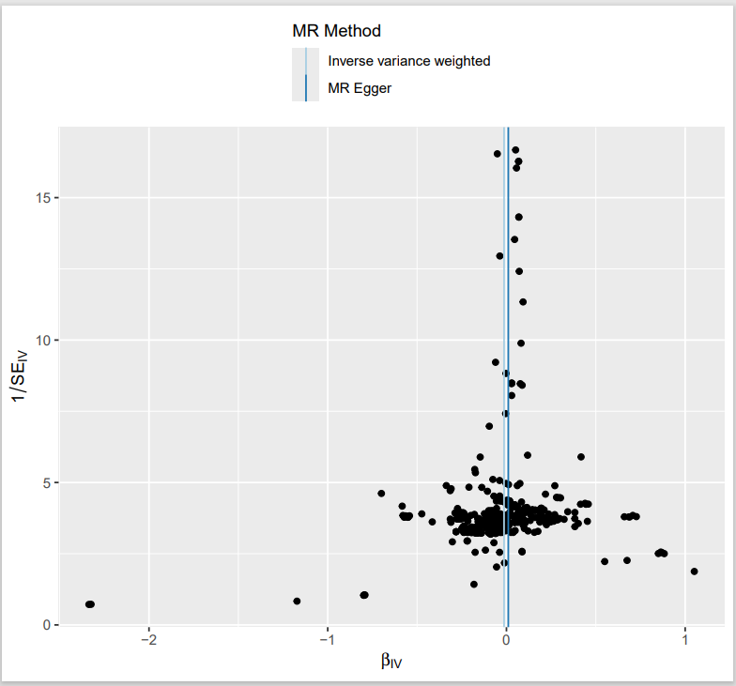
Results of heterogeneity analysis
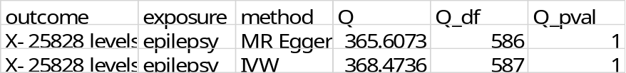
Results of horizontal pleiotropic effects analysis
8. Mannose to trans-4-hydroxyproline ratio—epilepsy
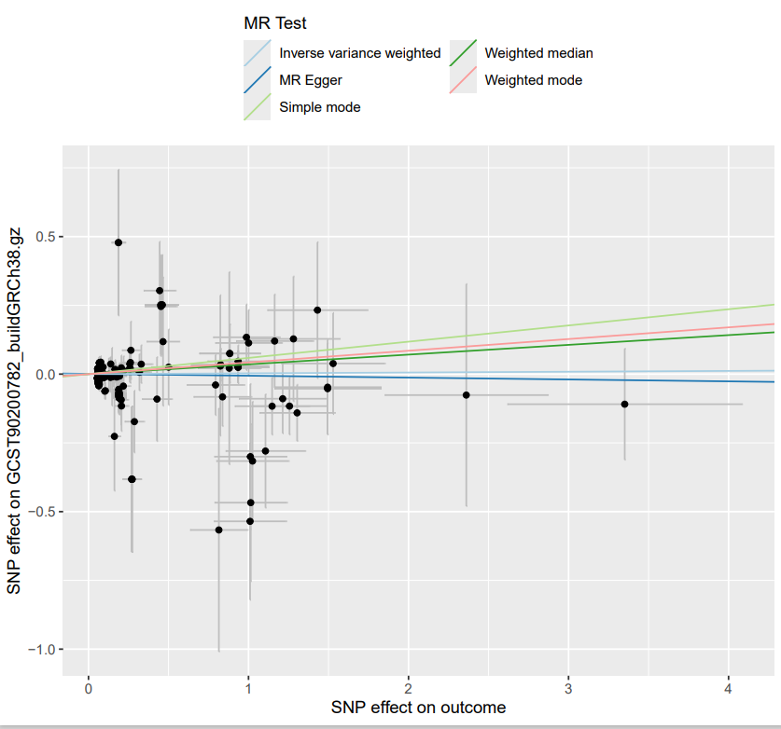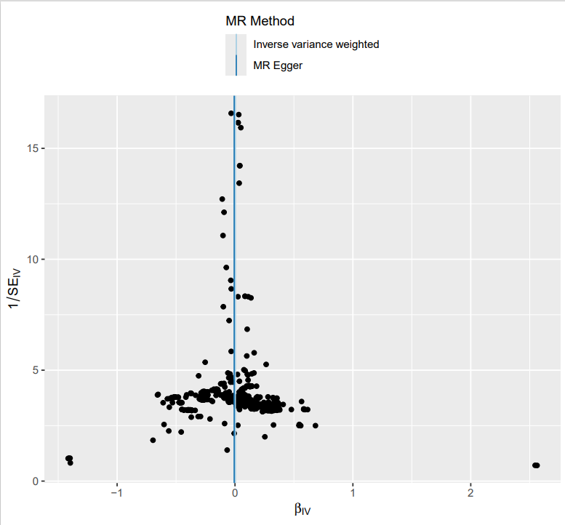
Results of heterogeneity analysis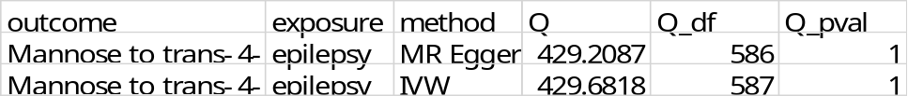
Results of horizontal pleiotropic effects analysis

