1. Epilepsy-Naive CD8br AC
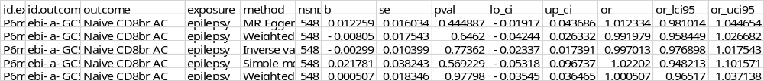

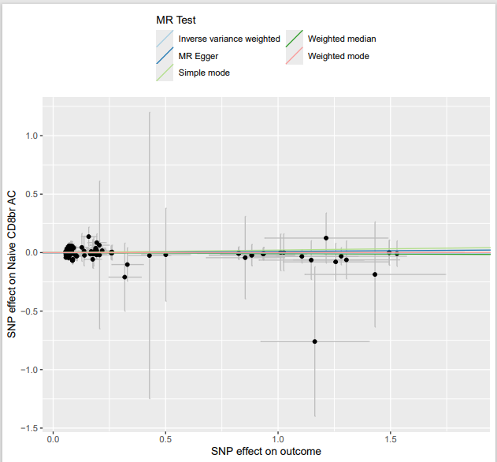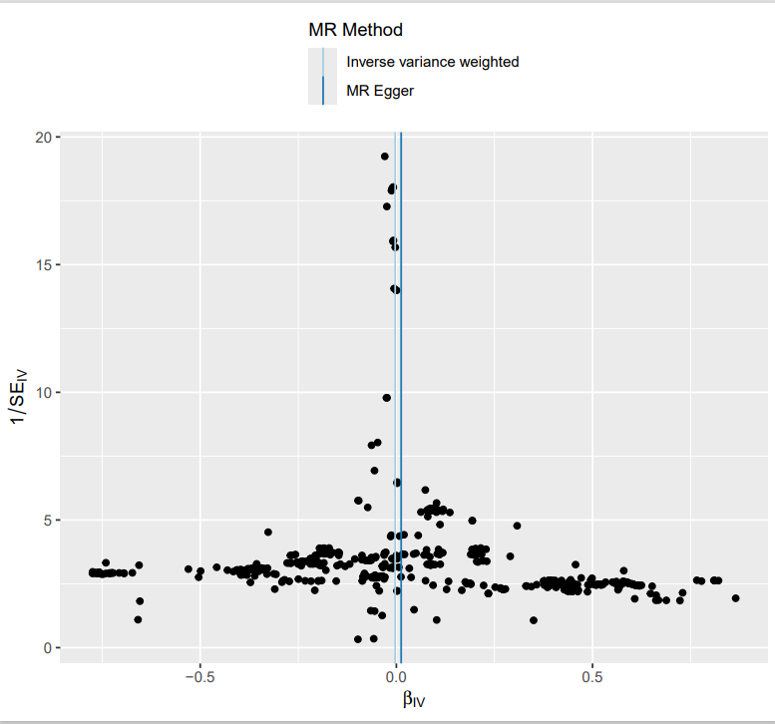
Results of heterogeneity analysis
Results of horizontal pleiotropic effects analysis

2. Epilepsy--IgD+ CD38- AC
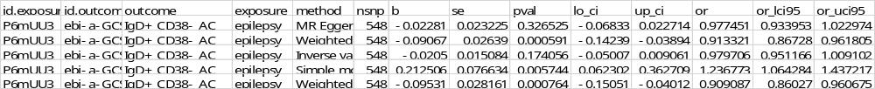

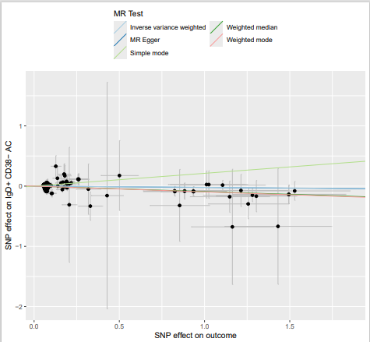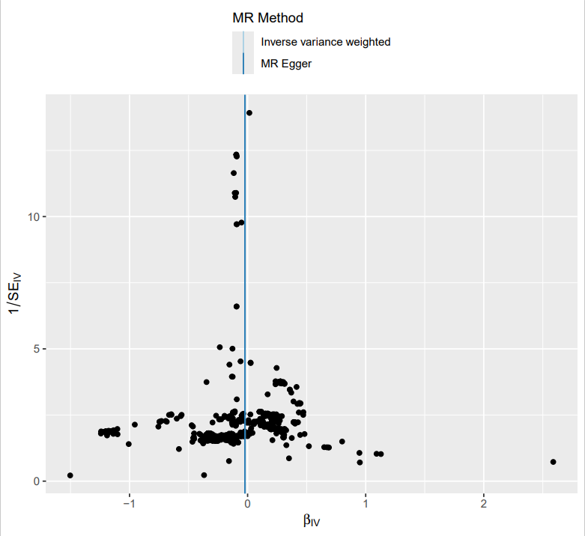
Results of heterogeneity analysis
Results of horizontal pleiotropic effects analysis

