Extended Data for

A Non-Invasive Stem Cell Therapy Boosts Lymphopoiesis and Averts Age-Related Blood Diseases in Mice
Anna Konturek-Ciesla¹, Qinyu Zhang¹, Shabnam Kharazi¹, David Bryder¹*
Affiliations:
¹Division of Molecular Hematology, Department of Laboratory Medicine, Lund Stem Cell Center, Medical Faculty, Lund University; Lund, Sweden.
*Corresponding author. Email: David.Bryder@med.lu.se

Contents:
Extended Data Figure 1
Extended Data Figure 2
Extended Data Figure 3

Supplementary Table 1
Detailed information on transplantation experiments. Related to Fig. 1-5.

Supplementary Table 2
List of antibodies used in this study.

Supplementary Table 3
Original data presented in this study. The table is provided as an Excel sheet.

Extended Data Fig. 1
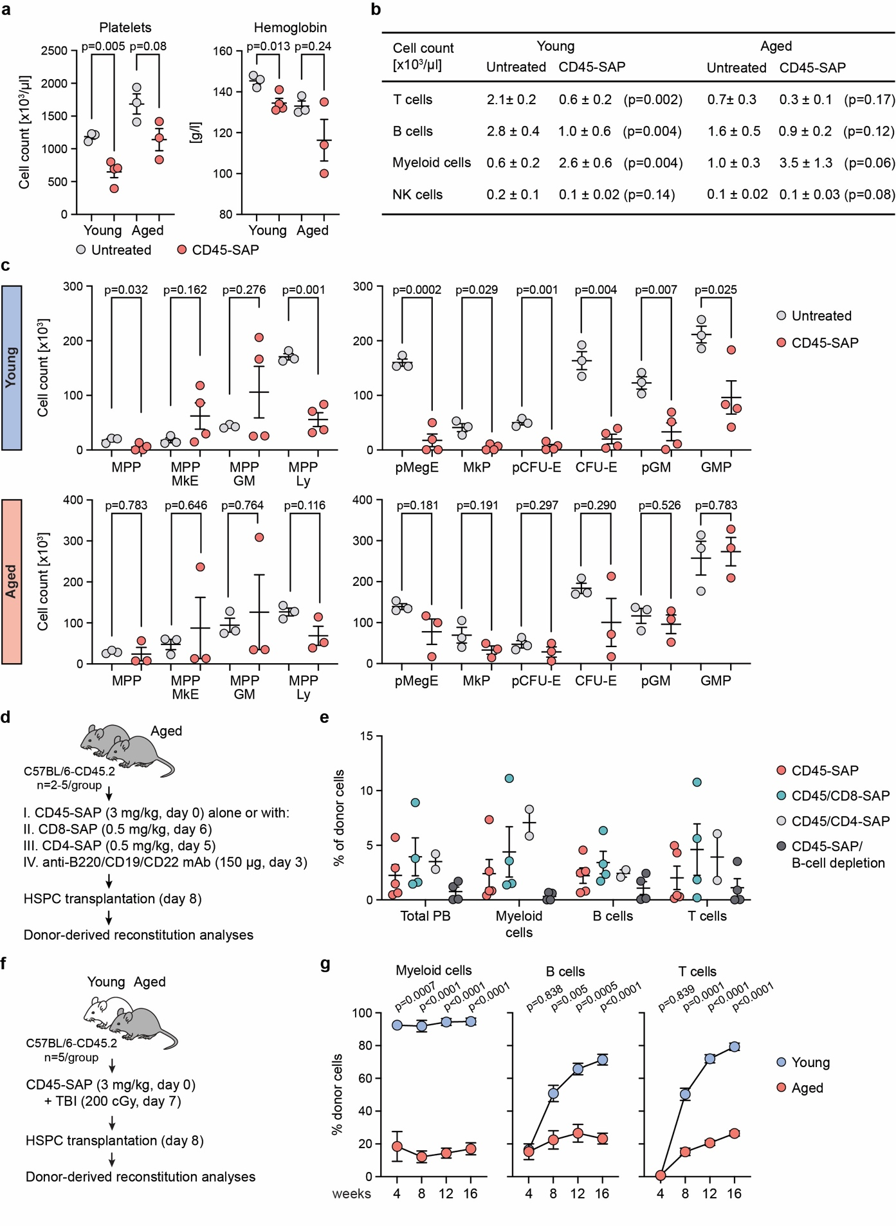
Extended Data Fig. 1. The aged bone marrow environment restrains HSC engraftment (Related to Fig. 1).
(a) Young (2 months) and aged (16 months) C57BL/6-CD45.2 mice received CD45-SAP (3 mg/kg), and hematopoietic parameters were analyzed after 8 days. Untreated mice served as controls. Platelet counts (left) and hemoglobin levels (right) in control and CD45-SAP-treated mice. n=3-4 mice/group. (b) Peripheral blood (PB) lymphoid and myeloid cell counts in control and CD45-SAP-treated mice. p-values are indicated in parenthesis. Shown is mean ± SD. (c) Absolute numbers of indicated hematopoietic stem and progenitor cell (HSPC) subsets in young (top) and aged (bottom) control and CD45-SAP-treated mice. (d) Experimental design for Extended Data Fig. 1e. Aged (16 months) C57BL/6-CD45.2 mice received CD45-SAP (3 mg/kg) with or without CD8-SAP (0.5 mg/kg), CD4-SAP (0.5 mg/kg) or B cell-depleting antibody cocktail (rat anti-mouse B220, anti-CD19 and anti-CD22, followed by anti-rat kappa light chain; 150 μg/mouse each antibody). After treatment, mice were transplanted with HSPCs derived from young donor mice. (e) Donor-derived reconstitution in indicated PB lineages in aged recipients 16 weeks after transplantation. n=2-5 mice/group. (f) Experimental design for Extended Data Fig. 1g. Young (2 months) and aged (16 months) C57BL/6-CD45.2 mice received CD45-SAP (3 mg/kg) and low-dose total body irradiation (TBI, 200 cGy). Following treatment, mice were transplanted with HSPCs derived from young mice. (g) Donor-derived reconstitution in indicated PB lineages in young and aged recipients. n=5 mice/group. In (a), (b) and (e), points indicate individual mice. Shown is mean ± SEM. Statistical significance was determined using an unpaired two-sided t-test with Welch correction. See also Supplementary Table 1.
Extended Data Fig. 2
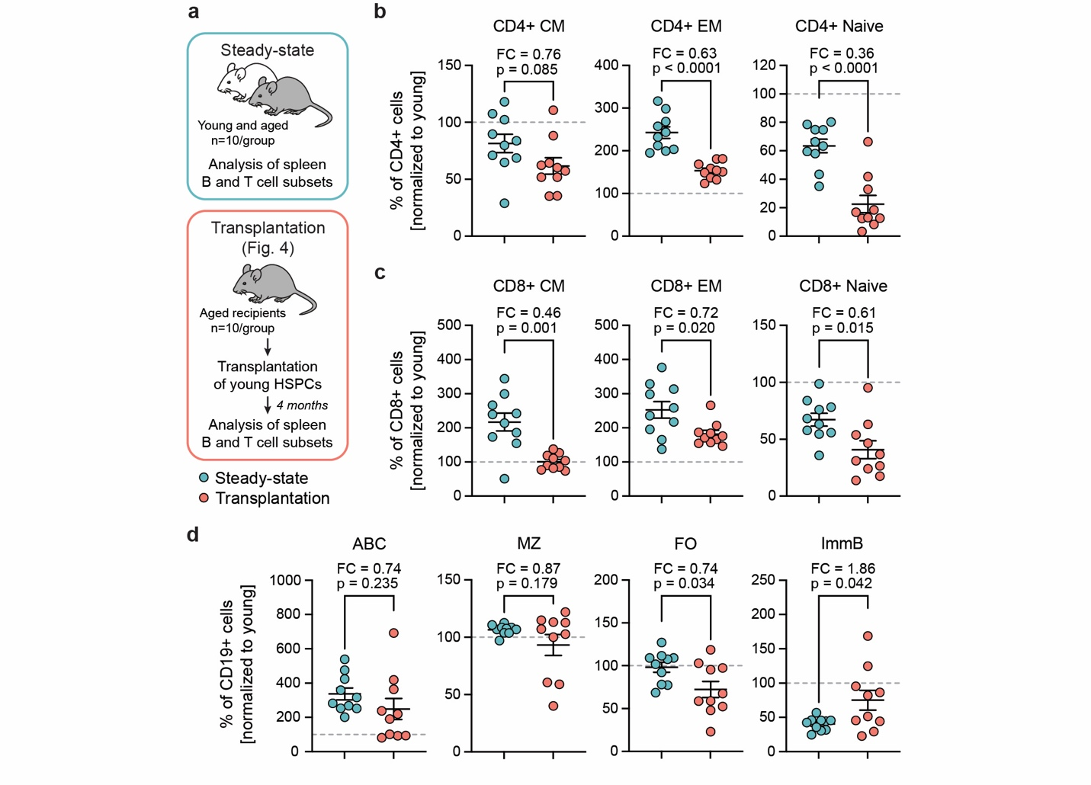
Extended Data Fig. 2. Young HSCs support youthful hematopoietic characteristics upon transplantation into aged recipients (Related to Fig. 4).
(a) Experiment design for Extended Data Fig. 2b-d. Analysis of splenic B and T cell subsets was carried out in steady-state young (2-3 months) and aged (19-20 months) mice (top). Parallel comparison was performed in aged mice following transplantation of young ex vivo expanded HSCs (bottom). Data for transplanted mice derive from Fig. 4. (b-c) Frequency of naive, central memory (CM) and effector memory (EM) T cells within CD4+ and CD8+ splenic cell fractions in aged steady-state and transplanted mice. (d) Frequency of age-associated B cells (ABC), marginal zone (MZ), follicular (FO), and immature (ImmB) B cells within splenic CD19+ cell fraction in aged steady-state and transplanted mice. In (b-d), each point indicates a value for individual aged mouse normalized to young controls. Shown is mean ± SEM. Dashed lines denote 100%. Statistical significance was determined using unpaired two-sided t-test with Welch correction. p-value and fold change (FC) are indicated above each comparison.
Extended Data Fig. 3
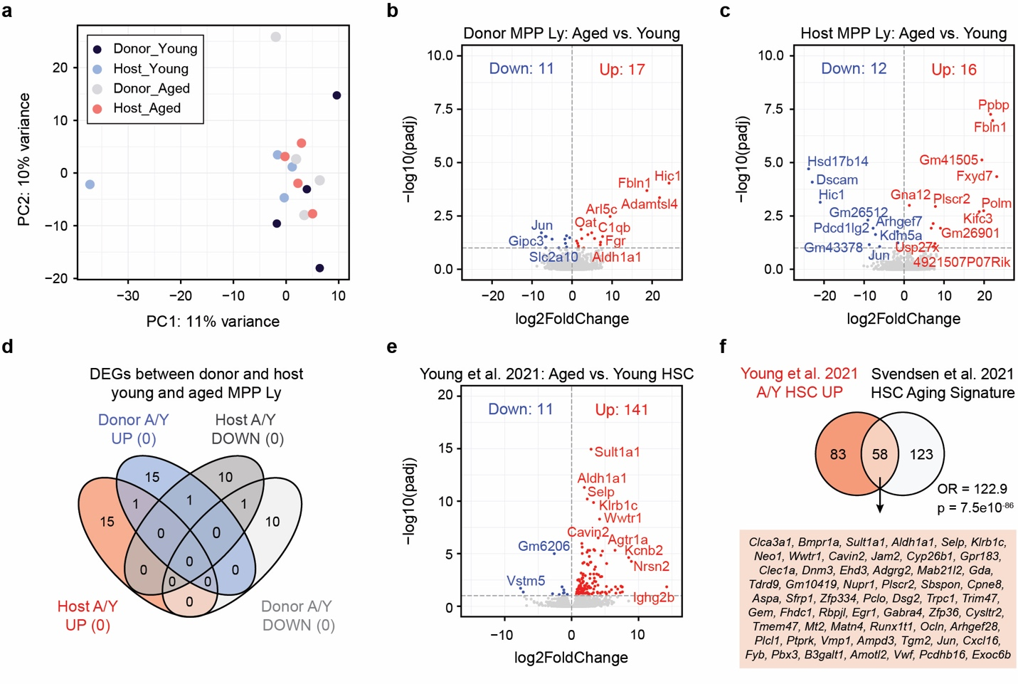
Extended Data Fig. 3. Young MPP Ly cells retain their molecular profile in an aging bone marrow environment (Related to Fig. 4).
(a) Principal component analysis (PCA) plot of donor and host-derived MPP Ly cells isolated from young and aged transplantation recipients (from Fig. 4). Contribution of each principal component to total variance is shown. (b-c) Volcano plots showing differentially expressed genes (DEGs) between donor (b) and host (c) cells isolated from young and aged recipients. The red and blue points represent the up- and down-regulated genes in cells isolated from aged recipients, respectively. (d) Venn diagrams displaying overlapping DEGs between donor and host cells isolated from young and aged recipients. (e) Volcano plots showing DEGs between young and aged HSCs. The red and blue points represent the up- and down-regulated genes in aged HSCs, respectively. Data derive from Young et al.³¹. (f) Venn diagrams displaying overlapping HSC age-associated genes identified from an independent study by Young et al.³¹. and the HSC Aging Signature derived from Flohr Svendsen et al.³². Odds ratio is shown. p-value for the hypergeometric distribution was calculated using Fisher’s exact test. In (b-c) and (e), a threshold of adjusted p-value < 0.1 was applied. Benjamini-Hochberg method was used to correct for multiple comparisons.
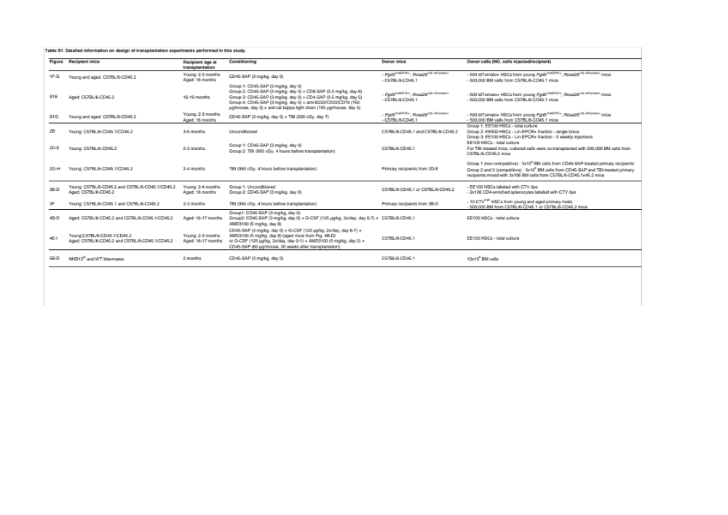
Supplementary Table 1
Supplementary Table 1. Detailed information on transplantation experiments. Related to Fig. 1-5.
Summary of experimental design for transplantation experiments performed in this study. For experiments involving CD45-SAP treatment (with or without co-treatment with other conditioning agents), CD45-SAP was administered on day 0 and transplantation was performed on day 8. For experiments with CD45-SAP and G-CSF/AMD3100 co-treatment, transplantation was performed 1 hour after AMD3100 injection. See also Material and Methods. BM, unfractionated whole bone marrow; CTV, Cell Trace Violet; EE100 or EE500, cultured cells equivalent to expansion of 100 or 500 HSCs; TBI, total body irradiation; WT, wild-type.
Table S2. List of antibodies used in this study.

Antibody | Clone | Source | Dilution
CD105 - PE-Cy7 | MJ7/18 | Biolegend | 1:200
CD11b - APC | M1/70 | Sony Biotechnology | 1:800
CD11c - Biotin | N418 | Sony Biotechnology | 1:200
CD16/32 - unconjugated (Fc block) | 2.4G2 | BioXCell (InVivoMAb) | 1:100
CD16/32 - Alexa Fluor 700 | 93 | eBioscience | 1:100
CD117 (cKIT) - APC | 2B8 | eBioscience | 1:200
CD117 (cKIT) - APC/eFluor 780 | 2B8 | Sony Biotechnology | 1:100
CD117 (cKIT) - Brilliant Violet 421 | 2B8 | Sony Biotechnology | 1:100
CD127 (IL7Ra) - Biotin | A7R34 | eBioscience | 1:200
CD135 (FLT3) - PE | A2F10 | eBioscience | 1:100
CD150 - PE/Cy7 | TC 150-12F12.2 | Sony Biotechnology | 1:200
CD150 - APC | TC 150-12F12.2 | Sony Biotechnology | 1:200
CD19 - PE/Cy7 | 6D5 | Sony Biotechnology | 1:200
CD19 - Alexa Fluor 700 | 6D5 | Sony Biotechnology | 1:200
CD201 - PE | RCR-16 | Sony Biotechnology | 1:200
CD201 - APC | eBio1560 | Sony Biotechnology | 1:200
CD21 - PE/Cy7 | 7E9 | eBioscience | 1:200
CD23 - Pacific Blue | B3B4 | Sony Biotechnology | 1:200
CD3 - Alexa Fluor 700 | 17A1 | BD Bioscience | 1:200
CD3 - Biotin | 17A1 | Sony Biotechnology | 1:200
CD3e - PE/Cy5 | 145-2C11 | Sony Biotechnology | 1:200
CD4 - APC/Cy7 | GK1.5 | BD Bioscience | 1:200
CD4 - Biotin | GK1.5 | Sony Biotechnology | 1:200
CD41 - FITC | MWReg30 | Sony Biotechnology | 1:200
CD43 - PE | S7 | Sony Biotechnology | 1:100
CD44 - PE | IM7 | BD Bioscience | 1:200
CD45.1 - Alexa Fluor 700 | A20 | BD Bioscience | 1:200
CD45.1 - Brilliant Violet 650 | A20 | Sony Biotechnology | 1:100
CD45.2 - Biotin | 104 | Sony Biotechnology
CD45.2 - Brilliant Violet 785 | 104 | Sony Biotechnology | 1:100
CD45.2 - FITC | 104 | Sony Biotechnology | 1:200
CD45R/B220 - Biotin | RA3-6B2 | Sony Biotechnology | 1:200
CD45R/B220 - Alexa Fluor 700 | RA3-6B2 | Sony Biotechnology | 1:200
CD45R/B220 - PE/Cy5 | RA3-6B2 | Sony Biotechnology | 1:200
CD45R/B220 - FITC | RA3-6B2 | Sony Biotechnology | 1:200
CD48 - FITC | HM 48-1 | Sony Biotechnology | 1:200
CD48 - Alexa Fluor 700 | HM 48-1 | Sony Biotechnology | 1:200
CD62L - Brilliant Violet 421 | MEL-14 | Sony Biotechnology | 1:200
CD8a - Biotin | 53-6.7 | Sony Biotechnology | 1:200
CD8a - PerCP/Cy5.5 | 53-6.7 | Sony Biotechnology | 1:200
CD93 - Brilliant Violet 785 | AA4.1 | BD Bioscience | 1:100
Fcer1a - FITC | MAR-1 | BD Bioscience | 1:200
Ly6G/Ly6C (Gr1) - PE | clone RB6-8C5 | eBioscience | 1:400
Ly6G/Ly6C (Gr1) - Biotin | clone RB6-8C5 | Sony Biotechnology | 1:400
Ly6G/Ly6C (Gr1) - PE-Cy5 | clone RB6-8C5 | Sony Biotechnology | 1:400
IgM - APC | RMM-2 | Biolegend | 1:200
NK1.1 - Biotin | PK136 | Sony Biotechnology | 1:200
NK1.1 - Pacific Blue | PK136 | BD Bioscience | 1:200
NK1.1 - PE/Cy5 | PK136 | Sony Biotechnology | 1:200
Ly6A/E (SCA-1) - Pacific Blue | E13-161.7 | Sony Biotechnology | 1:200
Ly6A/E (SCA-1) - BV711 | E13-161.7 | Sony Biotechnology | 1:200
TER119 - PerCP-Cy5.5 | TER119 | Sony Biotechnology | 1:400
TER119 - Biotin | TER119 | Sony Biotechnology | 1:400
TER119 - PE-Cy5 | TER119 | Sony Biotechnology | 1:400
Streptavidin - Brilliant Violet 605 |  | Sony Biotechnology | 1:400

