Supplementary File 1
Additional Results
Table 1: Comparisons of all single-measure outcomes for self-selected and fixed conditions.
Variable [range] | N | Fixed (Mean (SD)) | Self-selected (Mean (SD)) | Mean difference (95%CI)¹ | P (t-test)¹ | P (Wilcox)²
Distance covered [m] | 23 | 815.0 (56.0) | 817.2 (62.2) | 3.0 (-13.0, 18.9) | 0.703 | 0.731
Peak HR [b/min] | 23 | 171.9 (8.5) | 173.3 (9.9) | 1.4 (-1.4, 4.1) | 0.311 | 0.124
RPE [0-10] | 24 | 8.2 (0.6) | 8.3 (0.7) | 0.1 (-0.1, 0.3) | 0.359 | 0.284
Enjoyment [1-7] | 24 | 5.0 (1.3) | 5.3 (0.9) | 0.2 (-0.1, 0.6) | 0.110 | 0.120
Autonomy-Q.1 [1-5] | 24 | 3.7 (1.3) | 4.3 (0.9) | 0.6 (0.2, 0.9) | 0.002* | 0.006*
Autonomy-Q.2 [1-5] | 24 | 3.8 (1.0) | 3.9 (0.9) | 0.1 (-0.2, 0.5) | 0.503 | 0.499
Autonomy-Q.3 [1-5] | 24 | 3.1 (1.7) | 4.5 (0.8) | 1.4 (0.6, 2.1) | 0.001* | 0.003*
Autonomy-Total [1-15] | 24 | 10.6 (3.4) | 12.7 (2.1) | 2.1 (0.9, 3.3) | 0.002* | 0.004*
Boredom Personal [0-100] | 24 | 25.9 (21.3) | 20.0 (15.1) | -5.9 (-13.6, 1.8) | 0.127 | 0.117
Boredom Session [0-100] | 24 | 27.7 (22.0) | 21.8 (17.4) | -5.9 (-13.1, 1.4) | 0.107 | 0.141
Preference³ | 23 | 8 (0.0) | 15 (0.0) | 0.7 (0.5, 1) | 0.105 | -
*P-value < 0.05
¹P-values and CIs derived from paired t-tests
²P-values derived from a non-parametric Wilcoxon signed-rank test
³Results of single-proportion binomial test
Table 2: Comparisons of difference-in-differences in CMJ outcomes and ROF for self-selected and fixed conditions.
Variable | N | Fix (Mean (SD)) | SS (Mean (SD)) | Mean difference (95%CI)¹ | P (t-test)¹ | P (Wilcox)²
CMJ Height [cm] | 24 | -1.0 (1.4) | -1.1 (1.8) | 0.11 (-0.53, 0.75) | 0.723 | 0.684
CMJ Peak impulse [Kg×s] | 24 | -3.0 (3.8) | -3.0 (4.8) | -0.02 (-1.92, 1.88) | 0.981 | 0.922
CMJ Flight time [ms] | 24 | -11.5 (16.8) | -12.3 (16.8) | 0.85 (-5.77, 7.47) | 0.792 | 0.796
ROF Levels [0-10] | 23 | 2.1 (2.3) | 1.7 (2.5) | 0.57 (-0.24, 1.37) | 0.159 | 0.196
¹P values and CIs from paired t-tests.
²P values of a non-parametric Wilcoxon signed-rank test.
Table 3: The fixed effects estimates, and 95% CI derived from the mixed-effect model for distance. The model included a random effect for participants (random intercept).
Parameter | Estimate | Lower 95% | Upper 95% | P-value¹
(Intercept) | 65.343 | 63.328 | 67.358 | <0.001*
Interval 2 | 0.608 | -0.219 | 1.435 | 0.152
Interval 3 | 1.956 | 1.129 | 2.783 | <0.001*
Interval 4 | 3.548 | 2.721 | 4.375 | <0.001*
Block 2 | 0.598 | -0.118 | 1.314 | 0.104
Block 3 | 2.543 | 1.827 | 3.260 | <0.001*
Condition SS | 0.244 | -0.347 | 0.835 | 0.420
¹P values calculated using Satterthwaite d.f.
*Significancy < 0.05
Table 4: The fixed effects estimates and 95% CI derived from the mixed-effect model for peak HR. The model included a random effect for participants (random intercept).
Parameter | Estimate | Lower 95% | Upper 95% | P-value¹
(Intercept) | 160.794 | 156.509 | 165.079 | <0.001*
Interval 2 | 2.268 | 0.651 | 3.885 | 0.007*
Interval 3 | 3.498 | 1.868 | 5.127 | <0.001*
Interval 4 | 5.216 | 3.587 | 6.846 | <0.001*
Block 2 | 2.017 | 1.015 | 3.020 | <0.001*
Block 3 | 4.015 | 3.012 | 5.018 | <0.001*
Condition SS | 2.546 | 0.910 | 4.183 | 0.003*
Interval 2 : Condition SS | 1.625 | -0.683 | 3.933 | 0.171
Interval 3 : Condition SS | 0.760 | -1.558 | 3.077 | 0.524
Interval 4 : Condition SS | -2.255 | -4.568 | 0.058 | 0.058
¹P values calculated using Satterthwaite d.f.
*Significancy < 0.05
Table 5: The fixed effects estimates and 95% CI derived from the mixed-effect model for RPE. The model included a random effect for participants (random intercept).
Parameter | Estimate | Lower 95% | Upper 95% | P-value¹
(Intercept) | 7.214 | 6.930 | 7.497 | <0.001*
Interval 2 | 0.286 | 0.114 | 0.458 | 0.001*
Interval 3 | 0.668 | 0.496 | 0.840 | <0.001*
Interval 4 | 1.104 | 0.932 | 1.277 | <0.001*
Block 2 | 0.334 | 0.185 | 0.484 | <0.001*
Block 3 | 0.990 | 0.841 | 1.139 | <0.001*
Condition SS | 0.105 | -0.017 | 0.227 | 0.093
¹P values calculated using Satterthwaite d.f.
*Significancy < 0.05
Table 6: Fixed and Self-selected rests duration.
Interval¹ | Fix |  | SS
Interval¹ | Mean | SD | Mean | SD
interval 01 | 120.0 | 0.0 | 120.0 | 0.0
interval 02 | 89.7 | 0.8 | 67.0 | 13.1
interval 03 | 89.5 | 0.6 | 84.3 | 12.8
interval 04 | 89.6 | 0.7 | 117.7 | 17.8
interval 05 | 119.8 | 1.2 | 119.6 | 0.7
interval 06 | 89.5 | 0.6 | 69.9 | 12.8
interval 07 | 89.5 | 0.8 | 82.2 | 13.6
interval 08 | 89.6 | 0.6 | 116.4 | 18.9
interval 09 | 119.5 | 0.8 | 119.5 | 0.5
interval 10 | 89.6 | 0.6 | 72.9 | 15.4
interval 11 | 89.6 | 0.8 | 82.7 | 9.6
interval 12 | 89.6 | 0.7 | 113.1 | 20.7
¹Each rest period is numbered by the interval that followed it; i.e., `interval 01` is the rest period before the first interval, `interval 02` is the rest period before the second interval, and so on.
Scales
Figure 1: RPE scale and instructions.
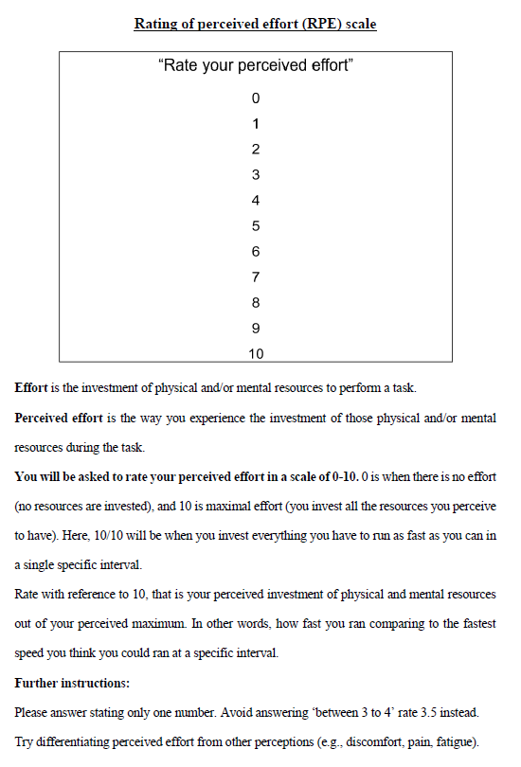
Figure 2: ROF scale and instructions.
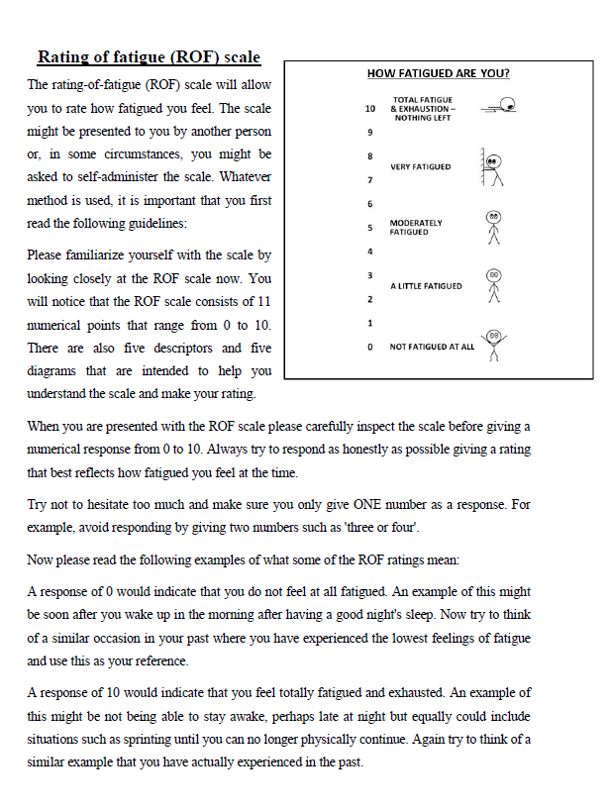
Questionnaires
Figure 3: The Intrinsic Motivation Inventory questionnaire (modified version).
