Supplementary Figure S1. Sequencing maps of Bmlark^{-/-} with different mutation. (A) Sequencing maps of Bmlark^{-/-} with mutation at target site1. (B) Sequencing maps of Bmlark^{-/-} with mutation at target site2. WT: wild type (Bmlark^{+/+}). Sequences in green box are the target sites. Sequence in red at the top of the red box means the deleted bases. Sequence in cyan is the PAM. KO1~KO6 refer to the types of mutations in which different base sequences are deleted.

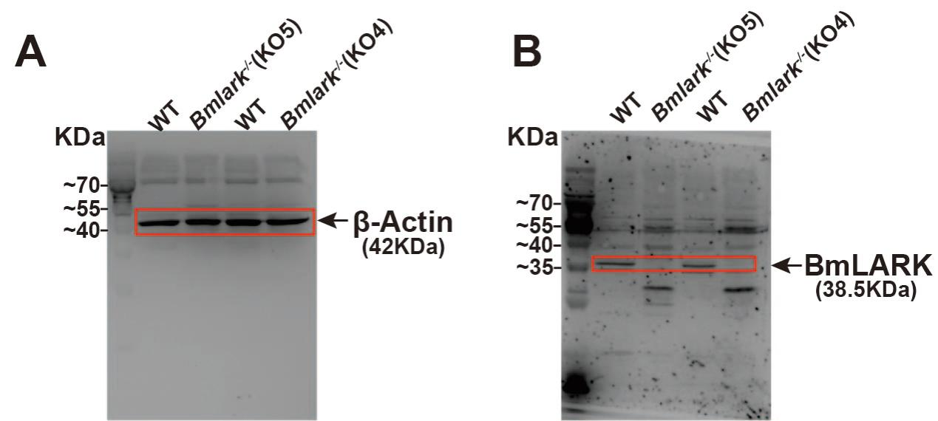
Supplementary Figure S2. Full-length western blot analysis of BmLARK protein in the WT and Bmlark^{-/-} mutant (KO4 and KO5) embryos at 168 h post oviposition. The red boxes represent the areas were cropped and displayed in Figure 1F.

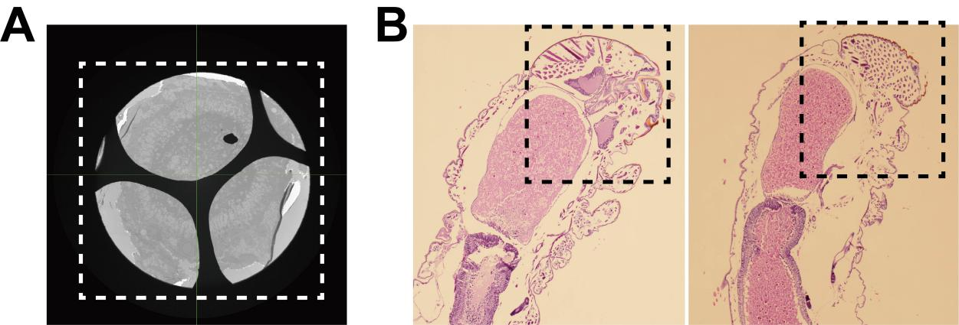
Supplementary Figure S3. Original image of Figure 2A and Figure 2E. (A) The original image showed a complete cross-section of Bmlark^{-/-} mutant. The white dotted box represents the area was cropped and displayed in Figure 2A. (B) The original images of enlarged heads of WT and Bmlark^{-/-} mutant. The black dotted boxes represent the areas were cropped and displayed in Figure 2E.
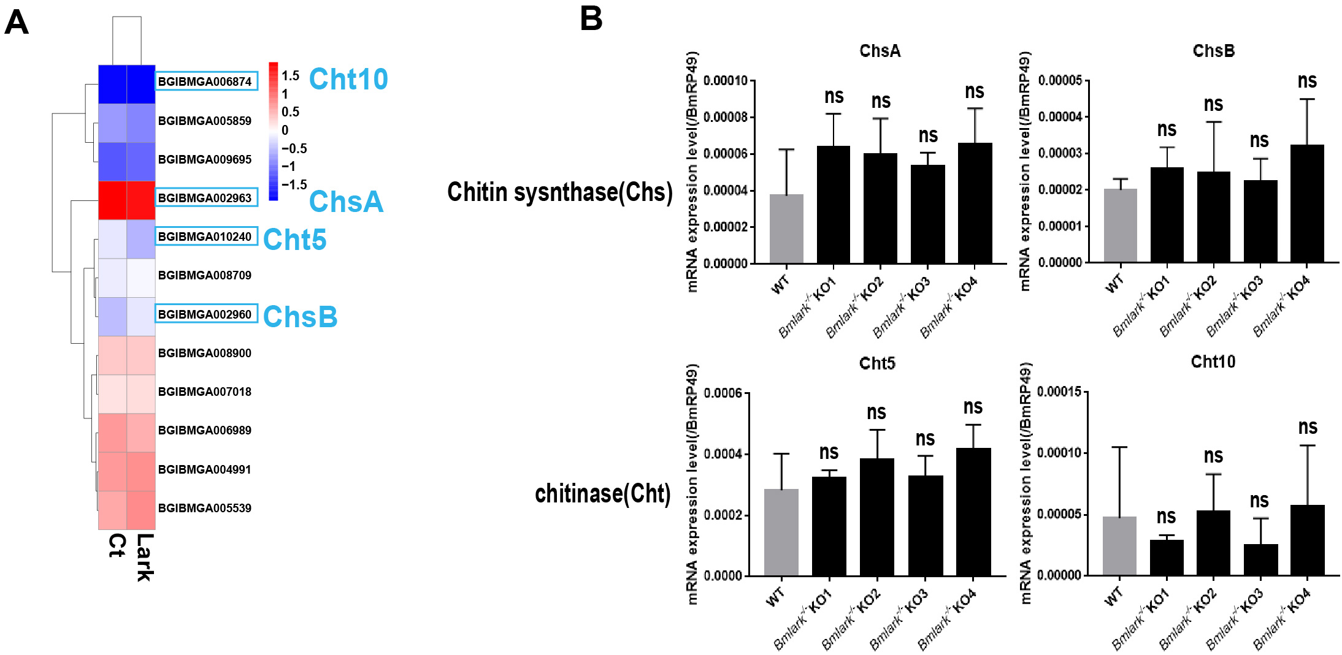

Supplementary Figure S4. The expressional analysis of chitin sysnthase and chitinase in Bmlark^{-/-} vs WT. Ct: the WT group; Lark: the Bmlark^{-/-} group. ns: no significance.

