Supplementary Figures and Tables
Figure S1. Overlap of TERTp Mutations, +7/-10 and EGFRamp in IDH-wildtype Gliomas.
Figure S2. Histologic and Molecular Characteristics of Eight Cases without Concurrence of TERTp and 1p/19q codeletion
Figure S3. Performance of the Layered Diagnostic Scheme Compared to WHO CNS5.
Figure S4. DNA Methylation-based Classification of three IDH-mutated Cases.
Figure S5. Characteristics of Two Non-Glioma Cases with TERTp Mutations in the Prospective Cohort
Figure S6. Sensitivity of Detection of Different Mutant Alleles in IDH and TERTp Using a qPCR Rapid Test
Figure S7. Accuracy and Turnaround Time for the Rapid Test Results in Prospective Cohort
Figure S8. Overall Survival of IDH Wild-Type Glioma Patients with Different Genetic Alterations in the Retrospective Cohort.
Table S1. Baseline Characteristics of the Patients
Table S2. Molecular Characteristics of All Glioma Patients in the Study
Table S3. Clinical and Molecular Characteristics of the Eight IDH-Mutant Cases without Concurrence of 1p/19q codeletion and TERTp Mutation in the Retrospective Cohort
Table S4. Primer Sequences for Mutation Detection of IDH and TERTp

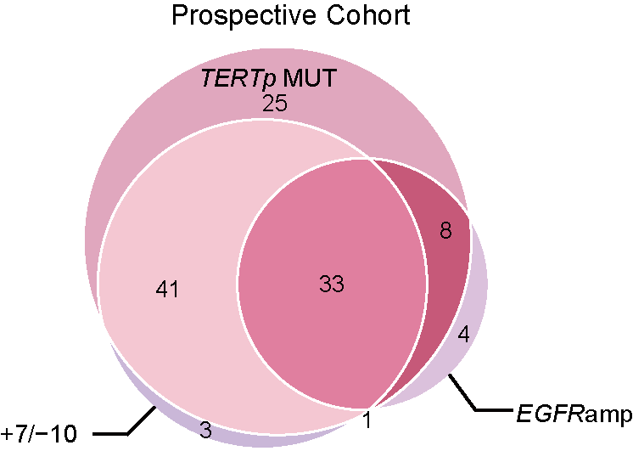

Figure S1. Overlap of TERTp Mutations, +7/-10 and EGFRamp in IDH-wildtype Gliomas. Venn diagram showing the numbers of patients with a TERTp mutation, EGFRamp, and a +7/-10 signature in IDH-wildtype glioblastoma in the prospective cohort.

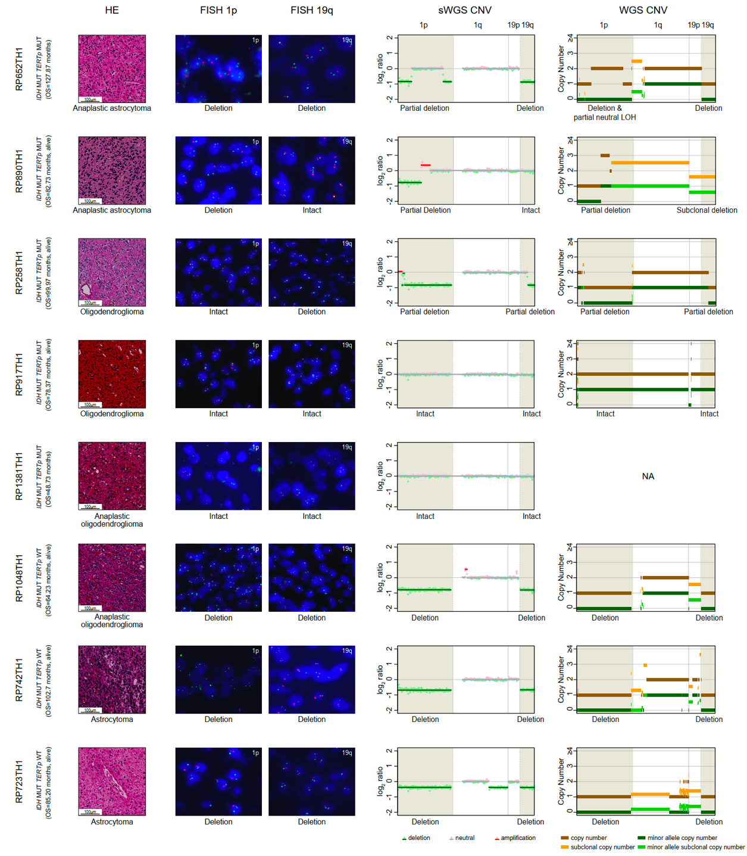

Figure S2. Histologic and Molecular Characteristics of Eight Cases without Concurrence of TERTp and 1p/19 codeletion. There were eight IDH-mutated cases without a concurrence of 1p/19q codeletion and TERTp mutation. FISH analysis revealed that RP652TH1 had a 1p/19q codeletion, RP890TH1 had a 1p deletion and intact 19q, RP258TH1 had an intact 1p and 19q deletion, and RP917TH1 and RP1381TH1 had intact 1p and 19q. However, shallow WGS analysis revealed that RP652TH1 had a 1p partial deletion and 19q deletion, RP890TH1 had a 1p partial deletion and intact 19q, RP258TH1 had a 1p/19q partial deletion, and RP917TH1 and RP1381TH1 had intact 1p and 19q. B-allele frequency analysis of polymorphic sites using WGS disclosed initial deletion of the entire 1p and copy-neutral loss of heterozygosity (LOH) at p35.2-p21.1p in RP652TH1. In addition, subclonal deletion of chromosome 19 as a whole was found in RP890TH1.

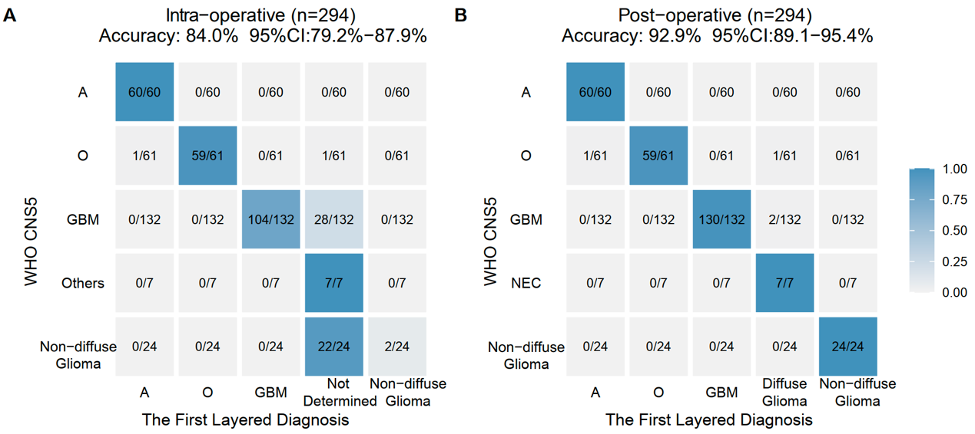

Figure S3. Performance of the Layered Diagnostic Scheme Compared to WHO CNS5. A and B, Heatmap shows the diagnostic accuracy of different subtypes from prospective cohort by the first layered diagnostic scheme compared with that according to WHO CNS5 intraoperatively and postoperatively.

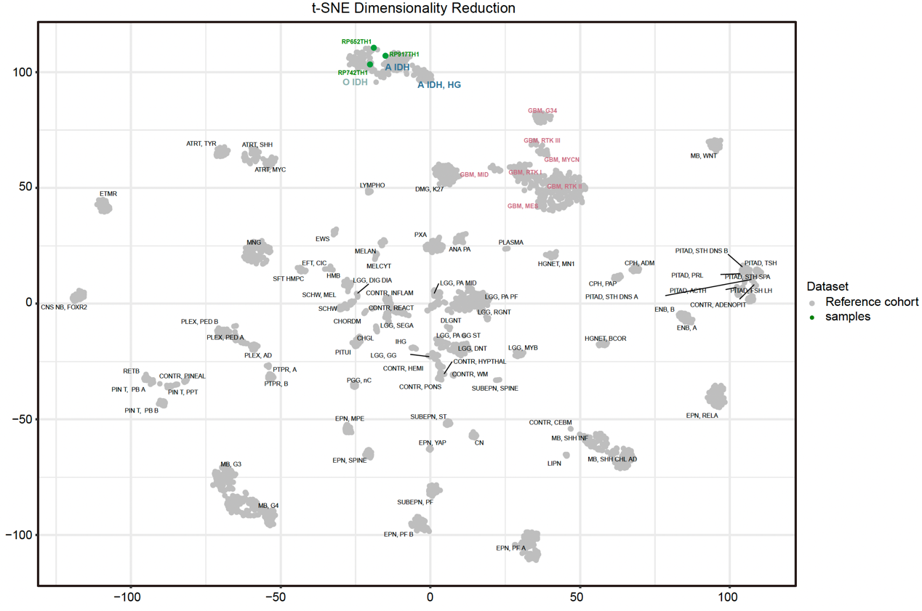

Figure S4. DNA Methylation-based Classification of three IDH-mutated Cases. Unsupervised clustering of the combined reference from public database (grey)and three cases without concurrence of TERTp and 1p/19 codeletion (green) using t-SNE dimensionality reduction.

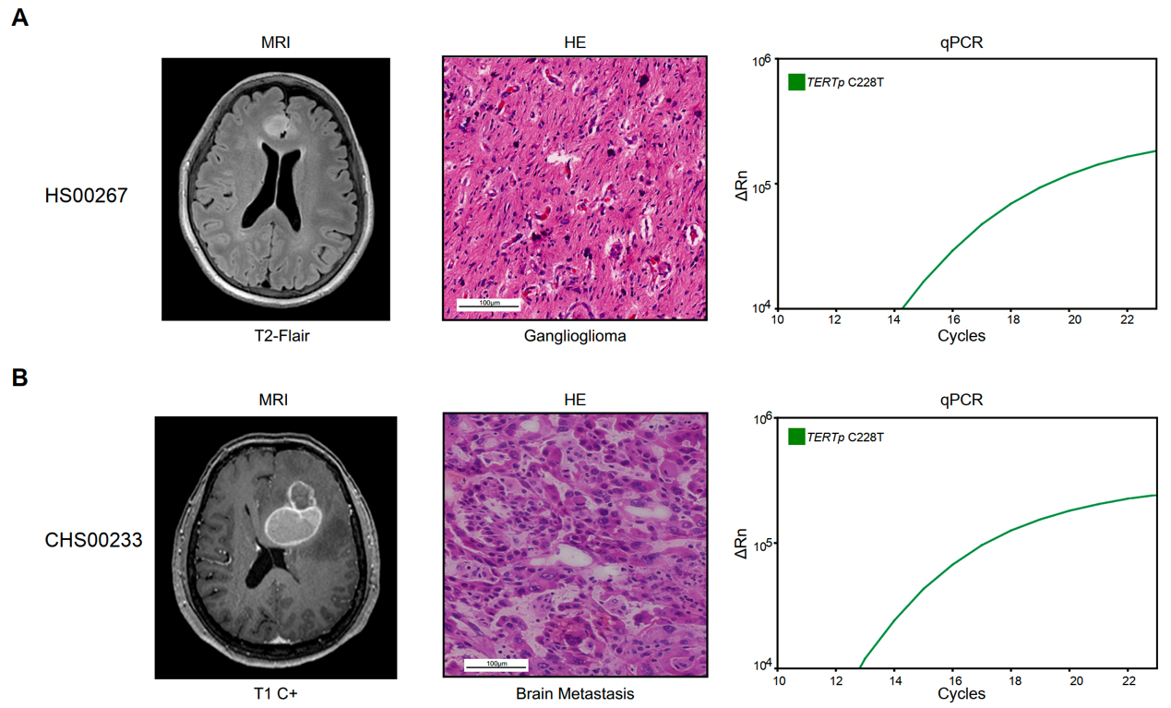Figure S5. Characteristics of Two Non-Glioma Cases with TERTp Mutations in the Prospective Cohort. The results of MRI imaging, HE histological evaluation, and rapid qPCR testing for two rare cases are presented. Based on MRI imaging, HS00267 and CHS00233 were suspected of having glioma, and a TERTp mutation was detected using the rapid qPCR test. The HE histological evaluation revealed that HS00267 was diagnosed with ganglioglioma and CHS00233 with a brain metastasis.
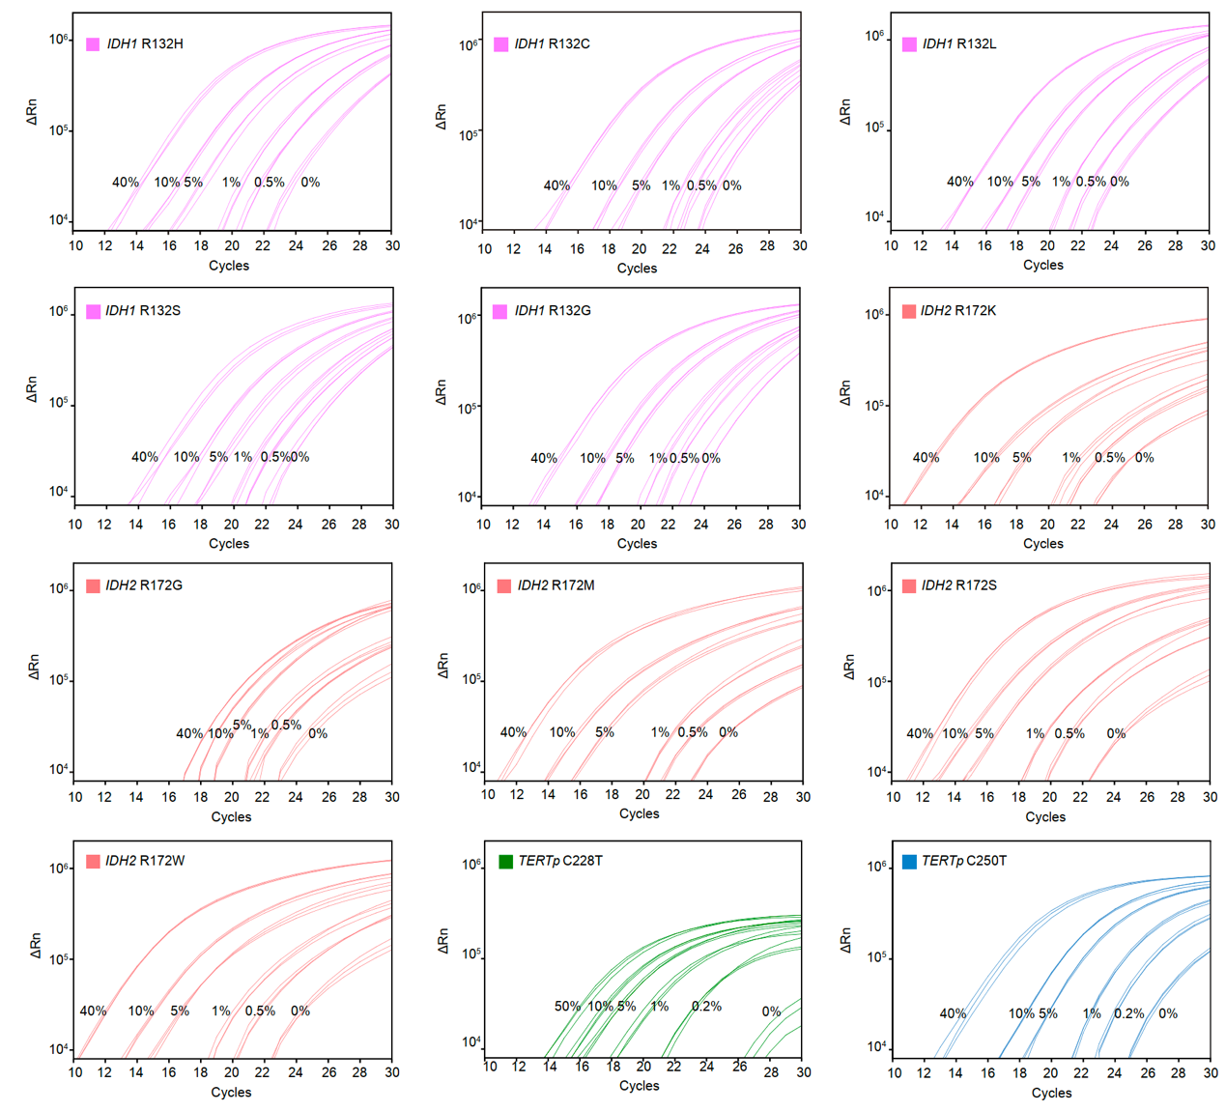Figure S6. Sensitivity of Detection of Different Mutant Alleles in IDH and TERTp Using a qPCR Rapid Test. According to the qPCR results, the rapid tests were capable of distinguishing TERTp and IDH mutations from wildtype alleles, even at very low variant allele frequencies of 0.2% and 0.5%, respectively.
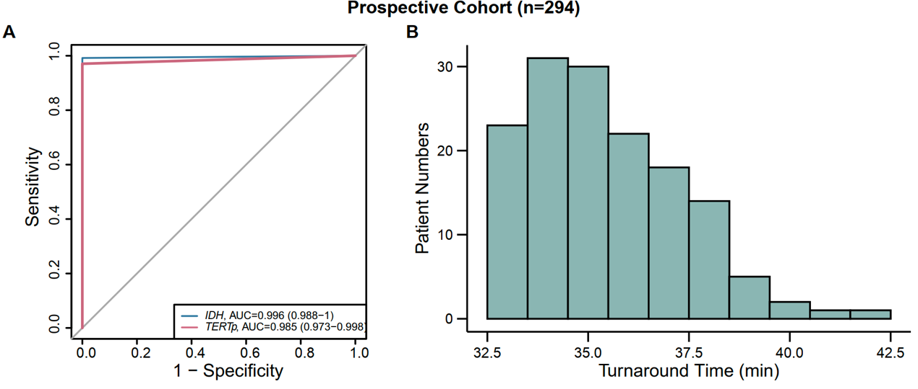

Figure S7. Accuracy and Turnaround Time for the Rapid Test Results in the Prospective Cohort. A and B, Detection accuracy and turnaround time of the rapid test in prospective cohort. Within a short timeframe, during surgery, the rapid test could be performed and completed with 100% accuracy, with a median turnaround time of 35 minutes.

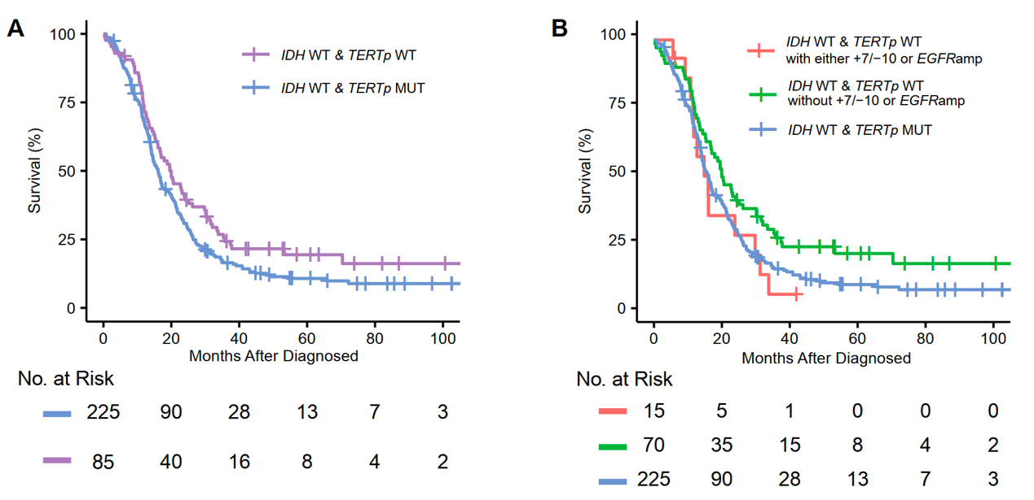Figure S8. Overall Survival of IDH Wild-Type Glioma Patients with Different Genetic Alterations in the Retrospective Cohort. A, Illustrates that the overall survival of TERTp wild-type patients (n = 85) was significantly better than that of patients with a TERTp mutation (n = 225) in IDH wild-type gliomas (median overall survival: 20.0 vs. 16.2 months; HR: 0.75; 95% CI, 0.58–0.97; P = 0.04). B, Demonstrates that the prognoses of IDH and TERTp double-wild-type glioma patients without +7/-10 or EGFRamp alterations (n = 70) were significantly better than those of glioma patients with a TERTp mutant only (n = 225) (median overall survival: 20.2 vs. 16.2 months; HR: 0.53; 95% CI, 0.61–0.92; P = 0.02). However, the overall survival of the IDH and TERTp double-wild-type glioma patients with +7/-10 and/or EGFRamp alterations (n = 15) was similar to that of glioma patients with a TERTp mutant only (n = 225) (median overall survival: 16.0 vs. 16.2 months; HR: 1.09; 95% CI, 0.61–1.96; P = 0.76).

Table S1. Baseline Characteristics of the Patients.
Characteristic | Retrospective Cohort  (n=746) | Prospective Cohort  (n=294)
Surgery
Removal | 746 | 277
Biopsy | 0 | 17
Tumor Location by Hemisphere, No. (%)
Right | 331/746 (44.4) | 145/294 (49.3)
Left | 383/746 (51.3) | 138/294 (47.0)
Bilateral | 14/746 (1.9) | 1/294 (0.3)
Midline | 18/746 (2.4) | 10/294 (3.4)
Tumor Location by Lobe, No. (%)
Frontal | 451/746 (60.5) | 131/294 (44.6)
Parietal | 47/746 (6.3) | 40/294 (13.6)
Temporal | 194/746 (26.0) | 77/294 (26.2)
Occipital | 21/746 (2.8) | 0/294 (0)
Insular, Basal ganglia, Thalamus, CC, Ventricle, etc. | 33/746 (4.4) | 46/294 (15.6)
Patients with Non-glioma
No. of patients | NA | 24
Median age (IQR), y | NA | 45.5 (36.7-58)
Female sex, No. (%) | NA | 10/24 (41.7)
Patients with Glioma
No. of patients | 746 | 270
Median age (IQR), y | 46 (38-57) | 49.5 (38-58)
Female sex, No. (%) | 322/746 (43.2) | 104/270 (38.5)
Permanent Section Histology, No. (%)
Astrocytoma | 141/746 (18.9) | 50/270 (18.5)
Anaplastic Astrocytoma | 68/746 (9.1) | 13/270 (4.8)
Oligodendroglioma | 138/746 (18.5) | 38/270 (14.1)
Anaplastic Oligodendroglioma | 62/746 (8.3) | 13/270 (4.8)
Oligoastrocytoma | 22/746 (3.0) | 8/270 (3.0)
Anaplastic Oligoastrocytoma | 9/746 (1.2) | 1/270 (0.4)
Glioblastoma | 306/746 (41.0) | 122/270 (45.2)
Low Grade Glioma | 0/746 (0) | 6/270 (2.2)
High Grade Glioma | 0/746 (0) | 15/270 (5.6)
Gliosis | 0/746 (0) | 1/270 (0.3)
Pediatric-type High-grade Diffuse Glioma | 0/746 (0) | 3/270 (1.1)
WHO CNS5 Diagnosis, No. (%)
Astrocytoma, IDH-mutant | 197/746 (26.4) | 60/270 (22.2)
Oligodendroglioma, IDH-mutant and 1p/19q-codeleted | 222/746 (29.8) | 61/270 (22.6)
Glioblastoma (IDH-wildtype & Microvascular Proliferation/Necrosis/ TERT-mutant/EGFRamp/+7/-10) | 311/746 (41.7) | 132/270 (48.9)
NEC | 16/746 (2.1) | 7/270 (2.6)
Pediatric-type High-grade Diffuse Glioma (Midline location with H3F3A-mutant or HIST1H3B mutant or H3 G34-mutant) | 0/746 (0) | 10/270 (3.7)
WHO Grade of Glioma, No. (%)
2 | 285/746 (38.2) | 76/270 (28.1)
3 | 121/746 (16.2) | 57/270 (21.1)
4 | 340/746 (45.6) | 136/270 (50.4)
NA* | 0/746 (0) | 1/270 (0.4)
NA*, gliosis.

Table S2. Molecular Characteristics of All Glioma Patients in the Study.
WHO CNS5 Diagnosis | No. of Tumors Included | Median Age of Patients | Female | Molecular Alterations
 | No. (%) | Yr (IQR) | No. (%) | IDH1/2-mutant | 1p/19q codel | TERTp-mutant | EGFR amp | +7/-10 | CDKN2A/B Homozygous deletion | H3.3-mutant
Retrospective cohort (n=746)
Astrocytoma, IDH-mutant | 197/746 (26.4) | 38 (32.0-45.0) | 96/746 (48.7) | 197 | 0 | 5 | 0 | 1 | 20 | 0
Oligodendroglioma, IDH  mutant and 1p/19q codeleted | 222/746 (29.8) | 43 (36.0-49.0) | 106/746 (47.8) | 222 | 222 | 219 | 0 | 2 | 2 | 0
Glioblastoma, IDH-wildtype | 311/746 (41.7) | 57 (48.0-64.0) | 114/746 (36.7) | 0 | 1 | 237 | 108 | 167 | 90 | 0
NEC | 16/746 (2.1) | 48 (34.0-58.5) | 6/746 (37.5) | 0 | 1 | 0 | 0 | 0 | 3 | 0
Prospective cohort (n=294)
Astrocytoma, IDH-mutant | 60/294 (20.4) | 38 (33-46.2) | 25/60 (41.7) | 60 | 0 | 0 | 1 | 1 | 6 | 0
Oligodendroglioma, IDH- mutant and 1p/19q-codeleted | 61/294 (20.7) | 46 (37-52) | 27/61 (44.3) | 61 | 61 | 61 | 0 | 0 | 0 | 0
Glioblastoma, IDH-wildtype | 132/294 (44.9) | 58 (49-65.0) | 44/132 (33.3) | 0 | 1 | 107 | 46 | 78 | 44 | 0
NEC | 7/294 (2.4) | 48 (26.5-57.0) | 3/7 (42.9) | 0 | 0 | 0 | 0 | 0 | 2 | 0
Pediatric-type High-grade Diffuse Glioma | 10/294 (3.4) | 39 (34.0-52.2) | 5/10 (50.0) | 0 | 0 | 0 | 0 | 0 | 0 | 10
Non-diffuse glioma | 24/294 (8.2) | 45.5 (36.7-58.0) | 10/24 (41.7) | 0 | 0 | 2 | 0 | 1 | 0 | 0
Abbreviations: WHO CNS5, the 2021 World Health Organization Classification of Tumors of the Central Nervous System; Yr, year; IQR, interquartile range; codel, codeletion; EGFRamp, EGFR gene amplification; +7/-10, whole chromosome 7 gain and whole chromosome 10 loss; NEC, not elsewhere classified.

Table S3. Clinical and Molecular Characteristics of the Eight IDH-Mutant Cases Without Concurrence of 1p/19q Codeletion and TERTp Mutation in the Retrospective Cohort.
Patient ID | Age | Tumor Location | Preoperative Seizure | Histology | WHO CNS5 Diagnosis | Layered Diagnosis
RP1381TH1 | 62 | LT | No | AO | Astrocytoma, IDH-mutant | Oligodendroglioma, double mutant
RP258TH1 | 42 | LF | Yes | O | Astrocytoma, IDH-mutant | Oligodendroglioma, double mutant
RP652TH1 | 55 | RF | No | AA | Astrocytoma, IDH-mutant | Oligodendroglioma, double mutant
RP890TH1 | 19 | RF | Yes | AA | Astrocytoma, IDH-mutant | Oligodendroglioma, double mutant
RP917TH1 | 72 | RF | Yes | O | Astrocytoma, IDH-mutant | Oligodendroglioma, double mutant
RP1048TH1 | 36 | LF | Yes | AO | Oligodendroglioma, IDH-mutant and 1p/19q-codeleted | Astrocytoma, IDH-mutant
RP723TH1 | 59 | LT | No | A | Oligodendroglioma, IDH-mutant and 1p/19q-codeleted | Astrocytoma, IDH-mutant
RP742TH1 | 32 | LF | Yes | A | Oligodendroglioma, IDH-mutant and 1p/19q-codeleted | Astrocytoma, IDH-mutant

Patient ID | PFS status | OS status | PFS (months) | OS (months) | IDH status | TERTp  status | 1p/19q  status | ATRX Mutation Status | TP53 Mutation Status | FUBP1 Mutation  Status | NOTCH1  Mutation  Status
RP1381TH1 | 1 | 1 | 42.53 | 48.73 | MUT | MUT | intact | NA | NA | NA | NA
RP258TH1 | 0 | 0 | 99.97 | 99.97 | MUT | MUT | intact | WT | WT | WT | WT
RP652TH1 | 1 | 1 | 105.4 | 127.87 | MUT | MUT | intact | WT | WT | Frameshift Variant | WT
RP890TH1 | 0 | 0 | 82.73 | 82.73 | MUT | MUT | intact | WT | WT | WT | WT
RP917TH1 | 0 | 0 | 78.37 | 78.37 | MUT | MUT | intact | Protein Altering Variant | Missense Variant | WT | WT
RP1048TH1 | 1 | 0 | 57.43 | 64.23 | MUT | WT | codeleted | WT | WT | WT | WT
RP723TH1 | 0 | 0 | 85.2 | 85.2 | MUT | WT | codeleted | NA | NA | NA | NA
RP742TH1 | 0 | 0 | 102.7 | 102.7 | MUT | WT | codeleted | WT | WT | Frameshift Variant | Inframe Deletion
Abbreviations: RF, right frontal lobe; LT, left temporal lobe; LF, left frontal lobe; RO, right occipital lobe; A, astrocytoma; O, oligodendroglioma; GBM, glioblastoma; MUT, mutant; WT, wildtype; PFS, Progression Free Survival; OS, overall survival; PFS/OS status, 1, event; 0, censor; NA, Not Available.

Table S4. Primer Sequences for Mutation Detection of IDH and TERTp.
Primer Sequences for the Rapid Test
Gene | Forward Primer (5' to 3') | Reverse Primer (5' to 3') | Univeral Primer (5' to 3')
IDH1
IDH1 R132C | ATGGGTAAAACCTATCATCATAGGT/iXNA_T/ | AACATGCAAAATCACATTATTGCC | ACA/iXNA_T/GA/iXNA_C/TT/iXNA_A/CT/iXNA_T/GATCCCCA
IDH1 R132S | ATGGGTAAAACCTATCATCATAGGT/iXNA_A/ | AACATGCAAAATCACATTATTGCC | ACA/iXNA_T/GA/iXNA_C/TT/iXNA_A/CT/iXNA_T/GATCCCCA
IDH1 R132G | TGGGTAAAACCTATCATCATAGGT/iXNA_G/ | AACATGCAAAATCACATTATTGCC | ACA/iXNA_T/GA/iXNA_C/TT/iXNA_A/CT/iXNA_T/GATCCCCA
IDH1 R132H | GGGTAAAACCTATCATCATAGGTC/iXNA_A/ | AACATGCAAAATCACATTATTGCC | ACA/iXNA_T/GA/iXNA_C/TT/iXNA_A/CT/iXNA_T/GATCCCCA
IDH1 R132L | GGGTAAAACCTATCATCATAGGTC/iXNA_T/ | AACATGCAAAATCACATTATTGCC | ACA/iXNA_T/GA/iXNA_C/TT/iXNA_A/CT/iXNA_T/GATCCCCA
IDH2
IDH2 R172K | AAGCCCATCACCATTGGCA/iXNA_A/ | GATCCCCTCTCCACCCTG | CC/iXNA_T/AC/iXNA_C/TG/iXNA_G/TC/iXNA_G/CC
IDH2 R172G | CCAAGCCCATCACCATTGTCG | GATCCCCTCTCCACCCTG | CC/iXNA_T/AC/iXNA_C/TG/iXNA_G/TC/iXNA_G/CC
IDH2 R172M | AAGCCCATCACCATTGGCA/iXNA_T/ | GATCCCCTCTCCACCCTG | CC/iXNA_T/AC/iXNA_C/TG/iXNA_G/TC/iXNA_G/CC
IDH2 R172W | CAAGCCCATCACCATTGGC/iXNA_T/ | GATCCCCTCTCCACCCTG | CC/iXNA_T/AC/iXNA_C/TG/iXNA_G/TC/iXNA_G/CC
IDH2 R172S | AAGCCCATCACCATTGGCGGT | GATCCCCTCTCCACCCTG | CC/iXNA_T/AC/iXNA_C/TG/iXNA_G/TC/iXNA_G/CC
TERT
TERTp C228T | GTCCTGCCCCTTCACCTTC | CTGGGAGGGCCCGGA/iXNA_A/ | AGC/iXNA_T/CC/iXNA_G/CC/iXNA_T/CC/iXNA_T/CC
TERTp C250T | GTCCTGCCCCTTCACCTTC | TGGGCCGAGGACCCGG/iXNA_A/ | AGC/iXNA_T/CC/iXNA_G/CC/iXNA_T/CC/iXNA_T/CC
BGB
BGB | TTTCCCACCCTTAGGCTG | GCATCAGGAGTGGACAGAT | TCTACCCTTGGACCCAGAGGTTCTTTGAGT
Primer Sequences for Sanger Sequencing
Gene | Forward Primer (5' to 3') | Reverse Primer (5' to 3')
IDH1 | TTGAGAAGAGGGTTGAGGAGTT | AACATGCAAAATCACATTATTGCC
IDH2 | GGGTTCAAATTCTGGTTGAA | TAGGCGAGGAGCTCCAGT
TERTp | GGCCGATTCGACCTCTCTC | AGCACCTCGCGGTAGTG

