Table 1 Optimization of the reaction conditions for the Hantzsch condensation of para-Chlorobenzaldehyde, dimedone, ethyl acetoacetate and ammonium acetate as a model reaction for the synthesis of polyhydroquinolines.
 | 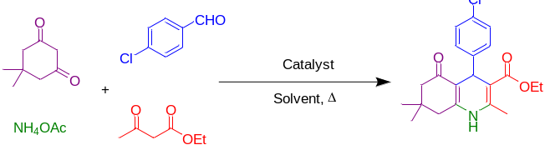
Entry | Catalyst | Amount of Catalyst (mg) | Solvent | Temperature (ºC) | Time (min) | Yield (%)^{a,b}
 | - | - | EtOH | reflux | 85 | 17
 | 4,6-diamino-2-pyrimidinethiol | 7 | EtOH | reflux | 85 | 23
 | Ag(NO₃)₂ | 7 | EtOH | reflux | 85 | Trace
 | Ag-CP | 4 | EtOH | reflux | 85 | 69
 | Ag-CP | 5 | EtOH | reflux | 85 | 74
 | Ag-CP | 6 | EtOH | reflux | 85 | 78
 | Ag-CP | 7 | EtOH | reflux | 85 | 87
 | Ag-CP | 7 | EtOH:H₂O | 80 | 90 | 82
 | Ag-CP | 7 | PEG-400 | 80 | 120 | 75
 | Ag-CP | 7 | DMF | 80 | 110 | 74
 | Ag-CP | 7 | DMSO | 80 | 125 | 78
 | Ag-CP | 7 | EtOH | 25 | 8 h | NR
 | Ag-CP | 7 | EtOH | 60 | 70 | 76
 | Ag-CP | 7 | EtOH | 70 | 75 | 79
ª Isolated yield.
^{b} Reaction conditions: 4-Chlorobenzaldehyde (1mmol), dimedone (1 mmol), ethyl acetoacetate (1 mmol), ammonium acetate (1.2 mmol), catalyst (mg) and solvent (3mL).

Table 2 Hantzsch synthesis of polyhydroquinoline derivatives in the presence of Ag-CP in EtOH at 80 °C.
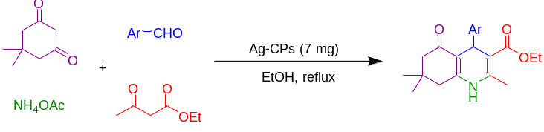
Entry | Aryl aldehyde | Product | Time (min) | Yield (%)^{a,b} | Melting point
 |  |  |  |  | measured | literature
1 | 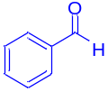 | 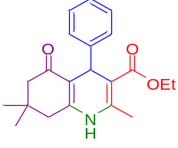 | 80 | 93 | 198-205 | 203-206 ⁵⁴
2 | 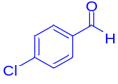 | 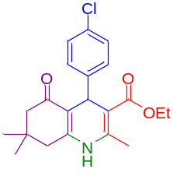 | 85 | 87 | 245-248 | 246-247 ⁵⁴
3 | 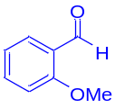 | 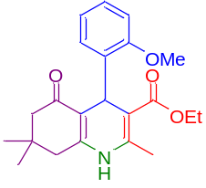 | 80 | 86 | 245-249 | 249-251 ⁵⁴
4 | 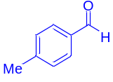 | 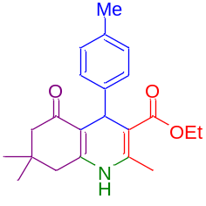 | 86 | 82 | 249-251 | 252-255 ⁴²
5 | 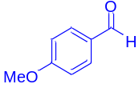 | 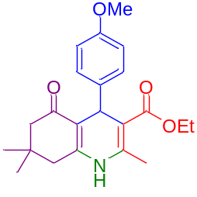 | 80 | 83 | 254-256 | 255-257 ⁴²
6 | 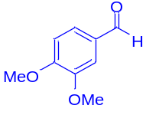 | 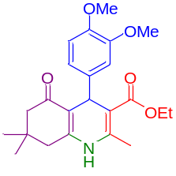 | 85 | 87 | 197-202 | 204-206 ⁵⁴
7 | 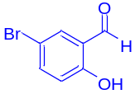 | 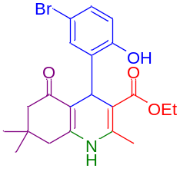 | 85 | 88 | 264-268 | 246 – 248 ⁵⁵
8 | 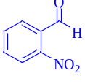 | 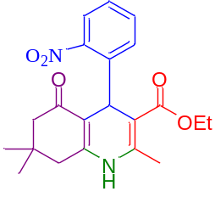 | 80 | 93 | 169-174 | 175-176 ⁵⁴
9 | 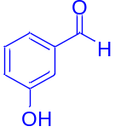 | 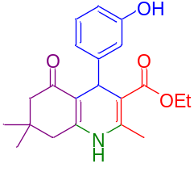 | 80 | 87 | 208-210 | 230-232 ³²
10 | 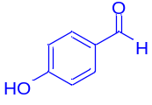 | 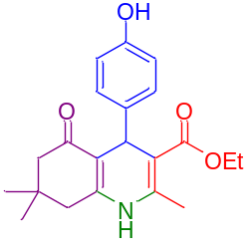 | 85 | 81 | 238-240 | 231–233 ⁴²
11 | 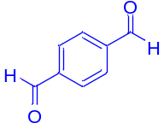 | 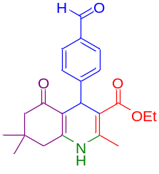 | 85 | 74 | 294-295 | 305 - 307 ⁵⁶
12 | 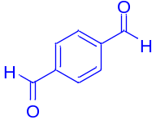 | 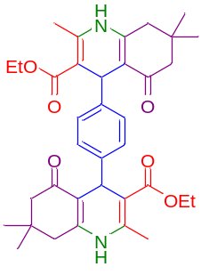 | 90 | 78^{c} | 298 = decomposition | 298-300 ⁵⁷
^{b} Isolated yields.
^{b} Reaction conditions: Aromatic aldehyde (1mmol), dimedone (1 mmol), ethyl acetoacetate (1 mmol), ammonium acetate (1.2 mmol), Ag-CP (7 mg) and EtOH (3mL) at 80°C reflux conditions.
^{c} Reaction conditions: Aromatic aldehyde (1mmol), dimedone (2 mmol), ethyl acetoacetate (2 mmol), ammonium acetate (2.4 mmol), Ag-CP (14 mg) and EtOH (6mL) at 80°C reflux conditions.

Table 3. Comparison of the synthesis of polyhydroquinolines in the presence of various catalysts.
Entry | Catalyst | Time (min) | Yield (%)ª | Ref
 | FeAl₂O₄ | 180 | 90 | ³²
 | Fe₃O₄@D-NH-(CH₂)₄-SO₃H | 90 | 86 | ⁵⁸
 | Fe₃O₄@FSM-16-SO₃H | 25 | 86 | ⁵⁹
 | AIL-SCMNPs | 15 | 80 | ⁶⁰
 | Ag-CP | 85 | 87 | This work
ª Isolated yield.

