Supplementary Materials
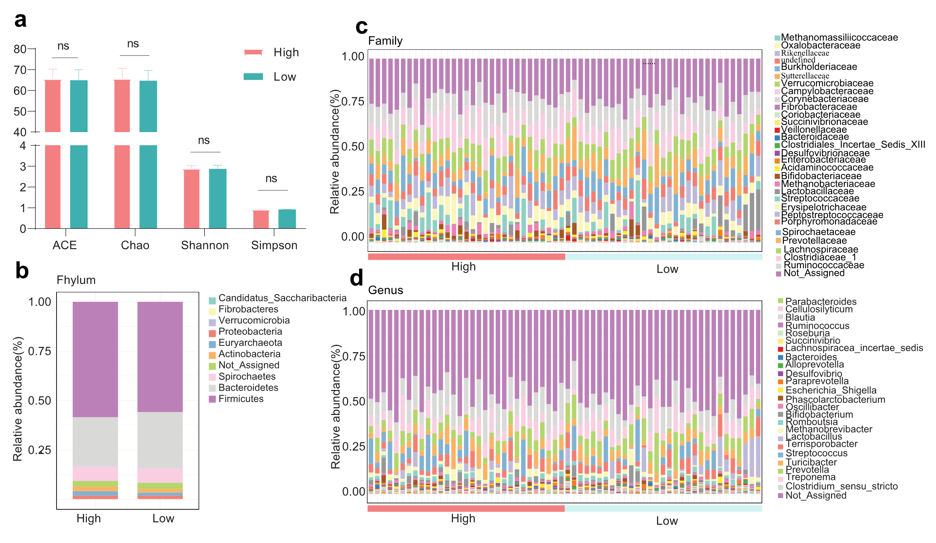
Fig. S1 The Fecal microbiota of HRP and LRP sows (n = 31) using 16S rRNA gene amplicon sequencing. (a) The α-diversity of HPR and LPR sows measured using ACE, Chao, Shannon and Simpson indices. (b) The relative abundance of microbial composition at the phylum level. (c,d) The relative abundance of microbial composition at the family and genus level.

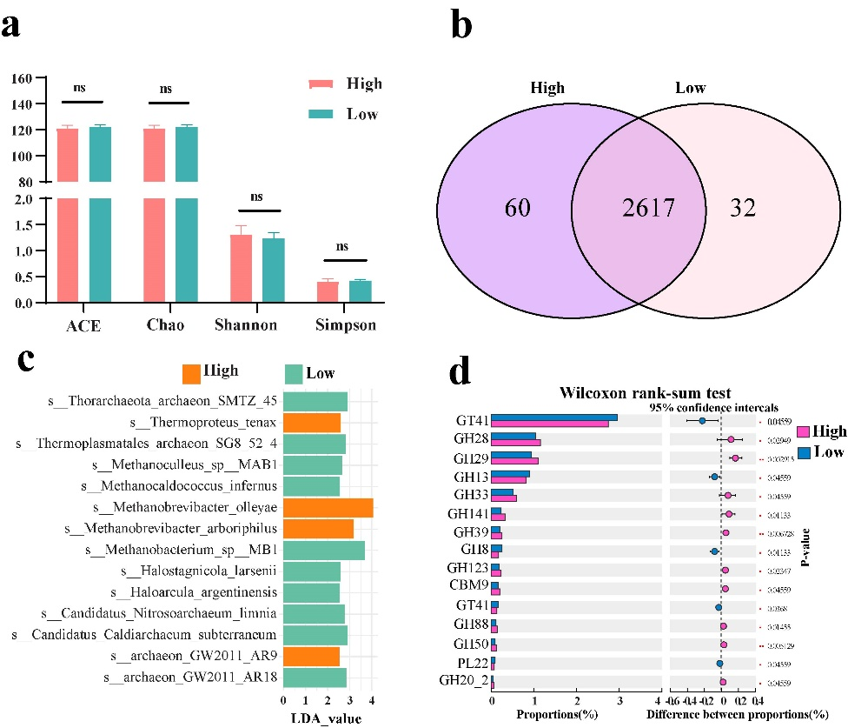

Fig. S2 Faecal microbiota of HRP(n=10) and LRP sows (n =8) can be distinguished using metagenome sequencing. (a) The α-diversity of HPR and LPR sows measured using ACE, Chao, Shannon and Simpson indices. (b) Venn diagram analysis based on different groups of gut microbes on genu level. (c) LDA score plot of enriched archaea taxa abundance determined by linear discriminant analysis effect size (LEfSe) analysis (LDA value>2.0; p-value<0.05. (d) Differential CAZyme functions in the two groups based on family-level enzymes (Wilcoxon rank-sum test, p<0.05). CBM, carbohydrate‐binding modules; GH, glycoside hydrolase family; GT, glycosyl transferase; PL, polysaccharide lyase;

