Supplementary Information for

Wafer-scale vertical injection III-nitride deep-ultraviolet light emitters
Jiaming Wang^{1,5}, Chen Ji^{1,5}, Jing Lang^{1,5}, Fujun Xu^{1*}, Lisheng Zhang^{1,2}, Xiangning Kang¹, Zhixin Qin¹, Xuelin Yang¹, Ning Tang^{1,3,4}, Xinqiang Wang^{1,3,4}, Weikun Ge¹ and Bo Shen^{1,3,4*}
¹State Key Laboratory of Artificial Microstructure and Mesoscopic Physics, School of Physics, Peking University, Beijing 100871, China
²Beijing SinoGaN Semiconductor Technology Co., Ltd., Beijing 101399, China
³Nano-optoelectronics Frontier Center of Ministry of Education, Peking University, Beijing 100871, China
⁴Collaborative Innovation Center of Quantum Matter, Beijing 100871, China
⁵These authors contributed equally: Jiaming Wang, Chen Ji, Jing Lang
*Email: fjxu@pku.edu.cn; bshen@pku.edu.cn
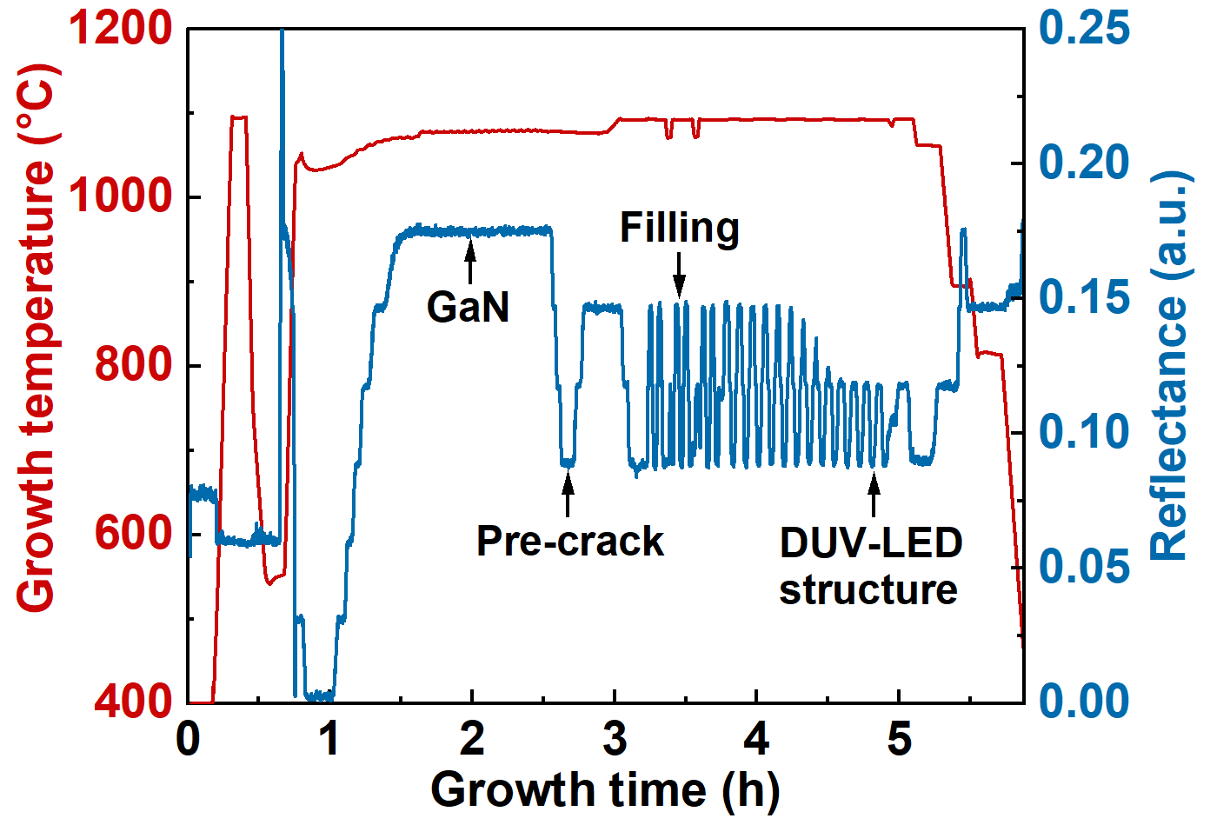
Fig. S1. In-situ monitoring curve for the growth of DUV-LEDs on GaN templates. The in-situ true growth temperature and optical reflectance curve (405 nm) are recorded by a LayTec EpiTT system. Worthy of note is that the peak temperature is 1095℃, within the capability of conventional MOCVD for InGaN-based visible LEDs.

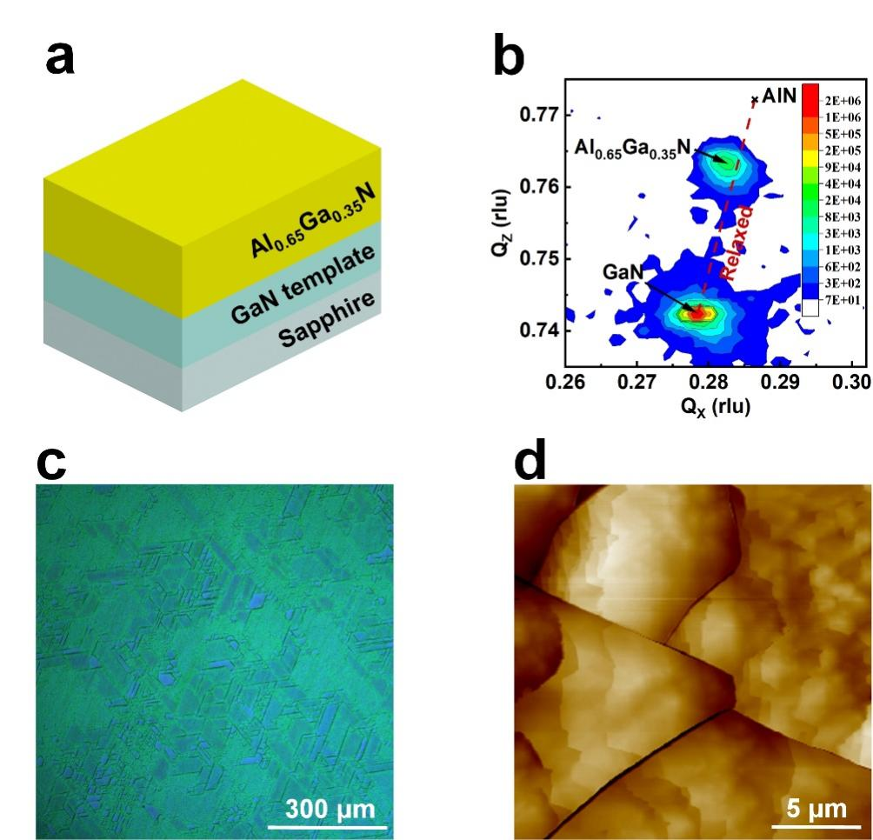
Fig. S2. The influence of crack size on the filling process. a, Schematic illustration of the reference sample, where Al_{0.65}Ga_{0.35}N is directly grown on the GaN template. b, X-ray reciprocal space mapping for the $\left(\overline{\text{1}}\text{015}\right)$ reflection of the reference sample. c, Nomarski contrast microscope image of the reference sample with 660 nm-thick Al_{0.65}Ga_{0.35}N. d, AFM image of the reference sample.
A reference sample is prepared to investigate the influence of the crack size on the filling process, where 660 nm-thick Al_{0.65}Ga_{0.35}N is directly grown on the GaN template (Fig. S2a). Al_{0.65}Ga_{0.35}N here plays the role of both pre-crack and filling, and hence the thickness of Al_{0.65}Ga_{0.35}N is controlled to be equal to the sum of Al_{0.8}Ga_{0.2}N (the sacrificial layer, 120 nm) and Al_{0.65}Ga_{0.35}N (the healing layer, 540 nm) in the validation sample (Fig. 2). However, this filling thickness is quite insufficient, since evident surface cracks can still be observed by Nomarski contrast microscope (Fig. S2c) and AFM (Fig. S2d). The evolution difference between the two samples is attributed to the different size of cracks, e.g. depth and width. Specifically, the critical thickness of Al_{0.65}Ga_{0.35}N on GaN is greater than that of Al_{0.8}Ga_{0.2}N, leading to deeper and wider cracks in the reference sample. It is convinced that the shallower and narrower the cracks, the easier the filling. The optimized Al composition in the sacrificial layer can hence lay a good foundation for the following filling process, as done in the validation sample.

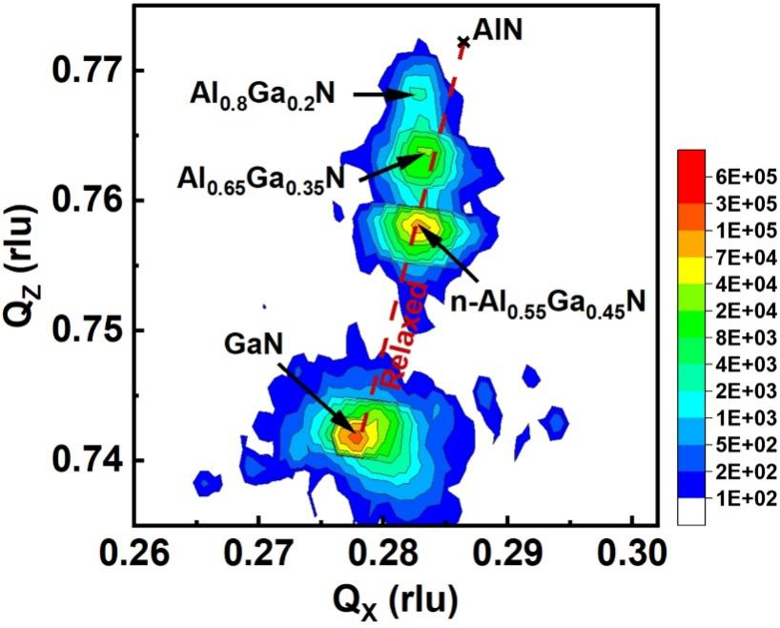
Fig. S3. X-ray reciprocal space mapping for $\left(\overline{\text{1}}\text{015}\right)$ reflection of the DUV-LED structure on the GaN template. n-Al_{0.55}Ga_{0.45}N in the DUV-LED structure can be clearly identified, which is strain-free according to the theoretical expectation (the red relaxed line). The peaks of EBL, p-AlGaN, and p-GaN are masked by the other layers with similar Al composition.

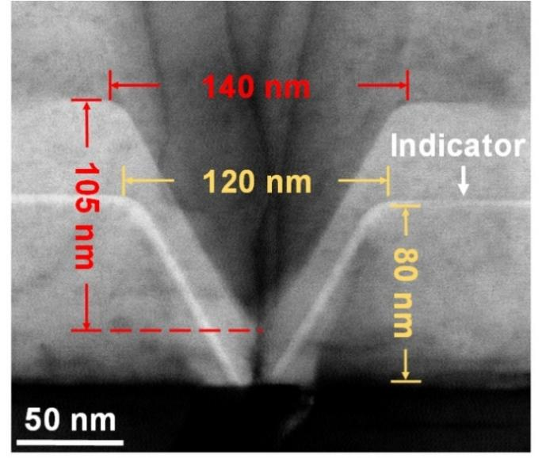
Fig. S4. Detailed size information of the pre-cracks. In fact, the indicator line is also buried into the Al_{0.8}Ga_{0.2}N sacrificial layer at the thickness of 80 nm, presented as the shallow contrast line in STEM here. The indicator line clearly shows the outline of the pre-crack, suggesting that the actual critical thickness of Al_{0.8}Ga_{0.2}N on GaN is less than 80 nm, in other words, the Al_{0.8}Ga_{0.2}N sacrificial layer has already been cracked within 80 nm. In the subsequent growth of the sacrificial layer, the pre-crack slightly deepens and broadens to 105 nm and 140 nm, respectively, which is attributed to the difference between the growth rate on the semi-polar sidewall and that on the Al-polar flat.

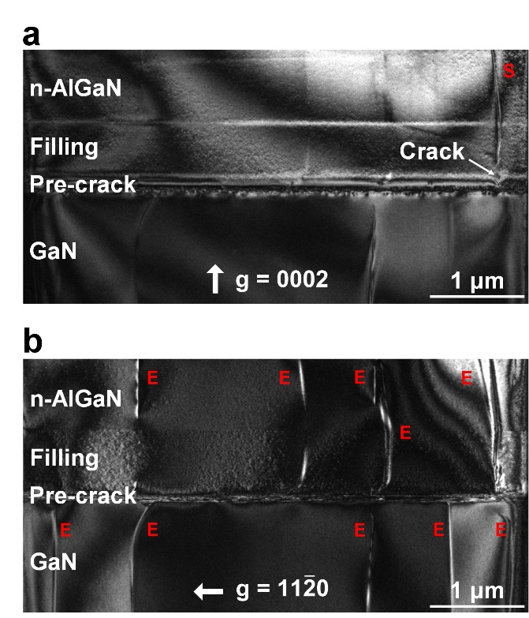
Fig. S5. Identification of TDs in AlGaN layers by cross-sectional dark-field TEM images under two-beam conditions with (a) $\text{g = 0002}$and (b) $\text{g = 11}\overline{\text{2}}\text{0}$, respectively. The screw- and edge-type TDs are labelled as S and E, respectively. The edge-type TDs dominate in both GaN and AlGaN, and meanwhile, the TD density is roughly the same in these two layers. It is demonstrated that there is no evident multiplication of TDs in the growth of the AlGaN healing layer.

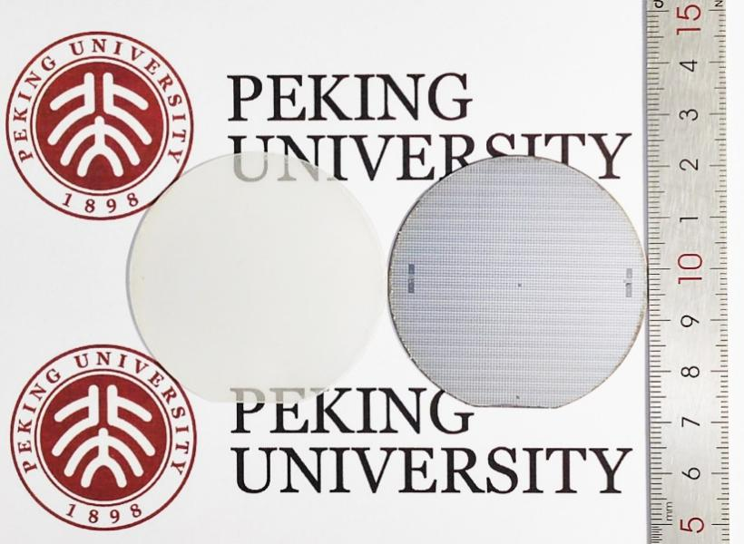
Fig. S6. 2-inch crack-free DUV-LED wafer on GaN templates after growth (left) and LLO (right). As is the case for 4-inch wafer, no surface crack is observed in the 2-inch wafer, even after the removal of sapphire by LLO, which is attributed to the decoupling between the DUV-LED structure and GaN template. Rh is adopted here as the p-electrode, so the wafer after the removal of sapphire is silver white in color.

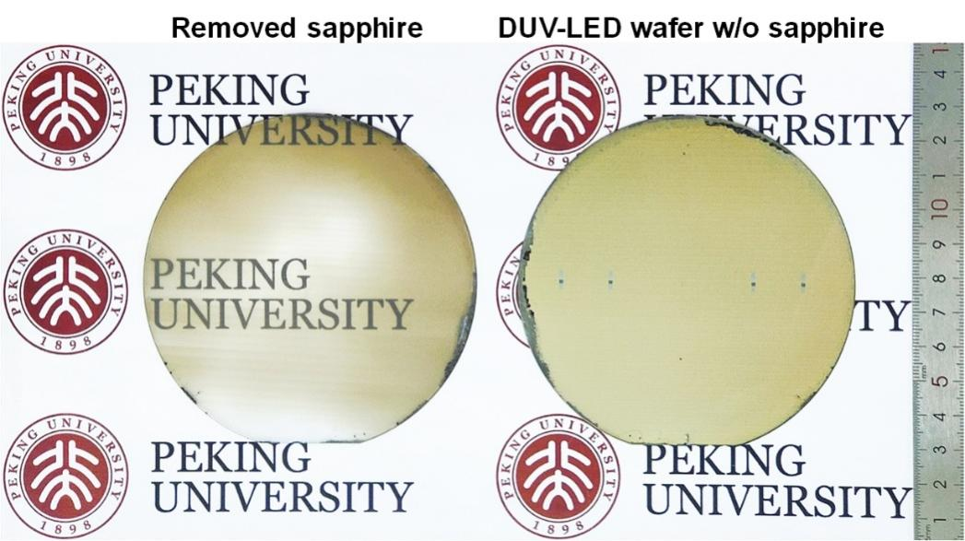
Fig. S7. 4-inch crack-free DUV-LED wafer on GaN templates after LLO. On the left is the removed sapphire substrate by LLO, and on the right is the DUV-LED wafer without sapphire.

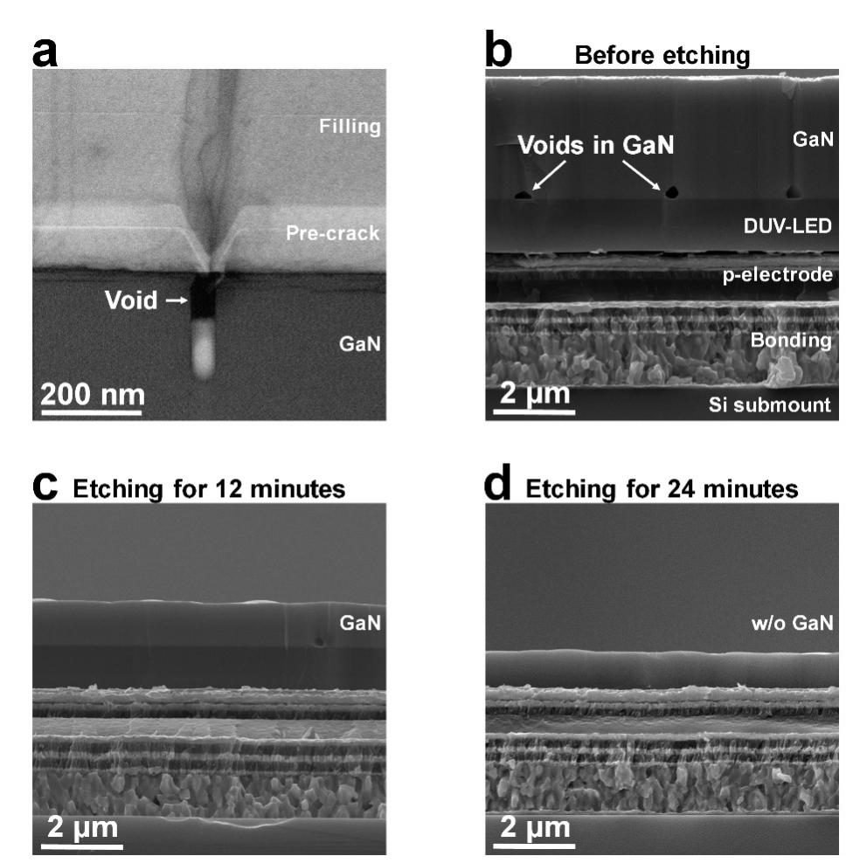
Fig. S8. Removal of GaN template after LLO. a, Cross-sectional bright-field STEM image of the filled-up pre-crack. b, Cross-sectional SEM of DUV-LED wafer after LLO (before GaN etching). c,d, Cross-sectional SEM of DUV-LED wafer after the etching of GaN.
Worthy of note is that the tensile strain-induced cracks run through the Al_{0.8}Ga_{0.2}N sacrificial layer, and even propagate to the GaN template as shown in Fig. S8a. During the subsequent growth of the Al_{0.65}Ga_{0.35}N healing layer, the pre-crack in the sacrificial layer can be filled up, while the one in the GaN template is only partly filled, resulting in the “buried” void around the Al_{0.8}Ga_{0.2}N/GaN interface. The voids can then serve as the guidepost during the etching of the GaN template, specifically, GaN is sufficiently thinned when the voids disappear. Figure S8b shows the cross-sectional SEM images of the DUV-LED wafer after LLO (before GaN etching), where obvious voids are observed with mean spacing of 3 μm, consistent with the AFM result in Fig. 1b. The etching rate of N-polar GaN is determined to be about 200 nm/min, and eventually no voids can be identified after the etching for 24 mins (Fig. S8d). It is convinced that the GaN template has been completely removed, and hence the relevant loss of DUV light due to the absorption is eliminated.
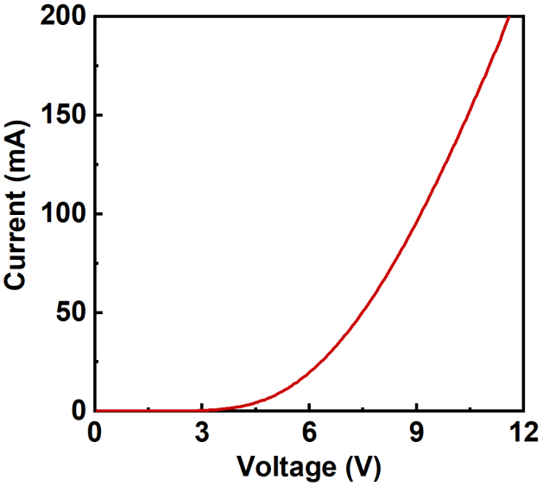
Fig. S9. Typical I-V curve of the vertical injection DUV-LED die. Good rectifying behavior can be identified in the I-V curve. However, the operating voltage is quite high, reaching 9.1 V at 100 mA. The high operating voltage is undoubtedly attributed to the high specific contact resistivity of n-electrode on the $\left[\text{000}\overline{\text{1}}\right]$-plane of n-Al_{0.55}Ga_{0.45}N. The issue can be effectively addressed through the fabrication of devices with the thin-film flip-chip configuration, and related processing is currently underway.

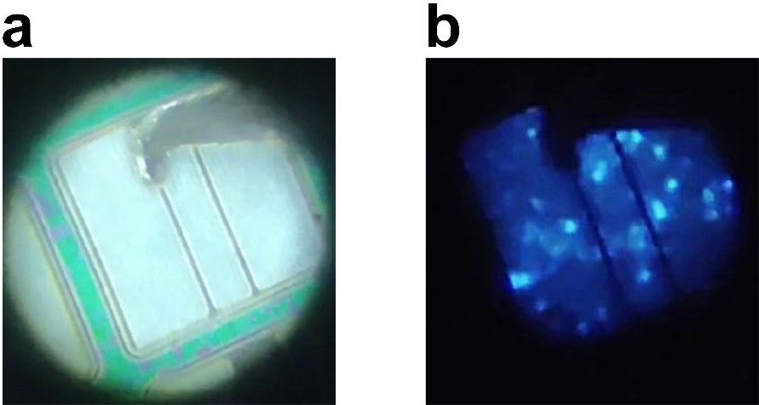
Fig. S10. Optical microscope images displaying the operation of the vertical injection DUV-LED die (a) at 0 mA and (b) at 20 mA. Cu foil is adopted as the positive pole here, on which the wafer is fixed with the aid of conductive silver adhesive.

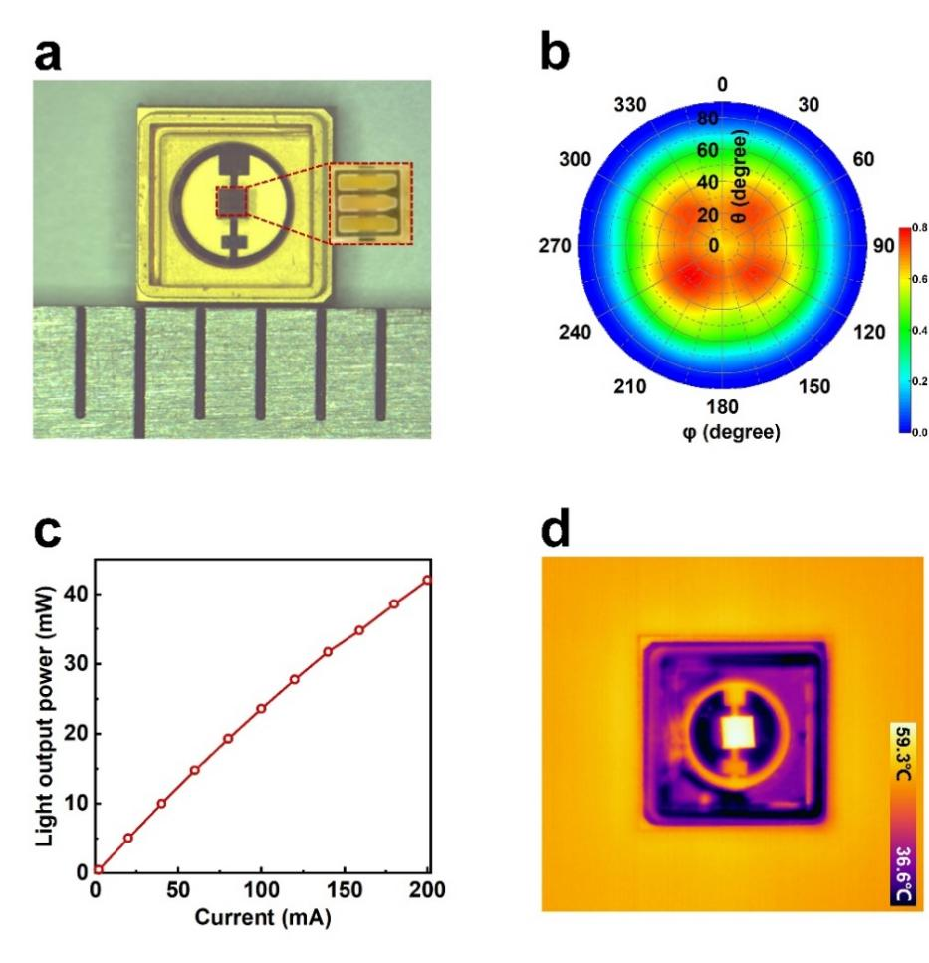
Fig. S11. Performance of flip-chip DUV-LEDs on AlN templates. a, Photograph of the flip-chip DUV-LED die. b, Full far-field radiation pattern of flip-chip DUV-LEDs on AlN template. c, Dependence of the light output power on the injection current for flip-chip DUV-LEDs. d, The temperature distribution of the flip-chip die at an injection current of 100 mA (5 mins).
The same DUV-LED structure as the vertical injection devices is grown on AlN templates, whose TD density is controlled at 9.8×10⁸ cm⁻², ensuring the crystalline quality of the upper n-Al_{0.55}Ga_{0.45}N approximate to that on the GaN templates. As such the conventional flip-chip (FC) devices are fabricated with the die size of 508 × 508 μm² as shown in Fig. S11a. In comparison with the vertical injection DUV-LEDs, significantly weaker EL intensity is observed in the far-field radiation pattern of the flip-chip DUV-LEDs (Fig. S11b). Correspondingly, the light output power of flip-chip DUV-LEDs is much less than the vertical injection ones, only 23.6 and 42.1 mW at 100 and 200 mA (Fig. S11c), respectively, which is mainly attributed to the smaller light extraction efficiency. Moreover, the temperature distribution in flip-chip DUV-LEDs is measured, where the maximum die temperature reaches 59.3℃ after an operation time of 5 mins at 100 mA, higher than that in the vertical injection ones.
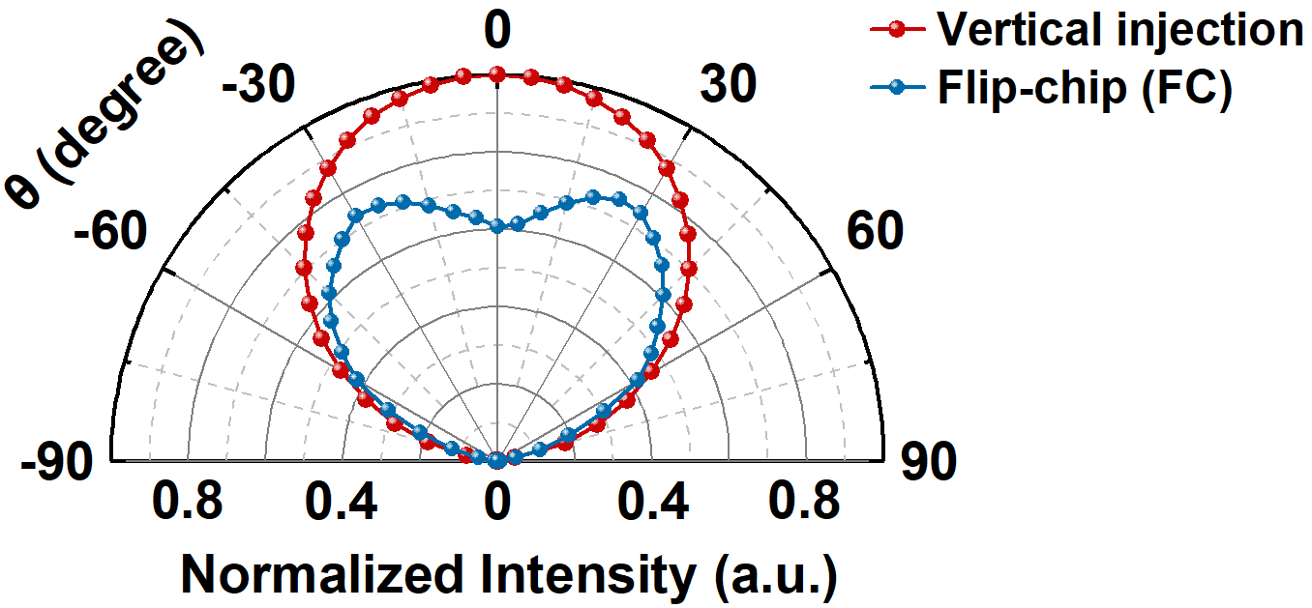
Fig. S12. Radiation patterns obtained from the vertical injection and flip-chip DUV-LEDs.
A Lambertian radiation pattern can be observed in the vertical injection DUV-LEDs, while a heart-shaped one for the flip-chip device (details in Fig. S11). Meanwhile, the on-axis intensity in the vertical injection device is significantly enhanced, mainly attributed to the surface roughening as well as the elimination of the total internal reflection at the epi/substrate interface.

