Figure 1: Intragroup comparison of forelimb muscular strength expressed as force (g) at different study time points. * Indicates comparison between day 3 and day 10; # indicates comparison between day 10 and day 30; $ indicates comparison between day 3 and day 30. Data expressed as Mean±SEM (n=6/ group). **p ≤0.01, ###/ $$$p ≤0.001

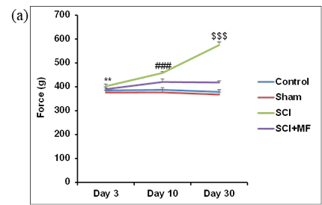

Figure 2: Intergroup comparison of withdrawal threshold (g) at (i) Day 3, (ii) Day 10, (iii) Day 32 after MF exposure. Right hindpaw (RH) (C); Left hindpaw (LH) (D). * indicates comparison between day 3 and day 10; # indicates comparison between day 10 and day 30; $ indicates comparison between day 3 and day 30. Data expressed as Mean±SEM (n=6/ group). * p ≤ 0.05; ** p ≤ 0.01; *** p ≤ 0.001. CD= could not be done.
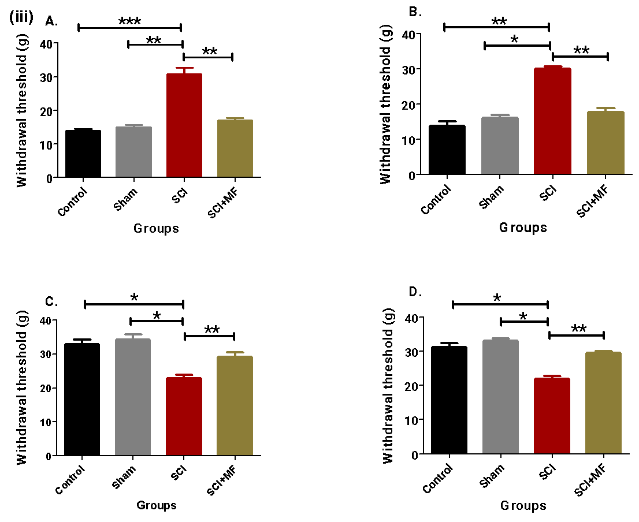
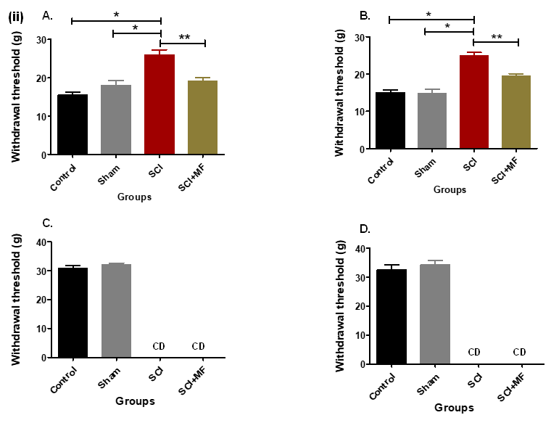
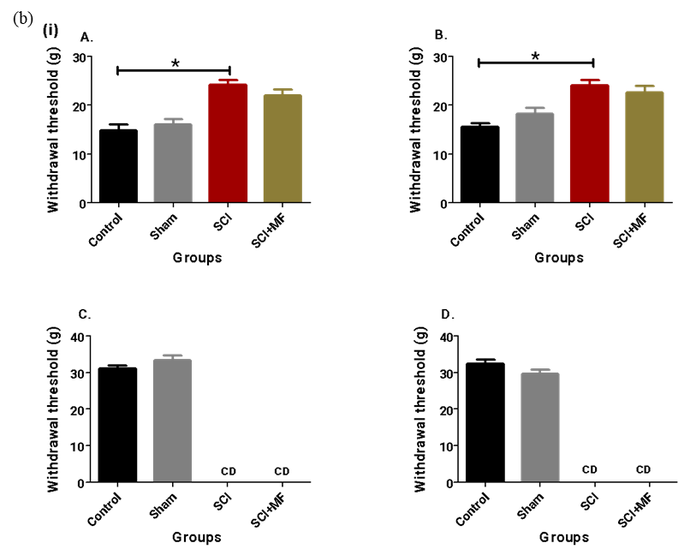
Right hindpaw (RH)
Left hindpaw (LH)
Day 5
Day 30
Day 10

Figure 3: (a) Intragroup temporal comparison of power (V)² for different waves (δ, θ, α, and β) for frontal and parietal lobes. (A) δ_{power}X10⁻¹⁰(V)² for frontal and parietal lobes; (B) θ_{power}X10⁻¹⁰(V)² for frontal and parietal lobes; (C) α_{power}X10⁻¹⁰(V)² for frontal and parietal lobes; (D) β_{power}X10⁻¹⁰(V)² for frontal and parietal lobes. (b) Intergroup comparison of power (V)² for different waves (δ, θ, α, and β) in frontal lobe after MF exposure on (i) Day 5, (ii) Day 12, (iii) Day 32. δ_{power}X10⁻¹⁰(V)² (A); θ_{power}X10⁻¹⁰(V)² (B); α_{power}X10⁻¹⁰(V)² (C), and β_{power}X10⁻¹⁰(V)² (D). * indicates comparison between day 5 and day 12; # indicates comparison between day 12 and day 32. Data expressed as Mean ±SEM (n=6/ group). * p ≤ 0.05; ** p ≤ 0.01; *** p≤ 0.001
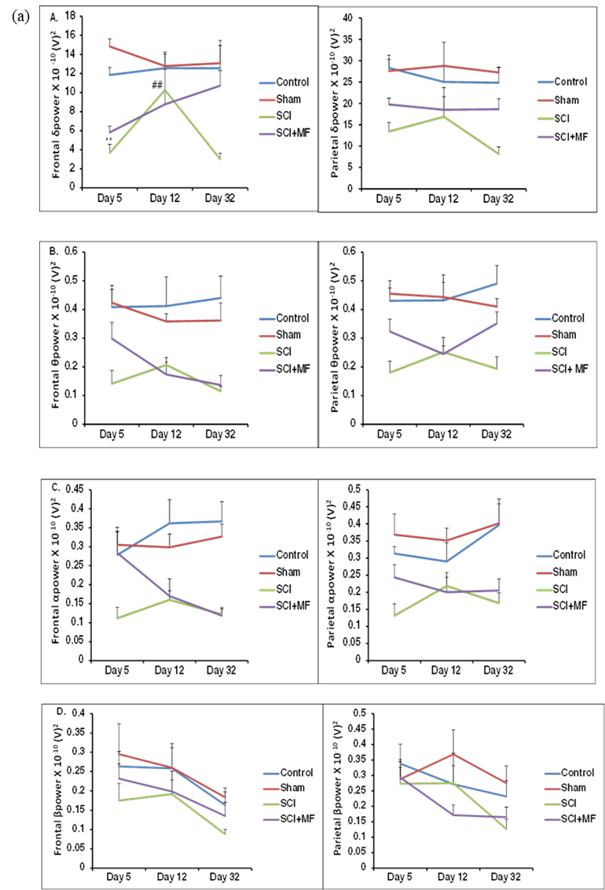

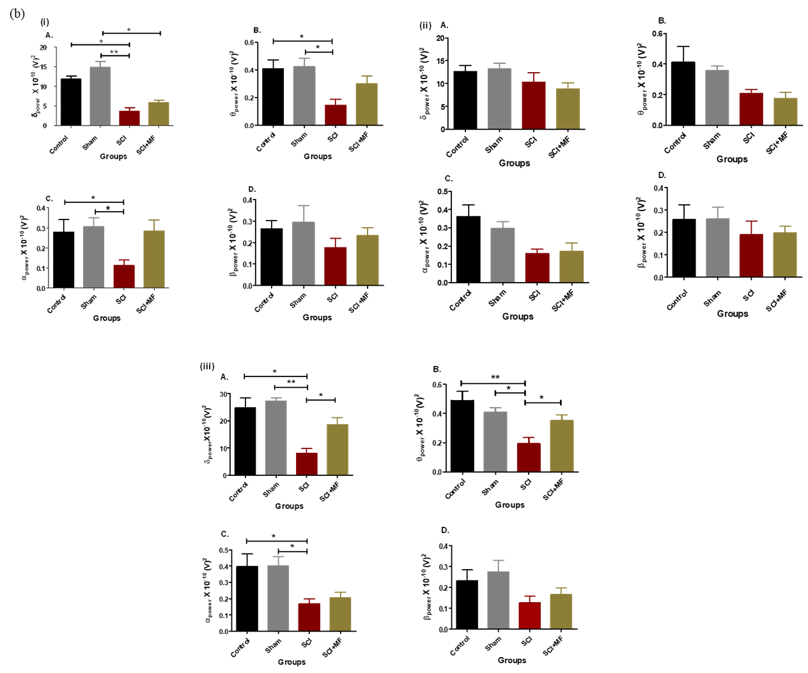
Day 5
Day 12
Day 32
Figure 4: (a) Intragroup temporal comparison of lesion area (mm²) and lesion volume (mm³) in various groups. (b) Intergroup comparison of lesion area (mm) ² and lesion volume (mm)³ after MF exposure. Day5 (A&B); day12 (C&D); day32 (E&F). Data expressed as Mean± SEM (n=6/ group) * indicates comparison between SCI and SCI+MF groups; p≤ 0.05.
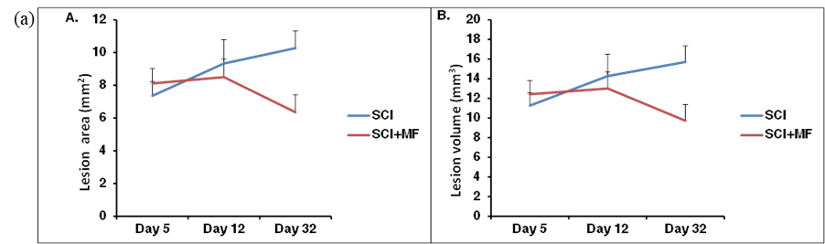
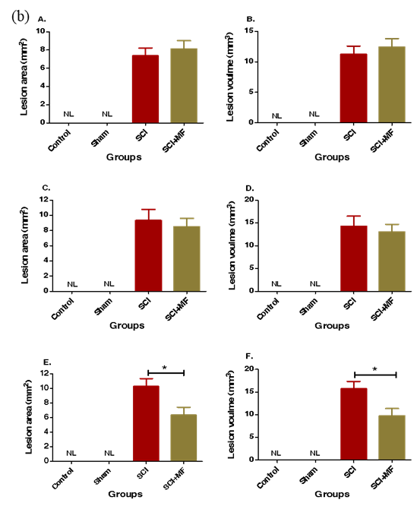
Day 12
Day 32
Day 5
Figure 5: Subcellular localization of Nogo-A (40X objective lens) of M1 (primary motor area) (1a-c); M2 (secondary motor area) (2a-c); S1FL (somatosensory forelimb area) (3a-c); S1HL (somatosensory hindlimb area) (4a-c) in (i) Control group, (ii) Sham (Day 32), (iii) SCI (Day 32), (iv) SCI+MF (Day 32).
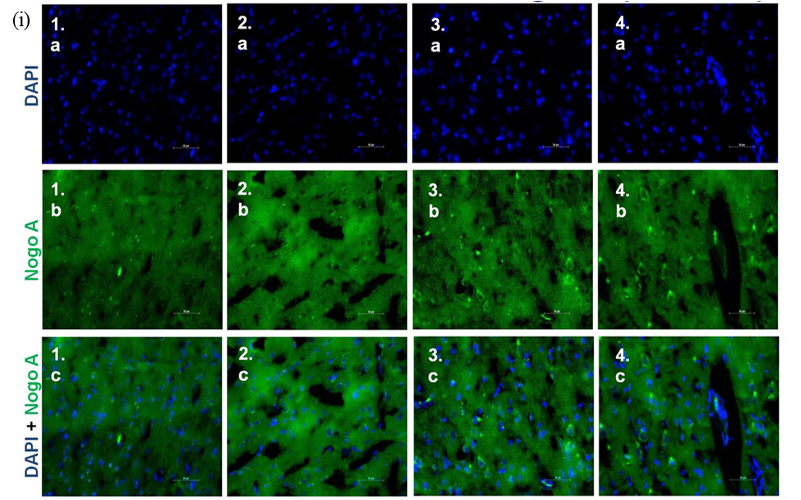
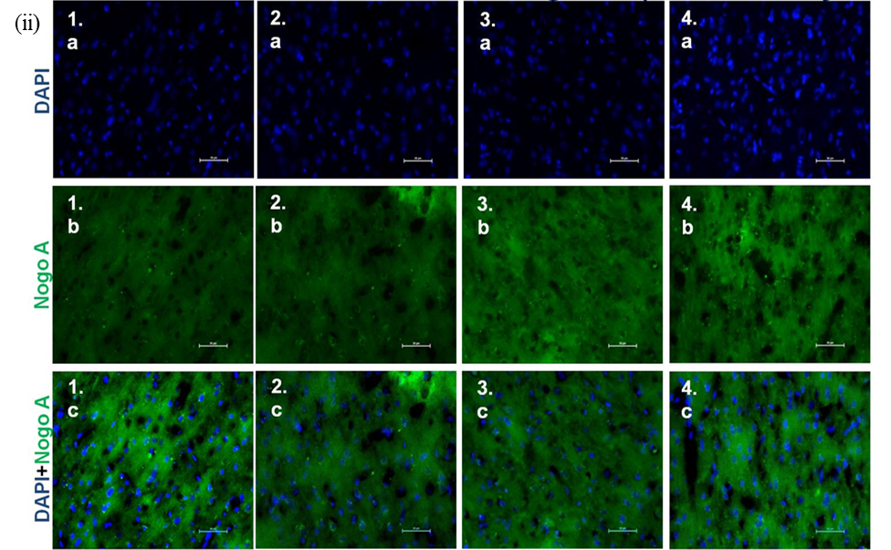
M1 M2 S1FL S1HL

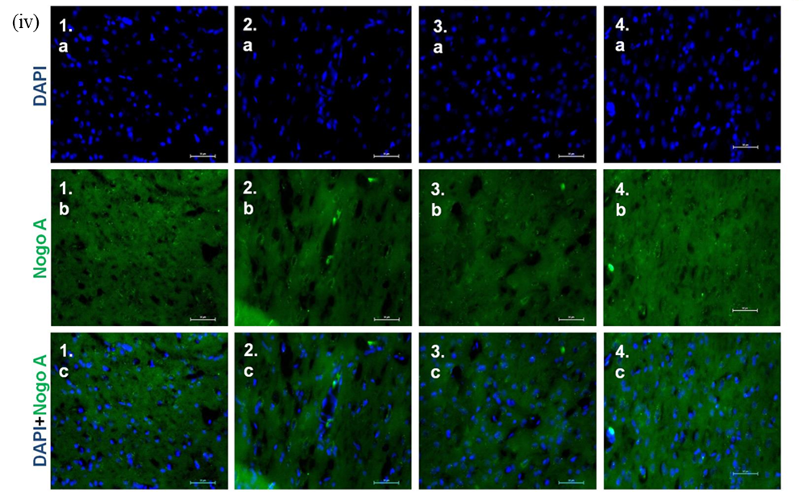
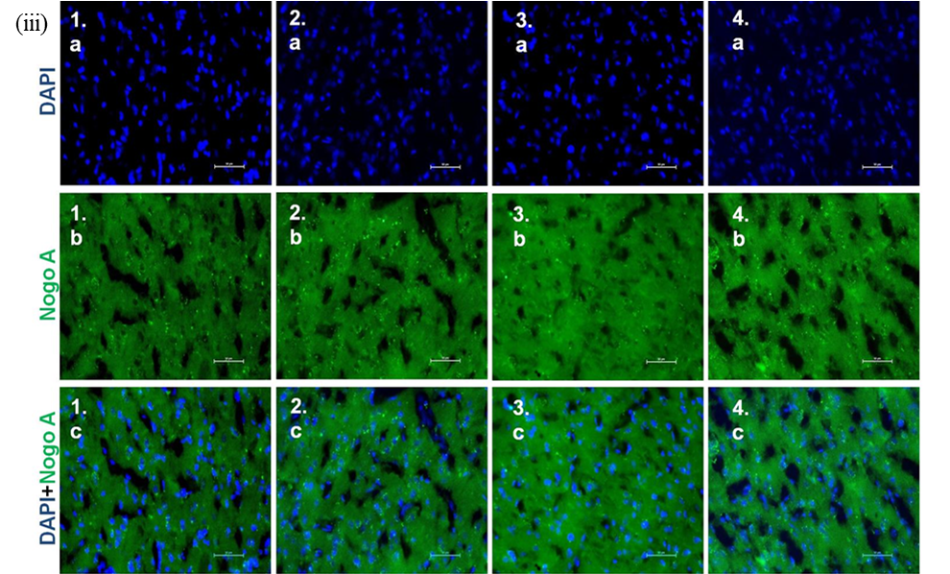

Figure 6: Subcellular localization of BDNF (40X objective lens) of M1 (primary motor area) (1a-c); M2 (secondary motor area) (2a-c); S1FL (somatosensory forelimb area) (3a-c); S1HL (somatosensory hindlimb area) (4a-c) in (i) Control group, (ii) Sham (Day 32), (iii) SCI (Day 32), (iv) SCI+MF (Day 32).
M1 M2 S1FL S1HL
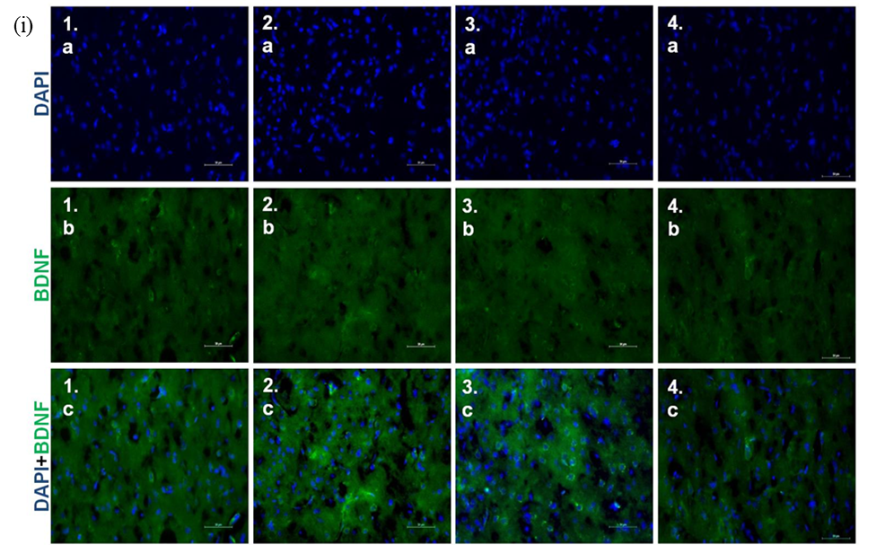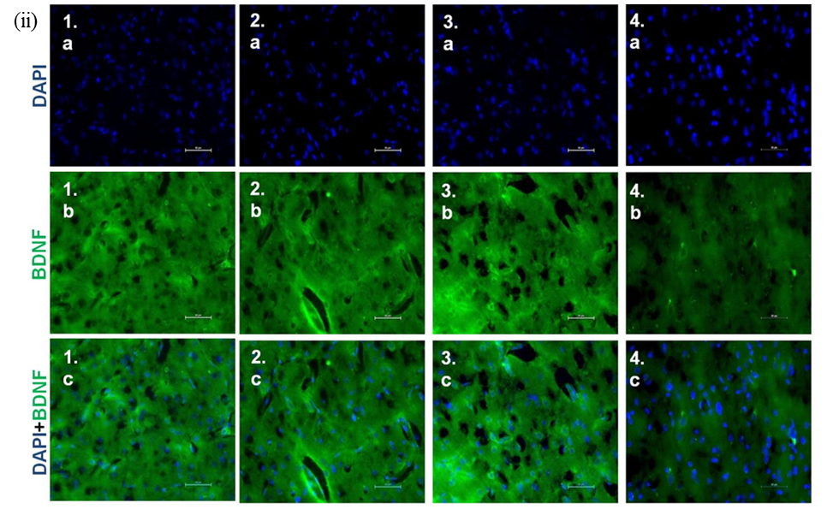
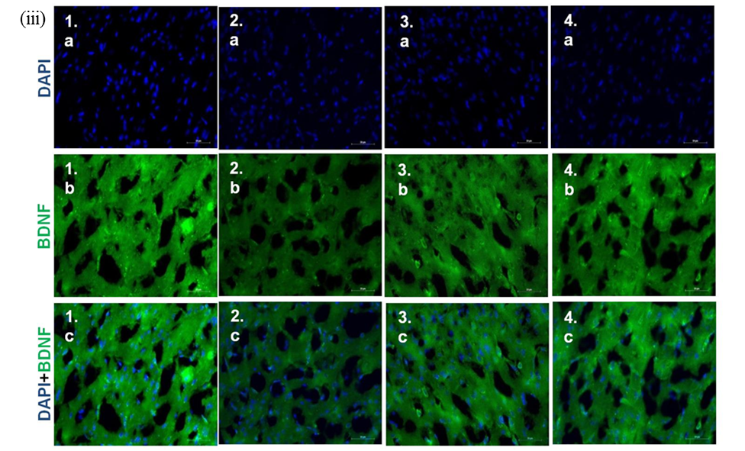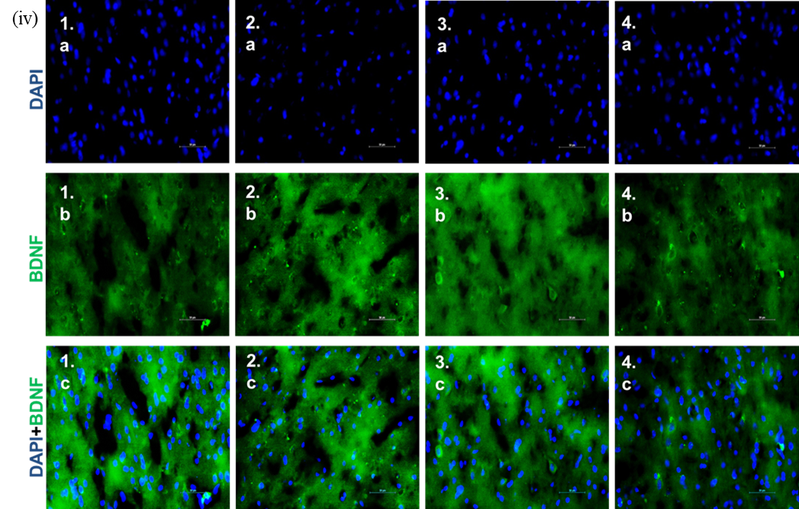

Figure 7: Intragroup temporal comparison of Nogo-A+ cells/ field of (i) M2 (secondary motor cortex), (ii) S1FL (somatosensory, forelimb cortex), (iii) S1HL (somatosensory, hindlimb cortex) in right cortical hemisphere (A) and left cortical hemisphere (B). Data expressed as Mean±SEM (n=3/ group). * indicates comparison between day 5 and day 12; # indicates comparison between day 12 and day 32; $ indicates comparison between day 5 and day 32. Field = 8730 μm². */#/$ ≤0.05; **/##/$$ ≤0.01, ***/###/$$$ ≤0.001.
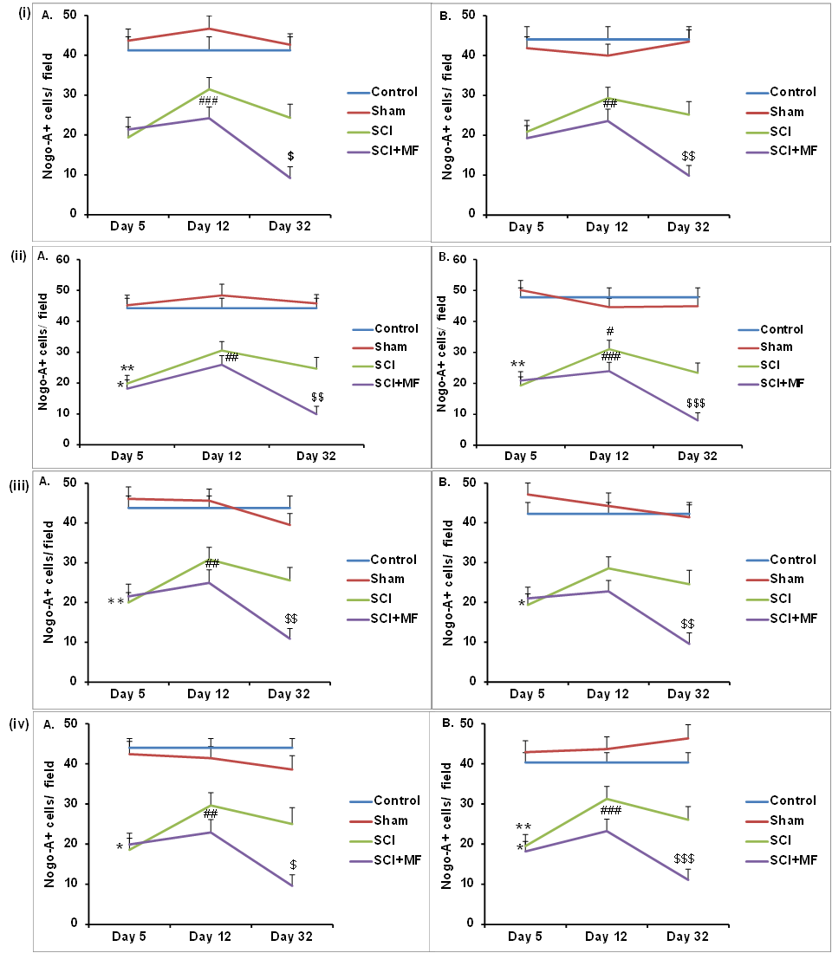
Left cortical hemisphere
Right cortical hemisphere
M2 (secondary motor cortex)
S1FL (somatosensory forelimb cortex)
S1HL (somatosensory, hindlimb cortex)
(i)
(ii)
(iii)

Figure 8: Intergroup comparison of Nogo-A+ cells/ field in (a) right and (b) left cortical hemisphere after MF exposure at (i) Day 5, (ii) Day 12 (iii) Day 32 at (A) M1= Primary Motor cortex; (B); M2= Secondary Motor Cortex; (C) S1FL= Primary somatosensory, forelimb and (D) S1HL= Primary somatosensory hindlimb. Data expressed as Mean±SEM (n=3/ group). Field = 8730 μm². * p ≤ 0.05; ** p ≤ 0.01; ***p ≤ 0.001.
Right cortical hemisphere

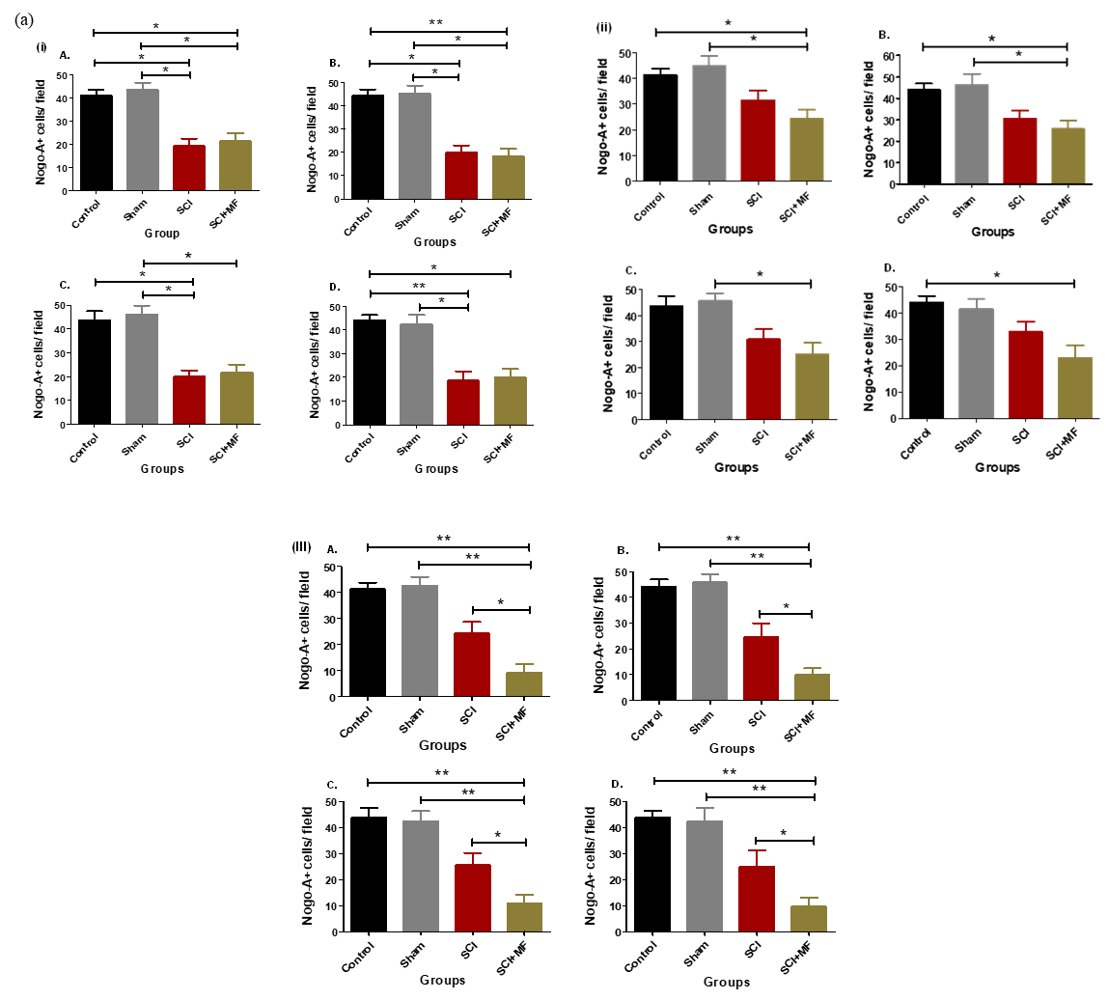
Day 5
Day 12
Day 32

Left cortical hemisphere
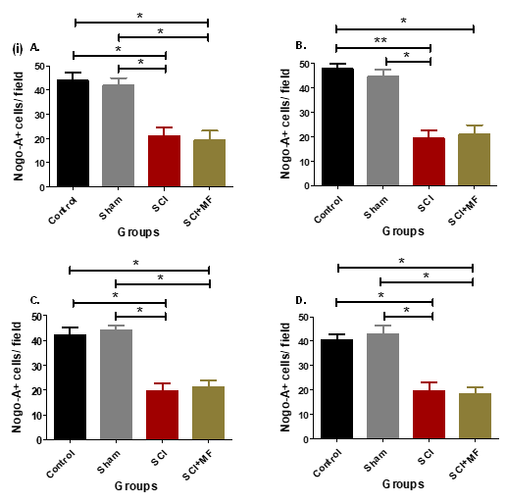
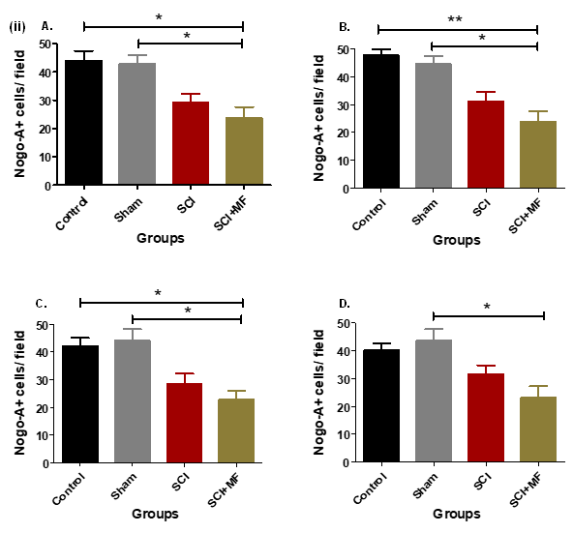
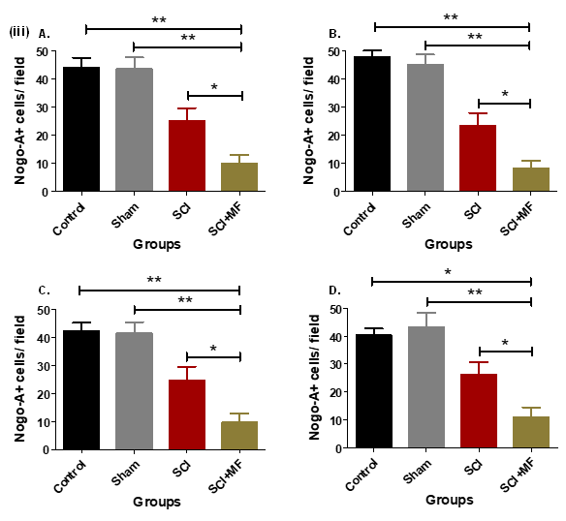
(b)
Day 12
Day 32
Day 5

Figure 9: Intragroup temporal comparison of BDNF+ cells/ field of (i) M2 (secondary motor cortex), (ii) S1FL (somatosensory, forelimb cortex), (iii) S1HL (somatosensory, hindlimb cortex) in right cortical hemisphere (A) and left cortical hemisphere (B). Data expressed as Mean±SEM (n=3/ group). * indicates comparison between day 5 and day 12; # indicates comparison between day 12 and day 32; $ indicates comparison between day 5 and day 32. Field = 8730 μm². */#/$ ≤0.05; **/##/$$ ≤0.01, ***/###/$$$ ≤0.001.
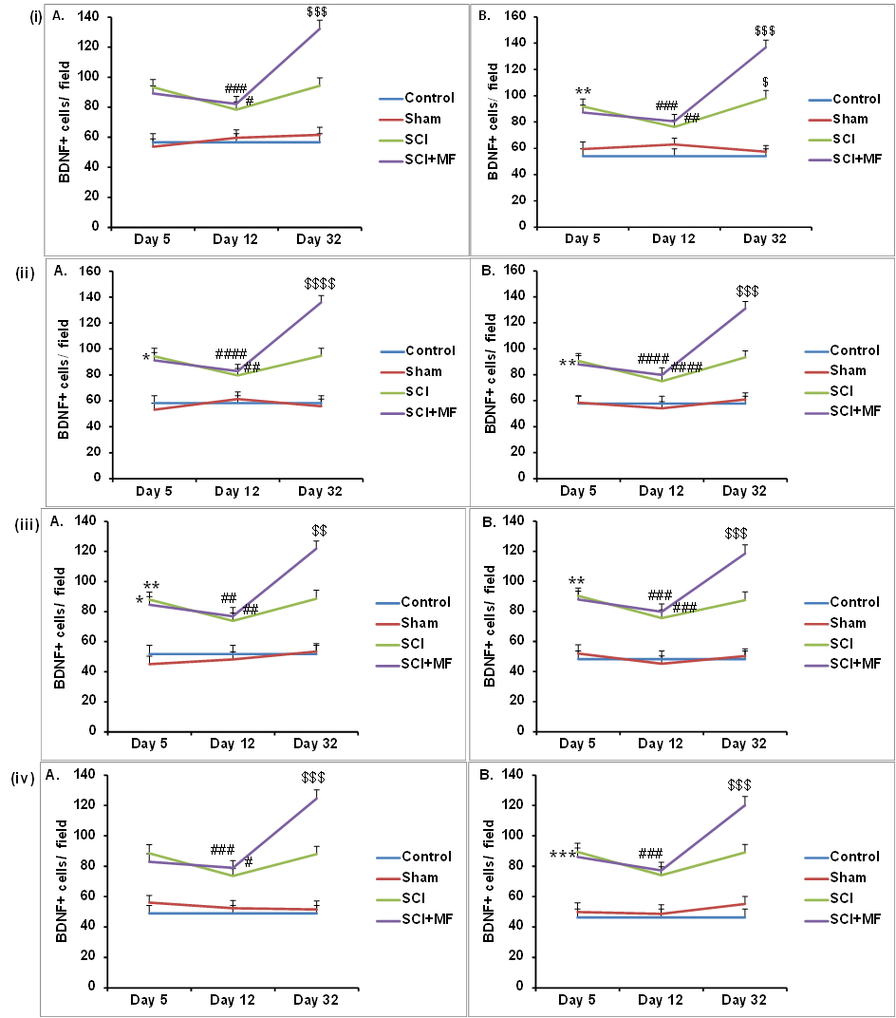
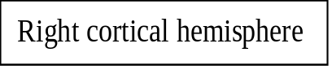
M2 (secondary motor cortex)
S1FL (somatosensory, forelimb cortex)
S1HL (somatosensory, hindlimb cortex)
Left cortical hemisphere
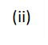
(i)
(iii)
Figure 10: Intergroup comparison of BDNF+ cells/ field in (a) right (b) left cortical hemisphere after MF exposure at (i) Day 5, (ii) Day 12 (iii) Day 32. M1= Primary Motor cortex (A); M2= Secondary Motor Cortex (B); S1FL= Primary somatosensory cortex, forelimb (C); and S1HL= Primary somatosensory cortex, hindlimb (D). Data expressed as Mean±SEM (n=3/ group). Field = 8730 μm². * p ≤ 0.05; ** p ≤ 0.01; ***p ≤ 0.001.
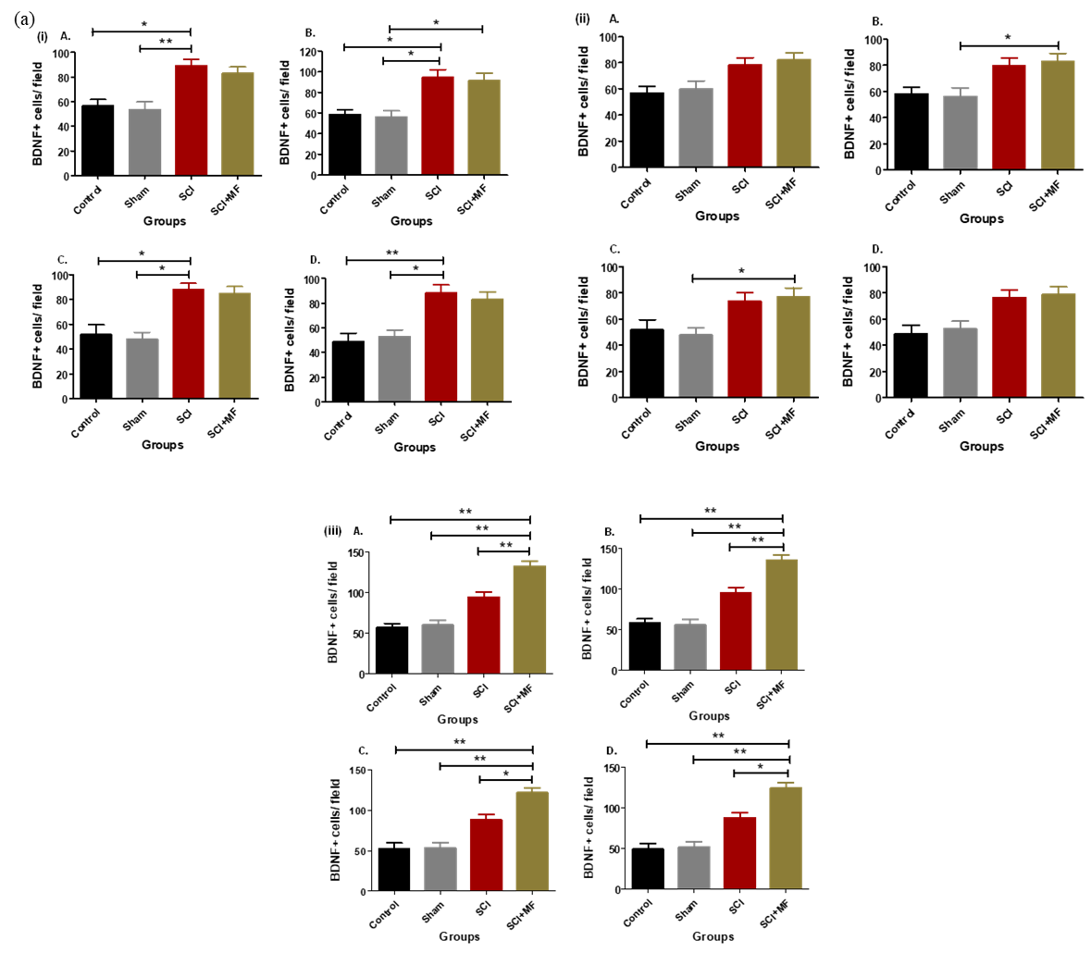
Day 5
Day 12
Day 32
Right cortical hemisphere

Left cortical hemisphere
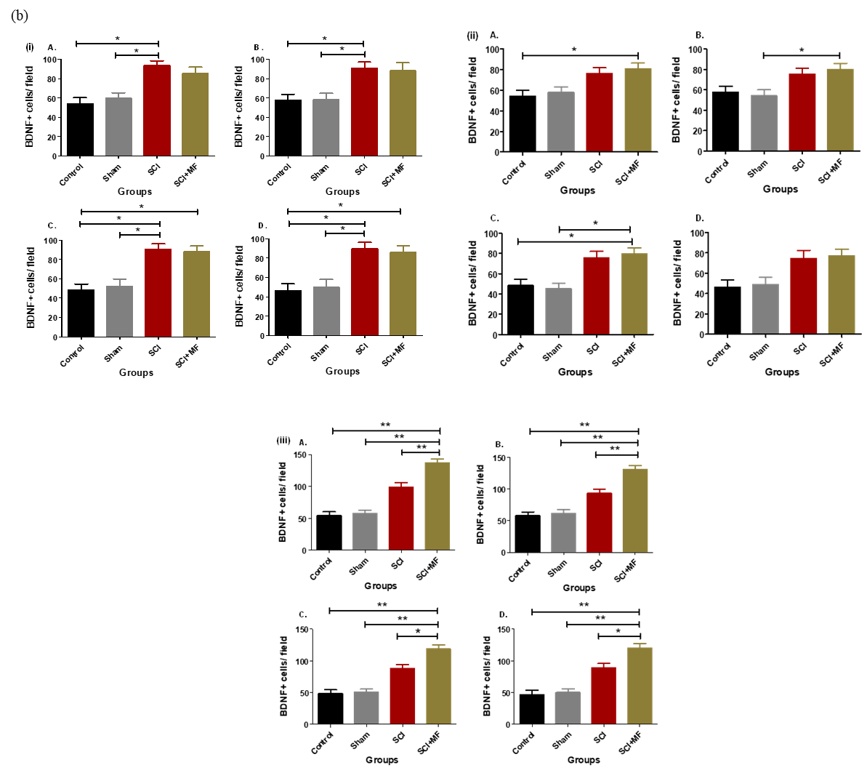
Day 5
Day 12
Day 32

