Supporting information
Synthesis, characterization, solvatochromic, and electrochemical investigation of novel 4-methylcoumarin-fused azo dyes as a NLO material and their biological studies.
Surendranaik. Y ª, Talavara Venkatesh ª *, Eresha naik ^{b}
ª Department of P.G. Studies and Research in Chemistry, Kuvempu University, Jnanasahyadri, Shankaraghatta - 577451, Shivamogga, Karnataka, India.
^{b} Department of PG Studies and Research in Industrial Chemistry, Sir. M.V. Govt. Science College, Bommanakatte, Shivamogga, Bhadravathi - 577 302, Karnataka, India.
* Corresponding author.
E-mail address: venkateshatalwar@gmail.com.

5-((4-Methyl-2-oxo-2H-chromen-7-yl)diazenyl)-2-thioxodihydropyrimidine-4,6(1H,5H)-dione (1a):
Brick red solid, yield 76 %, C₁₄H₁₀N₄O₄S, m.p 190-192 °C. FT-IR (KBr, cm⁻¹): 3448 (NH), 3057 (Ar-CH), 1744 (C=O), 1551 (C=C), 1441 (N=N), 1373 (CH₃) & 1127 (C=S). ¹H NMR (400 MHz, DMSO-d_{6,} δ ppm): 11.58 (s, 2H, 2-NH), 7.73 -7.70 (d, J = 8.7 Hz, 2H, Ar-H), 7.50 (s, 1H, Ar-H), 7.37 (s, 1H, Ar-H), 6.25 (s, 1H, Ar-H), 2.39 (s, 3H, CH₃). ¹³C NMR (101 MHz, DMSO-d₆ δ ppm):177.40 (C=S), 160.79 (C=O), 159.01, 154.53, 153.86, 145.33, 126.35 (C=C) & 18.72 (CH₃). Calculated HR-MS (m/z): 330.3186, Observed HR-MS (m/z): 329.0257 (M-H).

1,3-Dimethyl-5-((4-methyl-2-oxo-2H-chromen-7-yl)diazenyl)pyrimidine-2,4,6(1H,3H,5H)-trione (1b):
Yellow colour solid, yield 72 %, C₁₈H₁₈N₂O₄, m.p 186-187 °C. FT-IR (KBr, cm⁻¹): 3213 (NH----O), 3091 (Ar-CH), 1743 (C=O), 1613 (C=N), 1574 (C=N), 1443 (N=N) & 1344 (CH₃). ¹H NMR (400 MHz, DMSO-d₆, δ ppm): 14.03 (s, 1H, NH), 7.70-7.68 (d, J = 8.7 Hz, 2H, Ar-H), 7.39 (s, 1H, Ar-H), 6.35 (s, 1H, Ar-H), 3.25 (s, 6H, 2N-CH₃), 2.34 (s, 3H, CH₃). ¹³C NMR (101 MHz, DMSO- d₆, δ ppm): 157.62, 156.02, 144.41, 140.58, 135.88, 126.91, 25.62, 22.54 & 14.23 (CH₃). Calculated HR-MS (m/z): 342.3062, Observed HR-MS (m/z): 341.0789 (M-H).

5,5-Dimethyl-2-((4-methyl-2-oxo-2H-chromen-7-yl)diazenyl)cyclohexane-1,3-dione (1c):
Yellow colour solid, yield 81 %, C₁₈H₁₈N₂O₄, m.p 202-202 °C. FT-IR (KBr, cm⁻¹): 3206 (NH----O), 3109 (Ar-CH), 1703 (C=O), 1637 (C=N), 1530 (C=C), 1450 (N=N) & 1399 (CH₃). ¹H NMR (400 MHz, DMSO- d₆, δ ppm): 14.51 (s, 1H, N-H), 7.80-7.79 (d, J = 8.3 Hz, 2H, Ar-H), 7.54 (s, 1H, Ar-H), 6.29 (s, 1H Ar-H), 2.56 (s, 4H, 2 CH₂), 2.37 (s, 3H, CH₃), 1.07 – 0.97 (m, 6H, 2CH₃).¹³C NMR (101 MHz, DMSO- d₆, δ ppm): 160.24 (C=O), 154.49, 153.56, 145.26, 131.55, 127.47 (C=C), 52.56, 52.41 (CH₂) & 18.64 (CH₃). Calculated HR-MS (m/z): 326.3465, Observed HR-MS (m/z): 327.1184 (M+H).

2,2-Dimethyl-5-((4-methyl-2-oxo-2H-chromen-7-yl)diazenyl)-1,3-dioxane-4,6-dione (1d):
Yellow colour solid, yield 86 %, C₁₆H₁₄N₂O₆, m.p 197-199 °C. FT-IR (KBr, cm⁻¹): 3199 (NH----O), 3167 (Ar-CH), 1633 (C=O), 1611 (C=N), 1520 (C=C), 1444 (N=N) & 1336 (CH₃). ¹H NMR (400 MHz, DMSO-d₆, δ ppm): 13.15 (s, 1H, NH), 7.84-7.83 (d, J = 8.7 Hz, 1H, Ar-H), 7.63-7.61 (d, J = 8.6 Hz, 1H, Ar-H), 7.56 (s, 1H, Ar-H), 6.33 (s, 1H, Ar-H), 2.44 (s, 3H, CH₃), 1.72 (s, 6H, 2CH₃). ¹³C NMR (101 MHz, DMSO-d₆ , δ ppm): 171.47, 167.24 (C=O), 152.49, 136.42, 130.33, 124.40 (C=C), 27.04 & 18.25 (CH₃). Calculated HR-MS (m/z): 330.2922, Observed HR-MS (m/z): 329.0703 (M-H).

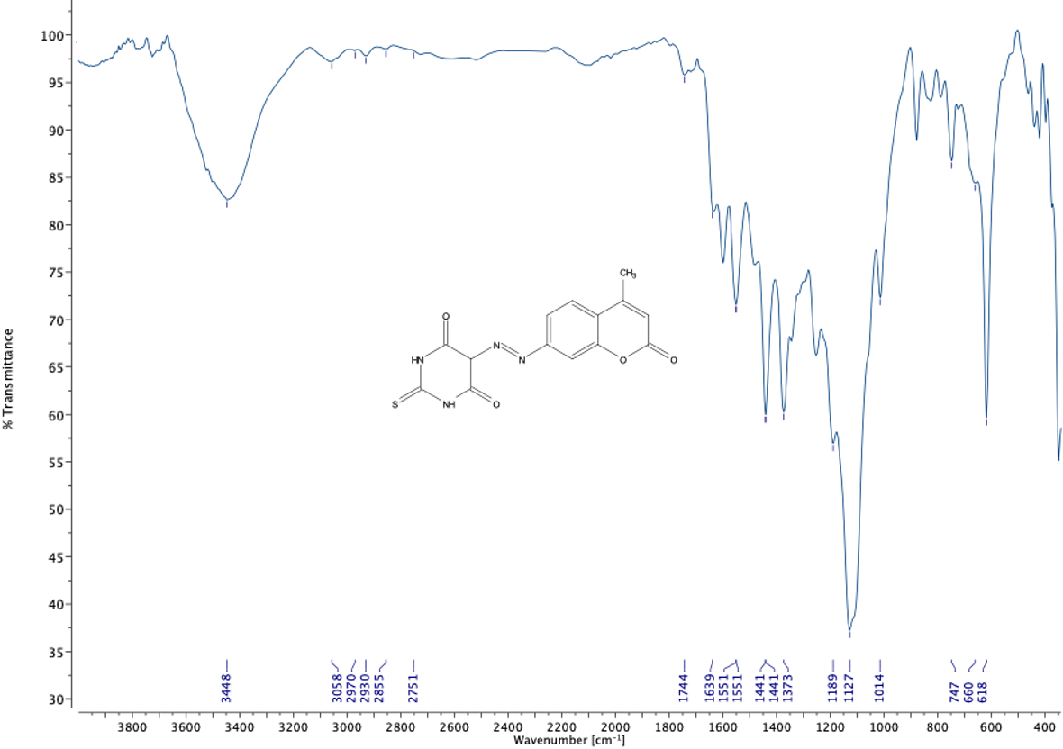
Figure S1:IR spectrum of compound 1a
Figure S2: ¹H NMR spectrum of compound 1a
Figure S3: ¹³C NMR spectrum of compound 1a
Figure S4: MASS spectrum of compound 1a

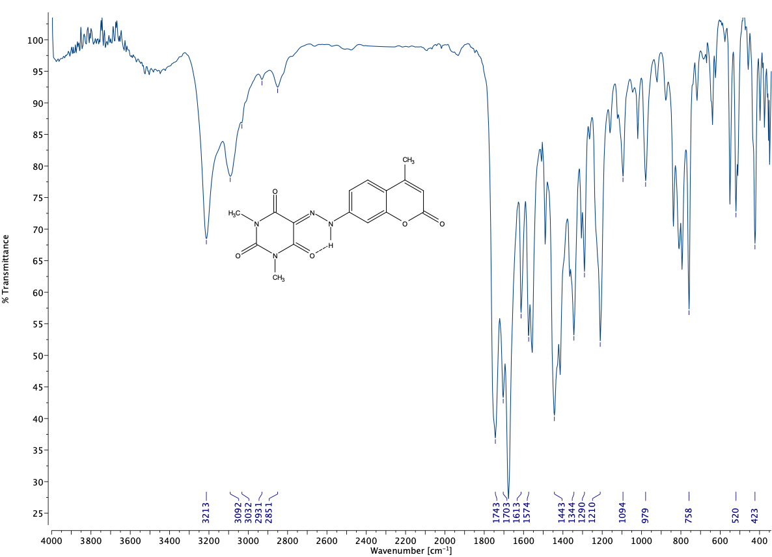
Figure S5 : IR spectrum of compound 1b
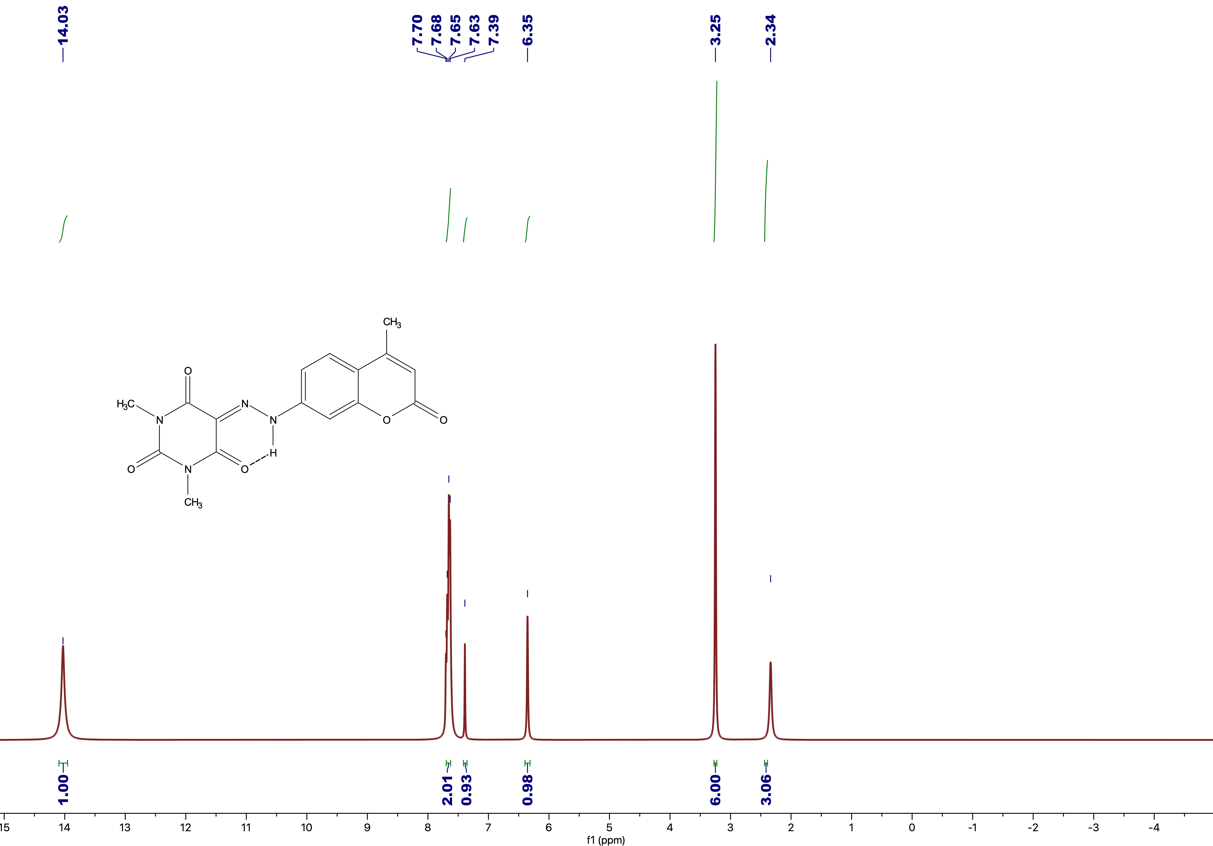
Figure S6: ¹H NMR spectrum of compound 1b
Figure S7: ¹³C NMR spectrum of compound 1b

Figure S8: MASS spectrum of compound 1b

Figure S9 : IR spectrum of compound 1c

Figure S10: ¹H NMR spectrum of compound 1c

Figure S11: ¹³C NMR spectrum of compound 1c

Figure S12: MASS spectrum of compound 1c

Figure S13: IR spectrum of compound 1d

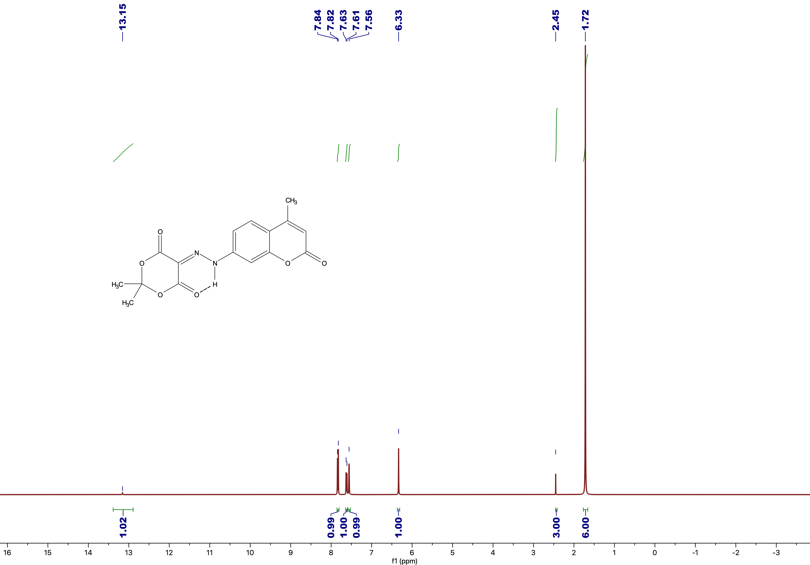
Figure S14: ¹H NMR spectrum of compound 1d

Figure S15: ¹³C NMR spectrum of compound 1d

Figure S16: MASS spectrum of compound 1d

Table S1: Results of second order perturbation theory analysis of Fock matrix in NBO basis for synthesized azo dyes compounds 1(a-d):
 | Donor NBO(i) | Type | Acceptor NBO(j) | Type | E⁽²⁾  kcal/mol | E(j)-E(i)  a.u. | F(i,j)  a.u.
1a | C15-C16 | $$σ$$ | O18-C19 | $$σ^{*}$$ | 113.17 | 0.37 | 0.187
1a | C15-C21 | $$σ$$ | O18-C19 | $$σ^{*}$$ | 140.29 | 0.35 | 0.203
1a | C16-H28 | $$σ$$ | O18-C19 | $$σ^{*}$$ | 257.19 | 0.20 | 0.210
1a | C21-C22 | $$σ$$ | C22-H31 | $$σ^{*}$$ | 175.77 | 2.43 | 0.585
1a | C21-C22 | $$σ$$ | O18-C19 | $$σ^{*}$$ | 486.91 | 0.32 | 0.365
1a | C22-H31 | $$σ$$ | O18-C19 | $$σ^{*}$$ | 469.94 | 0.13 | 0.225
1a | C22-H32 | $$σ$$ | O18-C19 | $$σ^{*}$$ | 1105.88 | 0.18 | 0.414
1a | C22-H32 | $$σ$$ | C22-H31 | $$σ^{*}$$ | 119.17 | 2.29 | 0.469
1a | C22-H33 | $$σ$$ | C16-C17 | $$π^{*}$$ | 103.94 | 0.08 | 0.087
1a | C22-H33 | $$σ$$ | C22-H31 | $$σ^{*}$$ | 160.41 | 1.88 | 0.490
1a | LP(1)-N1 | LP | C2-S7 | $$π^{*}$$ | 66.08 | 0.21 | 0.107
1a | LP(1)-N3 | LP | C2-S7 | $$π^{*}$$ | 69.80 | 0.21 | 0.108
1a | LP(2)-O18 | LP | C14-C15 | $$π^{*}$$ | 31.04 | 0.34 | 0.095
1a | C4-O8 | $$π^{*}$$ | C12-C17 | $$σ^{*}$$ | 639.95 | 0.96 | 1.971
1a | C4-O8 | $$π^{*}$$ | O18-C19 | $$σ^{*}$$ | 162.95 | 2.09 | 1.247
1a | C19-O23 | $$π^{*}$$ | C20-C21 | $$σ^{*}$$ | 100.26 | 0.70 | 0.611
1a | C20-C21 | $$π^{*}$$ | O18-C19 | $$σ^{*}$$ | 103.11 | 0.60 | 0.594
1a | C4-O8 | $$π^{*}$$ | C20-C21 | $$π^{*}$$ | 188.60 | 1.49 | 1.105
1b | C4-C5 | $$σ$$ | N3-C24 | $$σ^{*}$$ | 3.65 | 0.98 | 0.053
1b | C5-H26 | $$σ$$ | C6-O9 | $$π^{*}$$ | 6.10 | 0.52 | 0.053
1b | C12-C13 | $$π$$ | C14-C15 | $$π^{*}$$ | 21.54 | 0.29 | 0.072
1b | C12-C13 | $$π$$ | C16-C17 | $$π^{*}$$ | 16.28 | 0.30 | 0.063
1b | C14-C15 | $$π$$ | C16-C17 | $$π^{*}$$ | 19.16 | 0.29 | 0.069
1b | C20-C21 | $$π$$ | C19-O23 | $$π^{*}$$ | 25.04 | 0.29 | 0.078
1b | LP(1)-N1 | LP | C2-O7 | $$π^{*}$$ | 56.34 | 0.26 | 0.109
1b | LP(1)-N1 | LP | C6-O9 | $$π^{*}$$ | 58.15 | 0.26 | 0.114
1b | LP(1)-N3 | LP | C2-O7 | $$π^{*}$$ | 55.87 | 0.26 | 0.109
1b | LP(1)-N3 | LP | C4-O8 | $$π^{*}$$ | 57.23 | 0.26 | 0.113
1b | LP(2)-O23 | LP | O18-C19 | $$σ^{*}$$ | 43.16 | 0.51 | 0.134
1b | C14-C15 | $$π^{*}$$ | C16-C17 | $$π^{*}$$ | 233.24 | 0.01 | 0.079
1b | C14-C15 | $$π^{*}$$ | C20-C21 | $$π^{*}$$ | 96.08 | 0.02 | 0.073
1b | C19-O23 | $$π^{*}$$ | C20-C21 | $$π^{*}$$ | 71.80 | 0.02 | 0.077
1c | C1-H26 | $$σ$$ | C18-C19 | $$σ^{*}$$ | 44929.51 | 4.62 | 12.889
1c | C1-H26 | $$σ$$ | C19-H33 | $$σ^{*}$$ | 3822.04 | 12.86 | 6.314
1c | C1-H26 | $$σ$$ | C14-C20 | $$σ^{*}$$ | 1389.95 | 14.81 | 4.066
1c | C1-H26 | $$σ$$ | C23-H38 | $$σ^{*}$$ | 12720.08 | 8.91 | 9.606
1c | C1-H26 | $$σ$$ | C24-H41 | $$σ^{*}$$ | 1769.11 | 15.79 | 4.768
1c | C2-C3 | $$σ$$ | C19-C20 | $$π^{*}$$ | 1352.34 | 0.13 | 0.384
1c | C2-C24 | $$σ$$ | C14-C20 | $$σ^{*}$$ | 5916.18 | 0.05 | 0.507
1c | C3-C4 | $$σ$$ | C23-H38 | $$σ^{*}$$ | 30812.56 | 1.99 | 7.010
1c | C11-C12 | $$π$$ | C18-C19 | $$σ^{*}$$ | 21235.29 | 9.31 | 13.601
1c | C11-C12 | $$π$$ | C23-H38 | $$σ^{*}$$ | 8444.75 | 13.60 | 10.517
1c | C11-C12 | $$π$$ | C19-H33 | $$σ^{*}$$ | 4152.71 | 17.55 | 8.360
1c | C11-C12 | $$π$$ | C18-C19 | $$σ^{*}$$ | 21235.29 | 9.31 | 13.601
1c | LP(1)-O8 | LP | C19-C20 | $$π^{*}$$ | 1399.64 | 0.13 | 0.399
1c | LP(2)-O17 | LP | C14-C20 | $$σ^{*}$$ | 13683.71 | 0.01 | 0.401
1c | LP(1)-O8 | LP | C24-H41 | $$σ^{*}$$ | 496.27 | 1.21 | 0.696
1c | LP(2)-O8 | LP | C23-H37 | $$σ^{*}$$ | 899.44 | 0.13 | 0.321
1c | LP(2)-O8 | LP | C24-H41 | $$σ^{*}$$ | 898.25 | 0.78 | 0.772
1c | C19-C20 | $$π^{*}$$ | C14-C20 | $$σ^{*}$$ | 356.43 | 0.10 | 0.562
1d | C2-O3 | $$σ$$ | C19-C20 | $$π^{*}$$ | 258.25 | 0.13 | 0.171
1d | C2-C23 | $$σ$$ | C19-H29 | $$σ^{*}$$ | 141.00 | 0.61 | 0.263
1d | C2-C24 | $$σ$$ | C19-C20 | $$π^{*}$$ | 10002.05 | 0.02 | 0.414
1d | C15-H27 | $$σ$$ | C19-C20 | $$π^{*}$$ | 1976.36 | 0.11 | 0.432
1d | C2-C24 | $$σ$$ | C19-H29 | $$σ^{*}$$ | 753.54 | 0.72 | 0.656
1d | C2-C24 | $$σ$$ | C23-H33 | $$σ^{*}$$ | 285.47 | 0.39 | 0.299
1d | C14-C15 | $$σ$$ | C19-C20 | $$π^{*}$$ | 960.65 | 0.02 | 0.11
1d | C6-O8 | $$π$$ | C23-H33 | $$σ^{*}$$ | 294.44 | 0.12 | 0.171
1d | C6-O8 | $$π$$ | C19-H29 | $$σ^{*}$$ | 152.40 | 0.45 | 0.234
1d | LP(1)-O8 | LP | C19-C20 | $$π^{*}$$ | 283.23 | 0.02 | 0.061
1d | LP(1)-N9 | LP | C23-H33 | $$σ^{*}$$ | 220.77 | 0.26 | 0.217
1d | C19-C20 | $$π^{*}$$ | C19-H29 | $$σ^{*}$$ | 271.85 | 0.70 | 1.354
1d | C18-O22 | $$π^{*}$$ | C19-H29 | $$σ^{*}$$ | 369.18 | 0.03 | 0.238

Figure S 18: Electrochemical reduction mechanism of a synthesized azo dyes 1(a-d).

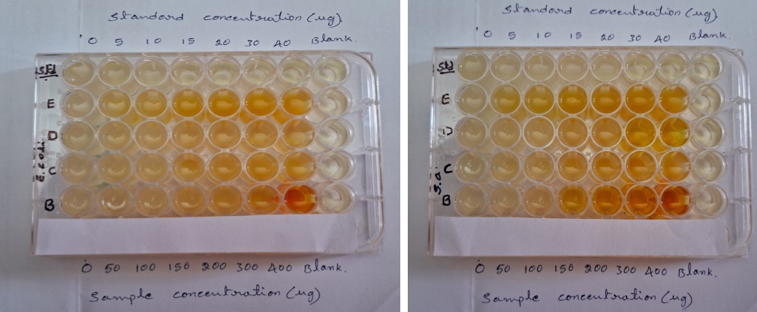
Figure S19: Images of antibacterial activity of synthesized azo dyes 1(a-d) against strains E. coli (a) S. aureus (b).
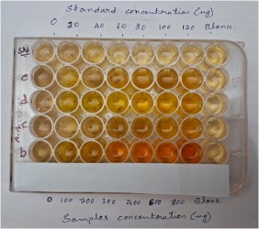
Figure S20: MIC image of fungus A. flavus against synthesized compounds 1(a-d)
Table S2: Results of in silico molecular docking study of synthesized azo dyes 1(a-d) and kanamycin against DNA gyrase protein for antibacterial activity.
Compounds | No. of H- bonds | H-Bond Length (A⁰) | H-Bond with residue | Hydrophobic interactions | Binding  Energy (kcal/mol)
1a | 2 | 2.31  3.29 | GLY 125  ARG144 | ASP57,ALA61,SER45 | -6.4
1b | 3 | 2.55  3.34  3.38 | TYR 171  ASN65  TYR63 | LYS170, GLY83 ASN82, GLY62, ALN64,GLY83 | -6.3
1c | 1 | 2.17 | ARG144 |  | -7.0
1d | 2 | 2.87  2.94 | THR173  GLY125 | GLU58 | -7.2
Kanamycin | 7 | 2.96  2.84  2.84  2.56  2.56  2.51  2.45 | ARG144  GLU58  ASP89  ASN54  ASP81 |  | -9.3

Table S3: In silico molecular docking results of synthesized azo dyes 1(a-d) and Std. fluconazole against target protein omt-1.
Compounds | No. of H- bonds | H-Bond Length (A⁰) | H-Bond with residue | Hydrophobic interactions | Binding  Energy (kcal/mol)
1a | 5 | 2.74  2.62  2.16  2.15  1.90 | GLN34  GLN53  TYR35  ARG31 | -- | -5.9
1b | 1 | 3.01 | HIS277 | GLU151, PHE176, HIS177 | -6.5
1c | 1 | 3.03 | LYS167 | ASN170, ALA144, ASP147, ASN170 | -7.6
1d | 1 | 2.57 | TRP333 | ALA29, ASP28 | -6.5
Fluconazole | 4 | 2.63  2.09  2.03  2.02 | GLN355  LYS349  GLN355 | GLU328, PRO326, ALA331, GLU333. | -5.6

