Heat-triggered Dynamic Self-healing Framework for Variable-temperature Stable Perovskite Solar Cells

Table of contents
Supplementary Note 1-4
Supplementary Figure 1-23
Supplementary Table 1

Supplementary Note 1. Space Charge Limited Current (SCLC) analysis
The trap density was calculated according to the equation: V_{TFL}=qn_{trap}L²/2ε₀ε
where V_{TEL} is the trap-filled limiting voltage, q is the elementary charge, L is the perovskite film thickness, ε₀ is the vacuum constant and ε is the dielectric constant of perovskite.

Supplementary Note 2. Thermal Admittance Spectroscopy (TAS) analysis
The trap density of trap states: N_{t}=$-\frac{Vbi}{qW}\frac{dc}{dw}\frac{ω}{KT}$
Where V_{bi}, q, W, C, $ω$, K, and T correspond to the following physical quantities: the built-in potential, elementary charge, depletion width, capacitance, angular frequency, Boltzmann constant, and temperature, respectively.

Supplementary Note 3. The dependence of V_{OC} and J_{SC} of PSCs on light intensity analysis
- Diode ideal factor n was obtained via the formula: n=$\frac{q}{kT}\frac{dV_{OC}}{dln(Ф)}$
Where K is the Boltzmann constant, T is the absolute temperature and q is the elementary charge. $\frac{dV_{OC}}{dln(Ф)}$ refers to the fitting slope of V_{OC} versus the logarithm of light intensity.

- Bimolecular recombination can be reflected by a log-log plot of J_{SC} versus incident light intensity (I), the relationship is according to the equation: J_{SC}∝I^{α}.

Supplementary Note 4. The maximum photoinduced carrier generation rate (G_{max}) and charge collection probability (P_{c}) analysis
photocurrent density J_{ph} is calculated by

J_{ph}=J_{L}-J_{D} (1)
where J_{L} and J_{D} are referring to the current density under illumination (100 mW/cm²) and in the dark, respectively
internal voltage (V_{int}) is calculated by
V_{int}=V_{bi}-V_{app} (2)

where V_{bi} is the built-in potential, and V_{app} is the applied voltage.
J_{ph} increases continuously at low voltage, and then tends to saturation, where the saturation photocurrent (J_{ph,sat}) is only limited by the number of absorbed photons.
Therefore, (J_{ph,sat}) can be described by
J_{ph,sat}=qLG_{max} (3)
where q is the elementary charge, L is the thickness of perovskite film, and G_{max} is the maximum photoinduced carrier generation rate per unit volume.
J_{ph} is also determined by
J_{ph}=qLG_{max}P_{c} (4)
Where Pc is the charge collection probability,
Combined with the above formulas,
P_{c} =J_{ph}/J_{ph,sat} (5)

Supplementary Fig.1. Transmittance FT-IR spectra of APD, TPA, and HDSF.

Supplementary Fig. 2. N1s XPS spectra of PVK films without a) and with b) HDSF.

Supplementary Fig. 3. Top-view SEM images of a) control PVK, and b) PVK: HDSF films.Statistic grain size distribution histograms of c) control and d) HDSF-treated perovskite films.

Supplementary Fig. 4. GIWAXS patterns of perovskite films surface: a) Control PVK, and b) PVK: HDSF films at incident angles of 0.15°.

Supplementary Fig. 5. Azimuthally integrated 1D (out-of-plane direction, azimuth=90°) of PVK films at incident angles of a) 0.4° and b) 0.15°.
Supplementary Fig. 6. XRD patterns of PVK films with and without HDSF.

Supplementary Fig. 7. SCLC curves for the a) electron-only and b) hole-only devices.

Supplementary Fig. 8. Electrical impedance spectra for devices, and the internal illustration includes the corresponding equivalent circuit diagram along with an enlarged view of R_{tra}.

Supplementary Fig. 9. J_{SC} versus light intensity plots for devices.

Supplementary Fig. 10. PL spectra of PVK films with or without HDSF.

Supplementary Fig. 11. TRPL spectra of PVK with or without HDSF coated on glass.

Supplementary Fig. 12. The schematic of the sample structure (FTO/SAM/PVK with or without HDSF) for the TA measurement, a 400 nm pump laser was used to probe the TA signal.

Supplementary Fig. 13. The pseudocolor TA spectrum of a) FTO/SAM/PVK/PCBM, b) FTO/SAM/PVK: HDSF/PCBM.

Supplementary Fig. 14. The normalized TA kinetic traces for photobleaching probed at 760 nm for the semi-devices based on corresponding perovskite films.

Supplementary Fig. 15. TPC measurements of devices with or without HDSF.

Supplementary Fig. 16. Dark J-V curves of the corresponding devices.

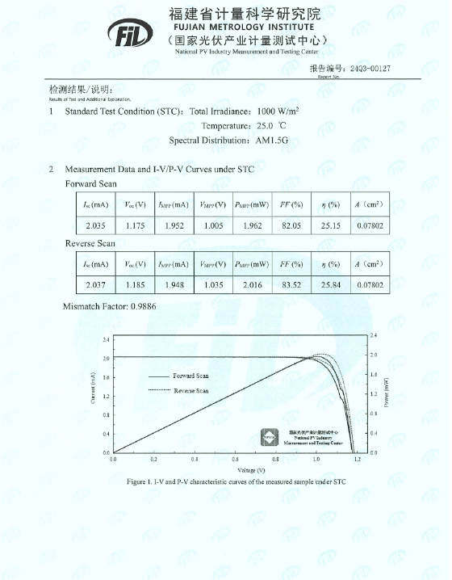
Supplementary Fig. 17. Certified performance of the HDSF-treated PSC. The certified efficiency is 25.84% under reverse scan (short-circuit current (I_{SC}) of 2.037 mA, V_{OC} of 1.185 V, and FF of 83.52%).

Supplementary Fig. 18. Mott–Schottky plots of devices with or without HDSF.

Supplementary Fig. 19. EQE spectra and integrated J_{SC} for devices.

Supplementary Fig. 20. Statistic box charts of a) PCE, b) FF, c) J_{SC}, and d) V_{OC} distribution of 20 devices per type.

Supplementary Fig. 21. Stabilized power output (SPO) at maximum-power point tracking under working conditions with 100 mW cm⁻² irradiation.

Supplementary Fig. 22. Statistical temperature-dependence profiles of a) FF, b) J_{SC}, c) V_{OC} for control devices, and d) FF, e) J_{SC}, and f) V_{OC} for HDSF-treated devices.

Supplementary Fig. 23. Thermal stability test of the unencapsulated devices at 85℃ in a nitrogen atmosphere.

Supplementary Table 1. The fitted parameters from TRPL curves of perovskite films. The average PL lifetime $τ_{ave}=\frac{A_{1}τ_{1}^{2}+A_{2}τ_{2}^{2}}{A_{1}τ_{1}+A_{2}τ_{2}}$.

Sample | A₁ | $τ_{1}$(ns） | A₂ | $τ_{2}$ (ns) | T_{ave}
Control | 5.81 | 8.00 | 0.76 | 104.50 | 68.98
HDSF | 20.51 | 4.03 | 1.69 | 185.61 | 147.74

