SUPPLEMENTARY MATERIAL

Sustainable bioprocess for efficient xylitol production from pistachio shell hydrolysate by Candida tropicalis in bioreactor and crystallization
Filiz Hazal^{1,} *, Hatice Neval Özbek¹, Murat Yılmaztekin², Fahrettin Göğüş¹, Derya Koçak Yanık³
¹Department of Food Engineering, Engineering Faculty, University of Gaziantep, 27310, Gaziantep, Türkiye
²Department of Food Engineering, Engineering Faculty, İnönü University, Malatya 44000, Türkiye
³Department of Food Engineering, Faculty of Agriculture, Eskisehir Osmangazi University, Eskisehir 26160, Türkiye

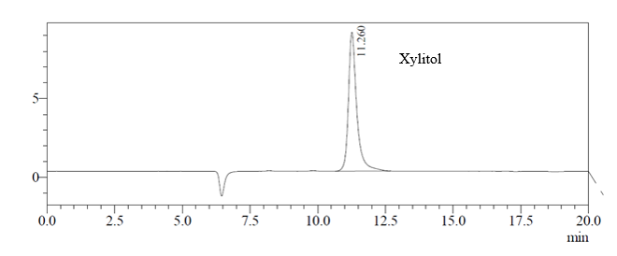
Fig. S1. HPLC chromatogram showing crystal purity

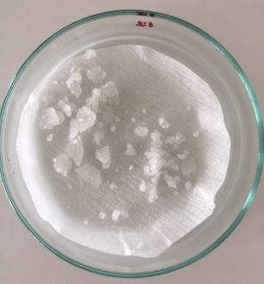

Fig. S2 Xylitol crystals obtained after crystallization

