Supplementary Information

The information of Human Cytokine Array

The information of NRF2 pathway PCR ARRAY
The information of Western blot membranes
For the Western blot analysis, after transferred to the PVDF membrane and blocking, the membrane were cut prior to hybridization with primary antibodies. The cut size of membranes was following the prestained protein marker (Bio-Rad, USA). For Nrf-2 (97-100 kDa), the cut size was above 75 kDa; the Keap1 (60-64 kDa) was 37-75 kDa; the NQO-1 (29 kDa) was below 37 kDa; the HO-1 (28 kDa) was below 50 kDa; the CAT (60 kDa) was 50-75 kDa and the GAPDH (37 kDa) was below 50 kDa. The final images were captured with Doc Molecular Imager (Bio-Rad, USA) from 30 - 300 sec.
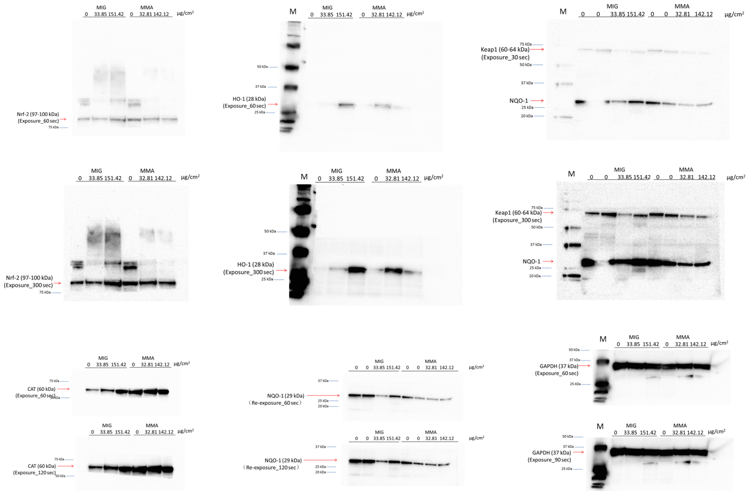
M: Marker; MIG: samples of melt inert gas welding; MMA: samples of manual metal arc welding
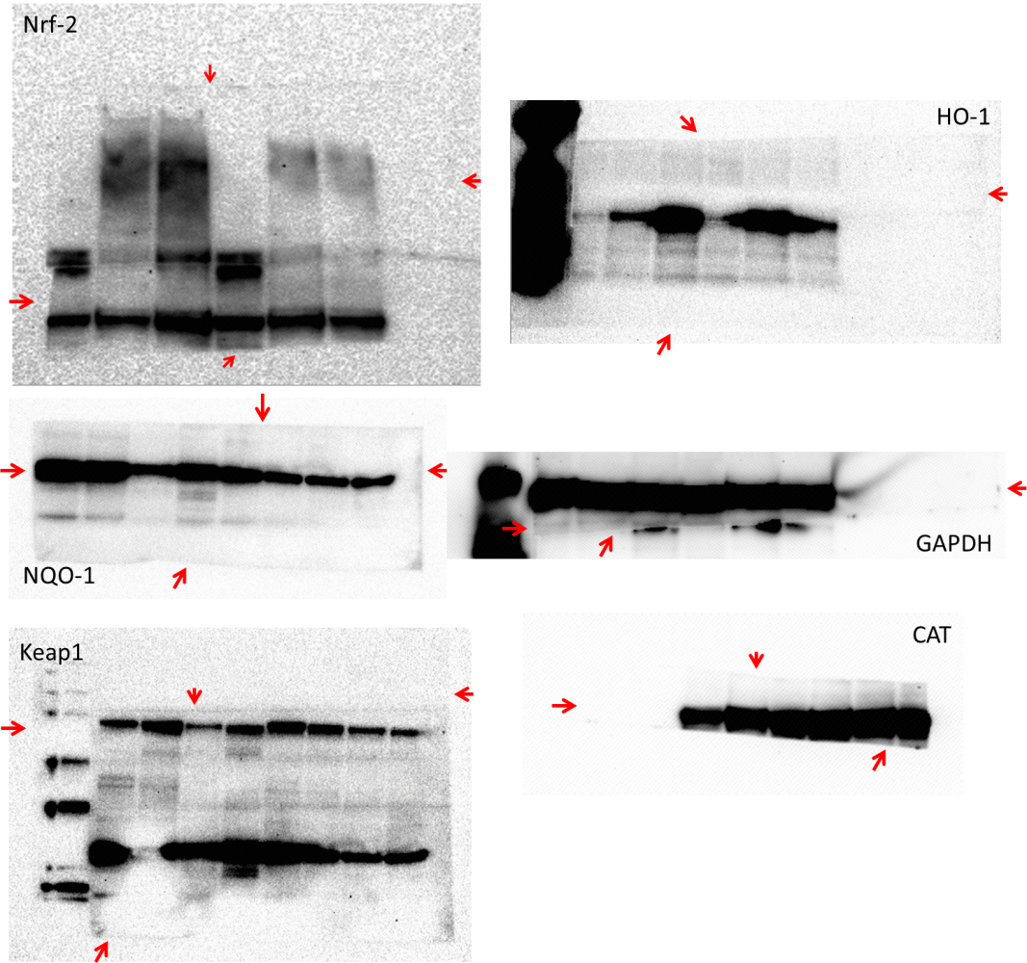
Red arrow: the edges of membranes
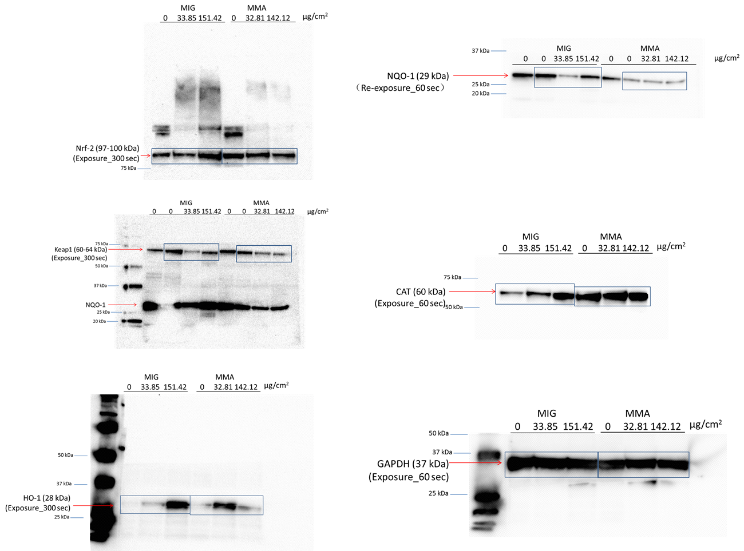
Blue square: the cut sides in manuscript

