Supplementary Material
  - Economic impact of labor productivity losses induced by heat stress: an agent-based macroeconomic approach

Industry-specific labor intensity
There are already several papers evaluating the impact of heat stress on the economy, but only a few focus on sector-disaggregated values for the reduction of labor productivity. Szewczyk et al. (2021) define four occupational groups regarding the definitions of the International Standard Classification of Occupations (ISCO) which they assign working intensities of low, medium, and high, and furthermore adding the fourth category of clerical work with a working intensity below 200W and minimal impact of heat stress. LFS data is used to identify the regional distribution of the four occupational groups, and the economic impact of productivity losses is quantified with a country-specific Solow growth model (Szewczyk, Mongelli, and Ciscar 2021). Therefore, no insights can be drawn on which sectors are specifically affected by heat stress, and a distinction between indoor and outdoor work is also not considered. Although the average work activity in an industry can vary greatly as Szewczyk et al. (2021) also mention, for this study we assume that we can attribute an average value of work intensity to a specific industry, which includes the different activities. This is also done by Costa et al. (2016) and Stalhandske et al. (2022).
To analyze the effects of excessive heat stress on labor productivity between different cities, Costa et al. (2016) assign five different working intensities to the NACE codes and compare the effects on the economy between the three cities London (United Kingdom), Bilbao (Spain), and Antwerp (Belgium). To be able to evaluate a sector-aggregated distinction between the cities, the NACE codes are summarized into seven groups (agriculture, manufacturing, other industry, information and communication, construction, wholesale and trade, financial and insurance activities, public administration, and defense), and an average labor intensity is assigned to each of them (Costa et al. 2016). In doing so, they refer to the threshold values used in the ISO standards, which are also used for this paper, but additionally classify two intensities in between, which serve as gap fillers. As in other studies, the agriculture and construction industry are classified as those with the highest level of labor intensity (415W) and as performed outdoor. Due to the rough classification and the incomprehensible assessments, we have decided to use the classifications by Costa et al. (2016) as a frame of reference, but to use different approximations for some industries based on Stalhandske et al. (2022) and Poulianiti et al. (2018), as well as to adhere to the three labor intensities classified by ISO 7243. Nevertheless, the comparison of the different cities made by Costa et al. (2016) can already show the impact of sectoral distinctions in different national economies on the respective susceptibility to heat effects and the benefits of sector-aggregated exposure-response functions.
To estimate the economic consequences related to the decline in labor productivity in Switzerland due to the increase in heat stress measured in WBGT caused by climate change, Stalhandske et al. (2022) assign a decline in labor productivity to the respective NACE codes based on ISO 7243 and weighted with the average salaries of the corresponding industry and their geographical distribution in Switzerland (Stalhandske et al. 2022: 4). The three categories low (200W), medium (300W) and high (400W) work intensities are assigned to the NACE codes as well as a differentiation if they are expected to appear outdoor or indoor. A comparison between the classifications made by Stalhandske et al. (2022) and Costa et al. (2016) reveals that different assumptions are made for a considerable number of industries, which could also be grounded in the different country contexts of the studies.
These classifications were compared with the metabolic rate values collected by Poulianti et al. (2018). This meta study provides a list of work intensity measurements for activities included in tourism, agriculture, construction, manufacturing and transportation (Poulianiti, Havenith, and Flouris 2018). 61 studies on labor intensity with a total of 1667 workers in the period from 1909 to 2017 were evaluated and assigned to each NACE code across the five industries (Poulianiti, Havenith, and Flouris 2018: 285). Since the studies considered cover a very broad period, not all activities in an industry are represented in the studies, there are geographical differences between the production processes and thus also the associated physical use of labor and the degree of technologization, these values cannot be adopted directly. Nevertheless, they provide valuable insights into the work intensity of activities in relation to the aggregation into NACE codes and vary in many aspects compared to the estimations drawn by Costa et al. (2016) and Stalhandske et al. (2022).
The comparison of work intensity aggregations reveals inevitable variations in labor intensity estimates across different activities within NACE codes. Drawing from these insights, this paper addresses considerations for Austria's NACE codes, including automation levels, heat exposure in indoor manufacturing, air-conditioning availability, and work clothing standards affecting heat stress on workers. Particularly in manufacturing, assumptions about heat stress exposure based on metabolic rates differ from Stalhandske et al. (2022). While they classify manufacturing as medium intensity with a 300 W metabolic rate indoors, this paper evaluates NACE REV.2 sectors in detail, considering additional reference values from Poulianti et al. (2018: 289) alongside our own assessments.
The industries where our classification as heavy work and outdoor corresponds to Stalhandske et al. (2022) are agriculture, forestry, and fishing (A01-A03) and the construction industry (F). We further classify the three industries “manufacture of paper and paper products (C17)”, “manufacture of coke and refined petroleum products (C19)” and “manufacture of basic metals (C24)” as heavy but indoor work, since they include production processes where already under normal conditions the workers are influenced by excessive heat through radiant heat by machineries with specific working clothes worn. In contrast, some manufacturing sectors where the production process is assumed to be highly automatized and there is a prevalence of air conditioning systems are classified as light work and indoor. Additionally, we classified the health care and social work sector (Q86-Q88) as moderate instead of light work to account for the physical and non-automated work in the health care sector which is mostly carried out under unfavorable climate conditions.
We use the categorization made by Stalhandske et al. (2022) for a sensitivity analysis to compare it with our own considerations made about the work intensity. This gives us two different estimates of labor intensity in many of the relevant industries. We use both estimates to examine the inevitable estimations made and thus simultaneously draw attention to the effects of the degree of technologization and possible adjustment measures within the respective industries. The following sections show the results for the two different estimations based on the Data extracted from the Work Place Heat Assessment Tool (WorkHeat) that is provided by the www.ClimateCHIP.org Web platform (ClimateCHIP 2024).

ABM Model
Figure 1: Outline of the ABM
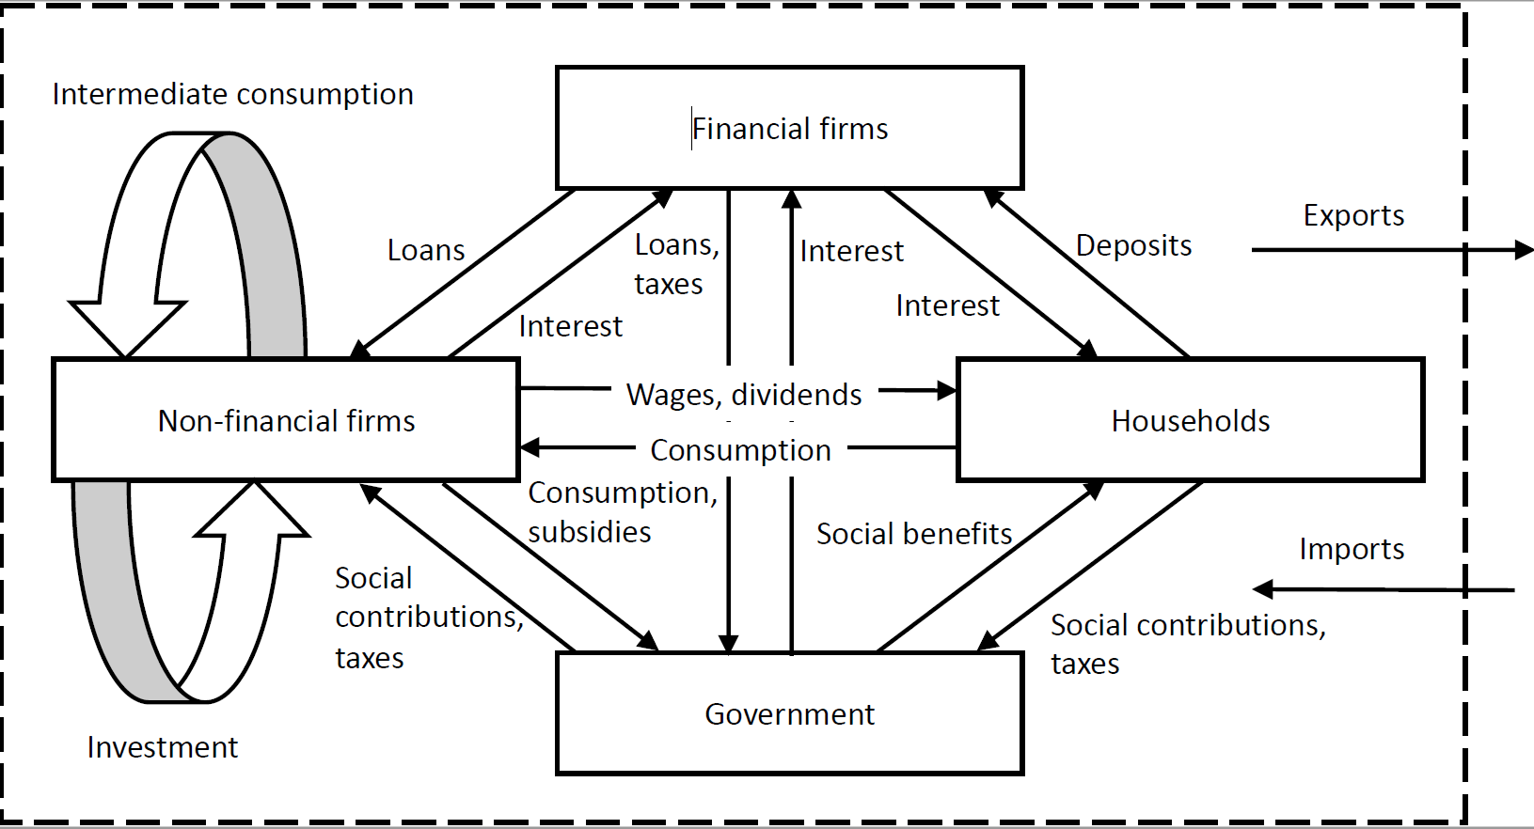

Labor productivity loss for climate scenario 2011-2040, based on Eurostat
Table 1: Labor productivity loss for climate scenario 2011-2040, based on Eurostat
NACE-sector |  |  | Own classification |  |  |  |  |  |  | Classification by Stalhandkse et al. (2022)
 |  |  | Sun  exposure | Work intensity | Productivity loss |  |  |  |  | Sun exposure | Work intensity | Productivity loss
 |  |  | Sun  exposure | Work intensity | Q1 | Q2 | Q3 | Q4 |  | Sun exposure | Work intensity | Q1 | Q2 | Q3 | Q4
A01 | Crop and animal production, hunting and related service activities |  | Sun | Heavy | 0.00% | 0.34% | 0.97% | 0.00% |  | Sun | Heavy | 0.00% | 0.34% | 0.97% | 0.00%
A02 | Forestry and logging |  | Sun | Heavy | 0.00% | 0.34% | 0.97% | 0.00% |  | Sun | Heavy | 0.00% | 0.34% | 0.97% | 0.00%
A03 | Fishing and aquaculture |  | Sun | Heavy | 0.00% | 0.34% | 0.97% | 0.00% |  | Sun | Heavy | 0.00% | 0.34% | 0.97% | 0.00%
B | Mining and quarrying |  | Sun | Heavy | 0.00% | 0.33% | 0.94% | 0.00% |  | Sun | Heavy | 0.00% | 0.33% | 0.94% | 0.00%
C10-12 | Manufacture of food products; beverages and tobacco products |  | Shade | Light | 0.00% | 0.01% | 0.03% | 0.00% |  | Shade | Moderate | 0.00% | 0.04% | 0.14% | 0.00%
C13-15 | Manufacture of textiles, wearing apparel, leather and related products |  | Shade | Light | 0.00% | 0.01% | 0.02% | 0.00% |  | Shade | Moderate | 0.00% | 0.03% | 0.11% | 0.00%
C16 | Manufacture of wood and of products of wood and cork, except furniture; manufacture of articles of straw and plaiting materials |  | Shade | Moderate | 0.00% | 0.03% | 0.11% | 0.00% |  | Shade | Moderate | 0.00% | 0.03% | 0.11% | 0.00%
C17 | Manufacture of paper and paper products |  | Shade | Heavy | 0.00% | 0.10% | 0.35% | 0.00% |  | Shade | Moderate | 0.00% | 0.04% | 0.14% | 0.00%
C18 | Printing and reproduction of recorded media |  | Shade | Light | 0.00% | 0.01% | 0.03% | 0.00% |  | Shade | Moderate | 0.00% | 0.04% | 0.14% | 0.00%
C19 | Manufacture of coke and refined petroleum products |  | Shade | Heavy | 0.00% | 0.16% | 0.57% | 0.00% |  | Shade | Moderate | 0.00% | 0.06% | 0.22% | 0.00%
C20 | Manufacture of chemicals and chemical products |  | Shade | Moderate | 0.00% | 0.05% | 0.18% | 0.00% |  | Shade | Moderate | 0.00% | 0.05% | 0.18% | 0.00%
C21 | Manufacture of basic pharmaceutical products and pharmaceutical preparations |  | Shade | Moderate | 0.00% | 0.04% | 0.15% | 0.00% |  | Shade | Moderate | 0.00% | 0.04% | 0.15% | 0.00%
C22 | Manufacture of rubber and plastic products |  | Shade | Moderate | 0.00% | 0.04% | 0.15% | 0.00% |  | Shade | Moderate | 0.00% | 0.04% | 0.15% | 0.00%
C23 | Manufacture of other non-metallic mineral products |  | Shade | Light | 0.00% | 0.01% | 0.03% | 0.00% |  | Shade | Moderate | 0.00% | 0.03% | 0.12% | 0.00%
C24 | Manufacture of basic metals |  | Shade | Heavy | 0.00% | 0.10% | 0.37% | 0.00% |  | Shade | Moderate | 0.00% | 0.04% | 0.15% | 0.00%
C25 | Manufacture of fabricated metal products, except machinery and equipment |  | Shade | Light | 0.00% | 0.01% | 0.03% | 0.00% |  | Shade | Moderate | 0.00% | 0.03% | 0.12% | 0.00%
C26 | Manufacture of computer, electronic and optical products |  | Shade | Light | 0.00% | 0.01% | 0.02% | 0.00% |  | Shade | Moderate | 0.00% | 0.02% | 0.10% | 0.00%

NACE code |  |  | Own classification |  |  |  |  |  |  | Classification by Stalhandkse et al. (2022)
 |  |  | Sun  exposure | Work intensity | Productivity loss |  |  |  |  | Sun exposure | Work intensity | Productivity loss
 |  |  | Sun  exposure | Work intensity | Q1 | Q2 | Q3 | Q4 |  | Sun exposure | Work intensity | Q1 | Q2 | Q3 | Q4
C27 | Manufacture of electrical equipment |  | Shade | Light | 0.00% | 0.01% | 0.03% | 0.00% |  | Shade | Moderate | 0.00% | 0.04% | 0.15% | 0.00%
C28 | Manufacture of machinery and equipment n.e.c. |  | Shade | Light | 0.00% | 0.01% | 0.03% | 0.00% |  | Shade | Moderate | 0.00% | 0.04% | 0.14% | 0.00%
C29 | Manufacture of motor vehicles, trailers and semi-trailers |  | Shade | Light | 0.00% | 0.01% | 0.03% | 0.00% |  | Shade | Moderate | 0.00% | 0.04% | 0.14% | 0.00%
C30 | Manufacture of other transport equipment |  | Shade | Light | 0.00% | 0.02% | 0.06% | 0.00% |  | Shade | Moderate | 0.00% | 0.06% | 0.22% | 0.00%
C31-32 | Manufacture of furniture; other manufacturing |  | Shade | Light | 0.00% | 0.01% | 0.03% | 0.00% |  | Shade | Moderate | 0.00% | 0.04% | 0.14% | 0.00%
C33 | Repair and installation of machinery and equipment |  | Shade | Moderate | 0.00% | 0.04% | 0.17% | 0.00% |  | Shade | Moderate | 0.00% | 0.04% | 0.17% | 0.00%
D35 | Electricity, gas, steam and air conditioning supply |  | Shade | Light | 0.00% | 0.01% | 0.03% | 0.00% |  | Sun | Moderate | 0.00% | 0.19% | 0.52% | 0.00%
E36 | Water collection, treatment and supply |  | Shade | Light | 0.00% | 0.01% | 0.04% | 0.00% |  | Sun | Moderate | 0.00% | 0.21% | 0.61% | 0.00%
E37-39 | Sewerage, waste management, remediation activities |  | Sun | Moderate | 0.00% | 0.21% | 0.58% | 0.00% |  | Sun | Moderate | 0.00% | 0.21% | 0.58% | 0.00%
F | Construction |  | Sun | Heavy | 0.00% | 0.39% | 1.09% | 0.00% |  | Sun | Heavy | 0.00% | 0.39% | 1.09% | 0.00%
G45 | Wholesale and retail trade and repair of motor vehicles and motorcycles |  | Shade | Light | 0.00% | 0.01% | 0.03% | 0.00% |  | Shade | Moderate | 0.00% | 0.04% | 0.15% | 0.00%
G46 | Wholesale trade, except of motor vehicles and motorcycles |  | Shade | Light | 0.00% | 0.01% | 0.04% | 0.00% |  | Shade | Moderate | 0.00% | 0.04% | 0.17% | 0.00%
G47 | Retail trade, except of motor vehicles and motorcycles |  | Shade | Light | 0.00% | 0.01% | 0.04% | 0.00% |  | Shade | Moderate | 0.00% | 0.04% | 0.15% | 0.00%
H49 | Land transport and transport via pipelines |  | Shade | Light | 0.00% | 0.01% | 0.04% | 0.00% |  | Sun | Moderate | 0.00% | 0.20% | 0.57% | 0.00%
H50 | Water transport |  | Shade | Light | 0.00% | 0.02% | 0.04% | 0.00% |  | Shade | Moderate | 0.00% | 0.05% | 0.19% | 0.00%
H51 | Air transport |  | Shade | Light | 0.00% | 0.01% | 0.04% | 0.00% |  | Shade | Moderate | 0.00% | 0.05% | 0.20% | 0.00%
H52 | Warehousing and support activities for transportation |  | Shade | Light | 0.00% | 0.01% | 0.04% | 0.00% |  | Shade | Moderate | 0.00% | 0.04% | 0.16% | 0.00%
H53 | Postal and courier activities |  | Sun | Moderate | 0.00% | 0.22% | 0.60% | 0.00% |  | Sun | Moderate | 0.00% | 0.22% | 0.60% | 0.00%
I | Accommodation and food service activities |  | Shade | Light | 0.00% | 0.01% | 0.03% | 0.00% |  | Shade | Moderate | 0.00% | 0.03% | 0.13% | 0.00%
J58 | Publishing activities |  | Shade | Light | 0.00% | 0.02% | 0.05% | 0.00% |  | Shade | Light | 0.00% | 0.02% | 0.05% | 0.00%
J59-60 | Motion picture, video, television programme production; programming and broadcasting activities |  | Shade | Light | 0.00% | 0.02% | 0.04% | 0.00% |  | Shade | Light | 0.00% | 0.02% | 0.04% | 0.00%

NACE code |  |  | Own classification |  |  |  |  |  |  | Classification by Stalhandkse et al. (2022)
 |  |  | Sun  exposure | Work intensity | Productivity loss |  |  |  |  | Sun exposure | Work intensity | Productivity loss
 |  |  | Sun  exposure | Work intensity | Q1 | Q2 | Q3 | Q4 |  | Sun exposure | Work intensity | Q1 | Q2 | Q3 | Q4
J61 | Telecommunications |  | Shade | Light | 0.00% | 0.03% | 0.05% | 0.00% |  | Shade | Light | 0.00% | 0.03% | 0.05% | 0.00%
J62-63 | Computer programming, consultancy, and information service activities |  | Shade | Light | 0.00% | 0.02% | 0.05% | 0.00% |  | Shade | Light | 0.00% | 0.02% | 0.05% | 0.00%
K64 | Financial service activities, except insurance and pension funding |  | Shade | Light | 0.00% | 0.01% | 0.04% | 0.00% |  | Shade | Light | 0.00% | 0.01% | 0.04% | 0.00%
K65 | Insurance, reinsurance and pension funding, except compulsory social security |  | Shade | Light | 0.00% | 0.01% | 0.04% | 0.00% |  | Shade | Light | 0.00% | 0.01% | 0.04% | 0.00%
K66 | Activities auxiliary to financial services and insurance activities |  | Shade | Light | 0.00% | 0.01% | 0.04% | 0.00% |  | Shade | Light | 0.00% | 0.01% | 0.04% | 0.00%
L68 | Real estate activities |  | Shade | Light | 0.00% | 0.02% | 0.04% | 0.00% |  | Shade | Light | 0.00% | 0.02% | 0.04% | 0.00%
M69-70 | Legal and accounting activities; activities of head offices; management consultancy activities |  | Shade | Light | 0.00% | 0.02% | 0.04% | 0.00% |  | Shade | Light | 0.00% | 0.02% | 0.04% | 0.00%
M71 | Architectural and engineering activities; technical testing and analysis |  | Shade | Light | 0.00% | 0.01% | 0.04% | 0.00% |  | Shade | Light | 0.00% | 0.01% | 0.04% | 0.00%
M72 | Scientific research and development |  | Shade | Light | 0.00% | 0.02% | 0.04% | 0.00% |  | Shade | Light | 0.00% | 0.02% | 0.04% | 0.00%
M73 | Advertising and market research |  | Shade | Light | 0.00% | 0.02% | 0.04% | 0.00% |  | Shade | Light | 0.00% | 0.02% | 0.04% | 0.00%
M74-75 | Other professional, scientific and technical activities; veterinary activities |  | Shade | Light | 0.00% | 0.02% | 0.04% | 0.00% |  | Shade | Light | 0.00% | 0.02% | 0.04% | 0.00%
N77 | Rental and leasing activities |  | Shade | Light | 0.00% | 0.01% | 0.04% | 0.00% |  | Shade | Light | 0.00% | 0.01% | 0.04% | 0.00%
N78 | Employment activities |  | Shade | Light | 0.00% | 0.01% | 0.04% | 0.00% |  | Shade | Light | 0.00% | 0.01% | 0.04% | 0.00%
N79 | Travel agency, tour operator reservation service and related activities |  | Shade | Light | 0.00% | 0.01% | 0.04% | 0.00% |  | Shade | Light | 0.00% | 0.01% | 0.04% | 0.00%
N80-82 | Security and investigation, service and landscape, office administrative and support activities |  | Shade | Light | 0.00% | 0.02% | 0.04% | 0.00% |  | Shade | Light | 0.00% | 0.02% | 0.04% | 0.00%
O84 | Public administration and defence; compulsory social security |  | Shade | Light | 0.00% | 0.01% | 0.04% | 0.00% |  | Shade | Light | 0.00% | 0.01% | 0.04% | 0.00%
P85 | Education |  | Shade | Light | 0.00% | 0.01% | 0.04% | 0.00% |  | Shade | Light | 0.00% | 0.01% | 0.04% | 0.00%
Q86 | Human health activities |  | Shade | Moderate | 0.00% | 0.04% | 0.16% | 0.00% |  | Shade | Light | 0.00% | 0.01% | 0.04% | 0.00%
Q87-88 | Residential care activities and social work activities without accommodation |  | Shade | Moderate | 0.00% | 0.04% | 0.16% | 0.00% |  | Shade | Light | 0.00% | 0.01% | 0.04% | 0.00%

NACE code |  |  | Own classification |  |  |  |  |  |  | Classification by Stalhandkse et al. (2022)
 |  |  | Sun  exposure | Work intensity | Productivity loss |  |  |  |  | Sun  exposure | Work intensity | Productivity loss
 |  |  | Sun  exposure | Work intensity | Q1 | Q2 | Q3 | Q4 |  | Sun  exposure | Work intensity | Q1 | Q2 | Q3 | Q4
R90-92 | Creative, arts and entertainment activities; libraries, archives, museums and other cultural activities; gambling and betting activities |  | Shade | Light | 0.00% | 0.01% | 0.04% | 0.00% |  | Shade | Light | 0.00% | 0.01% | 0.04% | 0.00%
R93 | Sports activities and amusement and recreation activities |  | Sun | Light | 0.00% | 0.06% | 0.19% | 0.00% |  | Shade | Light | 0.00% | 0.01% | 0.04% | 0.00%
S94 | Activities of membership organisations |  | Shade | Light | 0.00% | 0.01% | 0.04% | 0.00% |  | Shade | Light | 0.00% | 0.01% | 0.04% | 0.00%
S95 | Repair of computers and personal and household goods |  | Shade | Light | 0.00% | 0.01% | 0.04% | 0.00% |  | Shade | Light | 0.00% | 0.01% | 0.04% | 0.00%
S96 | Other personal service activities |  | Shade | Light | 0.00% | 0.01% | 0.04% | 0.00% |  | Shade | Light | 0.00% | 0.01% | 0.04% | 0.00%

Labor productivity loss for climate scenario 2041-2070, based on Eurostat
Table 2: Labor productivity loss for climate scenario 2041-2070, based on Eurostat
NACE-code |  |  | Own classification |  |  |  |  |  |  | Classification by Stalhandkse et al. (2022)
 |  |  | Sun  exposure | Work intensity | Productivity loss |  |  |  |  | Sun exposure | Work intensity | Productivity loss
 |  |  | Sun  exposure | Work intensity | Q1 | Q2 | Q3 | Q4 |  | Sun exposure | Work intensity | Q1 | Q2 | Q3 | Q4
A01 | Crop and animal production, hunting and related service activities |  | Sun | Heavy | 0.71% | 2.51% | 0.00% | 0.00% |  | Sun | Heavy | 0.00% | 0.71% | 2.51% | 0.00%
A02 | Forestry and logging |  | Sun | Heavy | 0.71% | 2.51% | 0.00% | 0.00% |  | Sun | Heavy | 0.00% | 0.71% | 2.51% | 0.00%
A03 | Fishing and aquaculture |  | Sun | Heavy | 0.71% | 2.51% | 0.00% | 0.00% |  | Sun | Heavy | 0.00% | 0.71% | 2.51% | 0.00%
B | Mining and quarrying |  | Sun | Heavy | 0.69% | 2.41% | 0.00% | 0.00% |  | Sun | Heavy | 0.00% | 0.69% | 2.41% | 0.00%
C10-12 | Manufacture of food products; beverages and tobacco products |  | Shade | Light | 0.03% | 0.20% | 0.00% | 0.00% |  | Shade | Moderate | 0.00% | 0.12% | 0.65% | 0.00%
C13-15 | Manufacture of textiles, wearing apparel, leather and related products |  | Shade | Light | 0.02% | 0.15% | 0.00% | 0.00% |  | Shade | Moderate | 0.00% | 0.09% | 0.50% | 0.00%
C16 | Manufacture of wood and of products of wood and cork, except furniture; manufacture of articles of straw and plaiting materials |  | Shade | Moderate | 0.09% | 0.52% | 0.00% | 0.00% |  | Shade | Moderate | 0.00% | 0.09% | 0.52% | 0.00%
C17 | Manufacture of paper and paper products |  | Shade | Heavy | 0.25% | 1.19% | 0.00% | 0.00% |  | Shade | Moderate | 0.00% | 0.11% | 0.62% | 0.00%
C18 | Printing and reproduction of recorded media |  | Shade | Light | 0.03% | 0.20% | 0.00% | 0.00% |  | Shade | Moderate | 0.00% | 0.11% | 0.63% | 0.00%
C19 | Manufacture of coke and refined petroleum products |  | Shade | Heavy | 0.40% | 1.82% | 0.00% | 0.00% |  | Shade | Moderate | 0.00% | 0.18% | 0.96% | 0.00%
C20 | Manufacture of chemicals and chemical products |  | Shade | Moderate | 0.14% | 0.77% | 0.00% | 0.00% |  | Shade | Moderate | 0.00% | 0.14% | 0.77% | 0.00%
C21 | Manufacture of basic pharmaceutical products and pharmaceutical preparations |  | Shade | Moderate | 0.13% | 0.66% | 0.00% | 0.00% |  | Shade | Moderate | 0.00% | 0.13% | 0.66% | 0.00%
C22 | Manufacture of rubber and plastic products |  | Shade | Moderate | 0.12% | 0.67% | 0.00% | 0.00% |  | Shade | Moderate | 0.00% | 0.12% | 0.67% | 0.00%
C23 | Manufacture of other non-metallic mineral products |  | Shade | Light | 0.02% | 0.17% | 0.00% | 0.00% |  | Shade | Moderate | 0.00% | 0.10% | 0.55% | 0.00%
C24 | Manufacture of basic metals |  | Shade | Heavy | 0.26% | 1.25% | 0.00% | 0.00% |  | Shade | Moderate | 0.00% | 0.12% | 0.65% | 0.00%
C25 | Manufacture of fabricated metal products, except machinery and equipment |  | Shade | Light | 0.02% | 0.17% | 0.00% | 0.00% |  | Shade | Moderate | 0.00% | 0.10% | 0.56% | 0.00%
C26 | Manufacture of computer, electronic and optical products |  | Shade | Light | 0.02% | 0.14% | 0.00% | 0.00% |  | Shade | Moderate | 0.00% | 0.08% | 0.46% | 0.00%

NACE code |  |  | Own classification |  |  |  |  |  |  | Classification by Stalhandkse et al. (2022)
 |  |  | Sun  exposure | Work intensity | Productivity loss |  |  |  |  | Sun exposure | Work intensity | Productivity loss
 |  |  | Sun  exposure | Work intensity | Q1 | Q2 | Q3 | Q4 |  | Sun exposure | Work intensity | Q1 | Q2 | Q3 | Q4
C27 | Manufacture of electrical equipment |  | Shade | Light | 0.03% | 0.21% | 0.00% | 0.00% |  | Shade | Moderate | 0.00% | 0.12% | 0.67% | 0.00%
C28 | Manufacture of machinery and equipment n.e.c. |  | Shade | Light | 0.03% | 0.20% | 0.00% | 0.00% |  | Shade | Moderate | 0.00% | 0.11% | 0.61% | 0.00%
C29 | Manufacture of motor vehicles, trailers and semi-trailers |  | Shade | Light | 0.03% | 0.20% | 0.00% | 0.00% |  | Shade | Moderate | 0.00% | 0.11% | 0.63% | 0.00%
C30 | Manufacture of other transport equipment |  | Shade | Light | 0.05% | 0.31% | 0.00% | 0.00% |  | Shade | Moderate | 0.00% | 0.18% | 0.95% | 0.00%
C31-32 | Manufacture of furniture; other manufacturing |  | Shade | Light | 0.03% | 0.20% | 0.00% | 0.00% |  | Shade | Moderate | 0.00% | 0.11% | 0.64% | 0.00%
C33 | Repair and installation of machinery and equipment |  | Shade | Moderate | 0.14% | 0.74% | 0.00% | 0.00% |  | Shade | Moderate | 0.00% | 0.14% | 0.74% | 0.00%
D35 | Electricity, gas, steam and air conditioning supply |  | Shade | Light | 0.03% | 0.20% | 0.00% | 0.00% |  | Sun | Moderate | 0.00% | 0.42% | 1.56% | 0.00%
E36 | Water collection, treatment and supply |  | Shade | Light | 0.03% | 0.23% | 0.00% | 0.00% |  | Sun | Moderate | 0.00% | 0.47% | 1.77% | 0.00%
E37-39 | Sewerage, waste management, remediation activities |  | Sun | Moderate | 0.46% | 1.72% | 0.00% | 0.00% |  | Sun | Moderate | 0.00% | 0.46% | 1.72% | 0.00%
F | Construction |  | Sun | Heavy | 0.80% | 2.73% | 0.00% | 0.00% |  | Sun | Heavy | 0.00% | 0.80% | 2.73% | 0.00%
G45 | Wholesale and retail trade and repair of motor vehicles and motorcycles |  | Shade | Light | 0.03% | 0.21% | 0.00% | 0.00% |  | Shade | Moderate | 0.00% | 0.12% | 0.67% | 0.00%
G46 | Wholesale trade, except of motor vehicles and motorcycles |  | Shade | Light | 0.04% | 0.24% | 0.00% | 0.00% |  | Shade | Moderate | 0.00% | 0.14% | 0.74% | 0.00%
G47 | Retail trade, except of motor vehicles and motorcycles |  | Shade | Light | 0.03% | 0.22% | 0.00% | 0.00% |  | Shade | Moderate | 0.00% | 0.13% | 0.68% | 0.00%
H49 | Land transport and transport via pipelines |  | Shade | Light | 0.03% | 0.21% | 0.00% | 0.00% |  | Sun | Moderate | 0.00% | 0.45% | 1.68% | 0.00%
H50 | Water transport |  | Shade | Light | 0.04% | 0.26% | 0.00% | 0.00% |  | Shade | Moderate | 0.00% | 0.15% | 0.81% | 0.00%
H51 | Air transport |  | Shade | Light | 0.04% | 0.27% | 0.00% | 0.00% |  | Shade | Moderate | 0.00% | 0.16% | 0.87% | 0.00%
H52 | Warehousing and support activities for transportation |  | Shade | Light | 0.03% | 0.23% | 0.00% | 0.00% |  | Shade | Moderate | 0.00% | 0.13% | 0.71% | 0.00%
H53 | Postal and courier activities |  | Sun | Moderate | 0.48% | 1.77% | 0.00% | 0.00% |  | Sun | Moderate | 0.00% | 0.48% | 1.77% | 0.00%
I | Accommodation and food service activities |  | Shade | Light | 0.03% | 0.18% | 0.00% | 0.00% |  | Shade | Moderate | 0.00% | 0.11% | 0.59% | 0.00%
J58 | Publishing activities |  | Shade | Light | 0.04% | 0.27% | 0.00% | 0.00% |  | Shade | Light | 0.00% | 0.04% | 0.27% | 0.00%
J59-60 | Motion picture, video, television programme production; programming and broadcasting activities |  | Shade | Light | 0.04% | 0.25% | 0.00% | 0.00% |  | Shade | Light | 0.00% | 0.04% | 0.25% | 0.00%

NACE code |  |  | Own classification |  |  |  |  |  |  | Classification by Stalhandkse et al. (2022)
 |  |  | Sun  exposure | Work intensity | Productivity loss |  |  |  |  | Sun exposure | Work intensity | Productivity loss
 |  |  | Sun  exposure | Work intensity | Q1 | Q2 | Q3 | Q4 |  | Sun exposure | Work intensity | Q1 | Q2 | Q3 | Q4
J61 | Telecommunications |  | Shade | Light | 0.05% | 0.31% | 0.00% | 0.00% |  | Shade | Light | 0.00% | 0.05% | 0.31% | 0.00%
J62-63 | Computer programming, consultancy, and information service activities |  | Shade | Light | 0.04% | 0.27% | 0.00% | 0.00% |  | Shade | Light | 0.00% | 0.04% | 0.27% | 0.00%
K64 | Financial service activities, except insurance and pension funding |  | Shade | Light | 0.03% | 0.24% | 0.00% | 0.00% |  | Shade | Light | 0.00% | 0.03% | 0.24% | 0.00%
K65 | Insurance, reinsurance and pension funding, except compulsory social security |  | Shade | Light | 0.03% | 0.24% | 0.00% | 0.00% |  | Shade | Light | 0.00% | 0.03% | 0.24% | 0.00%
K66 | Activities auxiliary to financial services and insurance activities |  | Shade | Light | 0.03% | 0.24% | 0.00% | 0.00% |  | Shade | Light | 0.00% | 0.03% | 0.24% | 0.00%
L68 | Real estate activities |  | Shade | Light | 0.04% | 0.24% | 0.00% | 0.00% |  | Shade | Light | 0.00% | 0.04% | 0.24% | 0.00%
M69-70 | Legal and accounting activities; activities of head offices; management consultancy activities |  | Shade | Light | 0.04% | 0.25% | 0.00% | 0.00% |  | Shade | Light | 0.00% | 0.04% | 0.25% | 0.00%
M71 | Architectural and engineering activities; technical testing and analysis |  | Shade | Light | 0.03% | 0.22% | 0.00% | 0.00% |  | Shade | Light | 0.00% | 0.03% | 0.22% | 0.00%
M72 | Scientific research and development |  | Shade | Light | 0.04% | 0.26% | 0.00% | 0.00% |  | Shade | Light | 0.00% | 0.04% | 0.26% | 0.00%
M73 | Advertising and market research |  | Shade | Light | 0.04% | 0.26% | 0.00% | 0.00% |  | Shade | Light | 0.00% | 0.04% | 0.26% | 0.00%
M74-75 | Other professional, scientific and technical activities; veterinary activities |  | Shade | Light | 0.04% | 0.25% | 0.00% | 0.00% |  | Shade | Light | 0.00% | 0.04% | 0.25% | 0.00%
N77 | Rental and leasing activities |  | Shade | Light | 0.03% | 0.23% | 0.00% | 0.00% |  | Shade | Light | 0.00% | 0.03% | 0.23% | 0.00%
N78 | Employment activities |  | Shade | Light | 0.04% | 0.25% | 0.00% | 0.00% |  | Shade | Light | 0.00% | 0.04% | 0.25% | 0.00%
N79 | Travel agency, tour operator reservation service and related activities |  | Shade | Light | 0.03% | 0.22% | 0.00% | 0.00% |  | Shade | Light | 0.00% | 0.03% | 0.22% | 0.00%
N80-82 | Security and investigation, service and landscape, office administrative and support activities |  | Shade | Light | 0.04% | 0.25% | 0.00% | 0.00% |  | Shade | Light | 0.00% | 0.04% | 0.25% | 0.00%
O84 | Public administration and defence; compulsory social security |  | Shade | Light | 0.03% | 0.22% | 0.00% | 0.00% |  | Shade | Light | 0.00% | 0.03% | 0.22% | 0.00%
P85 | Education |  | Shade | Light | 0.03% | 0.22% | 0.00% | 0.00% |  | Shade | Light | 0.00% | 0.03% | 0.22% | 0.00%
Q86 | Human health activities |  | Shade | Moderate | 0.13% | 0.70% | 0.00% | 0.00% |  | Shade | Light | 0.00% | 0.03% | 0.22% | 0.00%
Q87-88 | Residential care activities and social work activities without accommodation |  | Shade | Moderate | 0.13% | 0.70% | 0.00% | 0.00% |  | Shade | Light | 0.00% | 0.03% | 0.22% | 0.00%

NACE code |  |  | Own classification |  |  |  |  |  |  | Classification by Stalhandkse et al. (2022)
 |  |  | Sun  exposure | Work intensity | Productivity loss |  |  |  |  | Sun  exposure | Work intensity | Productivity loss
 |  |  | Sun  exposure | Work intensity | Q1 | Q2 | Q3 | Q4 |  | Sun  exposure | Work intensity | Q1 | Q2 | Q3 | Q4
R90-92 | Creative, arts and entertainment activities; libraries, archives, museums and other cultural activities; gambling and betting activities |  | Shade | Light | 0.04% | 0.24% | 0.00% | 0.00% |  | Shade | Light | 0.00% | 0.04% | 0.24% | 0.00%
R93 | Sports activities and amusement and recreation activities |  | Sun | Light | 0.18% | 0.75% | 0.00% | 0.00% |  | Shade | Light | 0.00% | 0.04% | 0.24% | 0.00%
S94 | Activities of membership organisations |  | Shade | Light | 0.04% | 0.24% | 0.00% | 0.00% |  | Shade | Light | 0.00% | 0.04% | 0.24% | 0.00%
S95 | Repair of computers and personal and household goods |  | Shade | Light | 0.04% | 0.24% | 0.00% | 0.00% |  | Shade | Light | 0.00% | 0.04% | 0.24% | 0.00%
S96 | Other personal service activities |  | Shade | Light | 0.04% | 0.24% | 0.00% | 0.00% |  | Shade | Light | 0.00% | 0.04% | 0.24% | 0.00%

Labor productivity loss for climate scenario 2011-2040, based on Statistics Austria
Table 3: Labor productivity loss for climate scenario 2011-2040, based on Statistics Austria
NACE-sector |  |  | Own classification |  |  |  |  |  |  | Classification by Stalhandkse et al. (2022)
 |  |  | Sun  exposure | Work intensity | Productivity loss |  |  |  |  | Sun exposure | Work intensity | Productivity loss
 |  |  | Sun  exposure | Work intensity | Q1 | Q2 | Q3 | Q4 |  | Sun exposure | Work intensity | Q1 | Q2 | Q3 | Q4
A01 | Crop and animal production, hunting and related service activities |  | Sun | Heavy | 0.00% | 0.37% | 1.05% | 0.00% |  | Sun | Heavy | 0.00% | 0.37% | 1.05% | 0.00%
A02 | Forestry and logging |  | Sun | Heavy | 0.00% | 0.22% | 0.64% | 0.00% |  | Sun | Heavy | 0.00% | 0.22% | 0.64% | 0.00%
A03 | Fishing and aquaculture |  | Sun | Heavy | 0.00% | 0.29% | 0.83% | 0.00% |  | Sun | Heavy | 0.00% | 0.29% | 0.83% | 0.00%
B | Mining and quarrying |  | Sun | Heavy | 0.00% | 0.28% | 0.78% | 0.00% |  | Sun | Heavy | 0.00% | 0.28% | 0.78% | 0.00%
C10-12 | Manufacture of food products; beverages and tobacco products |  | Shade | Light | 0.00% | 0.01% | 0.03% | 0.00% |  | Shade | Moderate | 0.00% | 0.04% | 0.15% | 0.00%
C13-15 | Manufacture of textiles, wearing apparel, leather and related products |  | Shade | Light | 0.00% | 0.01% | 0.02% | 0.00% |  | Shade | Moderate | 0.00% | 0.03% | 0.11% | 0.00%
C16 | Manufacture of wood and of products of wood and cork, except furniture; manufacture of articles of straw and plaiting materials |  | Shade | Moderate | 0.00% | 0.02% | 0.09% | 0.00% |  | Shade | Moderate | 0.00% | 0.02% | 0.09% | 0.00%
C17 | Manufacture of paper and paper products |  | Shade | Heavy | 0.00% | 0.08% | 0.26% | 0.00% |  | Shade | Moderate | 0.00% | 0.03% | 0.10% | 0.00%
C18 | Printing and reproduction of recorded media |  | Shade | Light | 0.00% | 0.01% | 0.04% | 0.00% |  | Shade | Moderate | 0.00% | 0.04% | 0.16% | 0.00%
C19 | Manufacture of coke and refined petroleum products |  | Shade | Heavy | 0.00% | 0.20% | 0.68% | 0.00% |  | Shade | Moderate | 0.00% | 0.07% | 0.26% | 0.00%
C20 | Manufacture of chemicals and chemical products |  | Shade | Moderate | 0.00% | 0.05% | 0.18% | 0.00% |  | Shade | Moderate | 0.00% | 0.05% | 0.18% | 0.00%
C21 | Manufacture of basic pharmaceutical products and pharmaceutical preparations |  | Shade | Moderate | 0.00% | 0.04% | 0.15% | 0.00% |  | Shade | Moderate | 0.00% | 0.04% | 0.15% | 0.00%
C22 | Manufacture of rubber and plastic products |  | Shade | Moderate | 0.00% | 0.04% | 0.15% | 0.00% |  | Shade | Moderate | 0.00% | 0.04% | 0.15% | 0.00%
C23 | Manufacture of other non-metallic mineral products |  | Shade | Light | 0.00% | 0.01% | 0.02% | 0.00% |  | Shade | Moderate | 0.00% | 0.03% | 0.11% | 0.00%
C24 | Manufacture of basic metals |  | Shade | Heavy | 0.00% | 0.11% | 0.37% | 0.00% |  | Shade | Moderate | 0.00% | 0.04% | 0.15% | 0.00%
C25 | Manufacture of fabricated metal products, except machinery and equipment |  | Shade | Light | 0.00% | 0.01% | 0.03% | 0.00% |  | Shade | Moderate | 0.00% | 0.03% | 0.12% | 0.00%
C26 | Manufacture of computer, electronic and optical products |  | Shade | Light | 0.00% | 0.01% | 0.02% | 0.00% |  | Shade | Moderate | 0.00% | 0.02% | 0.09% | 0.00%

NACE code |  |  | Own classification |  |  |  |  |  |  | Classification by Stalhandkse et al. (2022)
 |  |  | Sun  exposure | Work intensity | Productivity loss |  |  |  |  | Sun exposure | Work intensity | Productivity loss
 |  |  | Sun  exposure | Work intensity | Q1 | Q2 | Q3 | Q4 |  | Sun exposure | Work intensity | Q1 | Q2 | Q3 | Q4
C27 | Manufacture of electrical equipment |  | Shade | Light | 0.00% | 0.01% | 0.04% | 0.00% |  | Shade | Moderate | 0.00% | 0.04% | 0.17% | 0.00%
C28 | Manufacture of machinery and equipment n.e.c. |  | Shade | Light | 0.00% | 0.01% | 0.03% | 0.00% |  | Shade | Moderate | 0.00% | 0.04% | 0.14% | 0.00%
C29 | Manufacture of motor vehicles, trailers and semi-trailers |  | Shade | Light | 0.00% | 0.01% | 0.04% | 0.00% |  | Shade | Moderate | 0.00% | 0.04% | 0.15% | 0.00%
C30 | Manufacture of other transport equipment |  | Shade | Light | 0.00% | 0.02% | 0.05% | 0.00% |  | Shade | Moderate | 0.00% | 0.06% | 0.20% | 0.00%
C31-32 | Manufacture of furniture; other manufacturing |  | Shade | Light | 0.00% | 0.01% | 0.03% | 0.00% |  | Shade | Moderate | 0.00% | 0.04% | 0.15% | 0.00%
C33 | Repair and installation of machinery and equipment |  | Shade | Moderate | 0.00% | 0.05% | 0.18% | 0.00% |  | Shade | Moderate | 0.00% | 0.05% | 0.18% | 0.00%
D35 | Electricity, gas, steam and air conditioning supply |  | Shade | Light | 0.00% | 0.01% | 0.03% | 0.00% |  | Sun | Moderate | 0.00% | 0.16% | 0.46% | 0.00%
E36 | Water collection, treatment and supply |  | Shade | Light | 0.00% | 0.01% | 0.04% | 0.00% |  | Sun | Moderate | 0.00% | 0.24% | 0.68% | 0.00%
E37-39 | Sewerage, waste management, remediation activities |  | Sun | Moderate | 0.00% | 0.21% | 0.59% | 0.00% |  | Sun | Moderate | 0.00% | 0.21% | 0.59% | 0.00%
F | Construction |  | Sun | Heavy | 0.00% | 0.40% | 1.10% | 0.00% |  | Sun | Heavy | 0.00% | 0.40% | 1.10% | 0.00%
G45 | Wholesale and retail trade and repair of motor vehicles and motorcycles |  | Shade | Light | 0.00% | 0.01% | 0.03% | 0.00% |  | Shade | Moderate | 0.00% | 0.04% | 0.15% | 0.00%
G46 | Wholesale trade, except of motor vehicles and motorcycles |  | Shade | Light | 0.00% | 0.02% | 0.04% | 0.00% |  | Shade | Moderate | 0.00% | 0.05% | 0.17% | 0.00%
G47 | Retail trade, except of motor vehicles and motorcycles |  | Shade | Light | 0.00% | 0.01% | 0.04% | 0.00% |  | Shade | Moderate | 0.00% | 0.04% | 0.16% | 0.00%
H49 | Land transport and transport via pipelines |  | Shade | Light | 0.00% | 0.01% | 0.04% | 0.00% |  | Sun | Moderate | 0.00% | 0.21% | 0.58% | 0.00%
H50 | Water transport |  | Shade | Light | 0.00% | 0.02% | 0.05% | 0.00% |  | Shade | Moderate | 0.00% | 0.05% | 0.19% | 0.00%
H51 | Air transport |  | Shade | Light | 0.00% | 0.03% | 0.06% | 0.00% |  | Shade | Moderate | 0.00% | 0.06% | 0.25% | 0.00%
H52 | Warehousing and support activities for transportation |  | Shade | Light | 0.00% | 0.02% | 0.05% | 0.00% |  | Shade | Moderate | 0.00% | 0.05% | 0.19% | 0.00%
H53 | Postal and courier activities |  | Sun | Moderate | 0.00% | 0.22% | 0.62% | 0.00% |  | Sun | Moderate | 0.00% | 0.22% | 0.62% | 0.00%
I | Accommodation and food service activities |  | Shade | Light | 0.00% | 0.01% | 0.03% | 0.00% |  | Shade | Moderate | 0.00% | 0.04% | 0.14% | 0.00%
J58 | Publishing activities |  | Shade | Light | 0.00% | 0.02% | 0.05% | 0.00% |  | Shade | Light | 0.00% | 0.02% | 0.05% | 0.00%
J59-60 | Motion picture, video, television programme production; programming and broadcasting activities |  | Shade | Light | 0.00% | 0.02% | 0.05% | 0.00% |  | Shade | Light | 0.00% | 0.02% | 0.05% | 0.00%

NACE code |  |  | Own classification |  |  |  |  |  |  | Classification by Stalhandkse et al. (2022)
 |  |  | Sun  exposure | Work intensity | Productivity loss |  |  |  |  | Sun exposure | Work intensity | Productivity loss
 |  |  | Sun  exposure | Work intensity | Q1 | Q2 | Q3 | Q4 |  | Sun exposure | Work intensity | Q1 | Q2 | Q3 | Q4
J61 | Telecommunications |  | Shade | Light | 0.00% | 0.02% | 0.05% | 0.00% |  | Shade | Light | 0.00% | 0.02% | 0.05% | 0.00%
J62-63 | Computer programming, consultancy, and information service activities |  | Shade | Light | 0.00% | 0.02% | 0.05% | 0.00% |  | Shade | Light | 0.00% | 0.02% | 0.05% | 0.00%
K64 | Financial service activities, except insurance and pension funding |  | Shade | Light | 0.00% | 0.02% | 0.04% | 0.00% |  | Shade | Light | 0.00% | 0.02% | 0.04% | 0.00%
K65 | Insurance, reinsurance and pension funding, except compulsory social security |  | Shade | Light | 0.00% | 0.02% | 0.04% | 0.00% |  | Shade | Light | 0.00% | 0.02% | 0.04% | 0.00%
K66 | Activities auxiliary to financial services and insurance activities |  | Shade | Light | 0.00% | 0.02% | 0.04% | 0.00% |  | Shade | Light | 0.00% | 0.02% | 0.04% | 0.00%
L68 | Real estate activities |  | Shade | Light | 0.00% | 0.02% | 0.04% | 0.00% |  | Shade | Light | 0.00% | 0.02% | 0.04% | 0.00%
M69-70 | Legal and accounting activities; activities of head offices; management consultancy activities |  | Shade | Light | 0.00% | 0.02% | 0.04% | 0.00% |  | Shade | Light | 0.00% | 0.02% | 0.04% | 0.00%
M71 | Architectural and engineering activities; technical testing and analysis |  | Shade | Light | 0.00% | 0.01% | 0.04% | 0.00% |  | Shade | Light | 0.00% | 0.01% | 0.04% | 0.00%
M72 | Scientific research and development |  | Shade | Light | 0.00% | 0.02% | 0.05% | 0.00% |  | Shade | Light | 0.00% | 0.02% | 0.05% | 0.00%
M73 | Advertising and market research |  | Shade | Light | 0.00% | 0.02% | 0.05% | 0.00% |  | Shade | Light | 0.00% | 0.02% | 0.05% | 0.00%
M74-75 | Other professional, scientific and technical activities; veterinary activities |  | Shade | Light | 0.00% | 0.02% | 0.04% | 0.00% |  | Shade | Light | 0.00% | 0.02% | 0.04% | 0.00%
N77 | Rental and leasing activities |  | Shade | Light | 0.00% | 0.02% | 0.05% | 0.00% |  | Shade | Light | 0.00% | 0.02% | 0.05% | 0.00%
N78 | Employment activities |  | Shade | Light | 0.00% | 0.02% | 0.06% | 0.00% |  | Shade | Light | 0.00% | 0.02% | 0.06% | 0.00%
N79 | Travel agency, tour operator reservation service and related activities |  | Shade | Light | 0.00% | 0.01% | 0.04% | 0.00% |  | Shade | Light | 0.00% | 0.01% | 0.04% | 0.00%
N80-82 | Security and investigation, service and landscape, office administrative and support activities |  | Shade | Light | 0.00% | 0.02% | 0.05% | 0.00% |  | Shade | Light | 0.00% | 0.02% | 0.05% | 0.00%
O84 | Public administration and defence; compulsory social security |  | Shade | Light | 0.00% | 0.02% | 0.04% | 0.00% |  | Shade | Light | 0.00% | 0.02% | 0.04% | 0.00%
P85 | Education |  | Shade | Light | 0.00% | 0.01% | 0.04% | 0.00% |  | Shade | Light | 0.00% | 0.01% | 0.04% | 0.00%
Q86 | Human health activities |  | Shade | Moderate | 0.00% | 0.04% | 0.15% | 0.00% |  | Shade | Light | 0.00% | 0.01% | 0.04% | 0.00%
Q87-88 | Residential care activities and social work activities without accommodation |  | Shade | Moderate | 0.00% | 0.04% | 0.16% | 0.00% |  | Shade | Light | 0.00% | 0.01% | 0.04% | 0.00%

NACE code |  |  | Own classification |  |  |  |  |  |  | Classification by Stalhandkse et al. (2022)
 |  |  | Sun  exposure | Work intensity | Productivity loss |  |  |  |  | Sun  exposure | Work intensity | Productivity loss
 |  |  | Sun  exposure | Work intensity | Q1 | Q2 | Q3 | Q4 |  | Sun  exposure | Work intensity | Q1 | Q2 | Q3 | Q4
R90-92 | Creative, arts and entertainment activities; libraries, archives, museums and other cultural activities; gambling and betting activities |  | Shade | Light | 0.00% | 0.02% | 0.05% | 0.00% |  | Shade | Light | 0.00% | 0.02% | 0.05% | 0.00%
R93 | Sports activities and amusement and recreation activities |  | Sun | Light | 0.00% | 0.06% | 0.17% | 0.00% |  | Shade | Light | 0.00% | 0.01% | 0.04% | 0.00%
S94 | Activities of membership organisations |  | Shade | Light | 0.00% | 0.02% | 0.04% | 0.00% |  | Shade | Light | 0.00% | 0.02% | 0.04% | 0.00%
S95 | Repair of computers and personal and household goods |  | Shade | Light | 0.00% | 0.02% | 0.04% | 0.00% |  | Shade | Light | 0.00% | 0.02% | 0.04% | 0.00%
S96 | Other personal service activities |  | Shade | Light | 0.00% | 0.01% | 0.04% | 0.00% |  | Shade | Light | 0.00% | 0.01% | 0.04% | 0.00%

Labor productivity loss for climate scenario 2041-2070, based on Statistics Austria
Table 4: Labor productivity loss for climate scenario 2041-2070, based on Statistics Austria
NACE-sector |  |  | Own classification |  |  |  |  |  |  | Classification by Stalhandkse et al. (2022)
 |  |  | Sun  exposure | Work intensity | Productivity loss |  |  |  |  | Sun exposure | Work intensity | Productivity loss
 |  |  | Sun  exposure | Work intensity | Q1 | Q2 | Q3 | Q4 |  | Sun exposure | Work intensity | Q1 | Q2 | Q3 | Q4
A01 | Crop and animal production, hunting and related service activities |  | Sun | Heavy | 0.00% | 0.76% | 2.67% | 0.01% |  | Sun | Heavy | 0.00% | 0.76% | 2.67% | 0.01%
A02 | Forestry and logging |  | Sun | Heavy | 0.00% | 0.47% | 1.77% | 0.00% |  | Sun | Heavy | 0.00% | 0.47% | 1.77% | 0.00%
A03 | Fishing and aquaculture |  | Sun | Heavy | 0.00% | 0.60% | 2.17% | 0.01% |  | Sun | Heavy | 0.00% | 0.60% | 2.17% | 0.01%
B | Mining and quarrying |  | Sun | Heavy | 0.00% | 0.58% | 2.06% | 0.00% |  | Sun | Heavy | 0.00% | 0.58% | 2.06% | 0.00%
C10-12 | Manufacture of food products; beverages and tobacco products |  | Shade | Light | 0.00% | 0.03% | 0.21% | 0.00% |  | Shade | Moderate | 0.00% | 0.12% | 0.67% | 0.00%
C13-15 | Manufacture of textiles, wearing apparel, leather and related products |  | Shade | Light | 0.00% | 0.02% | 0.15% | 0.00% |  | Shade | Moderate | 0.00% | 0.08% | 0.49% | 0.00%
C16 | Manufacture of wood and of products of wood and cork, except furniture; manufacture of articles of straw and plaiting materials |  | Shade | Moderate | 0.00% | 0.07% | 0.43% | 0.00% |  | Shade | Moderate | 0.00% | 0.07% | 0.43% | 0.00%
C17 | Manufacture of paper and paper products |  | Shade | Heavy | 0.00% | 0.19% | 0.95% | 0.00% |  | Shade | Moderate | 0.00% | 0.09% | 0.49% | 0.00%
C18 | Printing and reproduction of recorded media |  | Shade | Light | 0.00% | 0.03% | 0.22% | 0.00% |  | Shade | Moderate | 0.00% | 0.13% | 0.69% | 0.00%
C19 | Manufacture of coke and refined petroleum products |  | Shade | Heavy | 0.00% | 0.49% | 2.12% | 0.00% |  | Shade | Moderate | 0.00% | 0.23% | 1.14% | 0.00%
C20 | Manufacture of chemicals and chemical products |  | Shade | Moderate | 0.00% | 0.14% | 0.76% | 0.00% |  | Shade | Moderate | 0.00% | 0.14% | 0.76% | 0.00%
C21 | Manufacture of basic pharmaceutical products and pharmaceutical preparations |  | Shade | Moderate | 0.00% | 0.12% | 0.65% | 0.00% |  | Shade | Moderate | 0.00% | 0.12% | 0.65% | 0.00%
C22 | Manufacture of rubber and plastic products |  | Shade | Moderate | 0.00% | 0.12% | 0.67% | 0.00% |  | Shade | Moderate | 0.00% | 0.12% | 0.67% | 0.00%
C23 | Manufacture of other non-metallic mineral products |  | Shade | Light | 0.00% | 0.02% | 0.16% | 0.00% |  | Shade | Moderate | 0.00% | 0.09% | 0.50% | 0.00%
C24 | Manufacture of basic metals |  | Shade | Heavy | 0.00% | 0.26% | 1.26% | 0.00% |  | Shade | Moderate | 0.00% | 0.12% | 0.67% | 0.00%
C25 | Manufacture of fabricated metal products, except machinery and equipment |  | Shade | Light | 0.00% | 0.02% | 0.17% | 0.00% |  | Shade | Moderate | 0.00% | 0.09% | 0.54% | 0.00%
C26 | Manufacture of computer, electronic and optical products |  | Shade | Light | 0.00% | 0.02% | 0.14% | 0.00% |  | Shade | Moderate | 0.00% | 0.08% | 0.44% | 0.00%

NACE code |  |  | Own classification |  |  |  |  |  |  | Classification by Stalhandkse et al. (2022)
 |  |  | Sun  exposure | Work intensity | Productivity loss |  |  |  |  | Sun exposure | Work intensity | Productivity loss
 |  |  | Sun  exposure | Work intensity | Q1 | Q2 | Q3 | Q4 |  | Sun exposure | Work intensity | Q1 | Q2 | Q3 | Q4
C27 | Manufacture of electrical equipment |  | Shade | Light | 0.00% | 0.03% | 0.23% | 0.00% |  | Shade | Moderate | 0.00% | 0.13% | 0.72% | 0.00%
C28 | Manufacture of machinery and equipment n.e.c. |  | Shade | Light | 0.00% | 0.02% | 0.19% | 0.00% |  | Shade | Moderate | 0.00% | 0.11% | 0.61% | 0.00%
C29 | Manufacture of motor vehicles, trailers and semi-trailers |  | Shade | Light | 0.00% | 0.03% | 0.22% | 0.00% |  | Shade | Moderate | 0.00% | 0.12% | 0.67% | 0.00%
C30 | Manufacture of other transport equipment |  | Shade | Light | 0.00% | 0.04% | 0.29% | 0.00% |  | Shade | Moderate | 0.00% | 0.17% | 0.91% | 0.00%
C31-32 | Manufacture of furniture; other manufacturing |  | Shade | Light | 0.00% | 0.03% | 0.21% | 0.00% |  | Shade | Moderate | 0.00% | 0.12% | 0.65% | 0.00%
C33 | Repair and installation of machinery and equipment |  | Shade | Moderate | 0.00% | 0.15% | 0.79% | 0.00% |  | Shade | Moderate | 0.00% | 0.15% | 0.79% | 0.00%
D35 | Electricity, gas, steam and air conditioning supply |  | Shade | Light | 0.00% | 0.02% | 0.18% | 0.00% |  | Sun | Moderate | 0.00% | 0.36% | 1.39% | 0.00%
E36 | Water collection, treatment and supply |  | Shade | Light | 0.00% | 0.04% | 0.25% | 0.00% |  | Sun | Moderate | 0.00% | 0.53% | 1.95% | 0.00%
E37-39 | Sewerage, waste management, remediation activities |  | Sun | Moderate | 0.00% | 0.47% | 1.74% | 0.00% |  | Sun | Moderate | 0.00% | 0.47% | 1.74% | 0.00%
F | Construction |  | Sun | Heavy | 0.00% | 0.81% | 2.76% | 0.00% |  | Sun | Heavy | 0.00% | 0.81% | 2.76% | 0.00%
G45 | Wholesale and retail trade and repair of motor vehicles and motorcycles |  | Shade | Light | 0.00% | 0.03% | 0.22% | 0.00% |  | Shade | Moderate | 0.00% | 0.12% | 0.68% | 0.00%
G46 | Wholesale trade, except of motor vehicles and motorcycles |  | Shade | Light | 0.00% | 0.04% | 0.24% | 0.00% |  | Shade | Moderate | 0.00% | 0.14% | 0.77% | 0.00%
G47 | Retail trade, except of motor vehicles and motorcycles |  | Shade | Light | 0.00% | 0.03% | 0.22% | 0.00% |  | Shade | Moderate | 0.00% | 0.13% | 0.69% | 0.00%
H49 | Land transport and transport via pipelines |  | Shade | Light | 0.00% | 0.03% | 0.22% | 0.00% |  | Sun | Moderate | 0.00% | 0.46% | 1.71% | 0.00%
H50 | Water transport |  | Shade | Light | 0.00% | 0.04% | 0.26% | 0.00% |  | Shade | Moderate | 0.00% | 0.15% | 0.80% | 0.00%
H51 | Air transport |  | Shade | Light | 0.00% | 0.06% | 0.35% | 0.00% |  | Shade | Moderate | 0.00% | 0.22% | 1.11% | 0.00%
H52 | Warehousing and support activities for transportation |  | Shade | Light | 0.00% | 0.04% | 0.26% | 0.00% |  | Shade | Moderate | 0.00% | 0.15% | 0.80% | 0.00%
H53 | Postal and courier activities |  | Sun | Moderate | 0.00% | 0.49% | 1.82% | 0.00% |  | Sun | Moderate | 0.00% | 0.49% | 1.82% | 0.00%
I | Accommodation and food service activities |  | Shade | Light | 0.00% | 0.03% | 0.20% | 0.00% |  | Shade | Moderate | 0.00% | 0.12% | 0.63% | 0.00%
J58 | Publishing activities |  | Shade | Light | 0.00% | 0.05% | 0.29% | 0.00% |  | Shade | Light | 0.00% | 0.05% | 0.29% | 0.00%
J59-60 | Motion picture, video, television programme production; programming and broadcasting activities |  | Shade | Light | 0.00% | 0.05% | 0.28% | 0.00% |  | Shade | Light | 0.00% | 0.05% | 0.28% | 0.00%

NACE code |  |  | Own classification |  |  |  |  |  |  | Classification by Stalhandkse et al. (2022)
 |  |  | Sun  exposure | Work intensity | Productivity loss |  |  |  |  | Sun exposure | Work intensity | Productivity loss
 |  |  | Sun  exposure | Work intensity | Q1 | Q2 | Q3 | Q4 |  | Sun exposure | Work intensity | Q1 | Q2 | Q3 | Q4
J61 | Telecommunications |  | Shade | Light | 0.00% | 0.05% | 0.29% | 0.00% |  | Shade | Light | 0.00% | 0.05% | 0.29% | 0.00%
J62-63 | Computer programming, consultancy, and information service activities |  | Shade | Light | 0.00% | 0.05% | 0.29% | 0.00% |  | Shade | Light | 0.00% | 0.05% | 0.29% | 0.00%
K64 | Financial service activities, except insurance and pension funding |  | Shade | Light | 0.00% | 0.04% | 0.25% | 0.00% |  | Shade | Light | 0.00% | 0.04% | 0.25% | 0.00%
K65 | Insurance, reinsurance and pension funding, except compulsory social security |  | Shade | Light | 0.00% | 0.04% | 0.26% | 0.00% |  | Shade | Light | 0.00% | 0.04% | 0.26% | 0.00%
K66 | Activities auxiliary to financial services and insurance activities |  | Shade | Light | 0.00% | 0.04% | 0.23% | 0.00% |  | Shade | Light | 0.00% | 0.04% | 0.23% | 0.00%
L68 | Real estate activities |  | Shade | Light | 0.00% | 0.04% | 0.23% | 0.00% |  | Shade | Light | 0.00% | 0.04% | 0.23% | 0.00%
M69-70 | Legal and accounting activities; activities of head offices; management consultancy activities |  | Shade | Light | 0.00% | 0.04% | 0.25% | 0.00% |  | Shade | Light | 0.00% | 0.04% | 0.25% | 0.00%
M71 | Architectural and engineering activities; technical testing and analysis |  | Shade | Light | 0.00% | 0.03% | 0.22% | 0.00% |  | Shade | Light | 0.00% | 0.03% | 0.22% | 0.00%
M72 | Scientific research and development |  | Shade | Light | 0.00% | 0.05% | 0.28% | 0.00% |  | Shade | Light | 0.00% | 0.05% | 0.28% | 0.00%
M73 | Advertising and market research |  | Shade | Light | 0.00% | 0.04% | 0.27% | 0.00% |  | Shade | Light | 0.00% | 0.04% | 0.27% | 0.00%
M74-75 | Other professional, scientific and technical activities; veterinary activities |  | Shade | Light | 0.00% | 0.04% | 0.25% | 0.00% |  | Shade | Light | 0.00% | 0.04% | 0.25% | 0.00%
N77 | Rental and leasing activities |  | Shade | Light | 0.00% | 0.04% | 0.27% | 0.00% |  | Shade | Light | 0.00% | 0.04% | 0.27% | 0.00%
N78 | Employment activities |  | Shade | Light | 0.00% | 0.05% | 0.30% | 0.00% |  | Shade | Light | 0.00% | 0.05% | 0.30% | 0.00%
N79 | Travel agency, tour operator reservation service and related activities |  | Shade | Light | 0.00% | 0.03% | 0.20% | 0.00% |  | Shade | Light | 0.00% | 0.03% | 0.20% | 0.00%
N80-82 | Security and investigation, service and landscape, office administrative and support activities |  | Shade | Light | 0.00% | 0.04% | 0.26% | 0.00% |  | Shade | Light | 0.00% | 0.04% | 0.26% | 0.00%
O84 | Public administration and defence; compulsory social security |  | Shade | Light | 0.00% | 0.04% | 0.25% | 0.00% |  | Shade | Light | 0.00% | 0.04% | 0.25% | 0.00%
P85 | Education |  | Shade | Light | 0.00% | 0.03% | 0.23% | 0.00% |  | Shade | Light | 0.00% | 0.03% | 0.23% | 0.00%
Q86 | Human health activities |  | Shade | Moderate | 0.00% | 0.13% | 0.68% | 0.00% |  | Shade | Light | 0.00% | 0.03% | 0.22% | 0.00%
Q87-88 | Residential care activities and social work activities without accommodation |  | Shade | Moderate | 0.00% | 0.13% | 0.70% | 0.00% |  | Shade | Light | 0.00% | 0.03% | 0.22% | 0.00%

NACE code |  |  | Own classification |  |  |  |  |  |  | Classification by Stalhandkse et al. (2022)
 |  |  | Sun  exposure | Work intensity | Productivity loss |  |  |  |  | Sun  exposure | Work intensity | Productivity loss
 |  |  | Sun  exposure | Work intensity | Q1 | Q2 | Q3 | Q4 |  | Sun  exposure | Work intensity | Q1 | Q2 | Q3 | Q4
R90-92 | Creative, arts and entertainment activities; libraries, archives, museums and other cultural activities; gambling and betting activities |  | Shade | Light | 0.00% | 0.04% | 0.26% | 0.00% |  | Shade | Light | 0.00% | 0.04% | 0.26% | 0.00%
R93 | Sports activities and amusement and recreation activities |  | Sun | Light | 0.00% | 0.16% | 0.69% | 0.00% |  | Shade | Light | 0.00% | 0.03% | 0.22% | 0.00%
S94 | Activities of membership organisations |  | Shade | Light | 0.00% | 0.04% | 0.25% | 0.00% |  | Shade | Light | 0.00% | 0.04% | 0.25% | 0.00%
S95 | Repair of computers and personal and household goods |  | Shade | Light | 0.00% | 0.04% | 0.23% | 0.00% |  | Shade | Light | 0.00% | 0.04% | 0.23% | 0.00%
S96 | Other personal service activities |  | Shade | Light | 0.00% | 0.03% | 0.23% | 0.00% |  | Shade | Light | 0.00% | 0.03% | 0.23% | 0.00%

Stock of capital and intermediary inputs
When production output is reduced, e.g. by lower labor productivity, less capital is involved in the production process and therefore gets depreciated. Consequently, less investments are necessary to keep a desired capital stock. To account for this mechanism, the ABM presented by Poledna et al. (2023) is adjusted as describe below. For further insights on the formulas and notation used, we refer to the comprehensive appendix of Poledna et al. (2023). Here, only the modifications are presented.

The desired capital stock $K_{i}^{*}$ of firm $i$ is set to the capital stock $K_{i}\left(t=0\right)$ of the initial period. The desired investments are adjusted by the difference of $K_{i}^{*}$ and the capital stock of the previous quarter.
$$I_{i}^{d}\left(t\right)=\frac{δ_{i}}{κ_{i}}\min\left(Q_{i}^{s}\left(t\right),κ_{i}K_{i}\left(t-1\right)\right)+\left(K_{i}^{*}-K_{i}\left(t-1\right)\right),\text{ with }I_{i}^{d}\left(t\right)>0$$

$δ_{i}$ is the firm’s depreciation rate, $κ_{i}$ is the productivity of capital and $Q_{i}^{s}\left(t\right)$ is the firm $i$’s supply choice in the current quarter.

As a result of the change in investment, the external cash flow $ΔD_{i}^{e}\left(t\right)$ of firm $i$ is affected as well. The required modification formulates as
$$ΔD_{i}^{e}\left(t\right)=Π_{i}^{e}\left(t\right)-θL_{i}\left(t-1\right)-τ^{FIRM}\max\left(0,Π_{i}^{e}\left(t\right)\right)-θ^{DIV}\left(1-τ^{FIRM}\right)\max\left(0,Π_{i}^{e}\left(t\right)\right)+\left(K_{i}^{⋆}-K_{i}\left(t-1\right)\right){\overline{P}}^{CF}\left(1+π^{e}\left(t\right)\right)$$

Similar to the investment, a reduced production requires fewer intermediary inputs, decreasing the necessary purchase of such goods and raw materials. As before, the stock of intermediary inputs $M_{i}^{⋆}$ is set to the initial stock $M_{i}\left(t=0\right)$. The purchases are adjusted by the difference of $M_{i}$ and the stock of inputs in the previous quarter.

$$ΔM_{i}^{d\left(t\right)}=\frac{\min\left(Q_{i}^{s}\left(t\right),κ_{i}K_{i}\left(t-1\right)\right)}{β_{i}}+\left(M_{i}^{⋆}-M_{i}\left(t-1\right)\right),\text{ with }ΔM_{i}^{d}\left(t\right)>0$$

$β_{i}$ are the production coefficients.

Additional results

Main results

Figure 2: Effects of reduced labor productivity over three years based on two climate scenarios. The timeseries of the macroeconomic variables are shown with a mean over 500 Monte Carlo runs and a non-parametric 95 percent confidence interval for the simulation results.
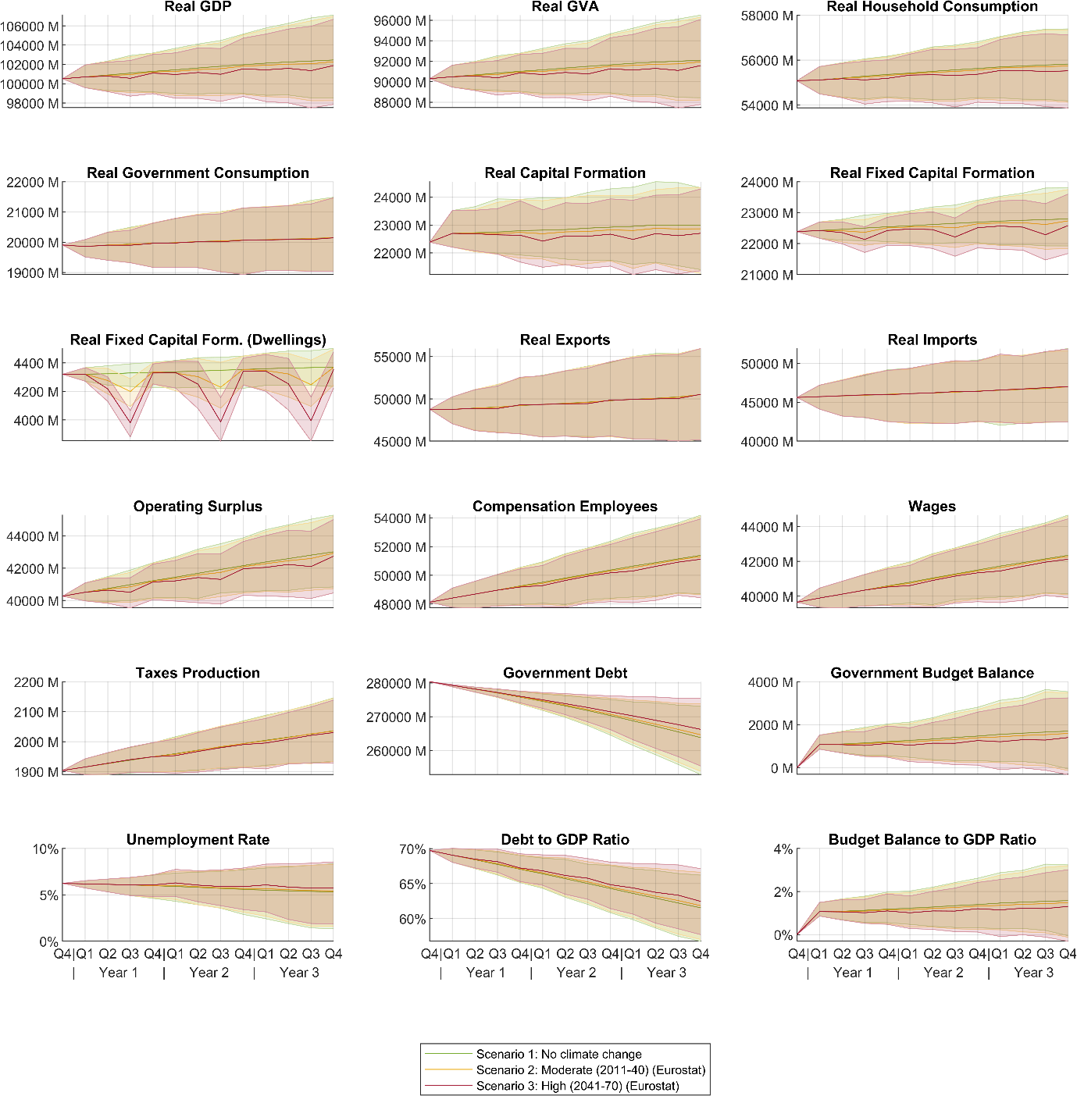

Figure 3: Gross value added by industry over three years with reduced labor productivity. The industries are identified by NACE codes. The figures show the mean over 500 Monte Carlo runs and a 95 percent confidence interval for the mean.
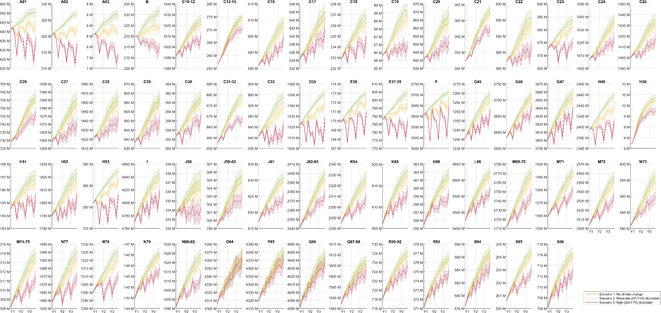

Figure 4: Direct and indirect effects on gross value added by industry over three years with reduced labor productivity. The industries are identified by NACE codes. The figures show the mean over 500 Monte Carlo runs.
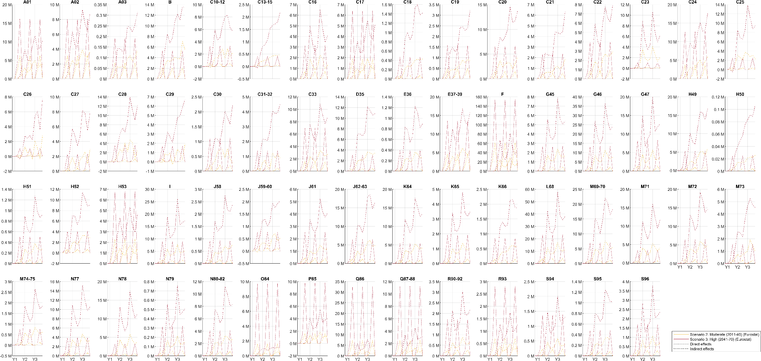

Robustness checks: Eurostat or Statistics Austria data basis

Comparison with results from Austrian register-based labor market data
The employment data from Eurostat used to estimate the average effect per industry on labor productivity have one major drawback: There is no detailed cross-classification of industries and regions available, which is why we had to rely on an estimation based on several datasets to calculate average industry specific productivity losses. To check the validity of this procedure, we repeated the analysis of the impacts of heat stress induced productivity losses using detailed data from Statistics Austria on employees by NACE industries (2 digits) and local administrative units, available in the register-based labor market statistics (Statistics Austria 2022) (STATcube – Statistical Database of Statistics Austria 2023). Furthermore, Statistics Austria also provides geodata on the population centers of the local administrative units (Statistics Austria 2024), which allows for a more accurate mapping of local administrative units and ClimateChip data).
Based on these detailed data, we analyzed the impacts on labor productivity in the scenarios with heat stress − moderate scenario (2) and high scenario (3) in comparison to the baseline scenario (1) without shock (no climate change-scenario). The results on the macro level (see Figure 5) do not differ substantially from the results obtained with data on employment from Eurostat (see chapter 4 in the paper), the respective lines mostly overlap. Thus, our analysis for Austria can be seen as a blueprint methodology that can be enlarged for comparative studies in heat stress and labor productivity for other EU countries.

Figure 5: Comparison of the simulation results of selected macroeconomic variables and gross value added of industries. As data bases, Eurostat and Statistics Austria data have been used. The figures show the means over 500 Monte Carlo runs and a 95 percent confidence interval for the mean.
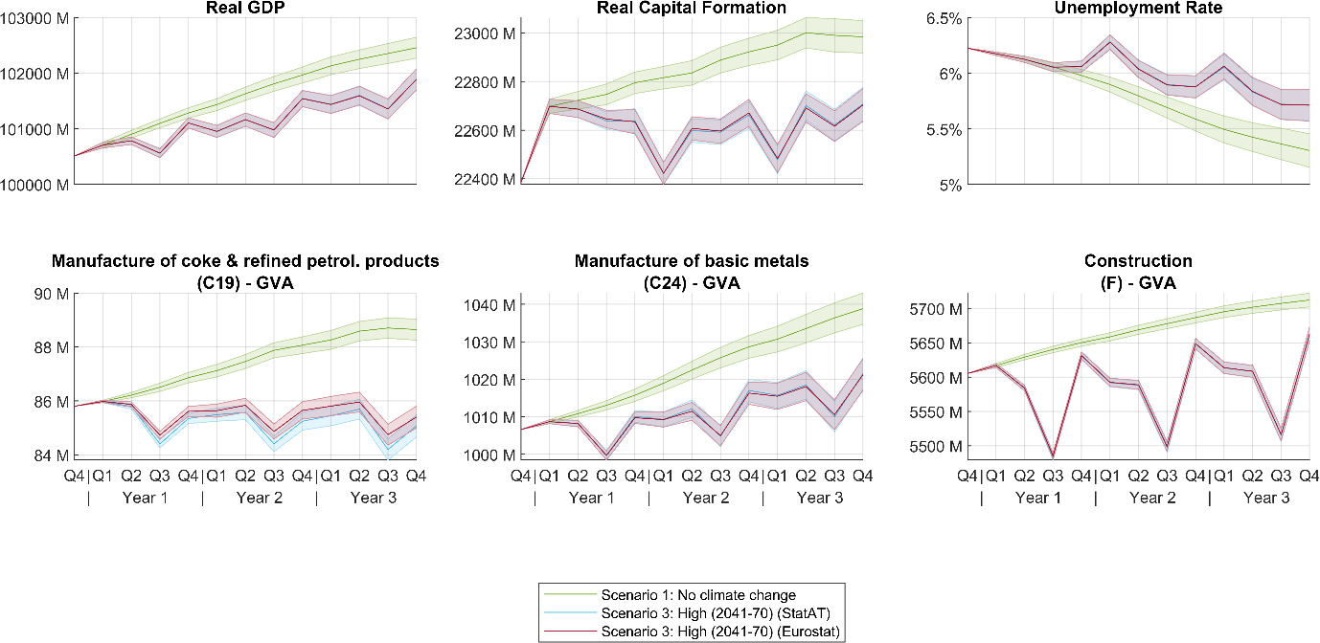

On an industry level, however, the results of the analysis based on the Austrian register-based labor market statistical data (STATcube – Statistical Database of Statistics Austria 2023) display certain but limited differences in the analysis of employment data from Eurostat. The comparison of the GVA loss per industry for the high scenario (3) compared to the baseline scenario shows noticeable differences in industries like the manufacture of coke and refined petroleum products or forestry. Here, the more detailed data from Statistics Austria leads to visible differences in the results. The main conclusions concerning the industry effects of heat stress are still confirmed.

Figure 6: Gross value added by industry over three years with reduced labor productivity. Data from Statistics Austria have been used. The industries are identified by NACE codes. The figures show the mean over 500 Monte Carlo runs and a 95 percent confidence interval for the mean.
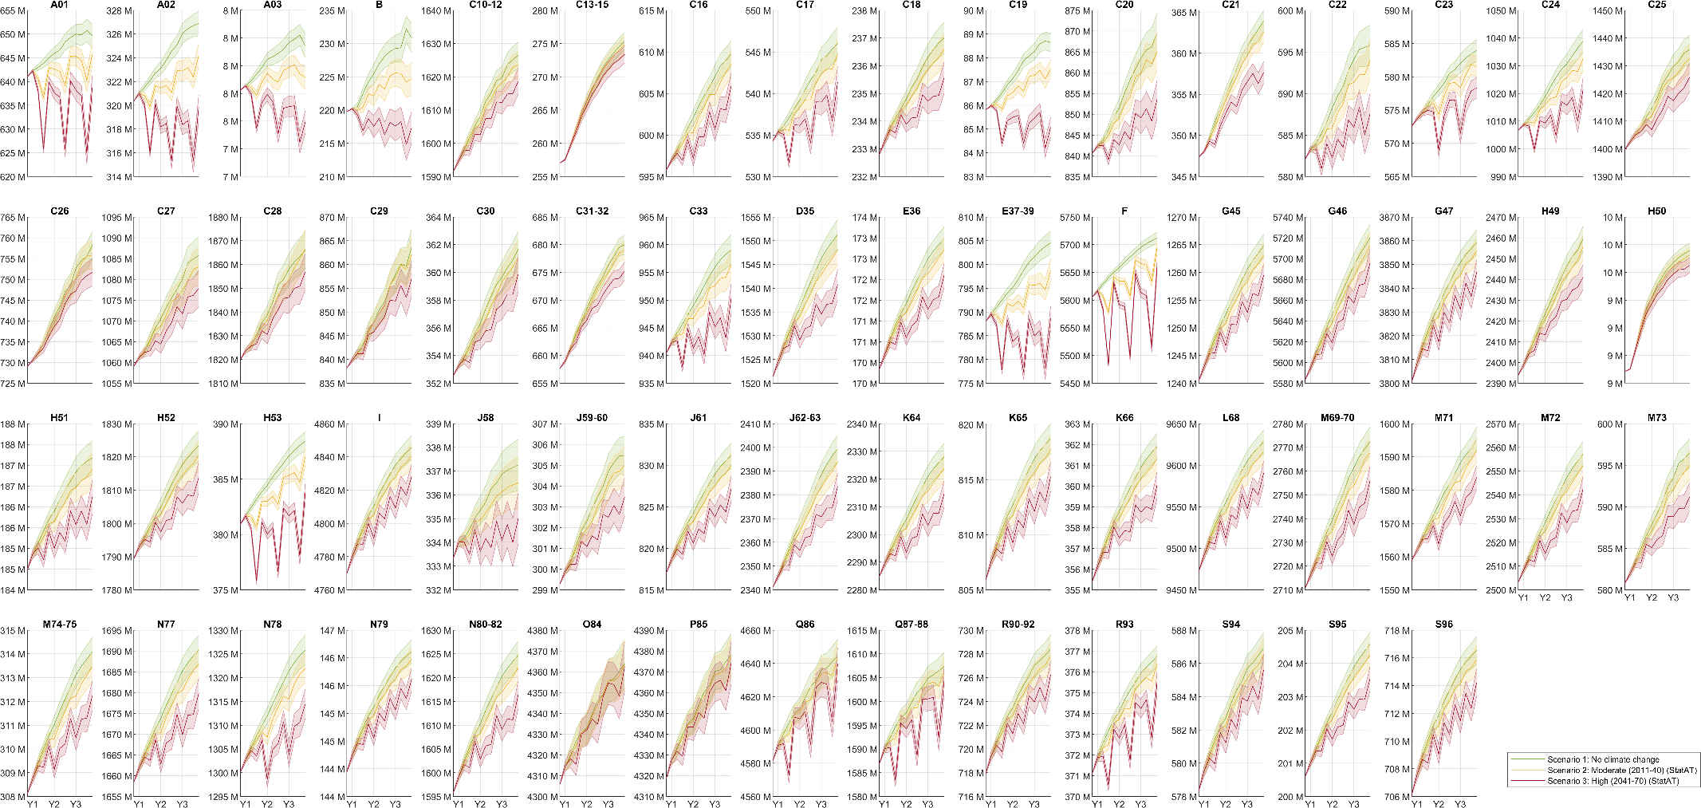

Robustness checks: Classification of sun exposure and work intensity

The type of work performed in an industry can vary considerably, even within one industry. Our categorization of the different NACE industries regarding work intensity and work environment, therefore, depends on assumptions and is not always unambiguous. In an additional sensitivity analysis, we recalculated the model using the categorization per industry applied by Stalhandske et al. (2022) for Switzerland (see Figure 7). On a macro level, slightly different paths emerge, but they do not result in substantial differences. For industries with identical categorization (e.g., construction), only marginal deviations occur due to follow-up effects, whereas industries with diverging assumptions regarding work intensity (e.g., manufacture of basic metals or petroleum products) also exhibit diverging patterns, i.e., a higher impact with higher work intensity, especially in the summer months.

Figure 7: Comparison of the simulation results of selected macroeconomic variables and gross value added of industries. Our own classification of sun exposure and work intensity is compared to the classification by Stalhandske et al. (2022). The figures show the means over 500 Monte Carlo runs and a 95 percent confidence interval for the mean.
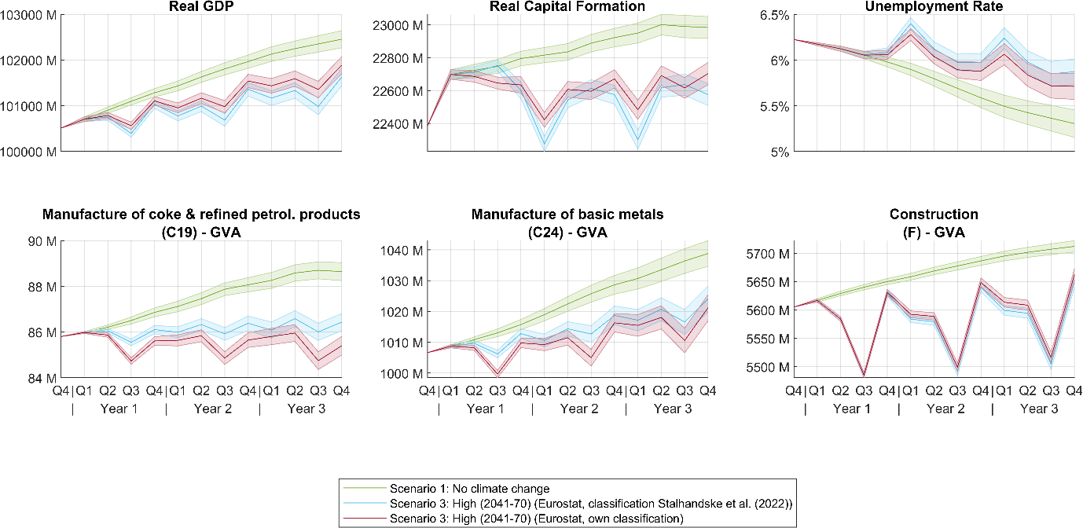
Figure 8: Comparison of the simulation results for our own classification of sun exposure and work intensity and the classification by Stalhandske et al. (2022). The figures show the means over 500 Monte Carlo runs and a 95 percent confidence interval for the mean.
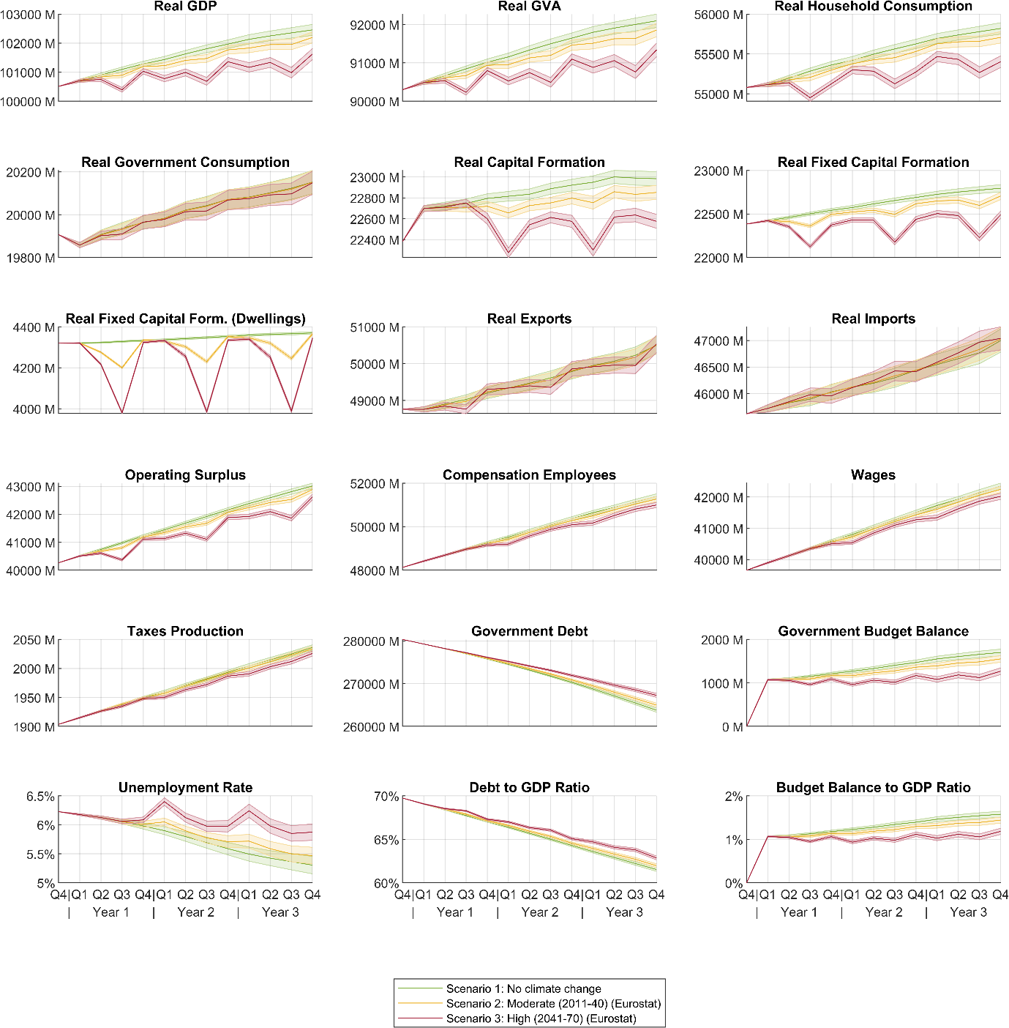

Figure 9: Gross value added by industry over three years with reduced labor productivity. The classification of industries on sun exposure and work intensity by Stalhandkse et al. (2022) has been used. The industries are identified by NACE codes. The figures show the mean over 500 Monte Carlo runs and a 95 percent confidence interval for the mean.
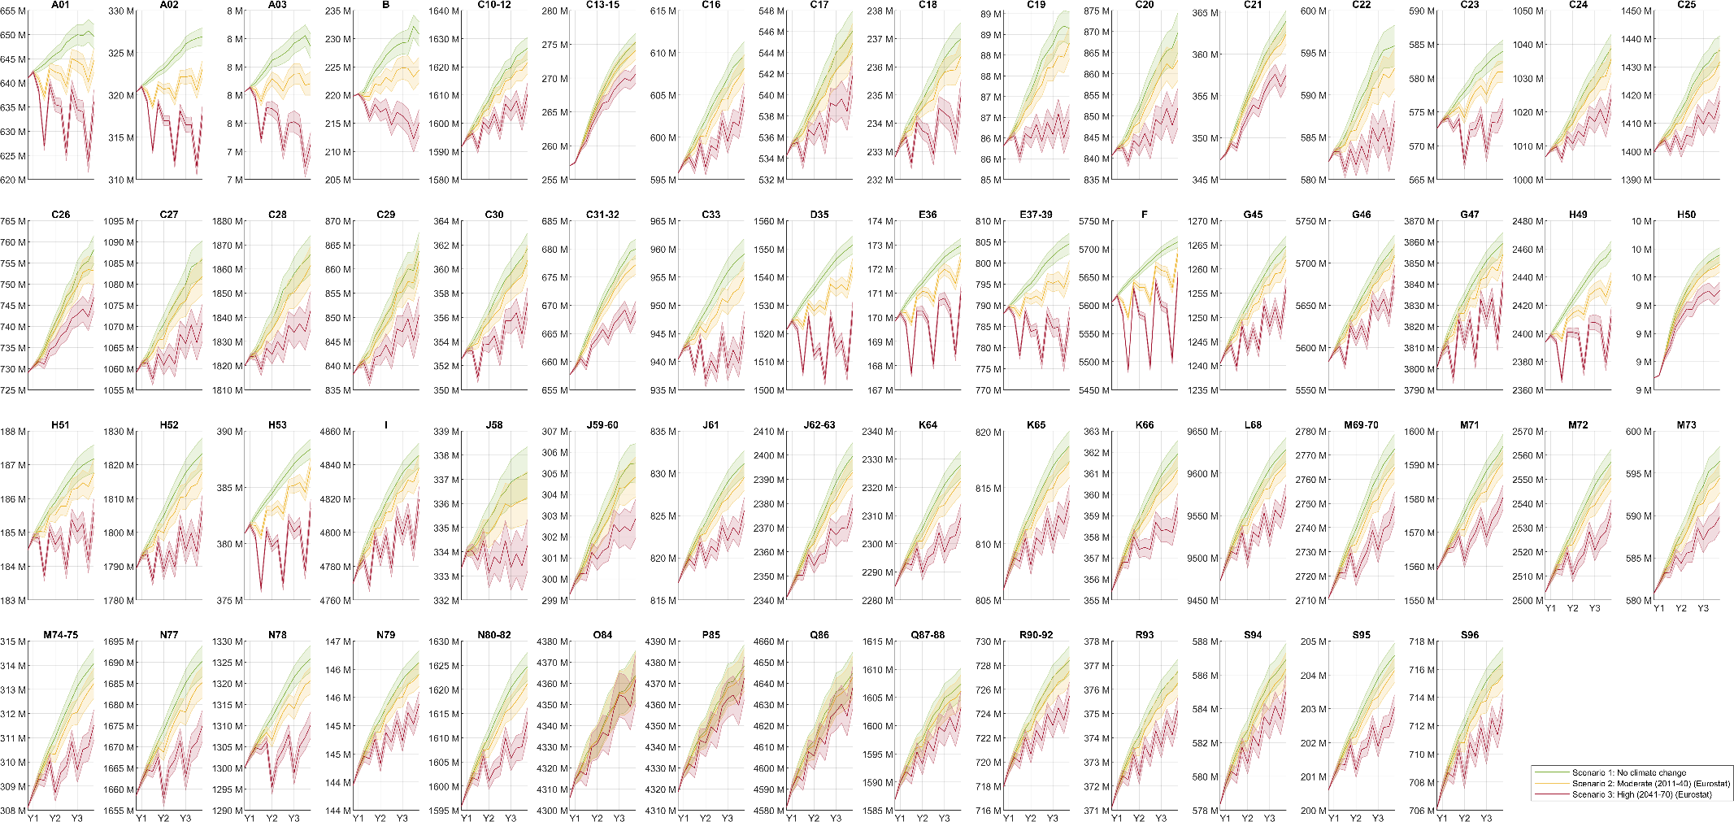

References
ClimateCHIP. 2024. “Climate Change Heat Impact & Prevention.” http://climatechip.org/.
Costa, Hélia, Graham Floater, Hans Hooyberghs, Stijn Verbeke, Koen De Ridder, and others. 2016. Climate Change, Heat Stress and Labour Productivity: A Cost Methodology for City Economies. Centre for Climate Change Economics and Policy London, UK.
Poledna, Sebastian, Michael Gregor Miess, Cars Hommes, and Katrin Rabitsch. 2023. “Economic Forecasting with an Agent-Based Model.” European Economic Review 151: 104306. https://doi.org/10.1016/j.euroecorev.2022.104306.
Poulianiti, Konstantina P., George Havenith, and Andreas D. Flouris. 2018. “Metabolic Energy Cost of Workers in Agriculture, Construction, Manufacturing, Tourism, and Transportation Industries.” Industrial Health 57 (3): 283–305. https://doi.org/10.2486/indhealth.2018-0075.
Stalhandske, Zélie, Valentina Nesa, Marius Zumwald, Martina S. Ragettli, Alina Galimshina, Niels Holthausen, Martin Röösli, and David N. Bresch. 2022. “Projected Impact of Heat on Mortality and Labour Productivity under Climate Change in Switzerland.” Natural Hazards and Earth System Sciences 22 (8): 2531–41. https://doi.org/10.5194/nhess-22-2531-2022.
STATcube – Statistical Database of Statistics Austria. 2023. “Register-Based Labour Market Statistics.” Statistics Austria. https://statcube.at/statistik.at.
Statistics Austria. 2024. “Regional Statistics. Regional Statistical Grid Units.” Statistics Austria. https://www.statistik.at/en/services/tools/services/regional-information/regional-statistics.
Statistics Austria. 2022. “Standard-Dokumentation Metainformationen. Abgestimmten Erwerbsstatistik und Erwerbsstatistik der Registerzählung 2011.”
Szewczyk, Wojciech, Ignazio Mongelli, and Juan-Carlos Ciscar. 2021. “Heat Stress, Labour Productivity and Adaptation in Europe—a Regional and Occupational Analysis.” Environmental Research Letters 16 (10): 105002. https://doi.org/10.1088/1748-9326/ac24cf.

