Uridine diphosphate (UDP)- glycosyltransferases (UGTs) confer insecticide resistance in the major malaria vectors Anopheles gambiae s.l and Anopheles funestus
Supplementary Figures
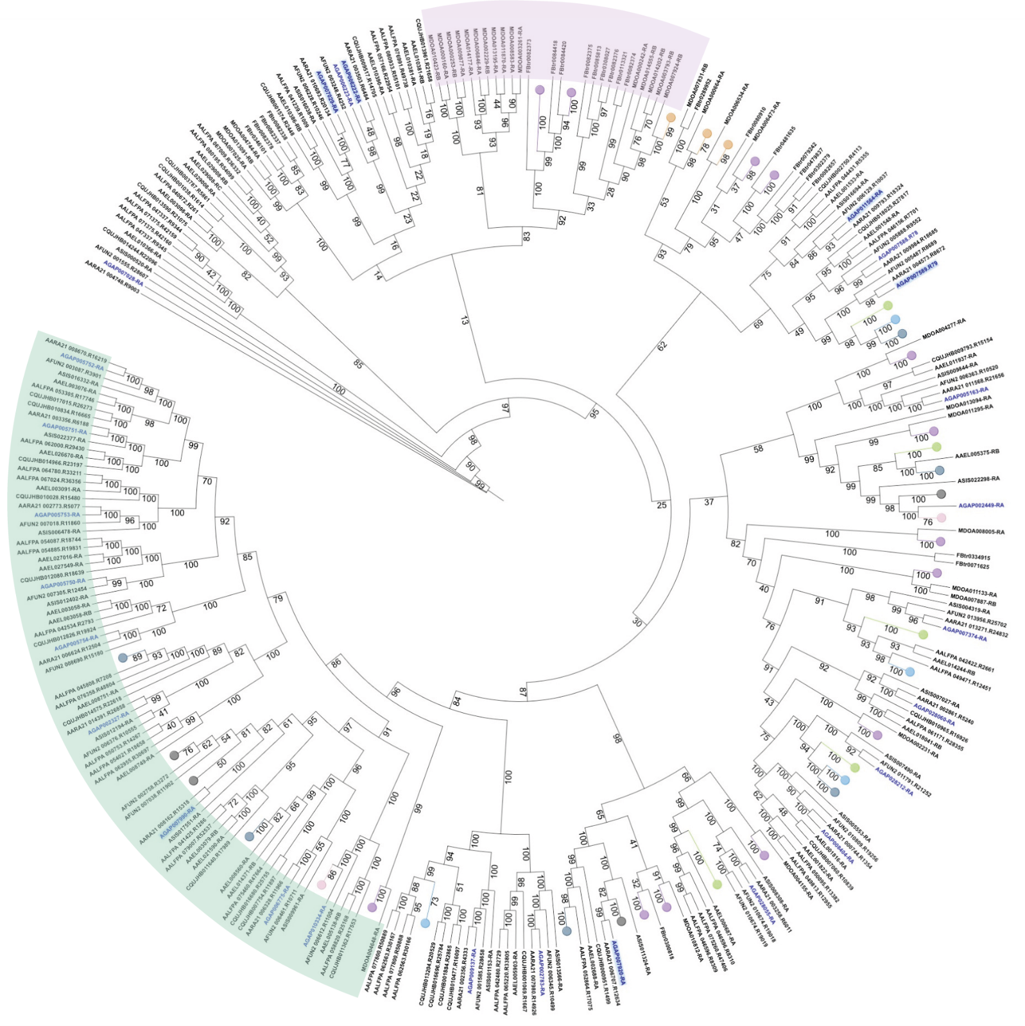
Figure S1: Phylogeny of UGTs across Diptera. An. gambiae (AGAP), blue text, those explored in more detail in this paper are highlighted in with light blue box, An. arabiensis (AAR), An. sinensis (ASIS), An. funestus (AFUN), Ae. aegypti (AAEL), Ae. albopictus (AALFPA), Cx. quinquefasciatus (CQUJ), D. melanogaster (FB) and M. domestica (MDOA) UGTs. Green shading represents an expansion of UGTs in mosquitoes, pink shading represents an expansion of UGTs in D. melanogaster and M. domestica. Splice variant ‘clades’ are represented by a circle with the following colour codes: AAR: pink; AFUN: grey; AAEL: light blue; AALFPA: dark blue; CQUJ: green; FBG: purple and MOD: orange. Bootstraps values from 1000 bootstraps shown on the branches.
Figure S2. Differential UGT transcript expression analysis with RT-qPCR due to circadian rhythm of resistant Anopheles coluzzii. Induction of UGTs – UGT302A1 (purple), UGT302H2 (pale blue), UGT306A2 (pale turquoise), UGT308G1 (pale peach) – mRNA isolated from mosquitoes 12 hours post-exposure ‘Exp.12hr’ to 0.05% deltamethrin. ‘Unexp.Imm.’ is mRNA isolated from unexposed mosquitoes in parallel as the 12 hours post-exposure samples. ‘Unexp.Imm’ is mRNA isolated from unexposed mosquitoes in parallel to mosquitoes removed immediately following exposure to 0.05% deltamethrin. The y-axis is the relative transcript expression fold change compared to control, and the x-axis is each comparison. Significance determined by one-way ANOVA and Dunnett’s multiple comparison test, only statistically significant overexpression presented, the data are mean ± SD, dotted line represents 1.

Figure S3. Increasing sensitivity to 0.05% deltamethrin through the inhibition of UGTs by sulfinpyrazone. (A) Anopheles gambiae, (B) Anopheles coluzzii, (C) Anopheles arabiensis. The y-axis is the mortality (%) caused by each condition, and the x-axis is concentration of sulfinpyrazone (%). Mortality of sulfinpyrazone alone is blue and the combination of deltamethrin plus sulfinpyrazone is purple. Dotted line represents mortality induced by deltamethrin alone, the data are mean ± SD.

Figure S5. Investigation of sulfinpyrazone affinity to Cytochrome P450s. CYP6M2 (purple), 6P3 (blue), 6P4 (teal) and 9K1 (orange) showed no changes in production of fluorescence with increasing doses of sulfinpyrazone demonstrating no affinity of CYP450s towards this compound. The y-axis is the relative fluorescence units produced per nmol CYP450 per second (RFU/nmol/s) mortality (%), and the x-axis is concentration of sulfinpyrazone (μM).

