Extended Data Figures

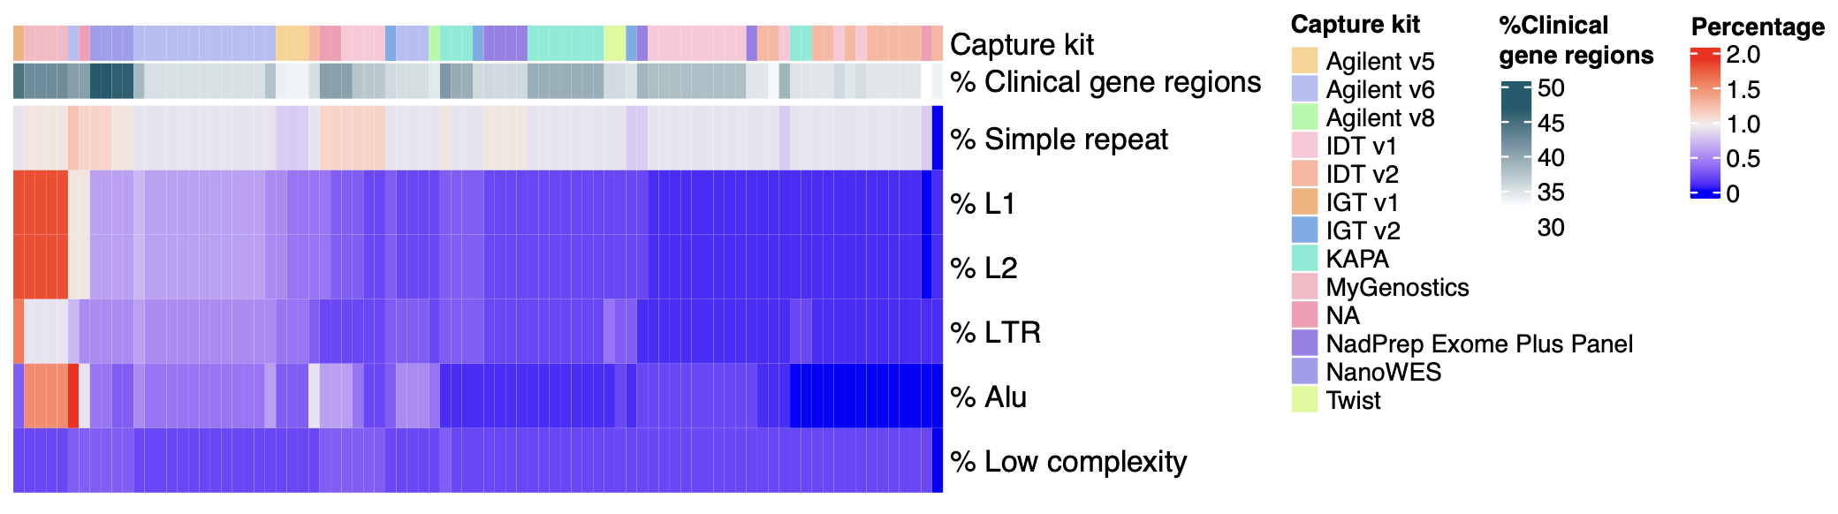
Extended Data Fig. 1 | Percentage of targeted regions overlapping with clinical gene regions and repetitive regions.
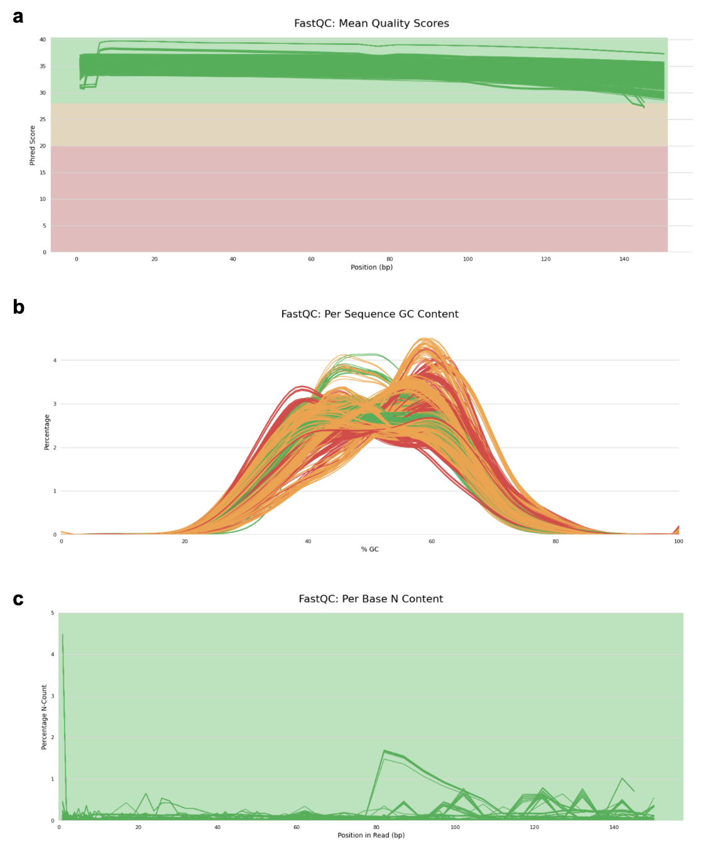
Extended Data Fig. 2 | Pre-alignment quality control of sequencing data using FastQC. (a) Sequence quality histograms show the mean quality value across each base position in the read. (b) Per-sequence GC content indicates the average GC content of reads. Normal random libraries typically have a roughly normal distribution of GC content. (c) Per-base N content represents the percentage of base calls at each position for which an N was called.
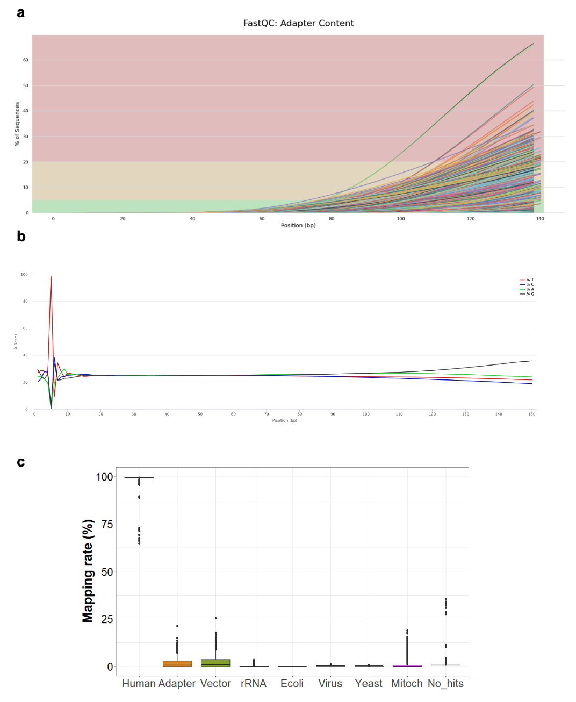
Extended Data Fig. 3 | Issues identified in pre-alignment quality control of sequencing data, include: (a) Cumulative percentage count of the proportion of libraries that have each adapter sequence at each position. (b) Proportion of each base position for which each of the four normal DNA bases has been called. (c) Library contamination checked by FastqScreen by mapping reads to genomes of other organisms, including adapter, vector, E.coli, virus, yeast, etc.
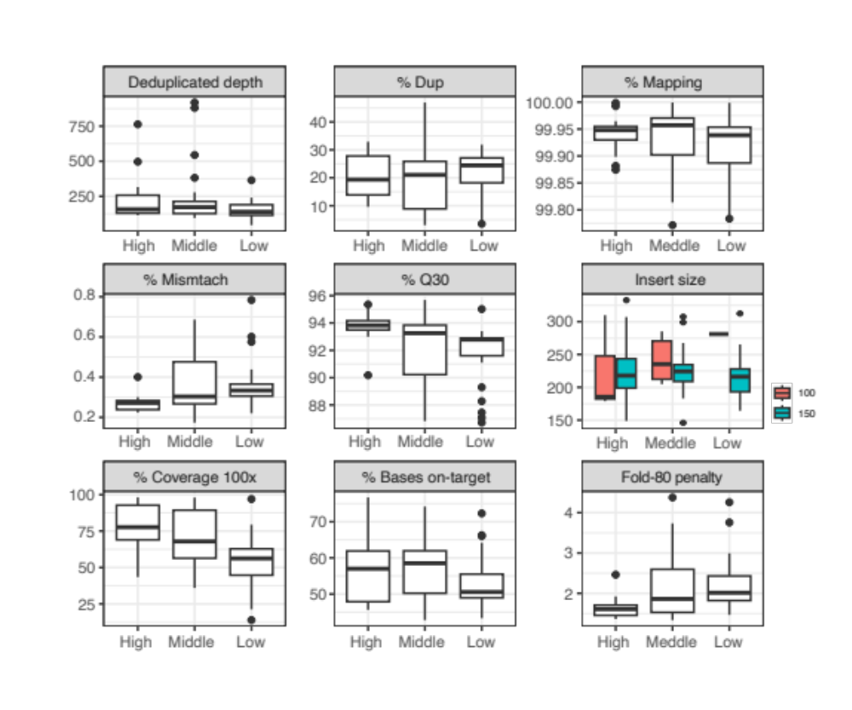
Extended Data Fig. 4 | Read quality and capture efficiency across high, middle, and low-quality groups.

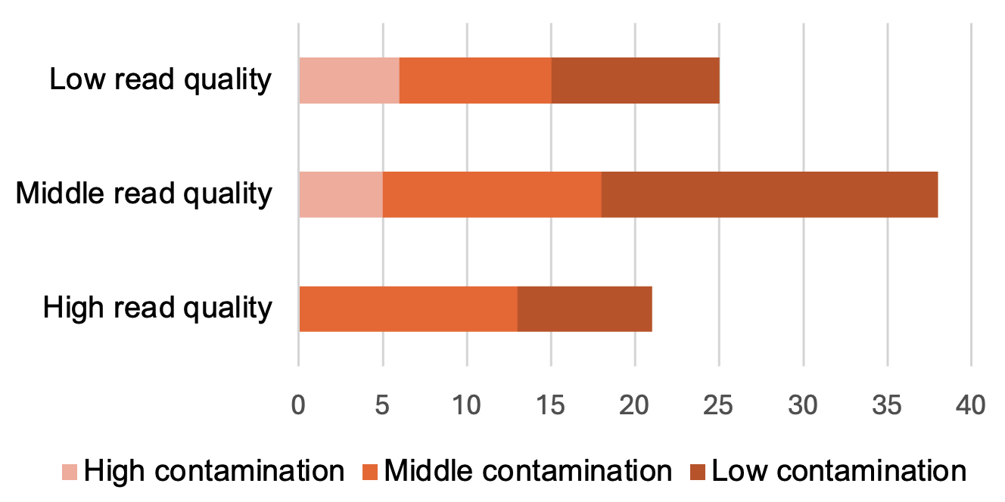
Extended Data Fig. 5 | Read quality groups and their contamination status. High contamination indicates less than 98% of reads mapped to the human genome, greater than 2% of reads mapped to vectors, and greater than 2% of reads not mapped to any organisms. Low contamination indicates greater than 98% of reads mapped to the human genome, less than 2% mapped to vectors, and less than 2% with no hit. The middle contamination satisfied two of three conditions.

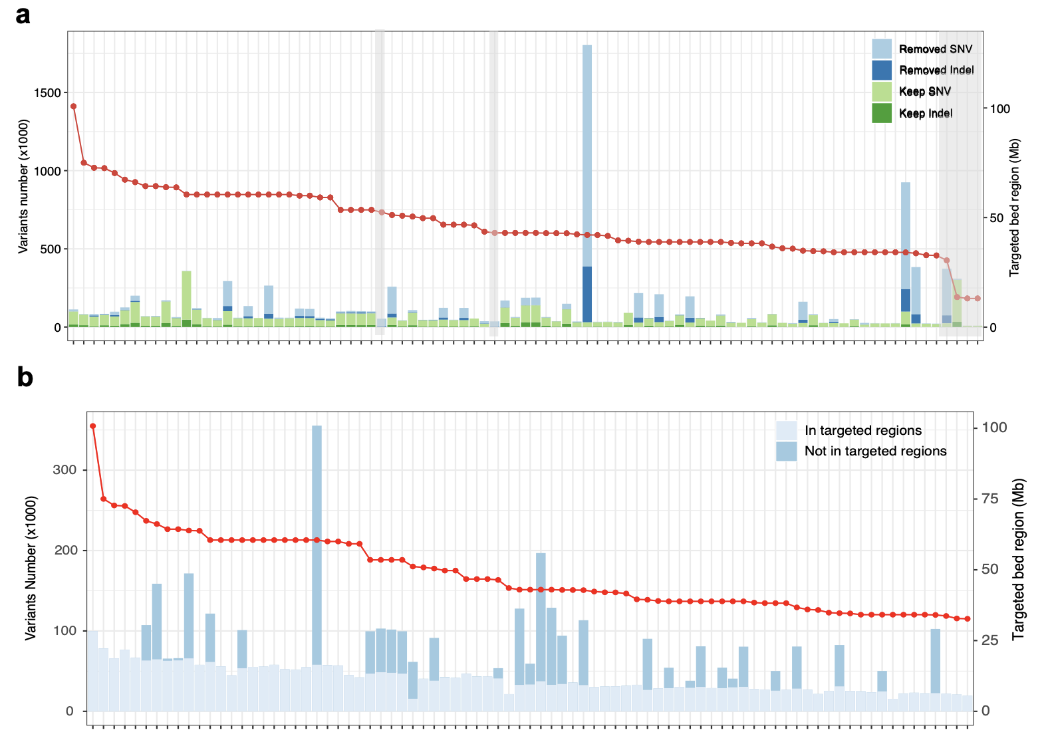
Extended Data Fig. 6 | Number of (a) reported SNVs and Indels from raw VCF files and after filtration, and (b) variants inside the targeted regions versus those outside of the targeted regions.
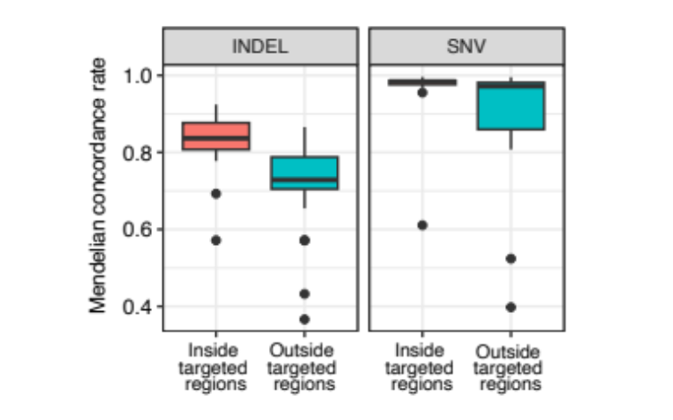
Extended Data Fig. 7 | Mendelian concordance rates of variants detected inside and outside the target regions.
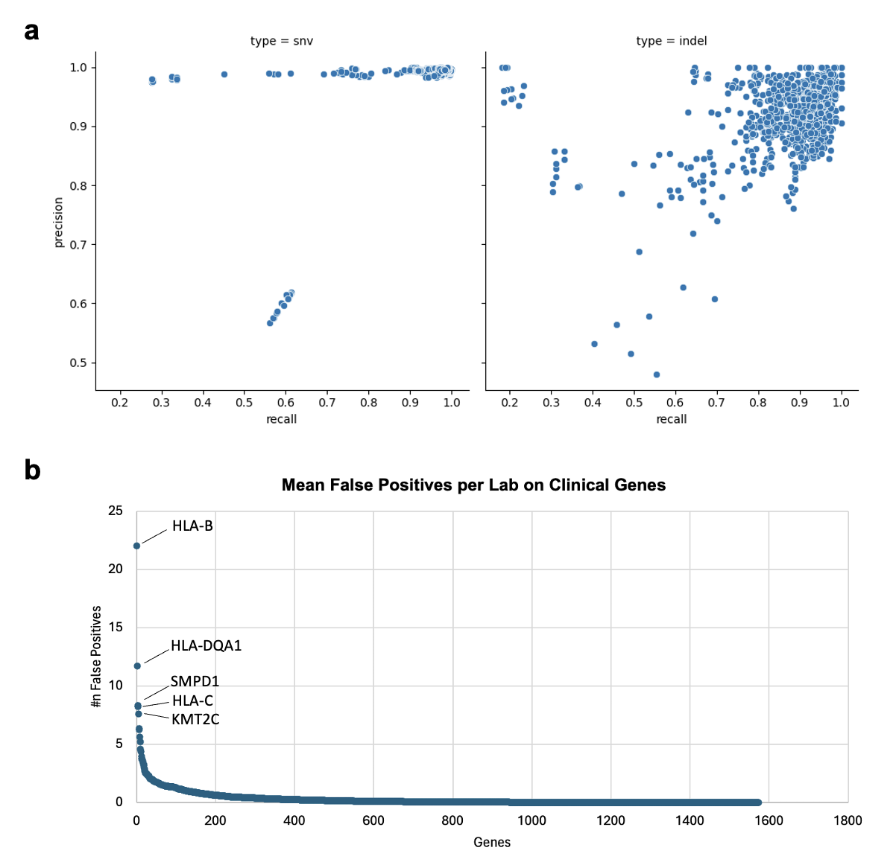
Extended Data Fig. 8 | Performance of small variants detection in clinical genes. (a) Precision and recall of small variants calling in clinical gene regions. (b) Mean false positives per lab on clinical genes.

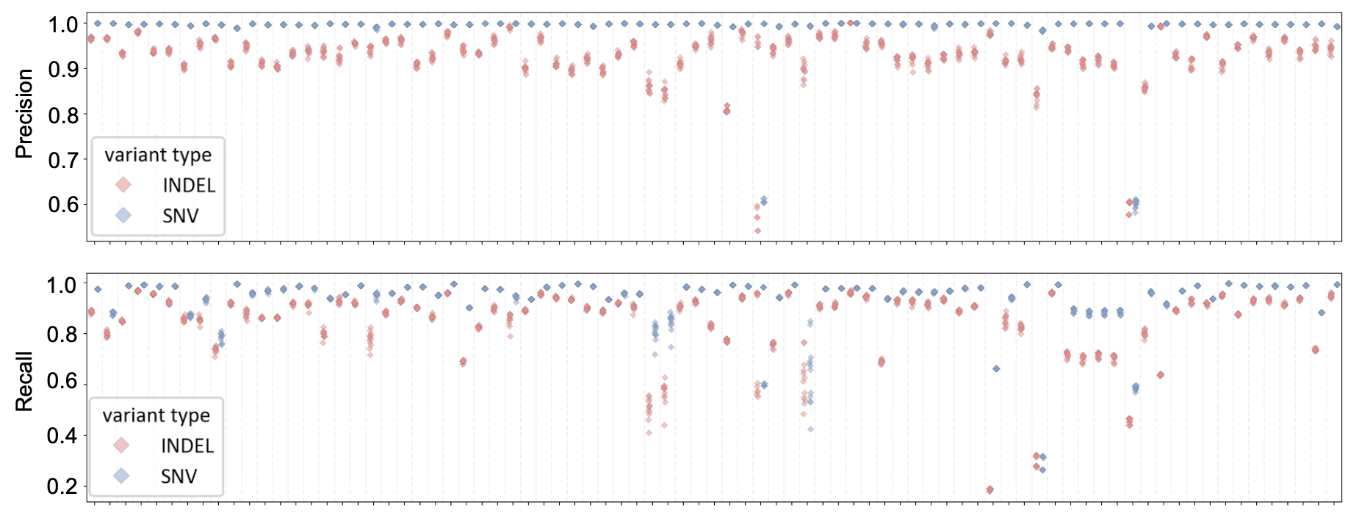
Extended Data Fig. 9 | Consistency of performance across 12 samples sequenced and analyzed in each lab.

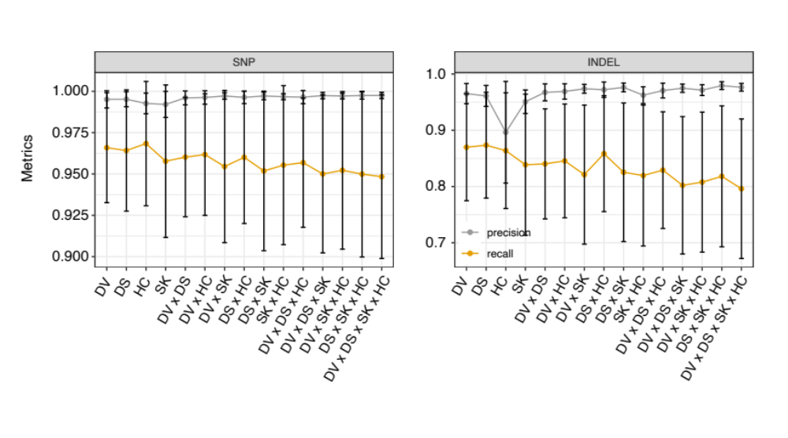
Extended Data Fig. 10 | Precision and recall of SNVs and Indels detected from low-quality sequencing datasets by one or more intersection of multiple callers.

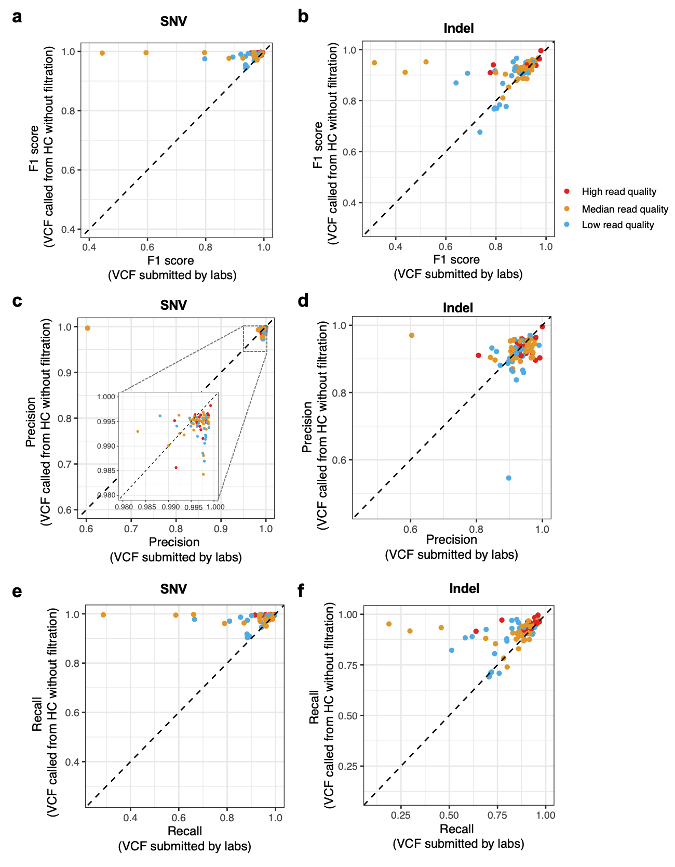
Extended Data Fig. 11 | Performance comparison between unfiltered (Sentieon HaplotypeCaller with BQSR) and filtered (submitted filtered VCF files by labs) variant calling results. (a) SNV F1 scores, (b) Indel F1 scores, (c) SNV precision, (d) Indel Precision, (e) SNV recall, (f) Indel recall.
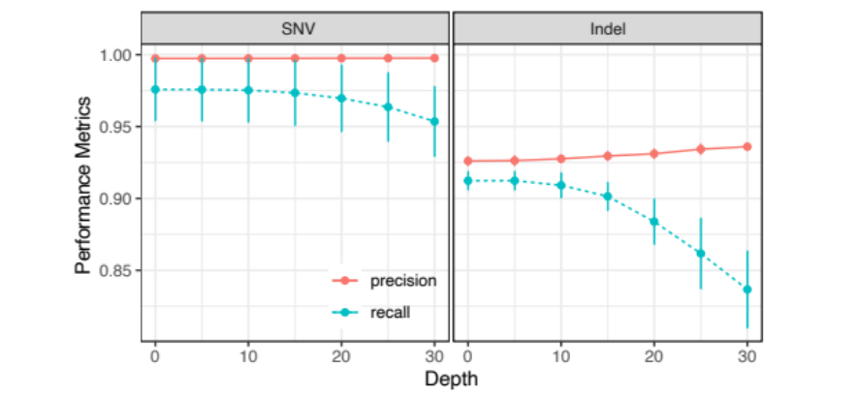
Extended Data Fig. 12 | Precision and recall of SNVs and Indels filtered by various depth thresholds.

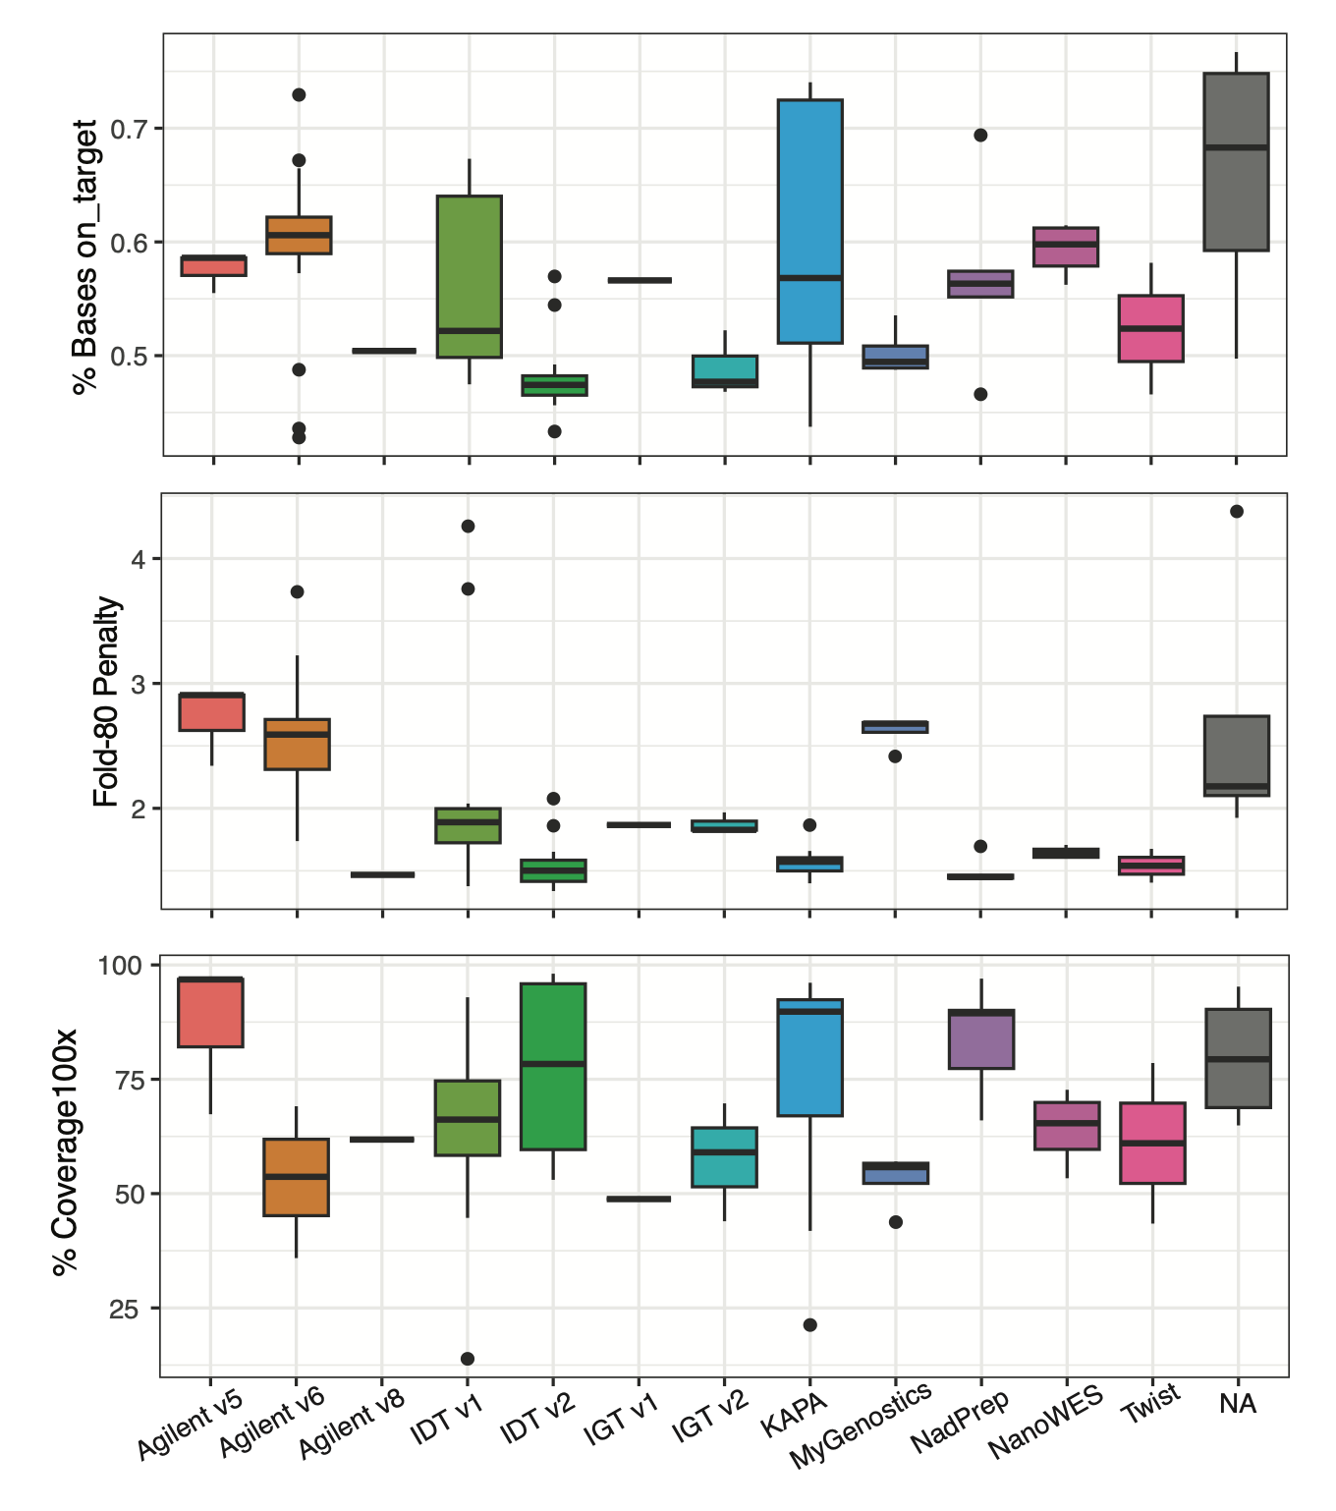
Extended Data Fig. 13 | The on-target bases rate, fold-80 penalty, and percentage of coverage greater than 100x in the target region for different capture kits.
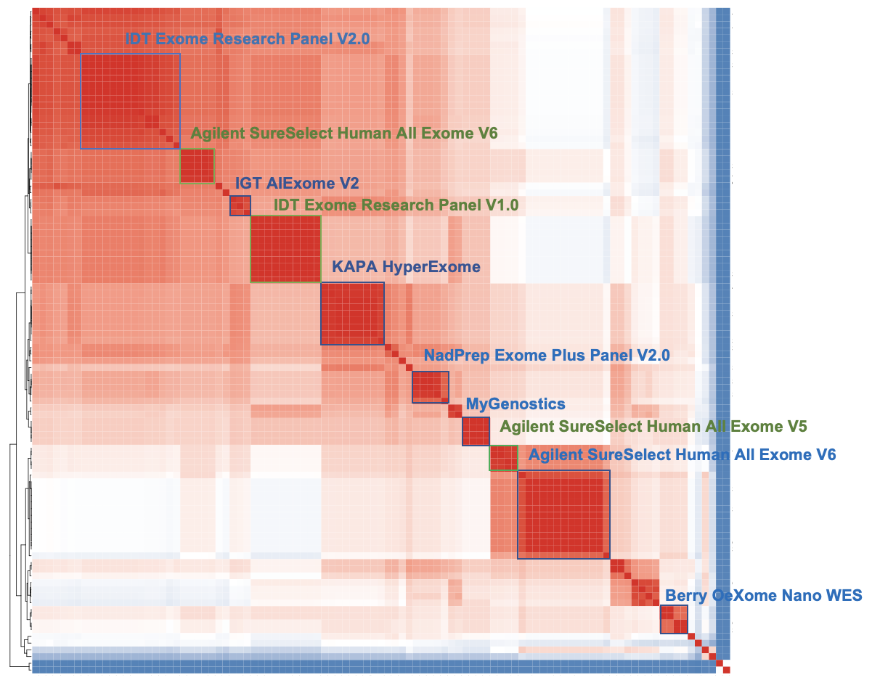
Extended Data Fig. 14 | Pairwise consistency between submitted targeted bed regions by participating labs.

Supplementary Tables

Supplementary Table 1. Metadata of sequencing datasets returned by participating labs, detailing experimental and analytical methods.

Supplementary Table 2. Capture kits used by participating labs.
Manufacture | Kit | Targeted Region (Mb) | Databases Used for Design | Year of Release
IDT | xGen Exome Research Panel V1.0 | 39 | RefSeq | 2015
IDT | xGen Exome Research Panel V2.0 | 34 | RefSeq | 2020
Agilent | SureSelect Human All Exon V5 | 50 | Refseq, GENCODE, UCSC, TCGA, CCDS and miRBase | 2012
Agilent | SureSelect Human All Exon V6 | 60 | Refseq, CCDS, GENCODE, HGMD, and OMIM | 2016
Agilent | SureSelect Human All Exon V8 | 35 | RefSeq, CCDS, GENCODE, and TERT promotors | 2021
NadPrep | Exome Plus Panel | 47 | Coding regions, gene fusions, satelliates, HLA | 2021
Roche | KAPA HyperExome | 43 | CCDS, Refseq, Ensembl, GENCODE, and variants from ClinVar | 2020
Twist | Exome Panel 2.0 | 36 | RefSeq, CCDS, GENCODE, Clnivar, ACMG, clinicaly relevant non-coding variants | 2021
IGT | AIExome V1 | 58 | Coding regions | 2017
IGT | AIExome V2 | 39 | Coding regions, ACMG, CliniVar, OMIM, HGMD | 2018
Berry | OeXome NanoWES | 60 | Coding regions, pathgenic non-coding variants, regulating elements | -
MyGenostics | - | 53 | Coding regions, HGMD, CliniVar, non-coding pathogenic variants | -

Supplementary Table 3. Clinical gene list.

