Supplementary Information

Population connectivity across a transboundary conservation network: potential for restoration? Landscape Ecology

Simon G. Dures^{1,2} | Chris Carbone¹ | Andrew J. Loveridge³ | Glyn Maude⁴ | Neil Midlane⁵ | Dada Gottelli¹
¹Institute of Zoology, Zoological Society of London, London, UK
²Department of Life Sciences, Imperial College London, Ascot, UK
³Department of Zoology, Wildlife Conservation Research Unit, Recanati‐ Kaplan Centre, University of Oxford, Tubney, UK
⁴Kalahari Research and Conservation, Maun, Botswana
⁵Singita, Cape Town, South Africa

Correspondence
Simon G. Dures - simondures@gmail.com

Appendix A - microsatellite diversity across the KAZA lion population
Measures of diversity of the 20 microsatellite loci across the KAZA lion population. N = number of alleles; AR = allelic richness; H^{E} = expected heterozygosity; H_{O} = observed heterozygosity; F_{IS} = Inbreeding coefficient.
Locus | N | AR | H_{E} | H_{O} | F_{IS}
Fca1 | 13 | 3.115 | 0.494 | 0.4853 | 0.02
Fca6 | 12 | 4.94 | 0.7962 | 0.5938 | 0.255*
Fca8 | 11 | 3.824 | 0.6843 | 0.601 | 0.122
Fca31 | 13 | 2.936 | 0.5352 | 0.5075 | 0.052
Fca45 | 6 | 2.508 | 0.3387 | 0.3317 | 0.021
Fca69 | 11 | 3.726 | 0.6862 | 0.635 | 0.075
Fca75 | 11 | 5.086 | 0.8273 | 0.7789 | 0.059
Fca77 | 7 | 3.478 | 0.6805 | 0.7114 | -0.046
Fca96 | 9 | 4.69 | 0.7915 | 0.7959 | -0.006
Fca97 | 14 | 5.516 | 0.8314 | 0.805 | 0.032
F115 | 13 | 5.399 | 0.8412 | 0.725 | 0.138*
Fca126 | 13 | 4.029 | 0.756 | 0.6318 | 0.165
Fca129 | 13 | 5.511 | 0.807 | 0.7178 | 0.111
Fca133 | 5 | 3.647 | 0.6972 | 0.6131 | 0.121
Fca193 | 8 | 3.949 | 0.7431 | 0.7121 | 0.042
Fca205 | 7 | 3.508 | 0.611 | 0.5885 | 0.037
Fca224 | 12 | 3.711 | 0.6399 | 0.592 | 0.075
Fca247 | 11 | 4.332 | 0.7031 | 0.6765 | 0.038
Fca391 | 8 | 4.909 | 0.7977 | 0.7136 | 0.106
Fca506 | 18 | 5.26 | 0.819 | 0.7562 | 0.077
Mean | 10.75 | 4.20 | 0.704 | 0.649 | 0.061
St. dev. | 3.193 | 0.910 | 0.130 | 0.117 | 0.051
*Significant for deviation from Hardy-Weinberg equilibrium (p>0.01)

Appendix B - Inbreeding coefficient for each KAZA genetic clusters
Inbreeding coefficient (F_{IS}) for each genetic cluster with 95% confidence intervals.

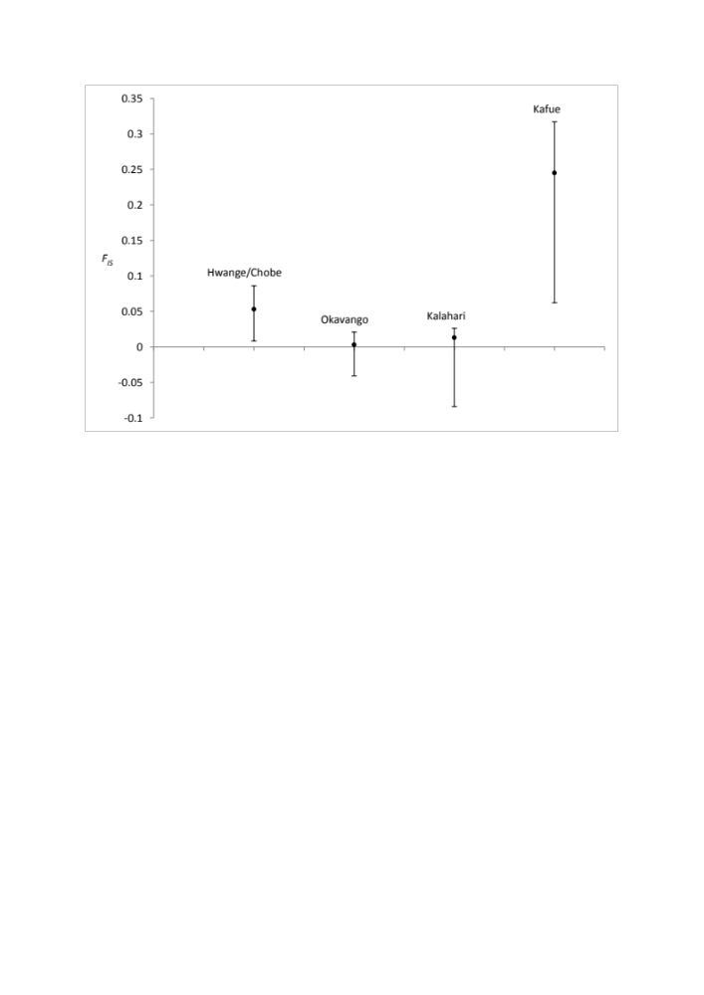

Appendix C – Private alleles for each KAZA genetic clusters
Mean number of private alleles per locus as a function of standardised sample size for each genetic cluster.
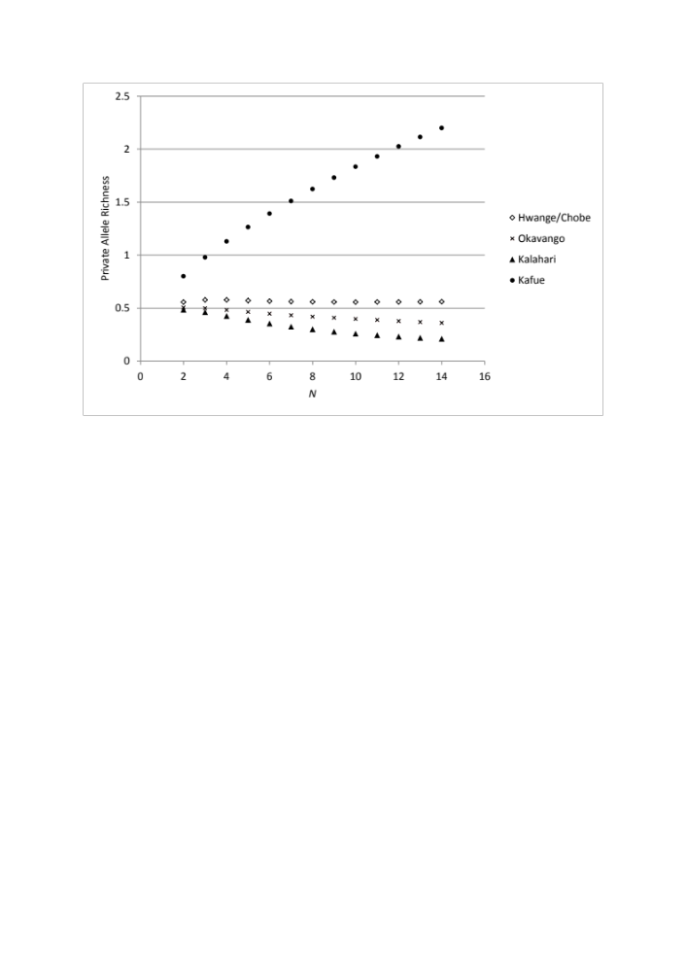

Appendix D – Okavango Substructure
STRUCTURE output showing Bayesian assignment probabilities for each individual lion based on sampling area for the Okavango Delta alone. Colours represent membership to each of the two clusters; green representing the central Okavango Delta island (Chiefs Island), blue representing the remainder of the Okavango Delta lion population. Lions were categorised using their maximum assignment probability.

