Supplementary Materials

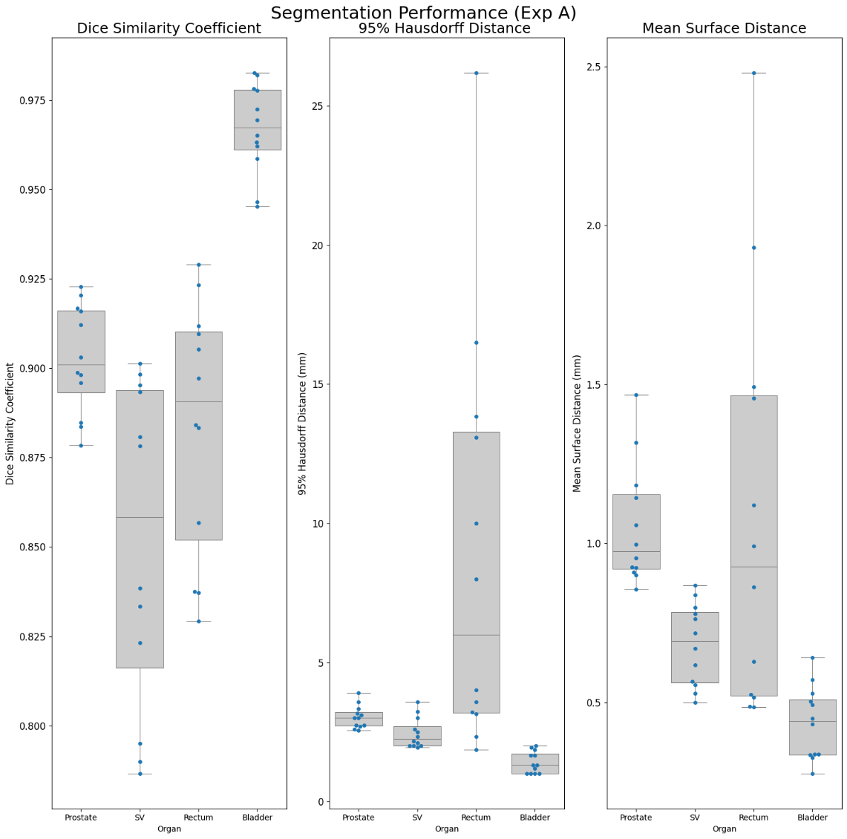
Fig. S1 DSC, 95% Hausdorff Distance and Mean Surface Distance Results of the Reference Model (Exp A) on Labelled Test Data
 | Prostate
 | DSC |  | 95% Hausdorff Distance (mm) |  | Mean Surface Distance (mm)
Exp Type | With Augmentation | No Augmentation | With Augmentation | No Augmentation | With Augmentation | No Augmentation
A (100%) | 0.903 [0.893 - 0.916] | 0.897 [0.890 - 0.910] | 3.035 [2.723 - 3.208] | 3.152 [2.734 - 3.432] | 1.053 [0.920 - 1.154] | 1.092 [0.968 - 1.154]
B (87.5%) | 0.903 [0.894 - 0.917] | 0.894 [0.885 - 0.905] | 3.015 [2.693 - 3.119] | 3.293 [3.000 - 3.621] | 1.047 [0.902 - 1.197] | 1.124 [0.994 - 1.210]
C (75%) | 0.902 [0.893 - 0.913] | 0.892 [0.881 - 0.908] | 3.047 [2.603 - 3.228] | 3.303 [2.678 - 3.833] | 1.072 [0.898 - 1.165] | 1.155 [1.022 - 1.275]
D (50%) | 0.891 [0.881 - 0.903] | 0.888 [0.872 - 0.905] | 3.307 [2.734 - 3.929] | 3.364 [2.923 - 3.679] | 1.123 [1.011 - 1.271] | 1.211 [1.067 - 1.380]
E (37.5%) | 0.892 [0.883 - 0.906] | 0.883 [0.870 - 0.895] | 3.146 [2.819 - 3.383] | 3.483 [3.070 - 3.936] | 1.186 [1.055 - 1.360] | 1.182 [1.093 - 1.237]
F (25%) | 0.888 [0.877 - 0.907] | 0.881 [0.871 - 0.892] | 3.296 [3.003 - 3.639] | 3.558 [3.260 - 3.727] | 1.232 [1.054 - 1.430] | 1.283 [1.197 - 1.361]
G (12.5%) | 0.715 [0.835 - 0.863] | 0.783 [0.771 - 0.809] | 4.386 [3.713 - 4.798] | 6.261 [5.555 - 7.181] | 1.492 [1.464 - 1.643] | 2.293 [1.998 - 2.699]
Table S1 Prostate Segmentation Performance in Restricted Dataset Setting. The metrics are presented as the mean [25th-75th percentile]. Note: * means these predictions included null predictions, resulting in some incalculable distance metrics. Such predictions were omitted, meaning that reported results are biased by omitting the worst predictions.
 | Seminal Vesicles
 | DSC |  | 95% Hausdorff Distance (mm) |  | Mean Surface Distance (mm)
Exp Type | With Augmentation | No Augmentation | With Augmentation | No Augmentation | With Augmentation | No Augmentation
A (100%) | 0.851 [0.816 - 0.894] | 0.740 [0.659 - 0.843] | 2.454 [2.000 - 2.703] | 4.175 [2.701 - 4.877] | 0.683 [0.563 - 0.784] | 1.235 [0.744 - 1.636]
B (87.5%) | 0.847 [0.812 - 0.889] | 0.746 [0.674 - 0.843] | 2.539 [2.000 - 2.864] | 4.089 [2.464 - 5.107] | 0.701 [0.587 - 0.801] | 1.187 [0.681 - 1.648]
C (75%) | 0.843 [0.807 - 0.888] | 0.745 [0.710 - 0.822] | 2.637 [2.086 - 3.000] | 4.316 [2.994 - 4.870] | 0.725 [0.607 - 0.844] | 1.237 [0.744 - 1.527]
D (50%) | 0.783 [0.732 - 0.843] | 0.764 [0.715 - 0.827] | 4.187 [2.464 - 5.226] | 3.947 [2.639 - 4.894] | 0.946 [0.745 - 1.135] | 1.104 [0.683 - 1.387]
E (37.5%) | 0.829 [0.792 - 0.868] | 0.690 [0.590 - 0.813] | 2.818 [2.420 - 2.801] | 5.574 [3.125 - 7.869] | 0.799 [0.696 - 0.895] | 1.476 [0.866 - 2.021]
F (25%) | 0.817 [0.780 - 0.863] | 0.645 [0.486 - 0.771] | 3.211 [2.453 - 3.250] | 5.781 [3.327 - 8.258] | 0.865 [0.735 - 0.962] | 1.698 [0.947 - 2.383]
G (12.5%) | 0.521 [0.407 - 0.697] | 0.396 [0.215 - 0.601] | 11.802 [6.624 - 8.757] | 17.202 [8.328 - 22.637] | 3.115 [1.659 - 2.167] | 4.574 [1.878 - 6.946]
Table S2 SV Segmentation Performance in Restricted Dataset Setting. The metrics are presented as the mean [25th-75th percentile]. Note: * means these predictions included null predictions, resulting in some incalculable distance metrics. Such predictions were omitted, meaning that reported results are biased by omitting the worst predictions.
 | Rectum
 | DSC |  | 95% Hausdorff Distance (mm) |  | Mean Surface Distance (mm)
Exp Type | With Augmentation | No Augmentation | With Augmentation | No Augmentation | With Augmentation | No Augmentation
A (100%) | 0.884 [0.852 - 0.910] | 0.893 [0.880 - 0.900] | 8.813 [3.191 - 13.284] | 4.341 [3.250 - 4.632] | 1.081 [0.521 - 1.466] | 0.846 [0.616 - 1.047]
B (87.5%) | 0.891 [0.866 - 0.916] | 0.890 [0.880 - 0.898] | 7.402 [3.002 - 11.164] | 4.436 [3.300 - 4.910] | 0.974 [0.600 - 1.150] | 0.854 [0.639 - 1.042]
C (75%) | 0.892 [0.871 - 0.910] | 0.886 [0.879 - 0.891] | 5.761 [2.924 - 8.000] | 4.723 [3.556 - 5.250] | 0.800 [0.543 - 0.931] | 0.918 [0.670 - 1.143]
D (50%) | 0.896 [0.879 - 0.911] | 0.863 [0.852 - 0.886] | 4.460 [3.026 - 6.000] | 8.633 [3.626 - 8.383] | 0.716 [0.609 - 0.848] | 1.425 [0.840 - 1.482]
E (37.5%) | 0.884 [0.873 - 0.897] | 0.860 [0.840 - 0.881] | 6.597 [3.976 - 5.138] | 8.731 [4.064 - 8.020] | 0.827 [0.598 - 0.861] | 1.422 [0.760 - 1.514]
F (25%) | 0.833 [0.785 - 0.871] | 0.839 [0.800 - 0.876] | 14.826 [8.169 - 21.734] | 10.840 [3.859 - 15.187] | 1.197 [0.628 - 1.647] | 1.883 [1.059 - 2.595]
G (12.5%) | 0.743 [0.868 - 0.899] | 0.772 [0.722 - 0.794] | 3.891 [2.800 - 4.181] | 12.683 [6.085 - 17.384] | 0.823 [0.717 - 0.915] | 2.487 [1.710 - 3.066]
Table S3 Rectum Segmentation Performance in Restricted Dataset Setting. The metrics are presented as the mean [25th-75th percentile]. Note: * means these predictions included null predictions, resulting in some incalculable distance metrics. Such predictions were omitted, meaning that reported results are biased by omitting the worst predictions.
 | Bladder
 | DSC |  | 95% Hausdorff Distance (mm) |  | Mean Surface Distance (mm)
Exp Type | With Augmentation | No Augmentation | With Augmentation | No Augmentation | With Augmentation | No Augmentation
A (100%) | 0.967 [0.961 - 0.978] | 0.963 [0.957 - 0.974] | 1.410 [1.000 - 1.716] | 1.527 [1.134 - 1.944] | 0.435 [0.336 - 0.509] | 0.488 [0.363 - 0.595]
B (87.5%) | 0.967 [0.962 - 0.978] | 0.963 [0.958 - 0.976] | 1.415 [1.000 - 1.716] | 1.483 [1.134 - 1.883] | 0.431 [0.326 - 0.499] | 0.485 [0.353 - 0.595]
C (75%) | 0.966 [0.960 - 0.977] | 0.963 [0.957 - 0.974] | 1.468 [1.000 - 1.863] | 1.507 [1.134 - 1.944] | 0.445 [0.333 - 0.542] | 0.496 [0.360 - 0.610]
D (50%) | 0.965 [0.956 - 0.978] | 0.962 [0.955 - 0.973] | 1.538 [1.000 - 1.944] | 1.586 [1.179 - 1.958] | 0.469 [0.355 - 0.556] | 0.509 [0.366 - 0.631]
E (37.5%) | 0.962 [0.957 - 0.973] | 0.962 [0.952 - 0.975] | 1.578 [1.271 - 1.958] | 1.937 [1.226 - 2.273] | 0.495 [0.384 - 0.572] | 0.532 [0.380 - 0.614]
F (25%) | 0.958 [0.953 - 0.976] | 0.899 [0.892 - 0.975] | 1.682 [1.271 - 2.000] | 9.977 [1.179 - 12.544] | 0.562 [0.343 - 0.643] | 1.453 [0.390 - 1.731]
G (12.5%) | 0.655 [0.338 - 0.960] | 0.622 [0.477 - 0.929] | 35.532 [2.750 - 76.173] | 45.037 [8.613 - 76.532] | 16.104 [0.586 - 13.260] | 10.788 [1.069 - 9.351]
Table S4 Bladder Segmentation Performance in Restricted Dataset Setting. The metrics are presented as the mean [25th-75th percentile]. Note: * means these predictions included null predictions, resulting in some incalculable distance metrics. Such predictions were omitted, meaning that reported results are biased by omitting the worst prediction

