Supplemental Material
Association between ambient temperature and insomnia using national emergency department database in the capital city of South Korea
Sunwoo Kang, Gyeongchan Kim, Subin Jeong, Woojae Myung*, Hyewon Lee*

This file includes
- Table S1. Characteristics of patients with insomnia who visited the emergency department in Seoul, South Korea from 2008 to 2017.
- Table S2. Pearson correlation coefficients between meteorological variables in Seoul, South Korea from 2008 to 2017.
- Table S3. Akaike information criteria values for the association between ambient mean temperature and emergency department visits due to insomnia according to various distributed lag nonlinear model specifications.
- Table S4. Sensitivity analyses altering model specifications of exposure functions in distributed lag nonlinear models for results of total insomnia.
- Table S5. Sensitivity analyses employing mean, maximum, and minimum temperatures as temperature measures.
- Table S6. Sensitivity analyses changing lag day from 28-lag day to 14- or 21-lag day.
- Figure S1. Sensitivity analyses additionally adjusting for air pollutants. PM₁₀, particulate matter with an aerodynamic diameter < 10 µm; PM_{2.5}, particulate matter with an aerodynamic diameter < 2.5 µm; NO₂, nitrogen dioxide; SO₂, sulfur dioxide; O₃, ozone; CO, carbon monoxide
Table S1. Characteristics of patients with insomnia who visited the emergency department in Seoul, South Korea from 2008 to 2017.
Variables |  | N (%)
Total |  | 7,855 (100.0)
Sex
 | Male | 3,490 (44.4)
 | Female | 4,365 (55.6)
Age
 | 18-34 years | 1,920 (24.4)
 | 35-49 years | 1,955 (24.9)
 | 50-64 years | 2,154 (27.4)
 | ≥65 years | 1,826 (23.3)
Presence of comorbidities
 | No | 5,354 (68.2)
 | Yes | 2,501 (31.8)
Season
 | Spring | 1,973 (25.1)
 | Summer | 1,859 (23.7)
 | Fall | 2,119 (27.0)
 | Winter | 1,904 (24.2)

Table S2. Pearson correlation coefficients between meteorological variables in Seoul, South Korea from 2008 to 2017.
Variables | Meteorological variables |  |  |  |  |  | Air pollutants
Variables | Max  temperature | Minimum  temperature | Humidity | Barometric pressure | Sun  shine | Precipitation | PM₁₀ | PM_{2.5} | NO₂ | SO₂ | CO | O₃
Mean  temperature | 0.99* | 0.99* | 0.39* | -0.78* | -0.04* | 0.09* | -0.20* | -0.13* | -0.24* | -0.44* | 0.55* | -0.43*
Maximum  temperature | 1 | 0.97* | 0.31* | -0.75* | 0.05* | 0.07* | -0.17* | -0.11* | -0.19* | -0.41* | 0.60* | -0.42*
Minimum  temperature |  | 1 | 0.46* | -0.80* | -0.12* | 0.11* | -0.22* | -0.15* | -0.27* | -0.46* | 0.51* | -0.44*
Humidity |  |  | 1 | -0.49* | -0.62* | 0.20* | -0.11* | 0.04* | -0.13* | -0.25* | -0.12* | -0.02
Barometric pressure |  |  |  | 1 | 0.17* | -0.14* | 0.16* | 0.15* | 0.36* | 0.40* | -0.50* | 0.43*
Sunshine |  |  |  |  | 1 | -0.17* | 0.03* | -0.06* | -0.05* | 0.08* | 0.43* | -0.13*
Precipitation |  |  |  |  |  | 1 | -0.11* | *0.10* | -0.08* | -0.12* | -0.06* | -0.07*
PM₁₀ |  |  |  |  |  |  | 1 | 0.82* | 0.52* | 0.59* | 0.06* | 0.57*
PM_{2.5} |  |  |  |  |  |  |  | 1 | 0.63* | 0.65* | 0.08* | 0.70*
NO₂ |  |  |  |  |  |  |  |  | 1 | 0.65* | -0.22* | 0.80*
SO₂ |  |  |  |  |  |  |  |  |  | 1 | -0.15* | 0.71*
CO |  |  |  |  |  |  |  |  |  |  | 1 | -0.38*
*, p < 0.05. Abbreviation: PM₁₀, particulate matter with an aerodynamic diameter < 10㎛; PM_{2.5}, particulate matter with an aerodynamic diameter < 2.5㎛; NO₂, nitrogen dioxide; SO₂, sulfur dioxide; CO, carbon monoxide; O₃, ozone

Table S3. Akaike information criteria (AIC) values for the association between ambient mean temperature and emergency department visits due to insomnia according to various distributed lag nonlinear model specifications.
 |  | AIC
 |  | 14-day lag | 21-day lag | 28-day lag
1 knot at 50th percentile |  | 23070.39 | 23061.35 | 23047.00*
2 knots at
 | equally spaced places | 23076.81 | 23067.71 | 23055.28
 | 33.3rd and 66.7th | 23071.87 | 23063.14 | 23053.95
 | 25th and 75th | 23071.60 | 23061.79 | 23054.11
 | 10th and 90th | 23078.46 | 23068.26 | 23058.93
3 knots at
 | 25th, 50th, and 75th | 23074.29 | 23065.23 | 23050.59
 | 10th, 75th, and 90th | 23085.53 | 23074.58 | 23062.99
 | 10th, 50th, and 90th | 23083.04 | 23074.57 | 23057.24
Cubic B-spine |  | 23076.90 | 23067.87 | 23055.63
*, Main model. Abbreviation: AIC, akaike information criteria

Table S4. Sensitivity analyses altering model specifications of exposure functions in distributed lag nonlinear models for results of total insomnia.
 | MinIT | Low temperature |  |  | High temperature
 | MinIT | MaxIT | OR |  | MaxIT | OR
Main model (50th) | -8.9 | NA |  |  | 29.3 | 2.09 (1.43, 3.04)*
2 knots at
equally spaced places | -8.9 | NA |  |  | 29.3 | 1.99 (1.36, 2.93)*
33.3rd and 66.7th | -8.9 | NA |  |  | 28.2 | 1.99 (1.39, 2.86)*
25th and 75th | -8.9 | NA |  |  | 26.1 | 1.96 (1.39 2.77)*
10th and 90th | -8.9 | NA |  |  | 26.6 | 2.03 (1.42, 2.89)*
3 knots at
25th, 50th, and 75th | -7.5 | -8.9 | 1.00 (0.95, 1.06) |  | 26.1 | 1.99 (1.44, 2.75)*
10th, 75th, and 90th | -8.9 | NA |  |  | 27 | 2.06 (1.43, 2.97)*
10th, 50th, and 90th | -8.6 | NA |  |  | 27 | 2.10 (1.48, 2.99)*
Cubic B-spine | -8.9 | NA |  |  | 29.3 | 2.02 (1.38, 2.96)*
*, p < 0.05. Abbreviation: MinIT, minimum insomnia temperature; MaxIT, maximum insomnia temperature; OR, odds ratio

Table S5. Sensitivity analyses employing mean, maximum, and minimum temperatures as temperature measures.
Variables | MinIT | Low temperature |  | High temperature
Variables | MinIT | MaxIT | OR | MaxIT | OR
Mean temperature (-8.9℃ to 29.3℃)
Total | -8.9 | NA |  | 29.3 | 2.09 (1.43, 3.04)*
Sex
Male | -8.9 | NA |  | 29.2 | 1.40 (0.72, 2.74)
Female | -8.9 | NA |  | 29.3 | 2.66 (1.51, 4.69)*
Age
18-34 years | -8.9 | NA |  | 29.4 | 1.93 (0.70, 5.34)
35-49 years | -8.9 | NA |  | 25.6 | 4.84 (2.02, 11.59)*
50-64 years | -8.9 | NA |  | 11.6 | 1.29 (0.69, 2.39)
≥65 years | -8.9 | NA |  | 29.3 | 2.23 (0.78, 6.37)
Presence of comorbidities
No | -8.9 | NA |  | 29.4 | 2.21 (1.35, 3.63)*
Yes | -8.9 | NA |  | 29.2 | 1.85 (0.84, 4.06)
Season
Spring | -1.6 | NA |  | 24.2 | 1.65 (0.96, 2.84)
Summer | 30.8 | 26.7 | 1.37 (0.93, 2.01) | NA
Fall | -0.6 | NA |  | 25.6 | 2.38 (1.46, 3.90)*
Winter | -11.3 | NA |  | 8.1 | 1.90 (1.17, 3.09)*
Min temperature (-12.4℃ to 26.5℃)
Total | -12.4 | NA |  | 26.5 | 2.09 (1.42, 3.08)*
Sex
Male | -12.2 | NA |  | 26.5 | 1.42 (0.72, 2.80)
Female | -12.5 | NA |  | 26.5 | 2.97 (1.67, 5.28)*
Age
18-34 years | -12.2 | NA |  | 26.5 | 2.30 (0.84, 6.30)
35-49 years | -12.3 | NA |  | 23.8 | 5.34 (2.13, 13.35)*
50-64 years | -12.5 | NA |  | 26.4 | 1.45 (0.56,3.74)
≥65 years | -12.3 | NA |  | 15.2 | 1.75 (0.88, 3.50)
Presence of comorbidities
No | -12.3 | NA |  | 26.5 | 2.50 (1.52, 4.13)
Yes | -12.5 | NA |  | 26.4 | 1.87 (0.83, 4.23)
Season
Spring | -5.0 | NA |  | 18.7 | 1.67 (1.01, 2.77)
Summer | 17.4 | 15.1 | 1.03 (0.80, 1.34) | 24.4 | 1.21 (0.93, 1.57)
Fall | -4.4 | NA |  | 22.7 | 2.18 (1.29, 3.66)*
Winter | -15.1 | NA |  | 5.6 | 2.16 (1.28, 3.66)*
Max temperature (-5.5℃ to 33.8℃)
Total | -5.5 | NA |  | 33.8 | 1.97 (1.39, 2.80)*
Sex
Male | -5.5 | NA |  | 33.7 | 1.28 (0.67, 2.44)
Female | -5.5 | NA |  | 33.8 | 2.47 (1.43, 4.26)*
Age
18-34 years | -5.6 | NA |  | 30.6 | 1.50 (0.62, 3.67)
35-49 years | -5.4 | NA |  | 28.4 | 4.19 (1.85, 9.51)*
50-64 years | 33.8 | 16.3 | 1.23 (0.63, 2.38) | NA
≥65 years | -5.4 | NA |  | 33.9 | 2.60 (0.91, 7.39)
Presence of comorbidities
No | -5.4 | NA |  | 33.9 | 2.02 (1.26, 3.23)*
Yes | -5.7 | NA |  | 33.5 | 1.78 (0.84, 3.74)
Season
Spring | 2.7 | NA |  | 31.3 | 1.67 (0.96, 2.93)
Summer | 21.0 | NA |  | 29.4 | 1.30 (0.81, 2.09)
Fall | 2.6 | NA |  | 30.8 | 2.49 (1.53, 4.07)*
Winter | -8.3 | NA |  | 13.1 | 1.67 (0.97, 2.87)
*, p < 0.05. Abbreviation: MinIT, minimum insomnia temperature; MaxIT, maximum insomnia temperature; OR, odds ratio

Table S6. Sensitivity analyses changing lag day from 28-lag day to 14- or 21-lag day.
Variables | MinIT | Low temperature |  | High temperature
Variables | MinIT | MaxIT | OR | MaxIT | OR
28-day lag (Main model)
Total | -8.9 | NA |  | 29.3 | 2.09 (1.43, 3.04)*
Sex
Male | -8.9 | NA |  | 29.2 | 1.40 (0.72, 2.74)
Female | -8.9 | NA |  | 29.3 | 2.66 (1.51, 4.69)*
Age
18-34 years | -8.9 | NA |  | 29.4 | 1.93 (0.70, 5.34)
35-49 years | -8.9 | NA |  | 25.6 | 4.84 (2.02, 11.59)*
50-64 years | -8.9 | NA |  | 11.6 | 1.29 (0.69, 2.39)
≥65 years | -8.9 | NA |  | 29.3 | 2.23 (0.78, 6.37)
Presence of comorbidities
No | -8.9 | NA |  | 29.4 | 2.21 (1.35, 3.63)*
Yes | -8.9 | NA |  | 29.2 | 1.85 (0.84, 4.06)
Season
Spring | -1.6 | NA |  | 24.2 | 1.65 (0.96, 2.84)
Summer | 30.8 | 26.7 | 1.37 (0.93, 2.01) | NA
Fall | -0.6 | NA |  | 25.6 | 2.38 (1.46, 3.90)*
Winter | -11.3 | NA |  | 8.1 | 1.90 (1.17, 3.09)*
14-day lag
Total | -8.9 | NA |  | 29.3 | 1.85 (1.32, 2.60)*
Sex
Male | -8.9 | NA |  | 29.2 | 1.44 (0.81, 2.56)
Female | -8.9 | NA |  | 29.3 | 2.59 (1.58, 4.26)*
Age
18-34 years | -8.9 | NA |  | 29.4 | 2.25 (0.93, 5.45)
35-49 years | -8.8 | NA |  | 29.2 | 5.43 (2.27, 13.01)*
50-64 years | -8.9 | NA |  | 8.7 | 1.21 (0.73, 2.00)
≥65 years | -8.9 | NA |  | 29.3 | 2.39 (0.97, 5.91)
Presence of comorbidities
No | -8.9 | NA |  | 29.1 | 2.07 (1.35, 3.19)*
Yes | -8.9 | NA |  | 29.2 | 1.68 (0.84, 3.39)
Season
Spring | -1.6 | NA |  | 24.2 | 1.52 (0.92, 2.48)
Summer | 18.9 | NA |  | 25.7 | 1.26 (0.89, 1.77)
Fall | -0.6 | NA |  | 25.6 | 2.63 (1.66, 4.15)*
Winter | -11.3 | NA |  | 8.1 | 1.54 (1.00, 2.36)*
21-day lag
Total | -8.9 | NA |  | 29.3 | 1.95 (1.36, 2.79)*
Sex
Male | -8.9 | NA |  | 29.2 | 1.25 (0.67, 2.35)
Female | -8.9 | NA |  | 29.3 | 2.59 (1.52, 4.41)*
Age
18-34 years | -8.9 | NA |  | 29.4 | 1.70 (0.65, 4.45)
35-49 years | -8.8 | NA |  | 26.1 | 5.34 (2.33, 12.26)*
50-64 years | -8.9 | NA |  | 14.5 | 1.28 (0.70, 2.34)
≥65 years | -8.9 | NA |  | 29.3 | 2.54 (0.94, 6.87)
Presence of comorbidities
No | -8.9 | NA |  | 29.4 | 2.27 (1.42, 3.63)*
Yes | -8.9 | NA |  | 29.2 | 1.57 (0.75, 3.30)
Season
Spring | -1.6 | NA |  | 24.2 | 1.81 (1.08, 3.06)*
Summer | 30.8 | 26.2 | 1.24 (0.86, 1.79) | NA
Fall | -0.6 | NA |  | 25.6 | 2.50 (1.55, 4.02)*
Winter | -11.3 | NA |  | 8.1 | 1.76 (1.11, 2.79)*
*, p < 0.05. Abbreviation: MinIT, minimum insomnia temperature; MaxIT, maximum insomnia temperature; OR, odds ratio

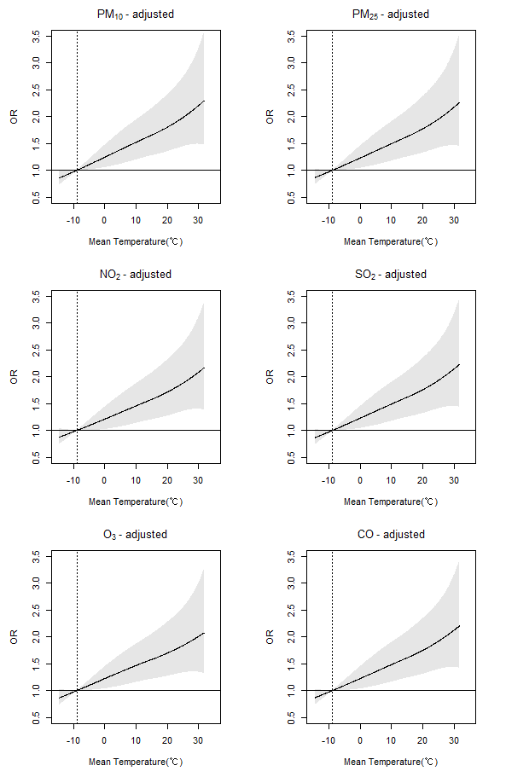
Fig S1. Sensitivity analyses additionally adjusting for air pollutants (PM₁₀, PM_{2.5}, NO₂, SO₂, O₃, and CO).

