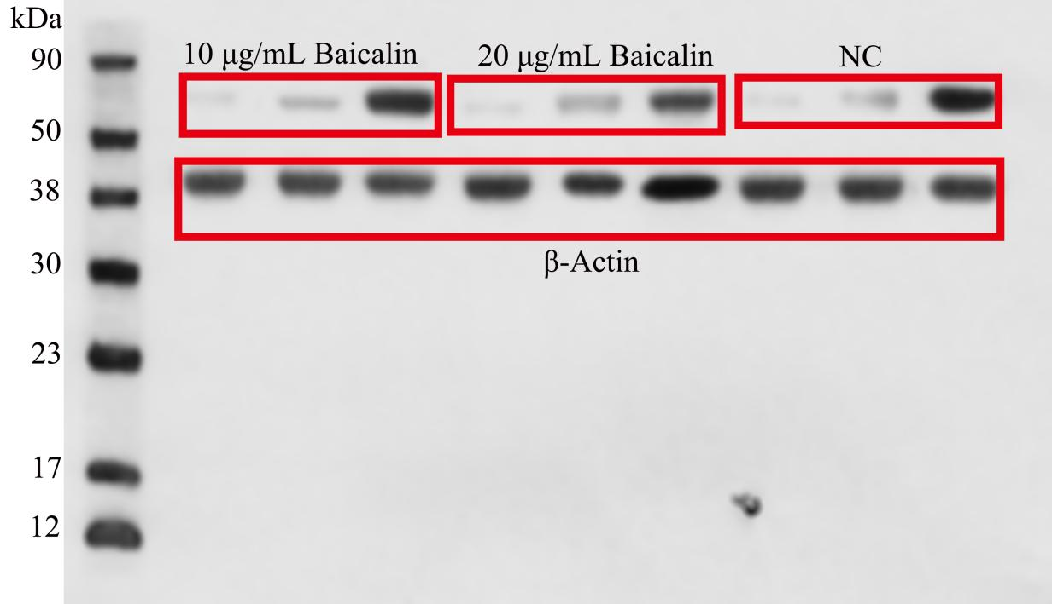
Figure S1. The relative expression levels of the IBV-N protein were detected by Western blot (Figure 2C).

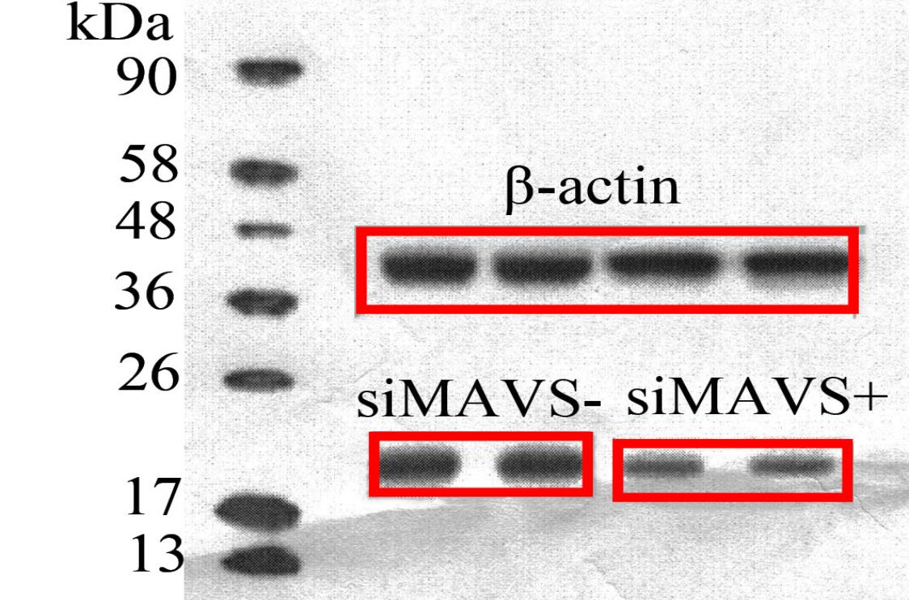

Figure S2. Protein expression of IFN-β in CEK cell after IBV infection were detected by Western blot (Figure 7D)

