Reusable and effective multi-biocatalyst system for transformation of glycerol to value-added dihydroxyacetone
Youngho Weeª, Gudi Satheesh Kumarª, Seongbeen Kim^{b}, Xueyan Sarah Zhao^{c}, Ping Wang^{d}, Jinwoo Lee^{b}, Ee Taek Hwang^{e,}*, and Jungbae Kim^{a,}*
ª Department of Chemical and Biological Engineering, Korea University, Seoul 02841, Korea
^{b} Department of Chemical and Biomolecular Engineering, Korea Advanced Institute of Science and Technology (KAIST), Daejeon, 34141 Republic of Korea
^{c} Department of Chemical Engineering and Bioengineering, Gordon and Jill Bourns College of Engineering, California Baptist University, Riverside, California 92504, United States
^{d} Bioproducts and Biosystems Engineering, and Biotechnology Institute, University of Minnesota, Saint Paul, Minnesota 55108, United States
^{e} Department of Food Biotechnology, Dong-A University, Busan 49315, Republic of Korea

* Corresponding author
Tel.: +82-2-3290-4850; E-mail: jbkim3@korea.ac.kr
Tel.: +82-51-200-7547; E-mail: ethwang@dau.ac.kr

Keywords: cofactor recycling, multi-enzyme immobilization, crosslinked enzyme aggregate, glycerol oxidation, dihydroxyacetone production
Table S1. Specific acidities and total turnover numbers of NAD+ reduction catalyzed by GDH, NADH oxidation catalyzed by ADH, and glycerol transformation to DHA catalyzed by GDH/ADH multi-enzyme system.
Sample | NAD⁺ reduction | NADH oxidation | DHA production |  | Total turnover number  (TTN)
Sample | NAD⁺ reduction | NADH oxidation | Without acetaldehyde | With  acetaldehyde | Total turnover number  (TTN)
NER-GDH | 0.46 | N/A | 0.65 | 5.60 | 8.61
NER-ADH | N/A | 0.76 | 0.65 | 5.60 | 8.61
NER-GDH/ADH | 0.37 | 0.81 | 0.37 | 6.83 | 18.63

TTN (Total turnover number) = $\frac{nP (Molar amount of product synthesized)}{nCofactor (Molar amount of cofactor used)}$

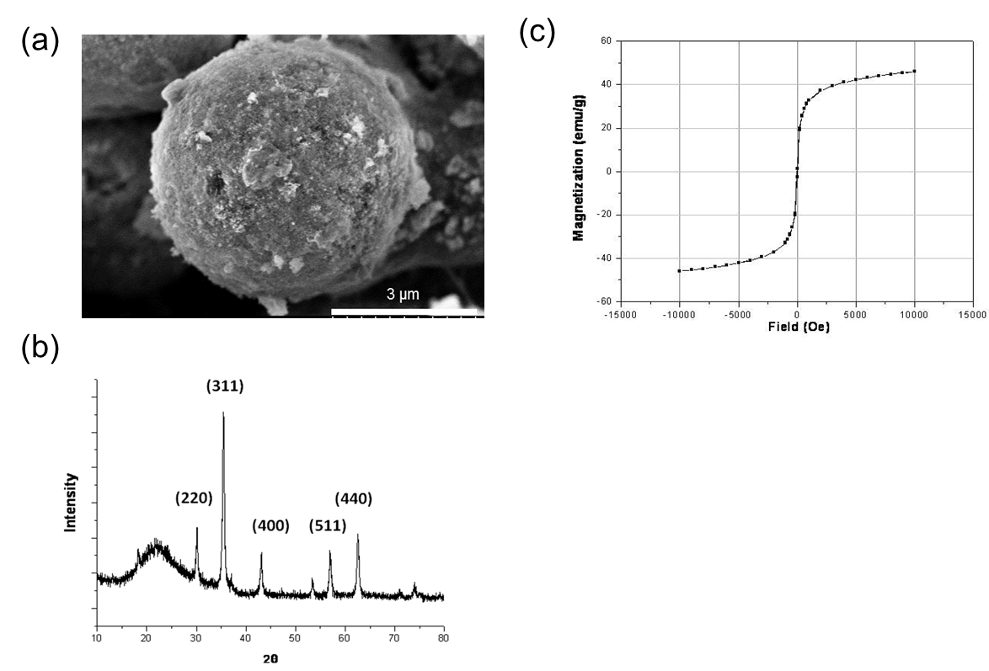

Fig. S1. Properties of Mag-S-MCF, (a) SEM image of the synthesized Mag-S-MCF. (b) The X-ray diffraction (XRD) pattern of the synthesized Mag-S-MCF corresponding to characteristic pure magnetite and mesocellular silica. (c) The magnetic properties of Mag-S-MCF showing the magnetization curve depicts the strong magnetic response to external magnetic field.

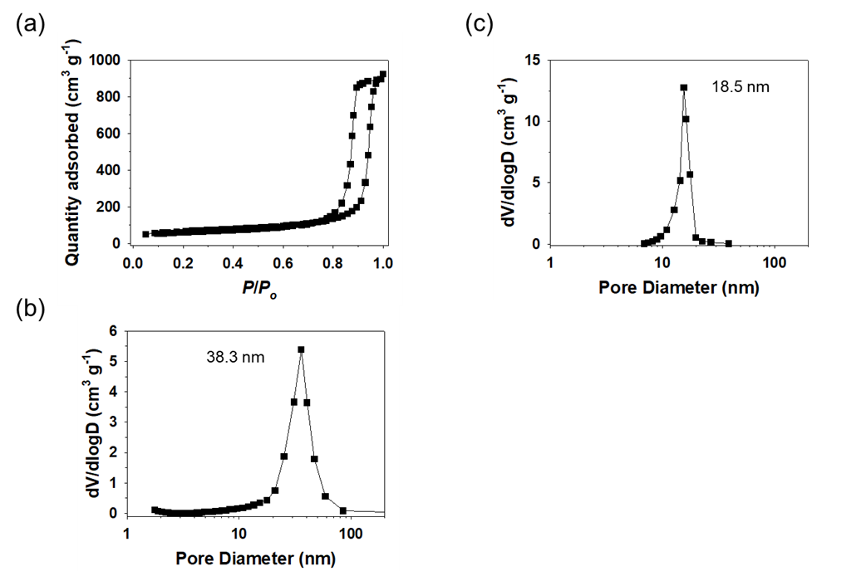
Fig. S2. Pore properties of as synthesized Mag-S-MCF. (a) N₂ adsorption-desorption curve and corresponding pore size distribution of (b) main pore and (c) window pore in the Mag-S-MCF.

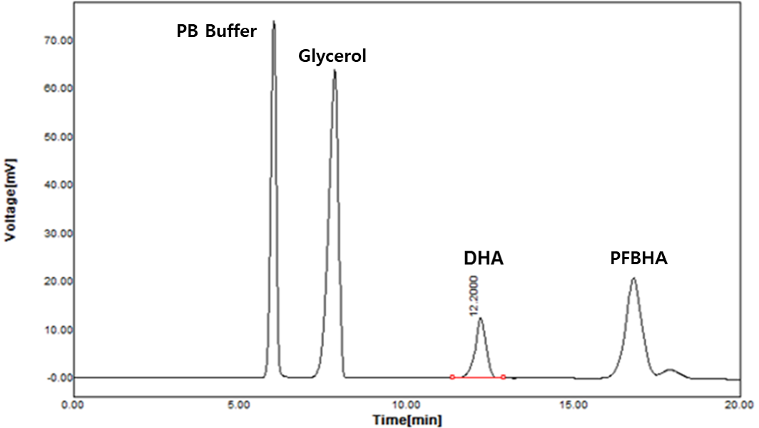
Fig. S3. HPLC chromatogram for the DHA analysis. The chromatogram showing the elution profile of DHA from the reaction mixture. The DHA extraction and analysis conditions are similar as described in materials and method.

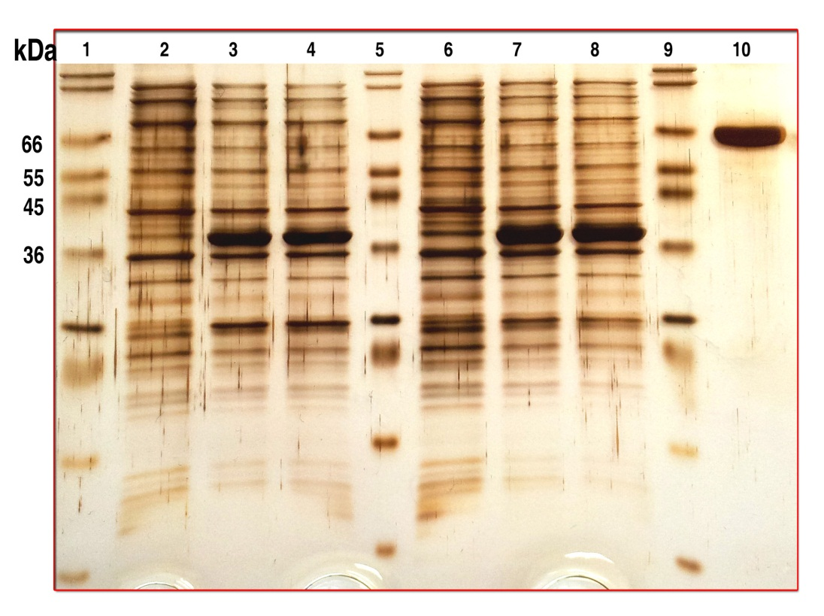
Fig. S4. SDS-PAGE of purified GDH. (Lane 1,5,9 are marker proteins, 2,6 are Un-induced recombinant E.coli for GDH expression, 3,4 are induced recombinant E.coli for GDH expression (2 h), 7,8 are induced recombinant E.coli for GDH expression (5 h), 10 is BSA

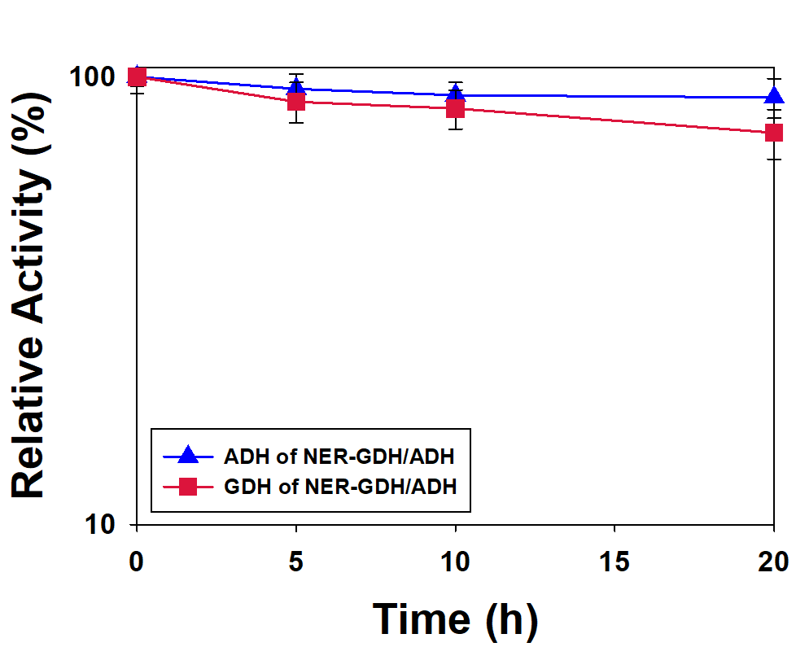
Figure S5. Aldehyde tolerance of NER-GDH/ADH in 100 mM acetaldehyde.

