Supplementary information:
Rearrangement of anti-synchronous activities in the brain functional network plays a crucial role in behavioral contagion
Authors:
Mohsen Mobasseri¹, Abdol-Hossein Vahabie^{2*}, Gholamreza Jafari³, Javad Hatami^{1,4}, Reza Khosrowabadi^{3*}

Affiliation:
¹Institute for Cognitive Science Studies, Tehran, Iran.
²College of Engineering / School of Electrical and Computer Engineering, University of Tehran, Iran.
³Institute for Cognitive and Brain Science, Shahid Beheshti University, Tehran, Iran.
⁴Faculty of Psychology and Educational Sciences, University of Tehran, Iran.
* Joint corresponding authors: Reza Khosrowabadi, Abdol-Hossein Vahabie.
Reza Khosrowabadi
Address: ²Institute for Cognitive and Brain Science, Shahid Beheshti University, Tehran, Iran.
email: r_khosroabadi@sbu.ac.ir.
Tel: +98(0)9101738501, ORCID: 0000-0002-6282-9389
Abdol-Hossein Vahabie
Address: College of Engineering / School of Electrical and Computer Engineering, University of Tehran, Tehran, Iran.
email: h.vahabie@ut.ac.ir .
Tel: +98(0)9194211374, ORCID: 0000-0003-1603-8866

Supplementary figures:

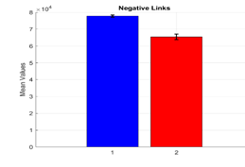 | 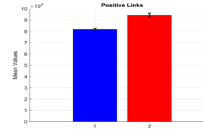 | 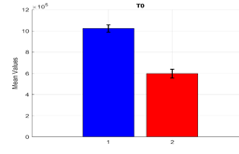
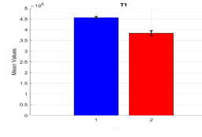 | 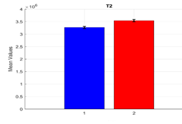 | 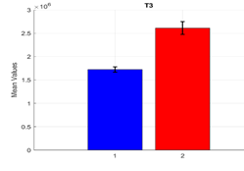
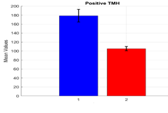 | 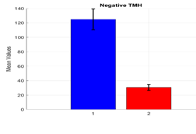 | 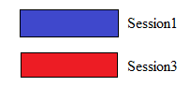

Figure S1. For the No Contagion group, the matched pairs in sessions 1 and 3 were measured. There were significant differences between matched pairs of number of negative links, number of positive links, negative TMH, positive TMH, T0, T1, T2, and T3.

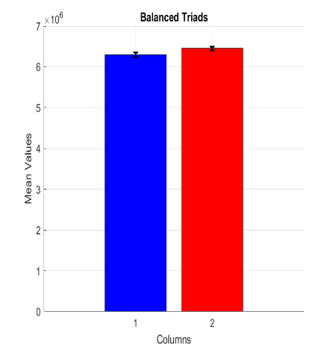 | 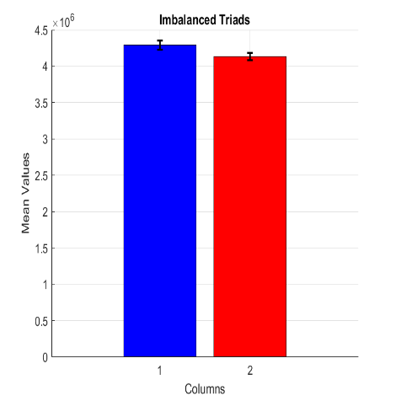 | 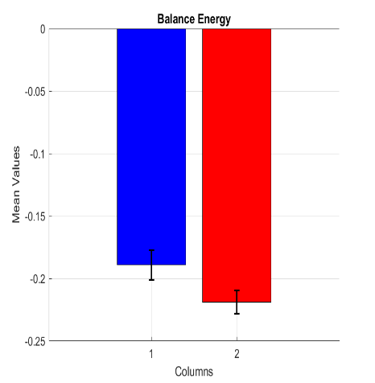

Figure S2. For the No Contagion group, the matched pairs in sessions 1 and 3 were measured. There were no significant differences between matched pairs consisted of number of balanced triads, number of imbalanced triads, and balance energy

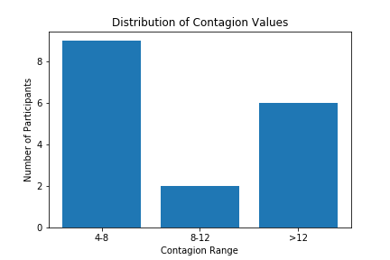

Figure S3. The number of participants with different BCR.

Supplementary tables:

Table.S1 Comparing the matched pairs of sessions 1 of two lists, and also Comparing sessions 3 of two lists (S and NS denote Significant and No Significant difference, respectively).
Comparing Sessions Between Lists | neg | pos | T0 | T1 | T2 | T3 | Negative TMH | Positive TMH | Balanced Triads | Imbalanced Triads | Balance Energy
Session 1 of Lists | S | S | S | S | NS | S | S | S | NS | NS | NS
Session 3 of Lists | S | S | NS | S | S | NS | NS | NS | NS | NS | NS

The data sets compiled and analyzed in this study for the "Contagion" and "No Contagion" groups are available in two separate tables at https://github.com/M-Mobasseri/-Behavioral-contagion .

