Additional file 1. Morphological analysis of trachea tissues isolated from control and Mycoplasma pneumonia in calves
(A and B) Trachea tissues from no clinical respiratory symptoms control and Mycoplasma pneumonia in calves were stained with hematoxylin and eosin. Cilia were detected on the epithelial cells of control calves. Scale bar: 32μm. (C-J) Trachea tissues from control and Mycoplasma pneumonia in calves were stained with cytokeratin-18 antibody, M. bovis antibody, and DAPI solution and analyzed by fluorescence microscope. Cytokeratin-18 is stained in red (C and D), M. bovis is stained in green (E and F), and nucleus is stained in blue (G and H). These images are overlayed (I and J). Representative images are shown. Positive area of M. bovis were detected in epithelial cells of trachea tissues from Mycoplasma pneumonia in calf (white arrows). Scale bar: 100μm. (K-N) Trachea mucosa from control and Mycoplasma pneumonia in calves were analyzed by SEM. Scale bar: 10μm. (K and L) Surface of tracheal mucosa from control calf was covered all over with cilia. (M) Bacterium-like aggregation structures on the tracheal mucosa from Mycoplasma pneumonia in calves were observed (yellow arrow heads). Red square was magnified in (N) to better show. (N) Bacteria were detected on the bacterium-like aggregation structures (red arrows).

Additional file 2. Morphological analysis of Mycoplasma bovis by scanning electron microscope
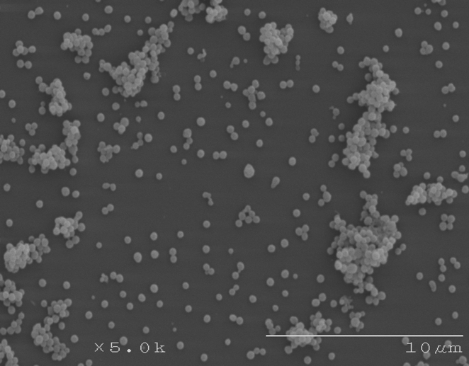
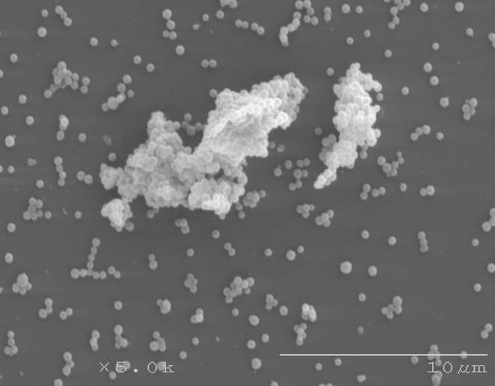
B
A

Biofilm formation of Mycoplasma bovis PG45 (A) and Strain M2(B) were analyzed by scanning electron microscope. Bacterium aggregation structures were observed (red arrow heads). Scale bar: 10μm.

Additional file 3. Quantitative analysis of biofilm formation co-cultured with M. bovis and T. pyogenes

T. pyogenes only
(Strain T2)
Strain M16
PG45
1×10⁷
1×10⁶
1×10⁵
1×10⁴
1×10⁷
1×10⁶
1×10⁵
1×10⁴
0
1×10⁷
1×10⁶
1×10⁵
1×10⁴
0
Biofilm biomass (OD 595nm)

M. bovis were co-cultured with 1×10⁴, 1×10⁵, 1×10⁶, or 1×10⁷ CFU T. pyogenes (Strain T2) per well in PPLO base medium for 24 h. Biofilms were quantified by crystal violet staining. Gray bars are M. bovis single culture. White bars are T. pyogenes single culture.

