Online Supplement

Title: Molecular Phenotyping of Patients with Sepsis and Kidney Injury and Differential Response to Fluid Resuscitation

Authors: Elizabeth Kiernan, MD; Leila R. Zelnick, PhD; Ayesha Khader MD.; et al.

Table of Contents
Online Methods
Figure S1. Correlation of UPlex and RPlex measured sTNFR-1
Figure S2. Flow Diagram of Analytic Population
Table S1. Characteristics of SP1 and SP2 in patients without AKI
Table S2. Study enrollment variables used in latent class analysis
Table S3. Model Fit Using Latent Class Analysis to identify AKI sub-phenotypes in CLOVERS
Table S4. Differences in clinical outcomes between sub-phenotypes and no AKI
Table S5. Association of sub-phenotypes Compared to no AKI for Kidney Replacement Therapy and Invasive Mechanical Ventilation
Table S6. Treatments by sub-phenotypes in 24 hours post-randomization
Table S7. Association of sub-phenotypes compared to no AKI with days out of the ICU
Table S8. Treatment Effects by Sub-phenotypes in patients with AKI/ESKD
Table S9. Treatment Effects by sub-phenotypes in patients with AKI for Mortality, Kidney Replacement Therapy (KRT) and Invasive Mechanical Ventilation (IMV) Excluding ESKD
Table S10. Cross-tabulation of AKI and ARDS/sepsis sub-phenotypes
Table S11. Treatment effect by ARDS sub-phenotypes

Online Methods

Sample Collection and Biomarker Measurement
Peripheral blood was collected into ethylenediaminetetraaceteic acid (EDTA) anticoagulant tubes on study enrollment. We measured Ang-1, Ang-2 and sTNFR-1 using electrochemiluminiscence-based immunoassays (MesoScale Discovery, Rockville, MD). The intra-plate coefficient of variation (CV) for Ang-1 was 5.4%, Ang-2 was 5.2% and sTNFR-1 was 8.1% and the inter-plate CV for Ang-1 was 11.6%, Ang-2 was 14.9% and sTNFR-1 was 12.1%. All samples underwent 1 freeze-thaw cycle prior to analysis. Only one sample was measured below the lower limit of detection, and this value was set to half of the lower limit of detection.

Latent Class Analysis
We applied LCA to 23-variables collected at study enrollment. A list of variables can be found in Table S2. Sub-phenotype classification was conducted without inclusion of clinical outcomes. We used the Vuong-Lo-Mendell-Rubin (VLMR) likelihood ratio test (tests whether n class is a better model than n-1 class) as our primary test for model fit based on prior reports. We also considered additional criteria, including the Bayesian Information Criteria (lower values suggest model parsimony), the entropy statistic (a measure of class separation, with optimal values greater than 0.8) and class prevalence. All continuous variables were standardized to a mean of 0 and a standard deviation of 1.

Figure S1. Correlation of UPlex and RPlex measured sTNFR-1
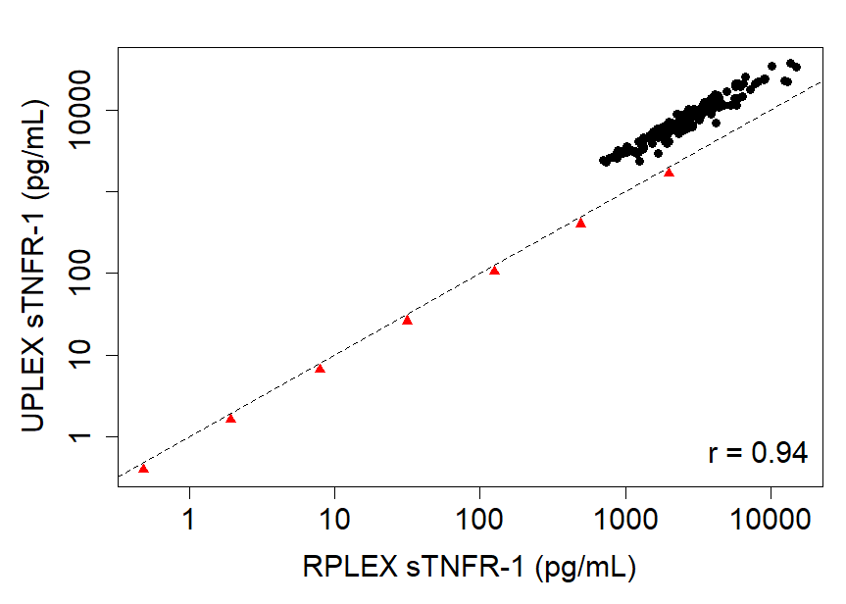

Red triangles are standards. Each black dot is a different patient sample (n=40). The same patient samples were measured on the UPlex and RPlex sTNFR-1 assays. The Pearson’s correlation for the two measurements was 0.94. The calibration equation to convert UPlex measured sTNFR-1 concentrations to RPlex was TNFR_R-Plex = -101.3387 +0.3617*TNFR_U-Plex.

Figure S2. Flow Diagram of Analytic Population
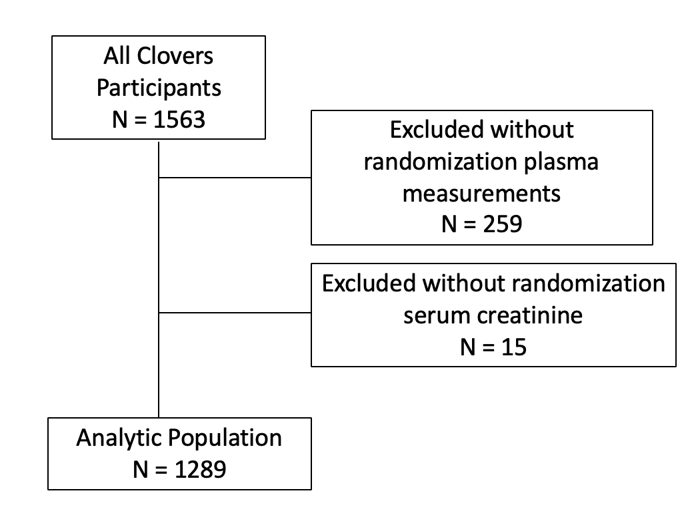

Figure Legend: Participants with sepsis-induced hypotension were enrolled in CLOVERS and plasma was collected at the time of study enrollment. Participants without plasma collected were excluded (n=259) and participants without a serum creatinine measured at randomization (n=15). The final analytic population included 1289 participants.

Table S1. Baseline characteristics stratified by sub-phenotypes in patients without AKI or ESKD on study enrollment

 | SP1  (N = 411) | SP2  (N = 32)
Age (years), average ± SD | 55.3 ± 16.8 | 65.3 ± 16.7
Male, n (%) | 189 (46%) | 28 (88%)
SOFA score, average ± SD | 2.0 ± 2.1 | 4.9 ± 2.7
History of CKD, n (%) | 12 (3%) | 7 (22%)
Baseline serum creatinine (mg/dL), average ± SD | 0.9 ± 0.5 | 2.0 ± 2.4
Randomization serum creatinine (mg/dL), average ± SD | 0.9 ± 0.5 | 2.0 ± 2.3
Biomarker Concentrations, median (IQR)
sTNFR-1 | 2957 (1999-4919) | 13668 (10127-17727)
Ang-1 | 6012 (2838-10201) | 1288 (343-2256)
Ang-2 | 5595 (4007-9458) | 20703 (12955-29463)
Ang-2/Ang-1 | 1.1 (0.5-2.4) | 17.6 (10.1-45.3)
Entries are mean (SD) for continuous variables and N (%) for categorical variables, except as noted.

Table S2. Study enrollment variables used in latent class analysis
Study Enrollment Variables
- Age
- Male
- White
- Body mass index
- Diabetes Mellitus
- Serum bicarbonate
- Vasopressors
- Pneumonia
- Acute respiratory distress syndrome
- Invasive mechanical ventilation on study enrollment
- History of cirrhosis
- White blood cell Count
- Sodium
- Blood urea nitrogen
- Lactate
- Hematocrit
- Platelets
- Serum creatinine
- Angiopoietin-1
- Angiopoieint-2
- Soluble tumor necrosis factor receptor-1
- Interleukin-6
- Angiopoietin 2:1 ratio

Table S3. Model Fit Using Latent Class Analysis to identify AKI sub-phenotypes in CLOVERS
Number of Classes | BIC* | Entropy | Number of Individuals Per Class |  |  |  | VLMR p-value
Number of Classes | BIC* | Entropy | N1 | N2 | N3 | N4 | VLMR p-value
2 | 40745 | 0.815 | 545 | 301 |  |  | <0.001
3 | 40225 | 0.855 | 495 | 267 | 84 |  | 0.218
4 | 39893 | 0.822 | 365 | 166 | 243 | 72 | 0.120
*BIC is sample size adjusted

Table S4. Differences in clinical outcomes between sub-phenotypes and no AKI
Clinical Outcomes | N at risk (N events) | Model 1: Adjusted HR (95% CI) | p-value | Model 2: Adjusted HR (95% CI) | p-value | Model 3: Adjusted HR (95% CI) | p-value
28-day Mortality
No AKI | 443 (40) | 1.0 (Ref.) |  | 1.0 (Ref.) |  | 1.0 (Ref.)
SP1 | 605 (61) | 0.94 (0.63, 1.40) | 0.76 | 0.70 (0.33, 1.48) | 0.35 | 1.12 (0.53, 2.38) | 0.76
SP2 | 241 (82) | 3.54 (2.38, 5.26) | < 0.0001 | 2.60 (1.31, 5.15) | 0.006 | 2.61 (1.33, 5.13) | 0.005
SP2 vs SP1 |  | 3.77 (2.67, 5.32) | < 0.0001 | 3.71 (2.59, 5.32) | < 0.0001 | 2.33 (1.60, 3.38) | < 0.0001
90-day Mortality
No AKI | 443 (68) | 1.0 (Ref.) |  | 1.0 (Ref.) |  | 1.0 (Ref.)
SP1 | 605 (105) | 0.94 (0.69, 1.28) | 0.70 | 0.74 (0.40, 1.39) | 0.35 | 1.14 (0.61, 2.12) | 0.69
SP2 | 241 (101) | 2.68 (1.94, 3.71) | < 0.0001 | 2.15 (1.21, 3.82) | 0.009 | 2.26 (1.28, 3.98) | 0.005
SP2 vs SP1 |  | 2.85 (2.14, 3.79) | < 0.0001 | 2.89 (2.14, 3.90) | < 0.0001 | 1.98 (1.45, 2.71) | < 0.0001

Model 1 adjusted for age, sex, prior history of chronic kidney disease, prior history of cardiovascular disease (which included the composite of cerebrovascular disease, coronary artery disease, myocardial infarction, and congestive heart failure), and resuscitation strategy.
Model 2 additionally adjusts Model 1 and kidney disease improving global outcomes stage of acute kidney injury or end-stage kidney disease.
Model 3 additionally adjusts for Model 2 and sequential organ failure assessment scores.

Table S5. Association of sub-phenotypes Compared to no AKI for Kidney Replacement Therapy and Invasive Mechanical Ventilation
Clinical Outcomes | N at risk (N events) | Model 1 |  | Model 2 |  | Model 3
 |  | Adjusted sHR (95% CI) | p-value | Adjusted sHR (95% CI) | p-value | Adjusted sHR (95% CI) | p-value
Kidney Replacement Therapy*
No AKI | 443 (7) | 1.0 (Ref.) |  | 1.0 (Ref.) |  | 1.0 (Ref.)
SP1 | 589 (14) | 1.39 (0.56, 3.47) | 0.48 | 2.06 (0.74, 5.79) | 0.17 | 1.48 (0.52, 4.22) | 0.47
SP2 | 182 (21) | 7.03 (2.95, 16.79) | < 0.0001 | 9.17 (3.66, 22.97) | < 0.0001 | 4.48 (1.6, 12.57) | 0.004
SP2 vs SP1 |  | 5.05 (2.56, 9.98) | < 0.0001 | 4.44 (2.19, 9.03) | < 0.0001 | 3.03 (1.42, 6.47) | 0.004
Invasive Mechanical Ventilation**
No AKI | 417 (32) | 1.0 (Ref.) |  | 1.0 (Ref.) |  | 1.0 (Ref.)
SP1 | 570 (59) | 1.30 (0.84, 2.01) | 0.24 | 0.73 (0.28, 1.89) | 0.51 | 1.1 (0.43, 2.85) | 0.84
SP2 | 220 (50) | 3.18 (1.99, 5.07) | < 0.0001 | 1.74 (0.7, 4.3) | 0.23 | 1.7 (0.7, 4.14) | 0.24
SP2 vs SP1 |  | 2.45 (1.66, 3.62) | < 0.0001 | 2.39 (1.59, 3.58) | < 0.0001 | 1.54 (1.00, 2.37) | 0.05
Models for kidney replacement therapy and invasive mechanical ventilation account for the competing risk of death.
Model 1 adjusted for age, sex, prior history of CKD, prior history of cardiovascular disease (which included the composite of cerebrovascular disease, coronary artery disease, myocardial infarction, and congestive heart failure), and resuscitation strategy.
Model 2 additionally adjusts for stage of AKI/dialysis.
Model 3 additionally adjusts for stage of AKI/dialysis and baseline SOFA score.
*Among participants who were not on maintenance dialysis (N = 1214)
**Among participants who were not mechanically ventilated at randomization (N = 1206)

Table S6. Treatments by sub-phenotypes in 24 hours post-randomization
 | Liberal, SP1  (N = 305) | Restrictive, SP1  (N = 300) | Liberal, SP2  (N = 123) | Restrictive, SP2  (N = 118)
Fluid volume (mL), mean (SD) | 3684 (1644) | 1684 (1657) | 4091 (1793) | 2244 (2305)
Vasopressor Administration, n (%) | 104 (34%) | 193 (64%) | 85 (69%) | 99 (84%)
Time from randomization to Vasopressor* (hours), mean (SD) | 3.2 (4.2) | 2.0 (3.7) | 2.8 (4.7) | 1.0 (2.5)
Duration of Vasopressor Use* (hours), mean (SD) | 13.5 (7.8) | 15.9 (7.8) | 17.1 (7.3) | 19.3 (6.8)
Entries are mean (SD) or N (%).
*Among participants who received vasopressors only

Table S7. Association of sub-phenotypes compared to no AKI for days out of the ICU
Clinical Outcomes | Mean (SD) | Model 1 |  |  | Model 2 |  |  | Model 3
 |  | Adjusted difference (95% CI) | p-value | Adjusted difference (95% CI) |  | p-value | Adjusted difference (95% CI) |  | p-value
Days out of the ICU from day 1 to day 28
No AKI | 24.5 (7.3) | 0 (Ref.) |  | 0 (Ref.) |  |  | 0 (Ref.)
SP1 | 23.8 (7.7) | -0.1 (-1.1, 0.9) | 0.86 | 0.7 (-2, 3.4) |  | 0.63 | -1.2 (-3.8, 1.4) |  | 0.36
SP2 | 17.1 (11.3) | -6.1 (-7.4, -4.7) | < 0.0001 | -5.2 (-7.7, -2.6) |  | < 0.0001 | -4.3 (-6.8, -1.9) |  | 0.0005
SP2 vs SP1 |  | -6.0 (-7.3, -4.7) | < 0.0001 | -5.8 (-7.2, -4.5) |  | < 0.0001 | -3.1 (-4.5, -1.8) |  | < 0.0001

Model 1 adjusted for age, sex, prior history of CKD, prior history of cardiovascular disease (which included the composite of cerebrovascular disease, coronary artery disease, myocardial infarction, and congestive heart failure), and resuscitation strategy.
Model 2 additionally adjusts for stage of AKI and ESKD.
Model 3 additionally adjusts for stage of AKI and ESKD and baseline SOFA score.

Table S8. Treatment Effects by Sub-phenotypes in patients with AKI and ESKD
Outcomes | Sub-phenotypes | N at risk/N of events, liberal | N at risk/N of events, restrictive | sHR (liberal is the reference group) (95% CI) | p-value for interaction
Risk of RRT* | SP-1 | 297 (7) | 292 (7) | 1.02 (0.36, 2.92) | 0.66
Risk of RRT* | SP-2 | 94 (12) | 88 (9) | 0.76 (0.32, 1.80)
Risk of IMV** | SP-1 | 289 (31) | 281 (28) | 0.92 (0.55, 1.54) | 0.46
Risk of IMV** | SP-2 | 113 (30) | 107 (20) | 0.69 (0.39, 1.22)
*Among participants who were not on maintenance dialysis (N = 771)
**Among participants who were not mechanically ventilated at randomization (N = 790)

Table S9: Treatment Effects by sub-phenotypes in patients with AKI for mortality, kidney replacement therapy (KRT) and invasive mechanical ventilation (IMV) excluding ESKD
Outcomes | AKI sub-phenotypes | N at risk, liberal | N events, liberal | N at risk, restrictive | N events, restrictive | Difference, restrictive-liberal (95% CI) | p-value for interaction
28-day mortality | SP-1 | 122 | 10% | 144 | 10% | 0% (-5%, 5%) | 0.16
28-day mortality | SP-2 | 25 | 39% | 20 | 29% | -11% (-24%, 3%)
90-day mortality | SP-1 | 122 | 18% | 144 | 17% | 0% (-7%, 6%) | 0.34
90-day mortality | SP-2 | 25 | 46% | 20 | 38% | -8% (-22%, 6%)
Difference estimate for 28-day and 90-day mortality is the difference in percentage with outcome comparing restrictive and liberal fluid treatment groups.

Table S10. Cross-tabulation of sub-phenotypes.
 | SP1 | SP2 | Total
Hypoinflammatory ARDS | 517 | 107 | 624
Hyperinflammatory ARDS | 88 | 134 | 222
Total | 605 | 241 | 846
Cohen’s Kappa for Agreement: 0.42
Hypo and hyperinflammatory acute respiratory distress syndrome (ARDS) sub-phenotypes were defined using a published four variable model that included plasma concentrations of interleukin-6, sTNFR-1, serum bicarbonate and clinical documentation of receipt of vasopressors prior to randomization (PMID: 31948926). AKI sub-phenotypes were defined using the following 3-variable biomarker prediction model: Logit(P(SP2)) = -35.44+1.99*log(Ang-2/Ang-1) + 3.41*log(TNFR_R-Plex). Patients with a probability cutoff greater than 0.5 were classified as SP2 and patients with less than or equal 0.5 were classified as SP1.

Table S11. Treatment effects by ARDS sub-phenotype status among patients with kidney dysfunction (n=846) in CLOVERS
CLOVERS Populations |  | % who died, liberal | % who died, restrictive | Difference, restrictive – liberal (95% CI) | Difference of Difference (95% CI) | p-value for interaction
28-day mortality | Hypo-inflammatory ARDS | 14% | 11% | -4% (-9%, 1%) | 8% (-5%, 21%) | 0.25
28-day mortality | Hyperinflammatory ARDS | 35% | 24% | -11% (-24%, 1%) | 8% (-5%, 21%) | 0.25
90-day mortality | Hypoinflammatory ARDS | 22% | 18% | -4% (-11%, 2%) | 4% (-10%, 18%) | 0.60
90-day mortality | Hyperinflammatory ARDS | 42% | 34% | -8% (-21%, 5%) | 4% (-10%, 18%) | 0.60

