Supplementary Information for the manuscript
Anthropogenic influence on excess warming in Europe during recent decades
Buwen Dong* and Rowan T. Sutton
National Centre for Atmospheric Science, Department of Meteorology, University of Reading
*corresponding author: Buwen Dong, b.dong@reading.ac.uk

Content:
- Supplementary Table S1
- Supplementary Figures S1-S9

Supplementary Table 1: CMIP6 and DAMIP models used in this study.
 | Model | Resolution (grid number in lat×lon) |  | Members
 | Model |  |  | All | GHG | AER | NAT
1  2  3 | ACCESS-CM2  ACCESS-ESM1-5  BCC-CSM2-MR |  | 145×192  144×192  160×320 | 1  1  3 | 3  1  3 | 3  1  3 | 3  1  3
4  5 | CanESM5  CESM2 |  | 64×128  192×288 | 25  6 | 10  3 | 10  1 | 10  3
6  7 | CNRM-CM6-1  GFDL-ESM4 |  | 128×256  180×288 | 10  1 | 10  1 | 10  1 | 10  1
8 | GISS-E2-1-G |  | 90×144 | 10 | 5 | 5 | 0
9 | HadGEM3-GC31-LL |  | 145×192 | 4 | 4 | 4 | 4
10 | IPSL-CM6A-LR |  | 143×144 | 9 | 10 | 10 | 10
11 | MIROC6 |  | 128×256 | 10 | 3 | 3 | 3
12 | MRI-ESM2-0 |  | 160×320 | 5 | 3 | 3 | 3
13 | NorESM2-LM  All models |  | 96×144 | 3  88 | 3  59 | 3  57 | 3  54

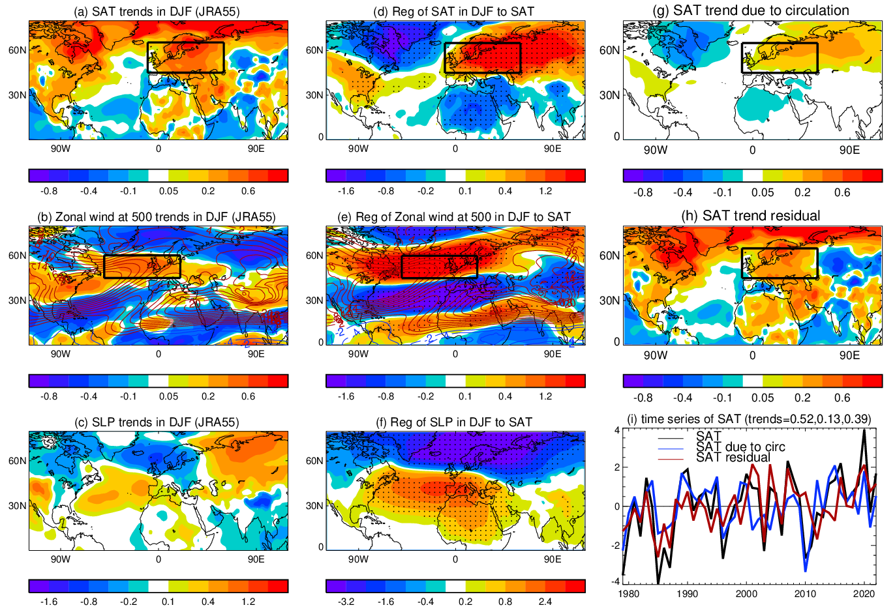

Supplementary Fig. S1: Linear trends of SAT, atmospheric circulation, regression patterns and circulation induced SAT trends in DJF based on JRA55 reanalysis. (a, b, c) Linear trends of SAT (ºC decade-1), zonal wind (m s⁻¹ decade⁻¹), and SLP (hPa decade⁻¹). (d, e, f) Regression patterns of SAT (ºC), zonal wind (m s⁻¹) at 500 hPa, and SLP (hPa) in DJF to the normalized time series of European SAT index which is defined as the area averaged SAT over the region (45ºN-65ºN, 10ºW-60ºE, black box in a, d, g, h) in DJF. (g, h) Linear trends of SAT due to circulation changes (ºC decade⁻¹) and SAT residual trend (ºC decade⁻¹). (i) Time series (i) of SAT anomalies (total, part due to circulation change, and the residual) over Europe and linear trends (ºC decade⁻¹; numbers in top right). The circulation index used for decomposition of SAT trends is the NAO index, defined as the difference of area averaged SLP over the southern box (36ºN-38ºN, 28ºW-22ºW) around Azores and the northern box (64ºN-66ºN, 26ºW-21ºW) around Iceland (see Methods). The global mean is removed in panels (a-h). Note that the removal of global mean has a very little impact on panels (b-g). The black box in panels (a, d, g, h) outlines the region that is used to define SAT index over Europe in DJF.

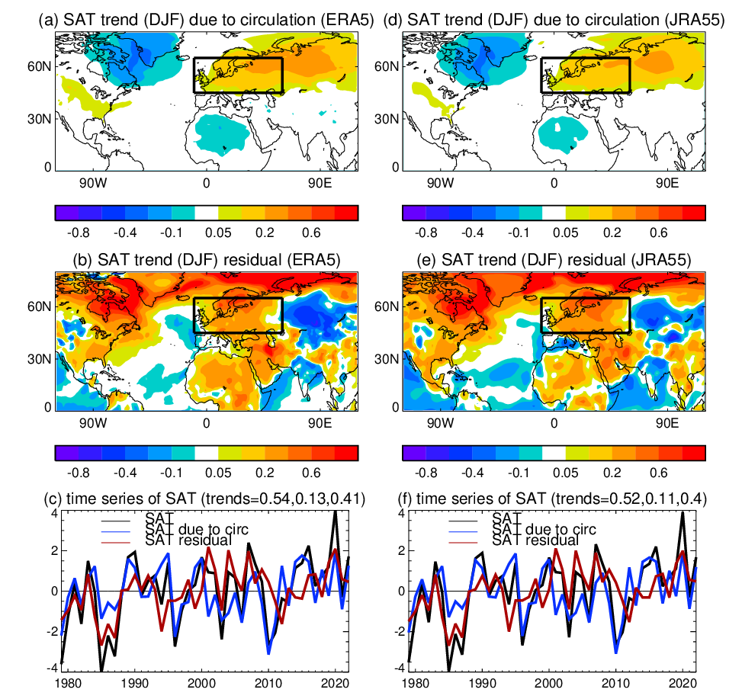

Supplementary Fig. S2: Linear trends of SAT due to circulation changes (based on a zonal wind index) and SAT residual trend in DJF. (a, d) SAT due to circulation changes (ºC decade⁻¹), (b, e) SAT residual trend (ºC decade⁻¹), and (c, f) time series of SAT anomalies over Europe. (a, b, c) ERA5 reanalysis and (d, e, f) JRA55 reanalysis. The circulation index is a zonal jet index averaged over the North Atlantic jet exit region (45ºN-60ºN, 50ºW-20ºE) at 500 hPa which is shown in black box in panels (b, e) in Fig. 2. The details for decomposition of SAT trends are in Methods.
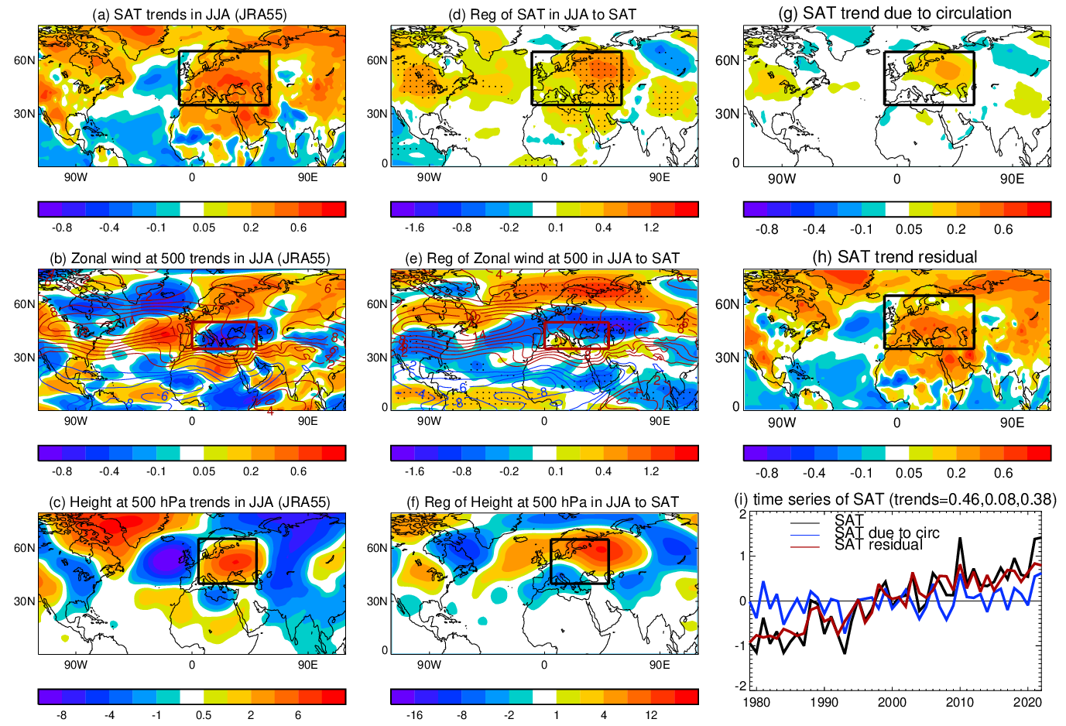

Supplementary Fig. S3: Linear trends of SAT, atmospheric circulation, regression patterns and circulation induced SAT trends in JJA based on JRA55 reanalysis. (a, b, c) Linear trends of SAT (ºC decade⁻¹), zonal wind (m s⁻¹ decade⁻¹) and geopotential height (m decade⁻¹) at 500 hPa. (d, e, f) Regression patterns of SAT (ºC), zonal wind (m s⁻¹) and geopotential height (m) at 500 hPa in JJA to the normalized time series of the European SAT index which is defined as area averaged SAT over the region (35ºN-65ºN, 10ºW-60ºE, black box in a, d, g, h) in JJA. (g, h) SAT trends due to circulation changes (ºC decade⁻¹) and SAT residual trend (ºC decade⁻¹). (i) Time series of SAT anomalies (total, part due to circulation change, and the residual) over Europe and linear trends (ºC decade⁻¹; numbers in top right). The circulation index used for decomposition of SAT trends is the height index, which is defined as the area averaged geopotential height over the region (40ºN-65ºN, 5º-50ºE, black box in c and f) with zonal averaged value over the same latitude band removed (see Methods). The global mean is removed in panels (a-h). Note that the removal of global mean has a very little impact on panels (b-g). The black box in panels (a, d, g, h) outlines the region that is used to define SAT index over Europe in JJA. The red box in (b) and (e) is used to define a zonal jet index over the Mediterranean to test the sensitivity of SAT trend decomposition over Europe to an alternative choices for the circulation index and results are shown in Supplementary Information Figure S4.
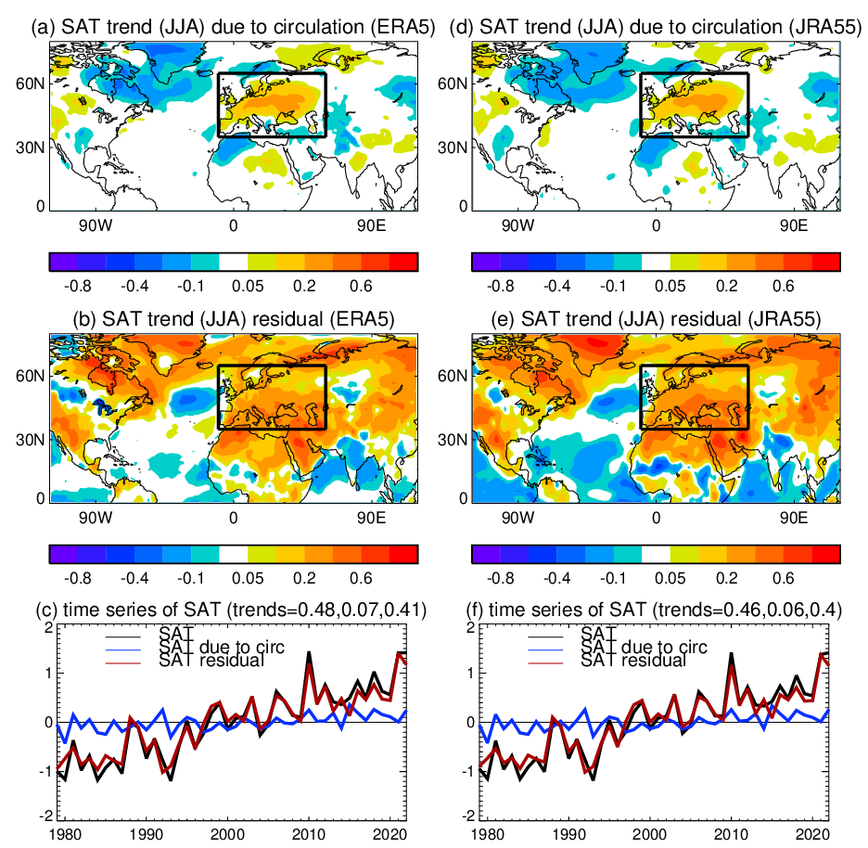

Supplementary Fig. S4: Linear trends of SAT due to circulation changes (based on a zonal wind index) and SAT residual trend in JJA. (a, d) SAT due to circulation changes (ºC decade⁻¹), (b, e) SAT residual trend (ºC decade⁻¹), and (c, f) time series of SAT anomalies over Europe. (a, b, c) ERA5 reanalysis and (d, e, f) JRA55 reanalysis. The circulation index is zonal index averaged over the Mediterranean (35ºN-50ºN, 0º-50ºE) at 500 hPa which is outlined in red box in panels (b, e) in Fig. 3. The details for decomposition of SAT trends are in Methods.
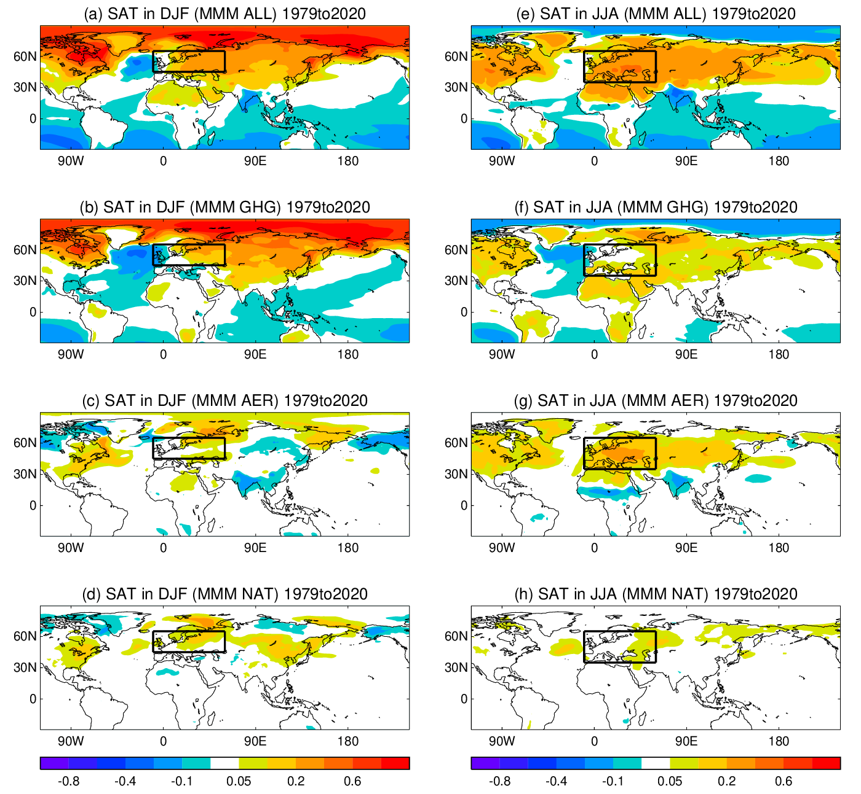

Supplementary Fig. S5: The multimodel mean (MMM) linear trends of SAT in winter (December, January, February) and summer (June, July, August) during 1979-2020 in CMIP6 (DAMIP) simulations with the global mean trend removed. (a, b, c, d) Response to different forcings (ALL, GHG, AER, NAT) in DJF and (e, f, g, h) in JJA. The details for analyses of model simulations are in Methods.

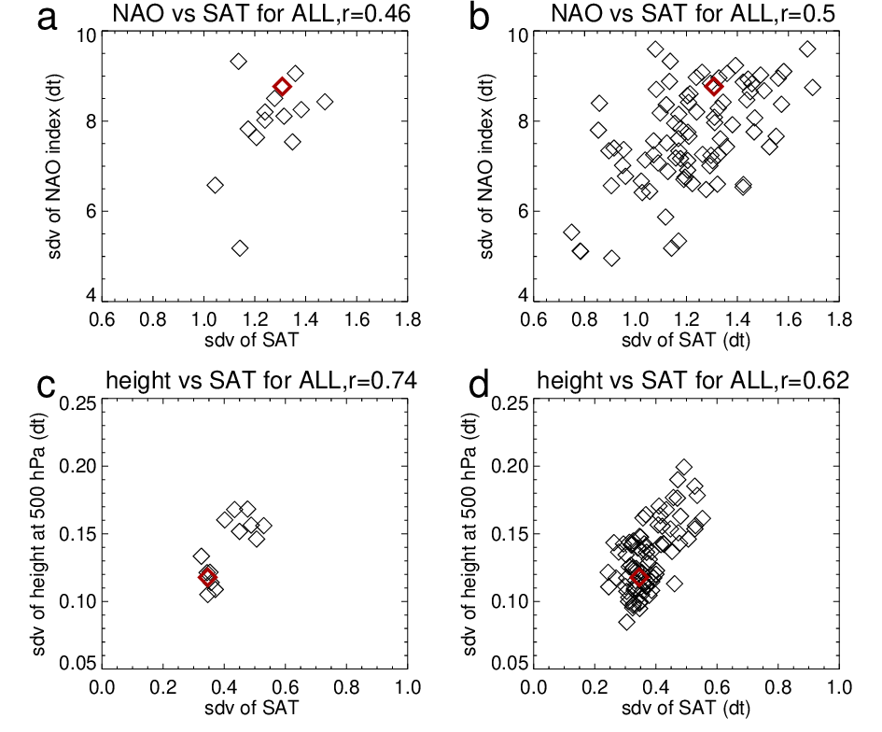
Supplementary Fig. S6: Relationships of between standard deviations of the area averaged SAT (ºC) over Europe with standard deviations of circulation indices in DJF and JJA during 1979-2020 based on CMIP6 historical (ALL forcing) simulations. (a, b) Standard deviations of the area averaged SAT (ºC) over Europe with standard deviations of NAO index. (c, d) Standard deviations of the area averaged SAT (ºC) over Europe with standard deviations of the area averaged height (100m) at 500 hPa over Europe. The indices are calculated with detrended data. (a, c) for ensemble mean for each model, and (b, d) for all members of all models. The red symbol is based on ERA5 reanalysis.

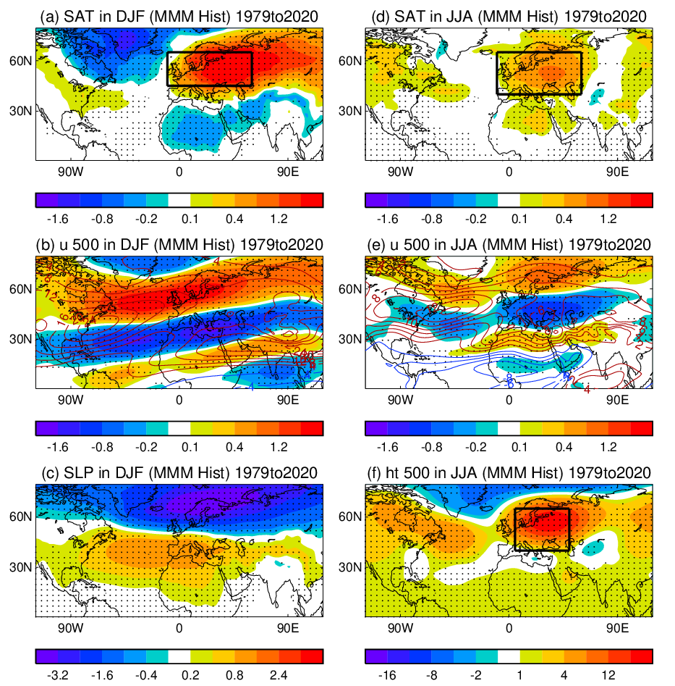
Supplementary Fig. S7: The multimodel mean (MMM) regression patterns of SAT and circulation in DJF and JJA to the normalized time series of the European SAT index based on CMIP6 multi-model historical (ALL forcing) simulations during 1979-2020. (a, b, c) MMM regression patterns of SAT (ºC), zonal wind (m s⁻¹) at 500 hPa, and (c) SLP (hPa) in DJF to the normalized time series of the European SAT index in DJF. (d, e, f) MMM regression patterns of SAT (ºC), zonal wind (m s⁻¹) and geopotential height (m) at 500 hPa in JJA to the normalized time series of the European SAT index in JJA. The indices and regression patterns are calculated with detrended data. Dots indicate regions where 80% models have the same sign of regression. The details for analyses of model simulations are in Methods.
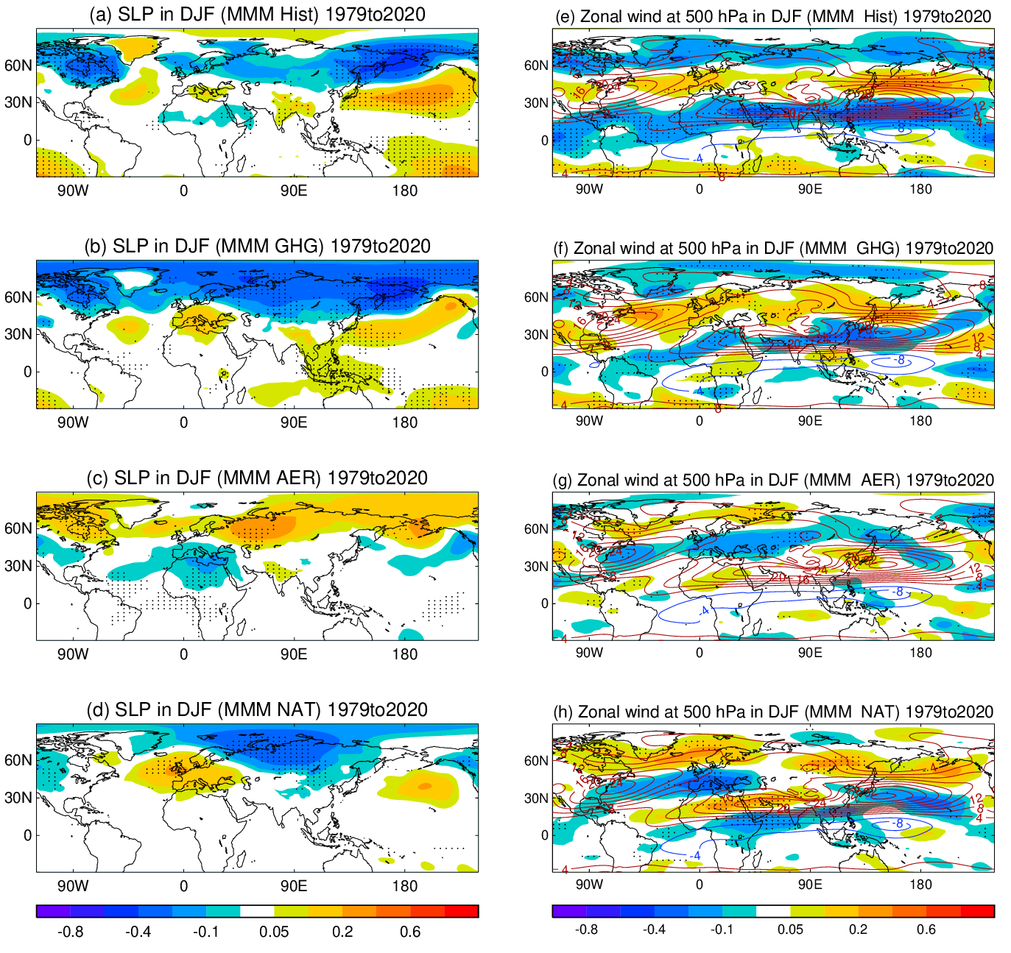

Supplementary Fig. S8: The multimodel mean (MMM) linear trends of SLP and zonal wind at 500 hPa in DJF during 1979-2020 based on CMIP6 (DAMIP) simulations. (a-d) SLP trends (hPa decade⁻¹) and (e-h) zonal wind trends (m s⁻¹ decade⁻¹) at 500 hPa in response to different forcings (ALL, GHG, AER, NAT). Dots indicate regions where 80% models have the same sign of trend. The details for analyses of model simulations are in Methods.
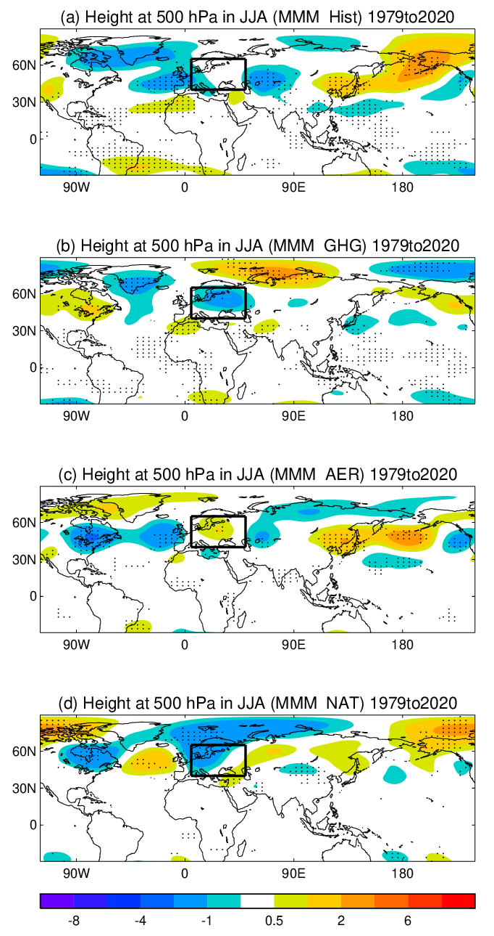
Supplementary Fig. S9: The multimodel mean (MMM) eddy component of geopotential height trends at 500 hPa during 1979-2020 in JJA based on CMIP6/DAMIP model simulations. (a-d) Geopotential height trends (m decade⁻¹) in response to different forcings (ALL, GHG, AER, NAT). Dots indicate regions where 80% models have the same sign of trend. The details for analyses of model simulations are in Methods.

