SUPPLEMENTARY MATERIALS
Comparing Race/Ethnicity in the Generated Images to the Real-World Epidemiology
Based on the image ratings, we determined how common a race or ethnicity is in a disease according to the text-to-image generators. For example, in images generated by Bing, 67% of patients with pyloric stenosis were White, 23% Asian, 9% BAA, and 1% HL (Table 1). In contrast, however, real-world epidemiological studies most commonly report the incidence, i.e., how common a disease is in a race or ethnicity. To allow for comparison between the generated images and the real-world data, we thus calculated how common a race or ethnicity is in a disease in the real world. To this end, we first collected the real-world incidences for the races/ethnicities for each disease. As incidences for Native Hawaiian or Other Pacific Islander or American Indian or Alaska Native are widely lacking, we focused on the four categories Asian, BAA, HL, and White. Based on these real-world incidences, we calculated the percentage distributions and interpolated these percentages based on the real-world number of Asian, BAA, HL, and White individuals (shown in Table 1).

Facial Expression in the Generated Images
In addition to the variables sex, age, race/ethnicity, and weight, we rated the facial expression of the persons depicted [neutral, happy, angry, sad or anxious or in pain, other]. Among both generators, patients with anxiety disorders, depression, and heart attack were most often depicted as sad, anxious, or in pain. This seems appropriate given the cardinal symptoms of these diseases. On the other hand, patients with multiple sclerosis were among those most often depicted as happy in both generators. The reasons for this are unclear as multiple sclerosis is still an incurable disease.

Sex Differences in Age, Facial Expression, and Weight Across all 29 Diseases
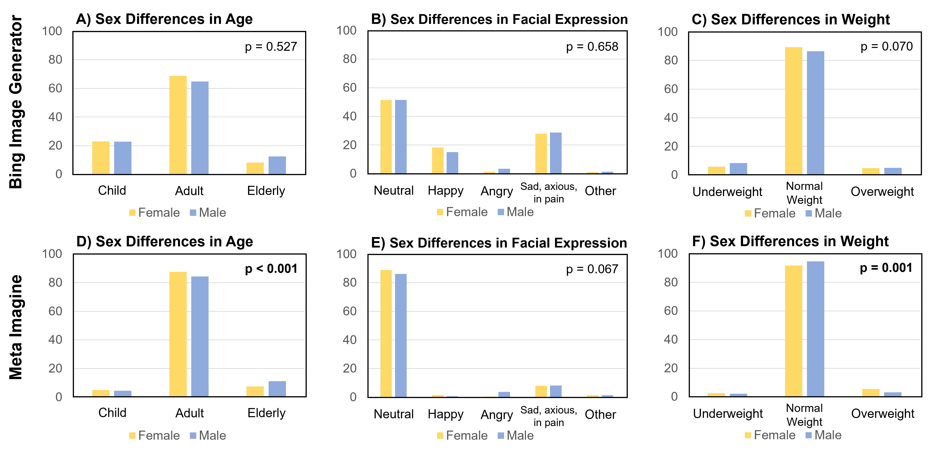
Supplementary Figure 1: Sex differences in age (A, D), facial expression (B, E), and weight (C, F) across all diseases. The top row of graphs shows the sex differences for images created by Bing, the bottom row for images created by Meta. P-values < 0.050 are marked in bold. Note: Reported p-values correspond to the analyses of covariance (ANCOVAs) controlling for the effects of the depicted disease, race, and age (not for analyses on sex differences in age).

Racial/Ethnical Differences in Age, Facial Expression, and Weight Across all 29 Diseases
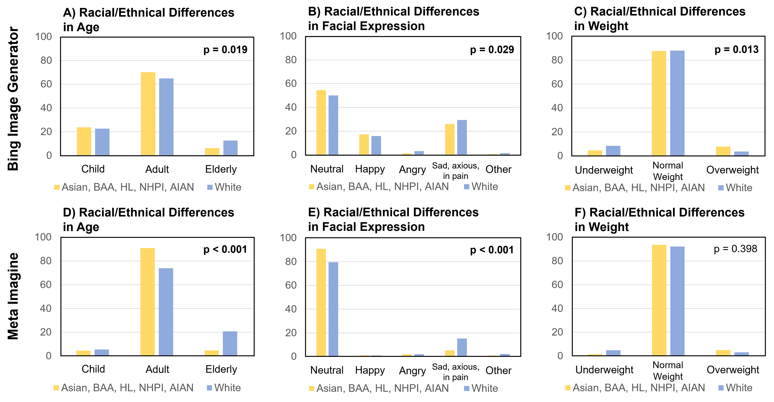
Supplementary Figure 2: Racial/ethnical differences in age (A, D), facial expression (B, E), and weight (C, F) across all diseases. The top row of graphs shows the racial/ethnical differences for images created by Bing, the bottom row for images created by Meta. P-values < 0.050 are marked in bold. Note: Reported p-values correspond to the analyses of covariance (ANCOVAs) controlling for the effects of the depicted disease, sex, and age (not for analyses on sex differences in age). Abbreviations: BAA = Black or African American, HL = Hispanic or Latino, NHPI = Native Hawaiian or Other Pacific Islander, AIAN = American Indian or Alaska Native.

