Supplemental figure 1. Galbraith plot of standard mean difference of serum vitamin D levels between RVO patients and controls.

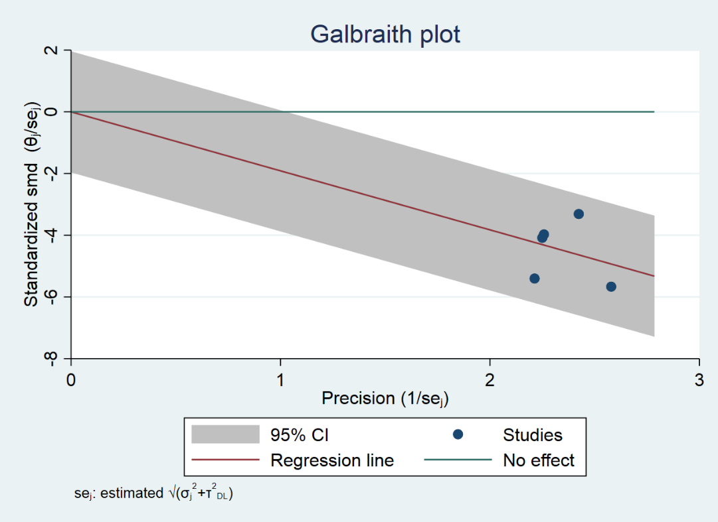

Supplemental figure 2. Forest plot of sensitivity analysis.

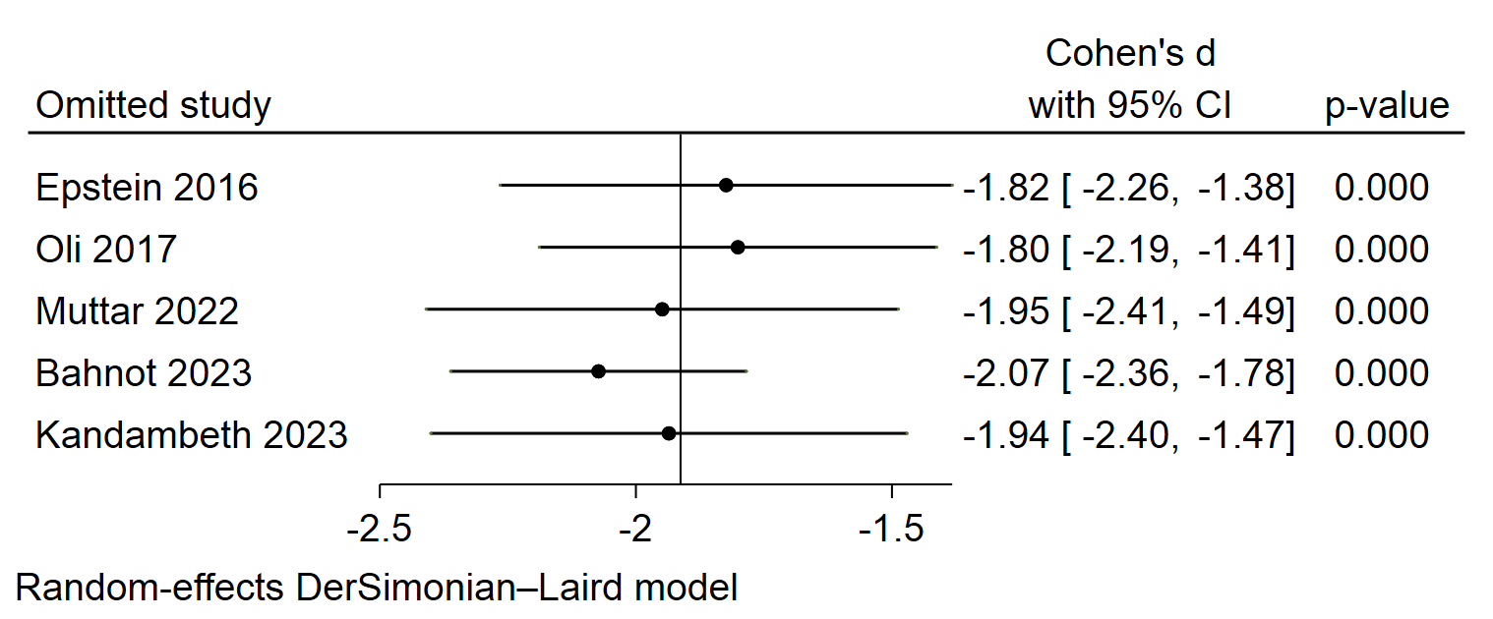

Supplemental figure 3. Forest plot of standard mean difference of vitamin D between RVO and controls according to the matching methodology based on control group population
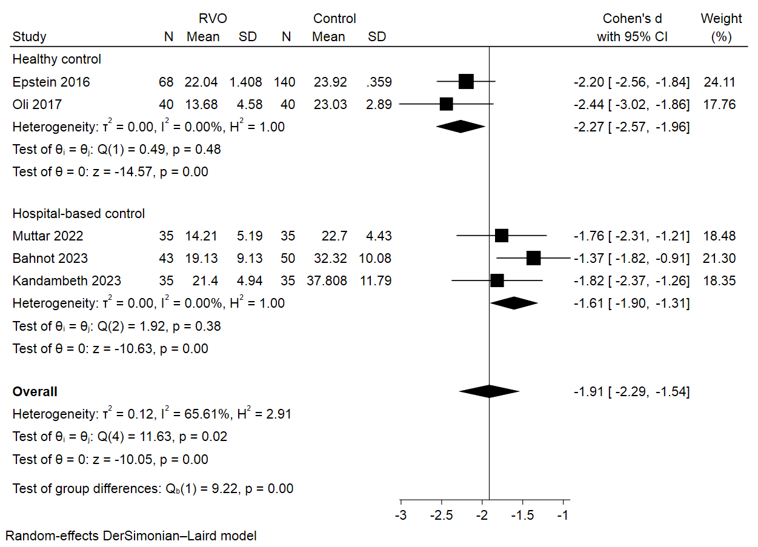

Supplemental figure 4. Forest plot of standard mean difference of vitamin D between RVO and controls according to the matching methodology based on seasonality
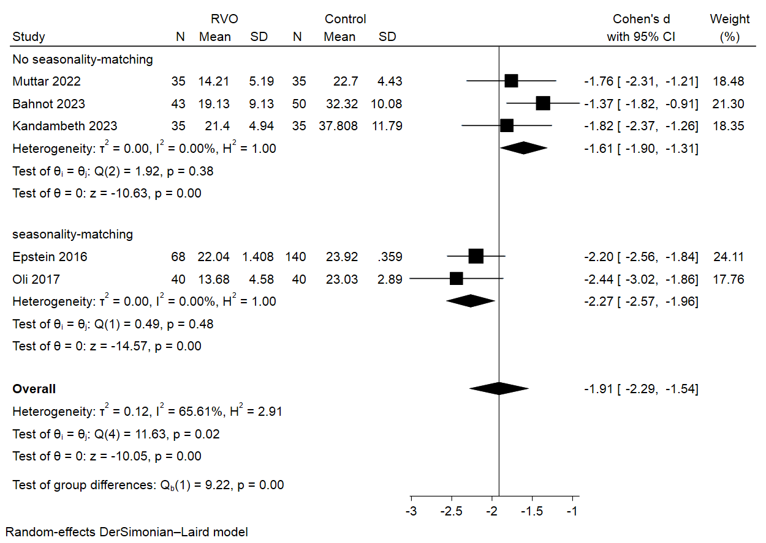

Supplemental figure 5. Forest plot of standard mean difference of vitamin D between RVO and controls according to the vitamin D measurement method
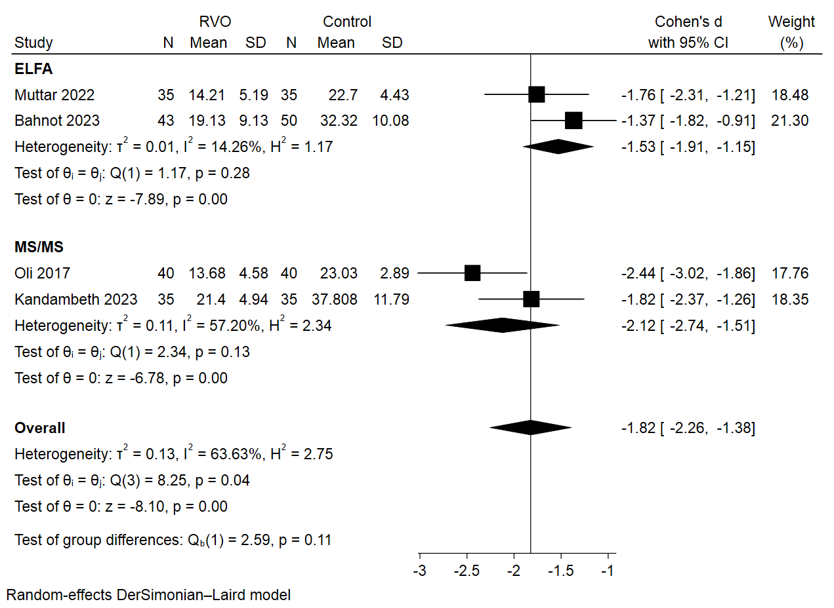

Supplemental figure 6. Forest plot of standard mean difference of vitamin D between RVO and controls according to the matching methodology based on sex

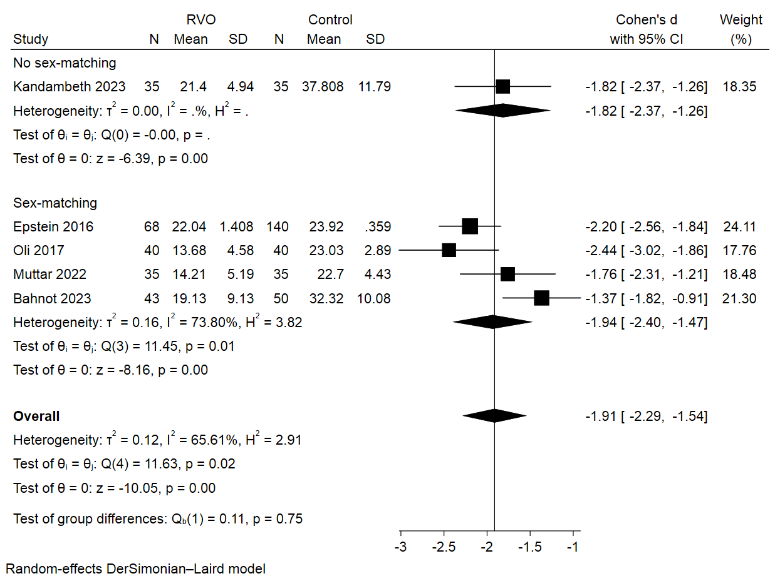

Supplemental figure 7. Forest plot of standard mean difference of vitamin D between RVO and controls according to the matching methodology based on diet

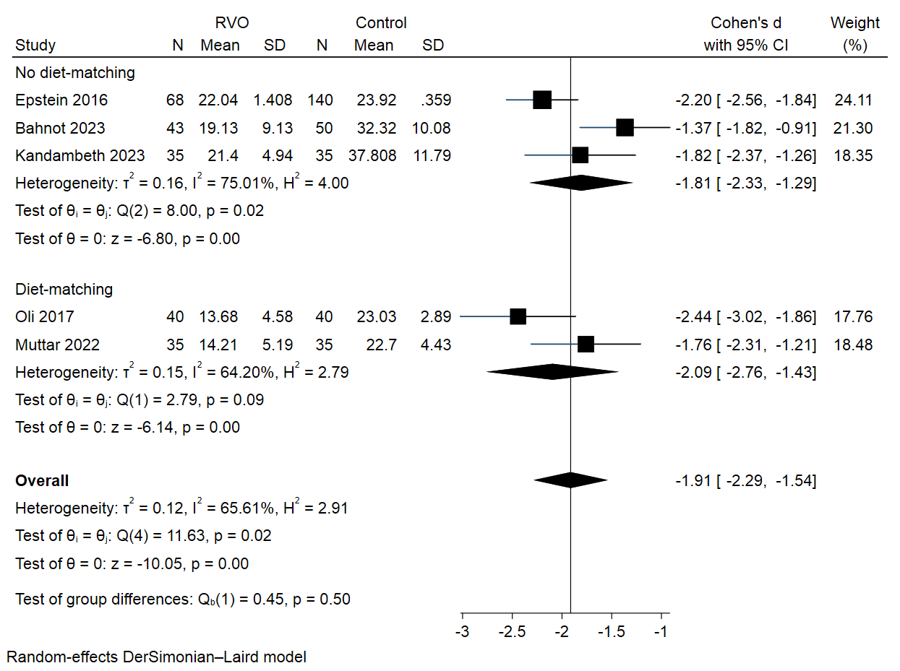

Supplemental figure 8. Forest plot of standard mean difference of vitamin D between RVO and controls according to the matching methodology based on country

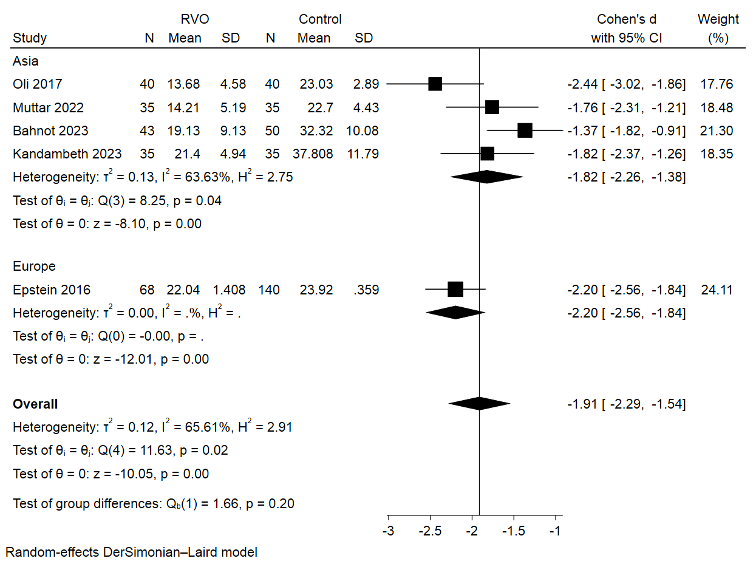

Supplemental figure 9. Funnel plot of studies. This funnel plot displays slight asymmetry, yet Egger’s and Begg’s tests reveal no significant publication bias (Egger’s P = 0.94, Begg’s P = 0.46).

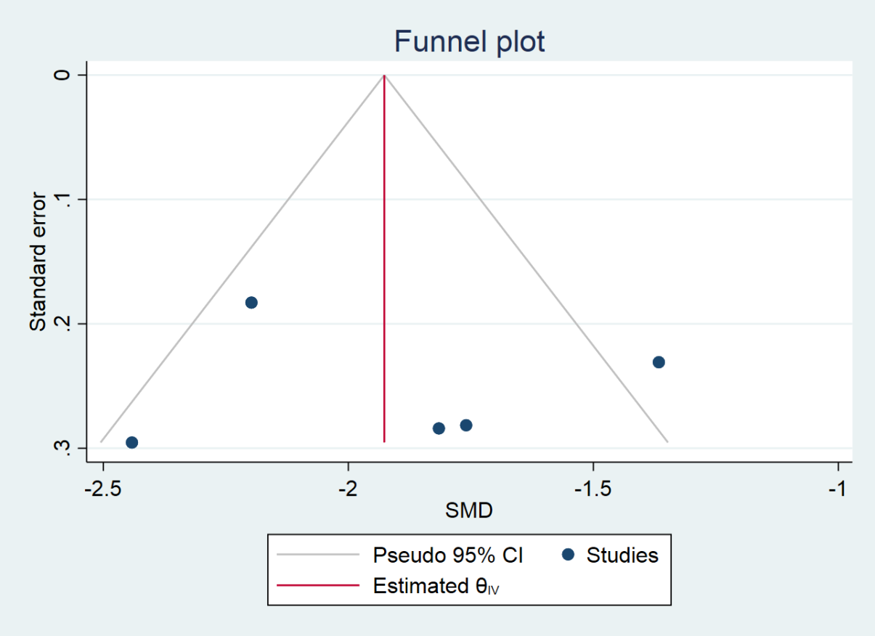

Supplemental figure 10. Forest plot of sensitivity analysis for prevalence of vitamin D deficiency. Study by Epstein et al, significantly influenced the pooled results.

