Immunotherapy Response and Resistance in Patients with Advanced Uveal Melanoma

Alexander Maurer^{1*}, Giulio Clerici^{2*}, Jan A. Schaab¹, Phil F. Cheng³, Daniela Mihic-Probst⁴, Cäcilia Mader¹, Michael Messerli¹, Martin W Huellner¹, Reinhard Dummer², Florentia Dimitriou²

- Department of Nuclear Medicine, University Hospital of Zurich, University of Zurich, Zurich, Switzerland
- Department of Dermatology, University Hospital of Zurich, University of Zurich, Zurich, Switzerland
- Department of Oncology, Geneva University Hospital, Geneva, Switzerland
- Institute for Pathology and Molecular Pathology, University Hospital Zurich, University of Zurich, Zurich, Switzerland

* Equal contribution as joint first authors

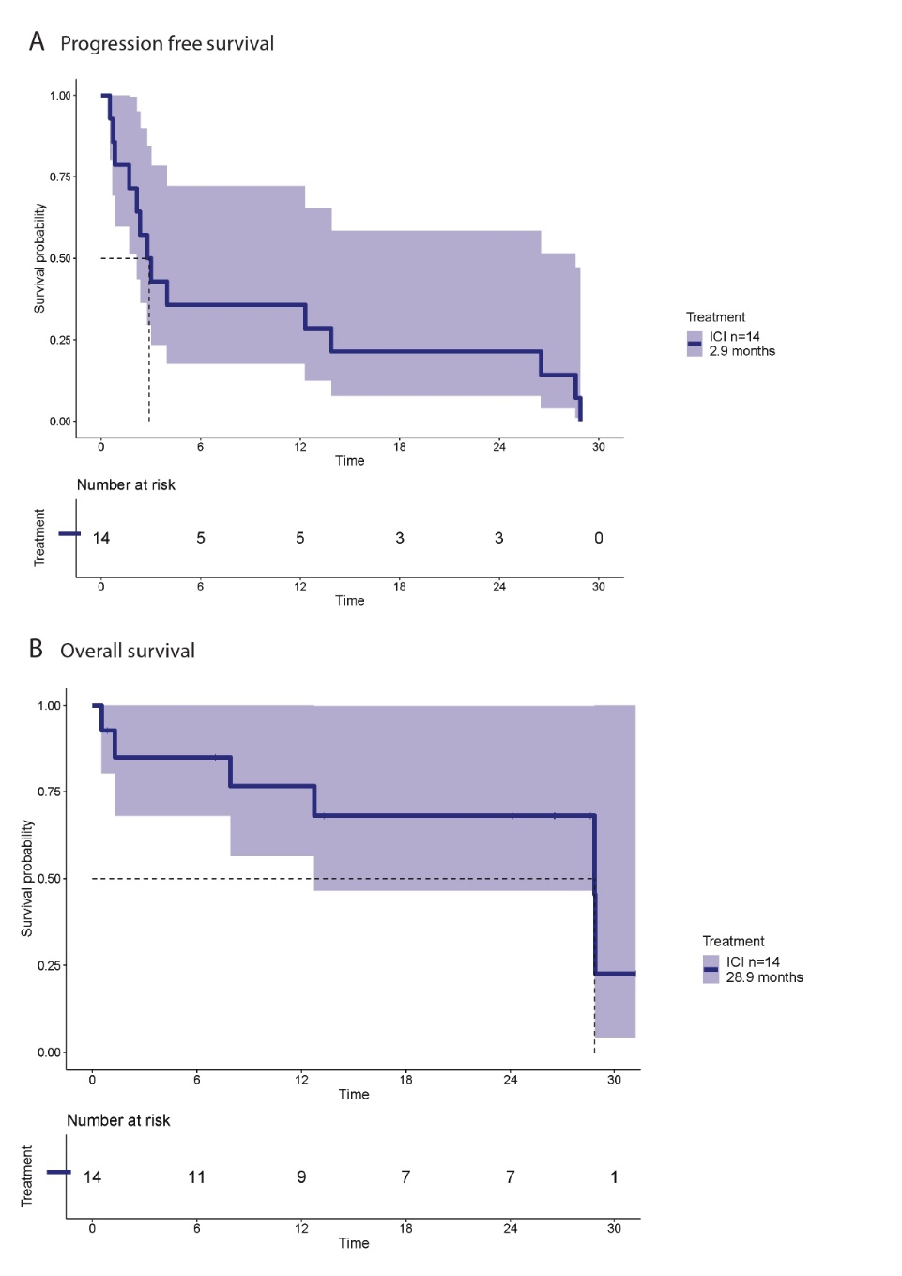

Supplementary Figure 1. Kaplan-Meier curve for progression free survival (PFS) (A) and overall survival (OS) (B) of patients treated with the immune checkpoint inhibitors (ICI) ipilimumab/nivolumab.

Supplementary Figure 2. Kaplan-Meier curve for progression-free survival (PFS) by lactate dehydrogenase (LDH) level at treatment start with ipilimumab/nivolumab.

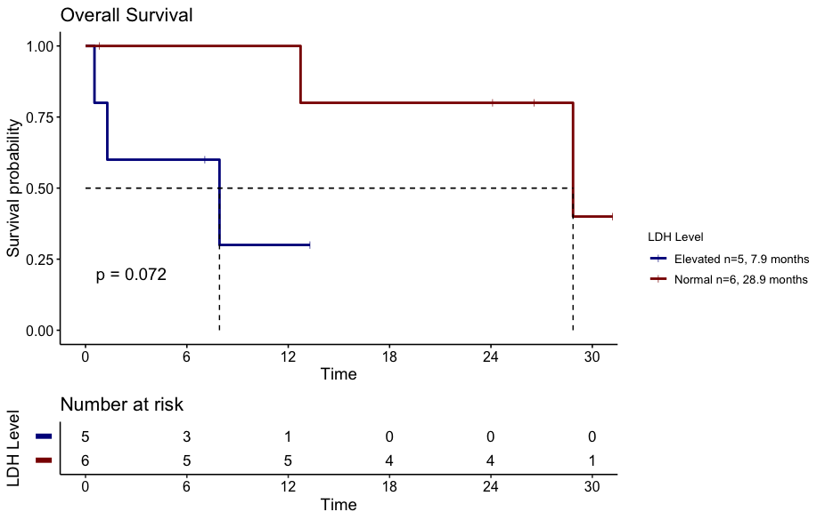

Supplementary Figure 3. Kaplan-Meier curve for overall survival (OS) by lactate dehydrogenase (LDH) level at treatment start with ipilimumab/nivolumab.
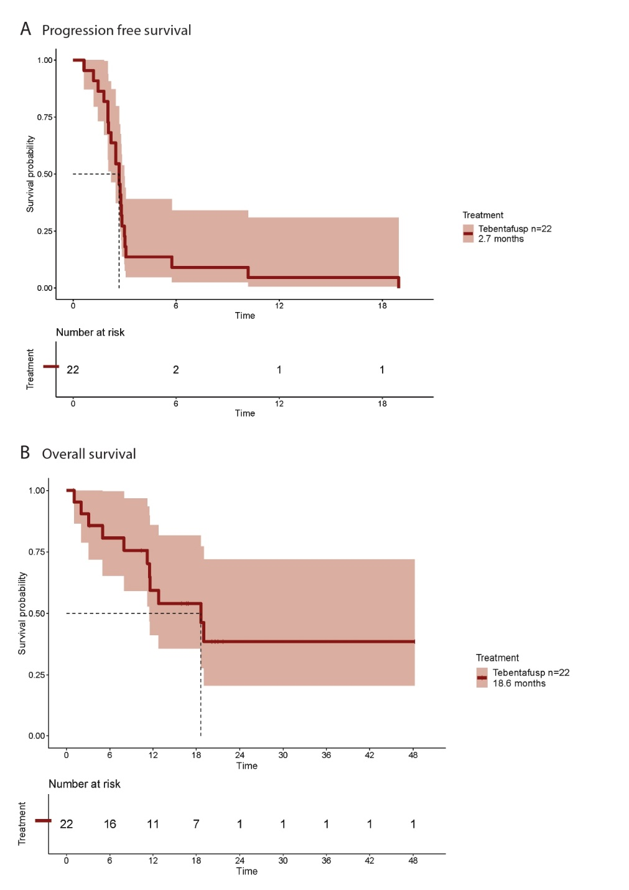

Supplementary Figure 4. Kaplan-Meier curve for progression-free survival (PFS) (A) and overall survival (OS) (B) of patients treated with tebentafusp.

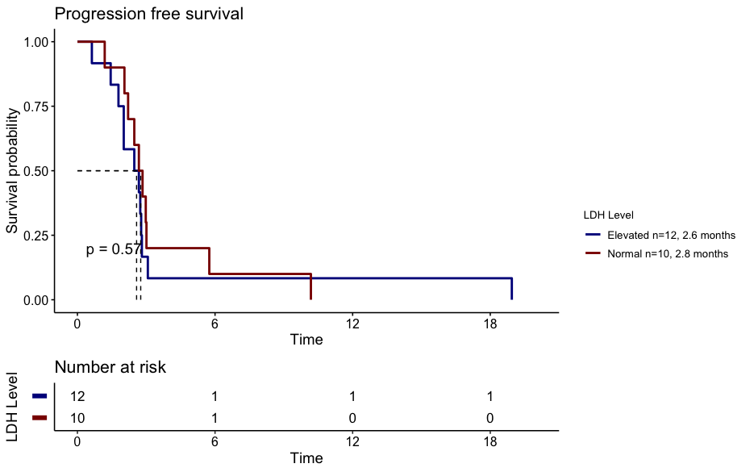

Supplementary Figure 5. Kaplan-Meier curve for progression-free survival (PFS) by lactate dehydrogenase (LDH) level at treatment start with tebentafusp.

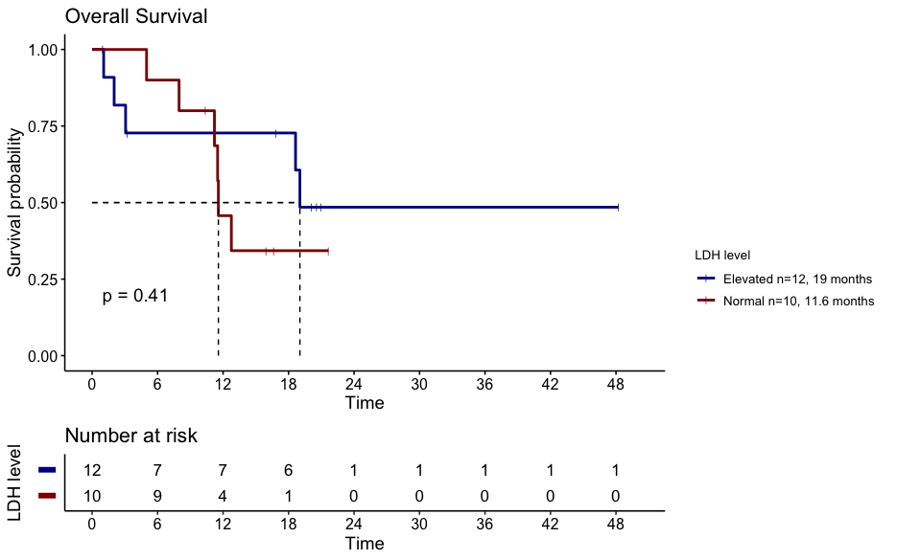

Supplementary Figure 6. Kaplan-Meier curve for overall survival (OS) by lactate dehydrogenase (LDH) level at treatment start with tebentafusp.

