Microchimica Acta

Supporting Information

A Sandwich-Type Photoelectrochemical Sensor Based on Anthocyanin-Sensitized ZnO/P5FIn Heterojunction for the Sensitive Detection of CYFRA21-1
Qinghua Gong, Yanting Guo, Lu Zhang, Jingjing Wang, Dandan Liu*, Guangming Nie*

Key Laboratory of Optic-Electric Sensing and Analytical Chemistry for Life Science, MOE, College of Chemistry and Molecular Engineering, Qingdao University of Science and Technology, Qingdao, 266042, PR China

*Corresponding author. Tel. +86-532-88959058, Fax. +86-532-88957187.
E-mail address: gnie@qust.edu.cn, liudandan0305@126.com (D. Liu)
Experimental Section
Materials and reagents
NHS, 1-Ethyl-3-(3-dimethylaminopropyl)carbodiimide (EDC) and 5-formylindole (5FIn ) were obtained from Aladdin Reagent (Shanghai) Co., Ltd. Anthocyanins and Zn(NO₃)₂·6H₂O were purchased from Shanghai Macklin Biochemical Co. Ltd. Melamine, thioureas (H₂NCSNH₂), K₄[Fe (CN)₆]·3H₂O and K₃[Fe (CN)₆] were purchased from Sinopharm Chemical Reagent Co. Ltd. TBATFB were purchased from Bailingwei Technology Co., Ltd. ACN were purchased from Tianjin Guangfu Fine Chemical Co., Ltd. CYFRA21-1 and Ab₁ of CYFRA21-1 were purchased from Shanghai Linc-Bio Science Co., Ltd. (Shanghai, China)
Instruments
Scanning electron microscopy (SEM) images were obtained using a JSM-6700F thermal field emission scanning electron microscope (JEOL Co., Japan). A JEOL JEM-2100 microscope (Japan) was used to take Transmission electron 3 microscopy (TEM) images. Computer Numerical Control ultrasonic cleaner was obtained from Kunshan Ultrasonic Instrument Co. Ltd. And all PEC (PEC) tests were performed on an MPI-A PEC analyzer system from Xi’an Remex analysis instruments Co., Ltd. (Xi’an, China)

Preparation of PDA
Dopamine was dissolved in 100 mL of 0.01 mol L⁻¹ Tris-HCl solution (pH=8.8), resulting in complete dissolution. Subsequently, 50 mL of isopropanol was added, and the mixture was thoroughly combined. The resulting product was stored under dark conditions with stirring for 24 h. Afterward, the obtained product was washed three times with deionized water and freeze-dried. Finally, the freeze-dried product was dissolved in 4 mL of deionized water and stored at 4 °C for future use.

Preparation of BN QDs
In this study, BN QDs were prepared with slight modifications to the method reported in literature, using a hydrothermal approach. Briefly, 1.6×10⁻² mol of boric acid (0.1 g) and 2.7×10⁻⁴ mol of melamine (0.0339 g) were completely dissolved in 10 mL of deionized water. The resulting mixture was then transferred to a high-pressure reaction vessel and heated at 200 °C in an oven for 15 h, yielding the BN QDs for subsequent use.

Preparation of anthocyanin-sensitized ZnO/P5FIn
Before the experiment, ITO electrodes were soaked in 1 M NaOH and 30% H₂O₂. Subsequently, they were sequentially cleaned in acetone, ethanol, and ultrapure water, and then dried at room temperature for later use. In this experiment, P5FIn was synthesized using an electrochemical method. Specifically, 0.0363 g of P5FIn, 0.1646 g of tetrabutylammonium tetra fluoroborate, and 0.0014 g of anthocyanin were dissolved in 5 mL of acetonitrile in a centrifuge tube. The cleaned ITO electrode was immersed in the above solution, and anthocyanin-sensitized P5FIn was polymerized using a constant charge method (with a potential of 1.45 V, Ag/AgCl electrode, and a charge of 30 mC). Finally, the electrode was washed with deionized water to remove surface impurities and electrolytes. ZnO thin films were then prepared using an electrochemical deposition method. A mixture of 0.01 M Zn(NO₃)₂·6H₂O and 0.01 M hexamethylenetetramine served as the electrolyte solution. The prepared anthocyanin/P5FIn electrode, stainless steel electrode, and Ag/AgCl electrode were immersed in the above solution and deposited at 80 °C for 300 s. After rinsing with deionized water, the electrode was dried at 60 °C
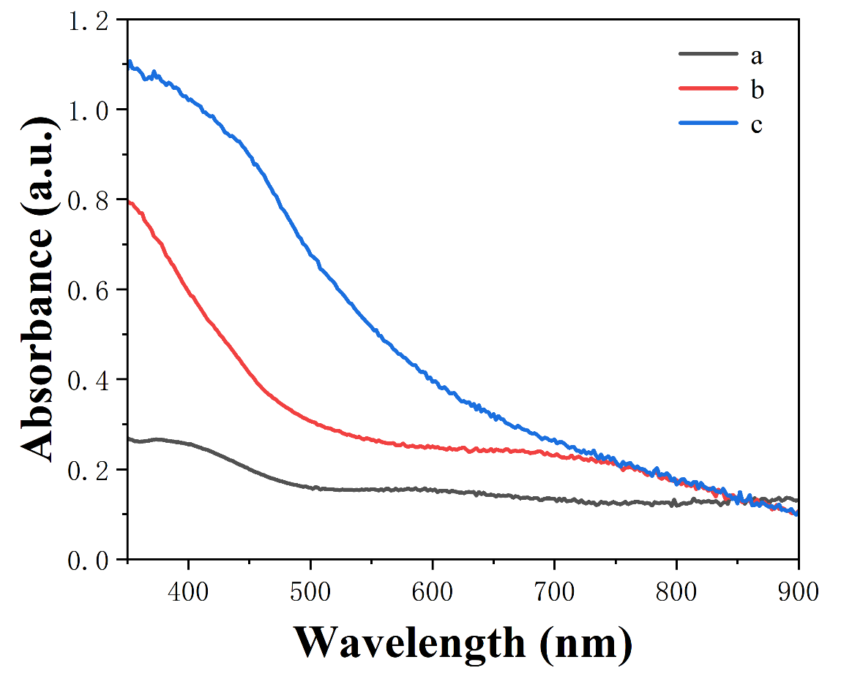
Fig. S1. UV- vis absorption spectra of (a) ZnO, (b)P5FIn/ anthocyanin, (c)ZnO/P5FIn/anthocyanin.
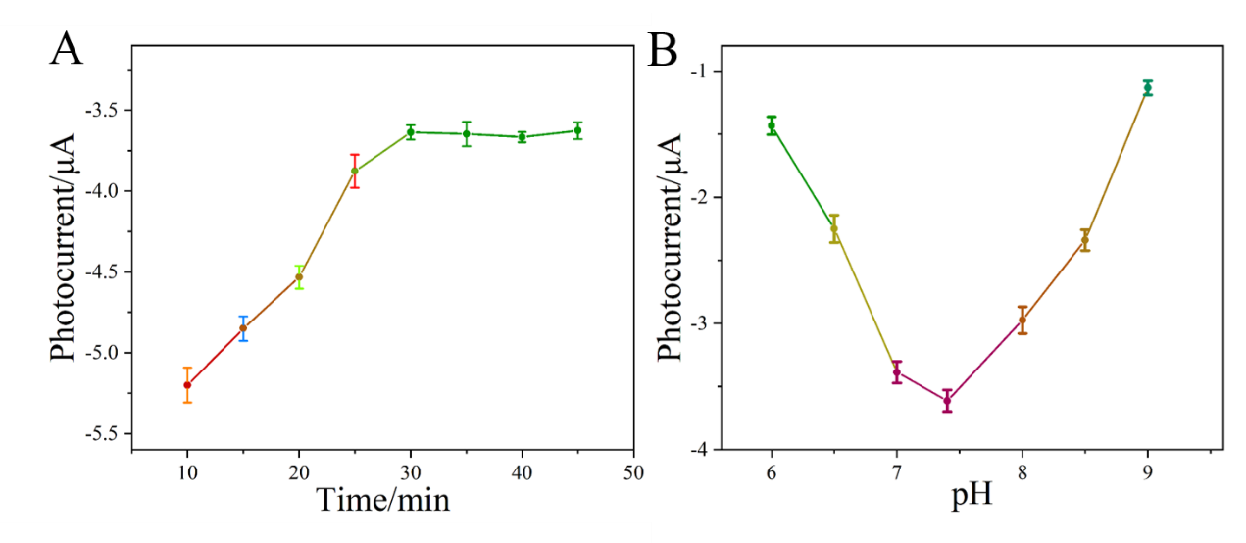
Fig. S2. The effects of (A) CYFRA21-1 incubation time, (B) detection solution pH on photocurrent response.

