Supplementary Materials
Pre-column Derivative HPLC and LC-Orbitrap-MS Analysis of Monosaccharides and Non-Polysaccharides in Polygonati Rhizoma
Ling Liang¹, Yu Li¹, Caiyun Peng², Luyun Ning¹, Wei Wang¹, Gangqiang Yi¹, Hanwen Yuan¹*, Pingan Liu¹*
¹TCM and Ethnomedicine Innovation & Development International Laboratory, Innovative Material Medical Research Institute, School of Pharmacy, Hunan University of Chinese Medicine, Changsha, China
²Institute of Innovation and Applied Research in Chinese Medicine Hunan University of Chinese Medicine, Changsha, China
* Correspondence: 723679086@qq.com (P. Liu); Hanwyuan@hnucm.edu.cn (H. Yuan)
Tables and figures of Contents for Supporting Information
SUPPORTING FIGURES AND TABLES
Fig.S1 The MS² spectrum of some compounds in Polygonati Rhizoma. a: malic acid, b: DL-phenylalanine, c: hexadecanamide, d: trigonelline, e: kingianoside Z, f: dibutyl sebacate

Table S1 List of samples
Table S2 Method validation of HPLC fingerprint analysis
Table S3 Similarity in fingerprints of Polygonatum rhizoma
Table S4 The recovery of each constituent (n＝3)
Table S5 Response factors (f) for the compounds
Table S6 Comparsion of the contents determined by calibration curve and QAMS methods (mg∙g⁻¹, n=3)

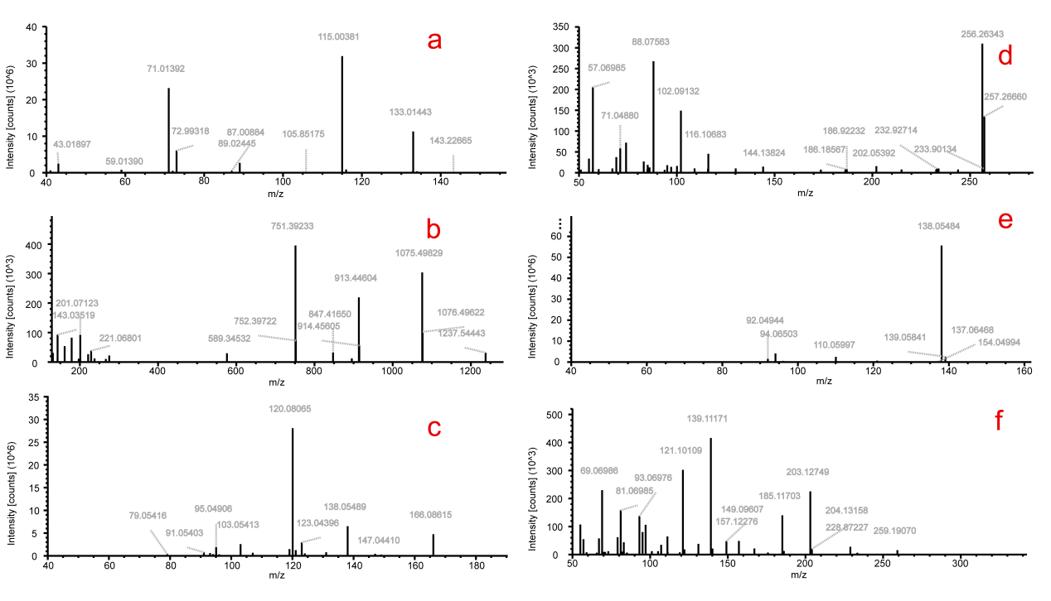
Fig.S1 The MS² spectrum of some compounds in Polygonati Rhizoma. a: malic acid, b: kingianoside Z, c: DL-phenylalanine, d: hexadecanamide, e: trigonelline, f: dibutyl sebacate

Table S1 List of samples
Latin name | Medicine part | Geographical origin | quantity | Sample name
Polygonatum cyrtonema Hua | rhizome | Guizhou, Guangdong, Hunan | 11 | DH-1~DH-11
Polygonatum kingianum coll.et Hemsl. | rhizome | Yunnan, Sichuan | 3 | D-1~D-3
Polygonatum sibiricum Red. | rhizome | Ningxia, Henan | 3 | JT-1~JT-3

Table S2 Method validation of HPLC fingerprint analysis
Analytes | RSD (%) | Precision | Repeatability | Stability | Durability
1 | RRT | 0.81 | 0.23 | 1.77 | 1.44
1 | RPA | 0.23 | 2.55 | 0.13 | 0.27
2 | RRT | 0.81 | 0.29 | 1.86 | 1.51
2 | RPA | 1.39 | 2.95 | 1.96 | 3.45
3 | RRT | 0.76 | 0.44 | 2.00 | 1.62
3 | RPA | 0.45 | 2.32 | 0.91 | 1.74
4 | RRT | 0.75 | 0.52 | 2.41 | 1.89
4 | RPA | 0.27 | 2.74 | 0.28 | 0.52
5 | RRT | 0.71 | 0.49 | 2.22 | 1.76
5 | RPA | 0.29 | 2.7 | 0.75 | 1.19

Table S3 Similarity in fingerprints of Polygonatum rhizoma
NO. | D-1 | D-2 | D-3 | DH-1 | DH-2 | DH-3 | DH-4 | DH-5 | DH-6 | DH-7 | DH-8 | DH-9 | DH-10 | DH-11 | JT-1 | JT-2 | JT-3 | Contrast
D-1 | 1
D-2 | 0.938 | 1
D-3 | 0.962 | 0.931 | 1
DH-1 | 0.993 | 0.922 | 0.981 | 1
DH-2 | 0.905 | 0.921 | 0.981 | 0.931 | 1
DH-3 | 0.944 | 0.89 | 0.995 | 0.963 | 0.994 | 1
DH-4 | 0.977 | 0.864 | 0.99 | 0.99 | 0.964 | 0.984 | 1
DH-5 | 0.911 | 0.854 | 0.98 | 0.944 | 0.986 | 0.982 | 0.974 | 1
DH-6 | 0.955 | 0.919 | 0.997 | 0.976 | 0.986 | 0.995 | 0.993 | 0.99 | 1
DH-7 | 0.988 | 0.906 | 0.943 | 0.974 | 0.895 | 0.936 | 0.965 | 0.888 | 0.937 | 1
DH-8 | 0.936 | 0.872 | 0.992 | 0.957 | 0.997 | 0.998 | 0.982 | 0.989 | 0.995 | 0.925 | 1
DH-9 | 0.975 | 0.914 | 0.929 | 0.966 | 0.872 | 0.917 | 0.957 | 0.871 | 0.923 | 0.985 | 0.903 | 1
DH-10 | 0.981 | 0.936 | 0.971 | 0.991 | 0.908 | 0.947 | 0.97 | 0.918 | 0.957 | 0.955 | 0.934 | 0.955 | 1
DH-11 | 0.97 | 0.973 | 0.898 | 0.964 | 0.911 | 0.863 | 0.935 | 0.851 | 0.895 | 0.947 | 0.854 | 0.953 | 0.954 | 1
JT-1 | 0.924 | 0.955 | 0.99 | 0.948 | 0.999 | 0.998 | 0.974 | 0.987 | 0.992 | 0.912 | 0.999 | 0.89 | 0.928 | 0.901 | 1
JT-2 | 0.919 | 0.854 | 0.99 | 0.945 | 0.997 | 0.996 | 0.969 | 0.985 | 0.99 | 0.902 | 0.996 | 0.882 | 0.931 | 0.901 | 0.999 | 1
JT-3 | 0.957 | 0.899 | 0.998 | 0.975 | 0.989 | 0.998 | 0.991 | 0.986 | 0.999 | 0.943 | 0.997 | 0.925 | 0.956 | 0.887 | 0.995 | 0.992 | 1
Contrast | 0.963 | 0.931 | 0.999 | 0.981 | 0.984 | 0.996 | 0.994 | 0.984 | 0.999 | 0.949 | 0.995 | 0.933 | 0.964 | 0.9 | 0.991 | 0.989 | 0.999 | 1

Table S4 The recovery of each constituent (n＝3)
Analytes | Original amount (mg) | Spiked  amount (mg) | Measured amount (mg) | Recovery（%） | RSD(%)
D-Mannose | 0.256 | 0.200 | 0.441 | 92.77 | 1.14
D-Mannose | 0.256 | 0.180 | 0.414 | 87.77 | 2.70
D-Mannose | 0.256 | 0.160 | 0.395 | 86.66 | 1.51
Rhamnose | 0.006 | 0.060 | 0.064 | 96.93 | 3.55
Rhamnose | 0.006 | 0.050 | 0.057 | 102.91 | 2.46
Rhamnose | 0.006 | 0.040 | 0.048 | 104.30 | 1.03
D-(+)-Glucose | 0.060 | 0.060 | 0.110 | 83.55 | 2.71
D-(+)-Glucose | 0.060 | 0.050 | 0.103 | 86.15 | 2.62
D-(+)-Glucose | 0.060 | 0.040 | 0.093 | 83.22 | 2.16
D-Galactose | 0.112 | 0.100 | 0.207 | 95.21 | 0.56
D-Galactose | 0.112 | 0.080 | 0.185 | 91.24 | 2.01
D-Galactose | 0.112 | 0.060 | 0.164 | 86.56 | 1.55
L- (+)-Arabinose | 0.056 | 0.050 | 0.105 | 97.81 | 3.69
L- (+)-Arabinose | 0.056 | 0.040 | 0.094 | 95.53 | 2.42
L- (+)-Arabinose | 0.056 | 0.030 | 0.084 | 93.71 | 1.90

Table S5 Response factors (f) for the compounds
NO. | D-Mannose |  |  | Rhamnose |  |  |  | D-(+) Glucose |  |  |  | D-(+) Galactose |  |  |  | L-(+)-Arabinose
NO. | C (mg/mL) | A |  | C (mg/mL) | A | f |  | C (mg/mL) | A | f |  | C (mg/mL) | A | f |  | C (mg/mL) | A | f
1 | 0.6 | 5146.043 |  | 0.02 | 142.663 | 1.202 |  | 0.2 | 1190.09 | 1.441 |  | 0.28 | 2467.886 | 0.973 |  | 0.1 | 1010.912 | 0.848
2 | 0.3 | 2610.668 |  | 0.01 | 73.487 | 1.184 |  | 0.1 | 597.728 | 1.456 |  | 0.14 | 1241.655 | 0.981 |  | 0.05 | 516.157 | 0.843
3 | 0.15 | 1305.138 |  | 0.005 | 36.571 | 1.190 |  | 0.05 | 295.486 | 1.472 |  | 0.07 | 615.947 | 0.989 |  | 0.025 | 254.933 | 0.853
4 | 0.075 | 622.496 |  | 0.0025 | 17.523 | 1.184 |  | 0.025 | 138.991 | 1.493 |  | 0.035 | 292.174 | 0.994 |  | 0.0125 | 120.614 | 0.860
5 | 0.0375 | 295.308 |  | 0.00125 | 8.367 | 1.176 |  | 0.0125 | 63.573 | 1.548 |  | 0.0175 | 135.058 | 1.020 |  | 0.00625 | 54.232 | 0.908
6 | 0.01875 | 145.989 |  | 0.000625 | 3.584 | 1.358 |  | 0.00625 | 31.299 | 1.555 |  | 0.00875 | 64.37 | 1.058 |  | 0.003125 | 25.771 | 0.944
Average |  |  |  |  |  | 1.22 |  |  |  | 1.49 |  |  |  | 1.00 |  |  |  | 0.88
RSD (%) |  |  |  |  |  | 5.77% |  |  |  | 3.19% |  |  |  | 3.16% |  |  |  | 4.64%

Table S6 Comparsion of the contents determined by calibration curve and QAMS methods (mg∙g⁻¹, n=3)
NO. | D-Mannose |  | Rhamnose |  |  | D-(+)-Glucose |  |  | D-Galactose |  |  | L-(+)-Arabinose
NO. | ESM |  | ESM | QAMS |  | ESM | QAMS |  | ESM | QAMS |  | ESM | QAMS
D-1 | 23.16 |  | 1.17 | 1.18 |  | 6.27 | 6.28 |  | 20.10 | 20.13 |  | 9.66 | 9.68
D-2 | 4.50 |  | 0.55 | 0.55 |  | 3.48 | 3.48 |  | 5.98 | 5.98 |  | 4.50 | 4.50
D-3 | 22.78 |  | 0.60 | 0.60 |  | 4.51 | 4.51 |  | 9.84 | 9.83 |  | 6.29 | 6.29
JT-1 | 51.35 |  | 0.79 | 0.80 |  | 5.25 | 5.25 |  | 17.85 | 17.85 |  | 8.49 | 8.49
JT-2 | 69.64 |  | 1.11 | 1.12 |  | 8.07 | 8.08 |  | 21.64 | 21.65 |  | 13.33 | 13.36
JT-3 | 31.02 |  | 0.65 | 0.65 |  | 5.36 | 5.37 |  | 13.80 | 13.81 |  | 6.57 | 6.58
DH-1 | 17.36 |  | 0.62 | 0.63 |  | 5.85 | 5.85 |  | 12.48 | 12.48 |  | 6.80 | 6.80
DH-2 | 60.84 |  | 0.97 | 0.97 |  | 5.36 | 5.36 |  | 19.38 | 19.40 |  | 7.71 | 7.74
DH-3 | 35.62 |  | 0.52 | 0.52 |  | 3.31 | 3.32 |  | 14.59 | 14.59 |  | 7.37 | 7.37
DH-4 | 32.17 |  | 0.78 | 0.78 |  | 9.30 | 9.31 |  | 18.71 | 18.73 |  | 7.95 | 7.95
DH-5 | 39.18 |  | 0.51 | 0.51 |  | 13.49 | 13.47 |  | 13.64 | 13.65 |  | 4.86 | 4.87
DH-6 | 39.38 |  | 0.94 | 0.94 |  | 9.73 | 9.73 |  | 17.45 | 17.47 |  | 8.14 | 8.16
DH-7 | 6.86 |  | 0.18 | 0.18 |  | nd | nd |  | 6.21 | 6.22 |  | 2.47 | 2.47
DH-8 | 65.46 |  | 1.27 | 1.27 |  | 8.47 | 8.44 |  | 25.82 | 25.85 |  | 10.51 | 10.52
DH-9 | 4.90 |  | nd | nd |  | 0.50 | 0.51 |  | 4.57 | 4.57 |  | 2.04 | 2.05
DH-10 | 21.76 |  | 0.74 | 0.74 |  | 6.85 | 6.85 |  | 14.32 | 14.32 |  | 12.81 | 12.82
DH-11 | 17.07 |  | 0.88 | 0.89 |  | 12.79 | 12.77 |  | 18.80 | 18.81 |  | 9.66 | 9.66

