Supporting Information

Therapeutic Potential of Desmodium styracifolium Polysaccharide in Attenuating Nano-Calcium Oxalate Induced Renal Injury and Epithelial-to-Mesenchymal Transition

Bang-Xian Yu^{1#}, Ling-Hong Huang^{1#}, Chun-Yao Li¹, Wei-Feng Liu¹, Quan Zhang¹, Jun-Yi Xian¹, Jun Long¹, Yong-Da Liu^{1*}, Guo-Hua Zeng^{1*}, Xin-Yuan Sun^{1*}
¹Department of Urology, Guangzhou Institute of Urology, Guangdong Key Laboratory of Urology, the First Affiliated Hospital of Guangzhou Medical University, Guangzhou Medical University, Guangzhou, Guangdong, 510230, China.
# These authors contributed equally to this work.

*Correspondence: Xin-Yuan Sun, E-mail address: sunxinyuan1985@163.com; Guo-Hua Zeng, E-mail address: 2008690094@gzhmu.edu.cn; Yong-Da Liu, E-mail address: liuydur@gzhmu.edu.cn. Department of Urology, Guangzhou Institute of Urology, Guangdong Key Laboratory of Urology, the First Affiliated Hospital of Guangzhou Medical University, Guangzhou Medical University, Guangzhou, Guangdong 510230, China.

Experimental Section
Extraction and purification of Ds
Fresh samples of Desmodium styracifolium (Osb.) Merr were washed, dried at a temperature of 60°C, and pulverized in a high-speed pulverizer. The resulting powder was then sieved and extracted with distilled water at a ratio of 1:10 (w/v) to obtain the polysaccharides. The resulting supernatant was filtered and concentrated at a temperature of 60°C using a rotary evaporator and subsequently precipitated with four times the volume of anhydrous ethanol. The obtained crude polysaccharide was then centrifuged for 10 minutes. The dried crude polysaccharide that was obtained was dissolved in water and then deproteinized using the Sevag method. Subsequently, a petroleum ether reagent was used to extract the fat. Next, a macroporous resin, AB-8, was employed to remove the pigment, followed by hydrodialysis (3000 Da) and concentration. Finally, the purified polysaccharide was obtained through a process of freeze-drying.

FTIR spectroscopy analysis of Ds
Fourier transform infrared spectrometry (FT-IR) was employed to determine the spectra of Ds utilizing a Nicolet iZ-10 spectrometer (Thermo Nicolet, USA). The Ds samples were mixed with KBr powder, pressed into 1 mm pellets, and measured for FT-IR in the range of 4000 to 400 cm-1 by Sanshu Biotech Co., LTD (Shanghai, China).

Monosaccharide composition analysis of Ds
About 5 mg of the Ds sample underwent hydrolysis via trifluoroacetic acid (2M) at 121°C. The hydrolysis was conducted in a sealed tube for two hours. Assisted by nitrogen, the sample was dried through blowing. Subsequently, it was washed with methanol and blow-dried. Methanol wash was repeated 2-3 times. The remaining substance was then dissolved in deionised water and sifted through a 0.22 μm microporous membrane. Ds underwent analysis through high-performance anion exchange chromatography (HPAEC) via utilization of a pulsed amperometric detector (PAD; Dionex ICS 5000+ system) on a CarboPac PA-20 anion exchange column (sizing 3 x 150 mm; Dionex). The flow rate constituted 0.5 mL/min; the injection volume was 5 μL. Solvent system A comprised ddH2O, solvent system B featured 0.1 M NaOH, and solvent system C comprised of 0.1 M NaOH and 0.2 M NaAc. Data collection through ICS5000+ (Thermo Scientific) preceded processing via chromeleon 7.2 CDS (Thermo Scientific).

Supporting Figures
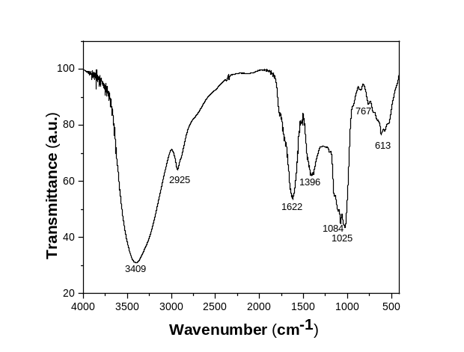
Figure S1. FT-IR spectra analysis of Ds

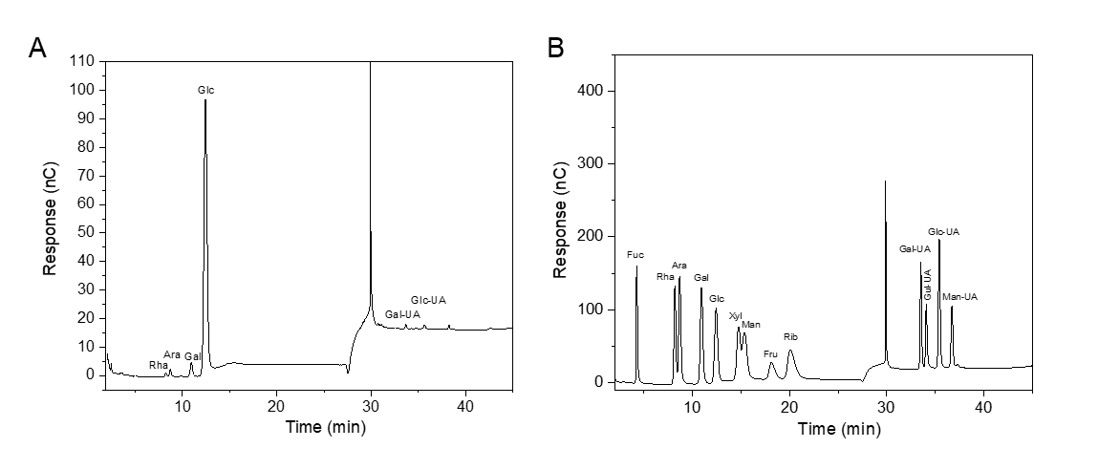
Figure S2. Structural characterization of Ds. (A) peak chart of monosaccharide standard; (B) monosaccharide components of Ds.

Supporting Tables
Table S1. Monosaccharide composition and standard curve information of the Ds polysaccharide
Standard monosaccharides | Peak time | Slope | Degree of fitting | Percentage composition
Fuc | 4.2668 | 1.2194 | 0.9916 | ns
Rha | 8.1918 | 1.3358 | 0.9994 | 0.73%
Ara | 8.6918 | 1.7974 | 0.9981 | 1.25%
Gal | 10.9418 | 1.7359 | 0.9995 | 3.36%
Glc | 12.4335 | 1.6828 | 0.9993 | 89.75%
Xyl | 14.7252 | 1.431 | 0.9965 | 0.75%
Man | 15.3335 | 1.3278 | 0.9935 | 1.49%
Fru | 18.1835 | 0.434 | 0.9976 | ns
Rib | 20.0585 | 0.9699 | 0.9973 | ns
Gal-UA | 33.5085 | 0.7587 | 0.9931 | 1.37%
Gul-UA | 34.0668 | 0.5295 | 0.9947 | ns
Glc-UA | 35.3835 | 1.0879 | 0.9979 | 1.30%
Man-UA | 36.6835 | 0.5052 | 0.9929 | ns

