Phosphorus solubilizing bacteria rather than arbuscular mycorrhizal fungi drive maize/faba bean intercropping advantages
Contents
Method S1 Preparation of bacterial suspensions 2
Method S2 Preparation of arbuscular mycorrhizal fungi (AMF) inoculum 3
Method S3 Isolation of phosphate solubilizing bacteria (PSB) 4
Method S4 P concentration was determined using dry ashing method 5
Method S5 The process of DNA extraction 6
Table S1 Basic physicochemical properties of desert soil in the experiment 7
Table S2 Medium formula for culturing inorganic phosphorus solubilizing bacteria (NBRIY) 8
Table S3 Medium formula for culturing organic P mineralization bacteria (PMB) 9
Table S4 Screening of target colonies 10
Table S5 Two-way ANOVA of variance on biomass and P content of receiver maize in experiment I 14
Fig. S1 linear discriminant analysis effect size of microbial communities related to different soil phosphorus cycling-related genes 15
Fig. S2 Functional gene composition of KEGG database for soils with different phosphorus input 16
Figure S3 Species composition at phylum level of NR database for soils with different phosphorus input 17
Fig. S4 Shoot biomass and phosphorus content of donor maize (a, b) and faba bean (c, d) (Experiment I) 18
Fig. S5 Shoot biomass (a) and phosphorus content (b) of donor species (Experiment II) 19
References 20

Method S1 Preparation of bacterial suspensions
Soil samples for preparing bacterial suspensions were collected from a field experiment with 10 years of P fertilizer input located at the Institute of Soils, Fertilizers and Water-Saving Agriculture, Gansu Academy of Agricultural Sciences, Zhangye, China (38◦85′ N, 100◦38′ E) on April 2021. We collected topsoil (0-20 cm) after removing surface litter from no P input and 100 kg P ha⁻¹ year⁻¹ input treatments, which were denoted as LP soil and HP soil, respectively. The P fertilizer was applied each year as triple superphosphate and the physicochemical properties of soil were described in Table S1. Then the soil was immediately stored in dry ice and transported to the laboratory. Each collected soil sample was divided into two parts, one of which was stored at 4℃ for preparing soil bacterial suspension, and the other part was stored at -80℃ for metagenomic analysis. To prepare the soil bacterial suspensions, 25 g of the soil from each sample was mixed with 1 L of sterile water for 30 min on an orbital shaker and filtered through a 30-μm mesh sieve.

Method S2 Preparation of arbuscular mycorrhizal fungi (AMF) inoculum
AM fungus Rhizophagus irregularis (R. irregularis, BGC JX04B) was selected for this study because it was widely used as a model AMF for studying fungal-plant symbiotic relationships (Stockinger et al., 2009). R. irregularis was provided by the Beijing Academy of Agriculture and Forestry Sciences and further propagated in a sterilized sand-soil mixture (2:1) using maize (Zea mays cv. Zhengdan 958) as host for four months to produce the inoculum for our study. Briefly, 6 plastic buckets with a capacity of 3 kg sand-soil mixture were prepared and two maize seed were planted in each bucket. Water the bucket every 2 days to ensure soil moisture and maize survival. After four months, the maize plants were taken out of the bucket and brush off the attached soil with a brush, then mix the soil and the produced AMF inoculum in all bucket for experimental use. The final AMF inoculum included spores (15 spores g⁻¹ inoculum), hyphae and residual root.

Method S3 Isolation of phosphate solubilizing bacteria (PSB)
The bacterial suspensions from LP and HP soils were used to isolate PSB. The PSB were isolated by serial dilution plate counting method (Ben-David & Davidson, 2014). Briefly, NBRIY and PSM media (Table S2, S3) were chosen to screen for inorganic and organic PSB, respectively (Table S4). The culture media were autoclaved and cooled to room temperature, and then HP and LP soil suspensions were applied to NBRIY and PSM culture media, respectively, to prepare cultures with 10⁻³, 10⁻⁴, 10⁻⁵ and 10⁻⁶ bacterial count. All experimental operations were performed in a sterile room, then all sealed petri dishes were transferred to room temperature (28°C) and incubated for getting purified PSB strains. We obtained 23 strains of inorganic PSB and 17 strains of organic PSB (Table S4). The individual colonies and the size of the P-dissolved circles produced by each of them were recorded on the third and seventh days of the incubation to determine the P-dissolving ability of the isolates. The larger the P-dissolved circle, the greater the P-dissolving ability of the bacteria. Finally, we selected three strains of inorganic PSB (Acinetobacter sp. CT 3-6, Pseudomonas sp., Pseudomonas silesiensis) and organic PSB (Pseudomonas sp., Pseudomonas thivervalensis, Pseudomonas chlororaphis) with the strongest P-solubilizing ability. For all the strains, the bacterial density of the suspension was assessed using the OD value and adjusted to a final concentration of 108 cells mL⁻¹ for greenhouse experiment inoculation.

Method S4 P concentration was determined using dry ashing method
Dry ashing method was used to determine P concentration of maize and faba bean shoots (Thomas et al., 1967). Briefly, 0.2 g of well-ground maize or faba bean shoot samples were placed in a 25 mL porcelain crucible and placed in a muffle furnace for dry ashing. During dry ashing, the samples were firstly carbonized at 180°C for 30 min and then dry-ashed at 450°C for 4 hours. After the ashed samples were cooled to room temperature, 2 mL of 2 mol L⁻¹ nitric acid and 18 mL of deionized water were added to each sample to leach the P in the ash. Then the solution was filtered with P-free filter paper and measured with vanadium molybdenum yellow colorimetric method. The P content indicated the plant P accumulation during the growth period, calculated as plant biomass multiplied by the P concentration.

Method S5 The process of DNA extraction
The concentration and purity of extracted DNA were determined with TBS-380 and NanoDrop2000, respectively. DNA quality was checked on 1% agarose gel. The hypervariable V3-V4 region of the 16S rRNA gene was amplified using the primer set 338F (5'-ACTCCTACGGGAGGCAGCAG-3') and 806R (5'-GGACTACHVGGGT WTCTAAT-3') (Lang et al., 2019). The PCR reaction mixture included 4 μL 5×Fast Pfu buffer, 2 μL 2.5 mM dNTPs, 0.8 μL each primer (5 μM), 0.4 μL Fast Pfu polymerase, 10 ng of template DNA, and ddH₂O to a final volume of 20 µL. PCR amplification was performed with an initial denaturation at 95℃ for 3 min, followed by 27 cycles of denaturing at 95℃ for 30 s, annealing at 55℃ for 30 s and extension at 72℃ for 45 s, and single extension at 72℃ for 10 min, and end at 4℃. Finally, an Illumina MiSeq sequencer (Majorbio Bio-pharm Technology Co., Ltd., Shanghai, China) was used to sequence the PCR products.

Table S1 Basic physicochemical properties of desert soil in the experiment
Soil type | pH | SOC  (g kg⁻¹) | TN  (g kg⁻¹) | TP  (g kg⁻¹) | Available P  (mg kg⁻¹)
LP | 8.02 | 11.4 | 1.1 | 0.83 | 6.5
HP | 8.67 | 9.4 | 1.0 | 0.82 | 16.7
Note: SOC: Soil organic carbon; TN: Total nitrogen in soil; TP: total Phosphorus in soil; LP: low phosphorus input; HP: high phosphorus input.

Table S2 Medium formula for culturing inorganic phosphorus solubilizing bacteria (NBRIY)
Ingredients | Proportion | Contents/Liter
Glucose | 1% | 10 g
Ca₃(PO₄)₂ | 0.5% | 5 g
(NH₄)₂SO₄ | 0.5% | 5 g
KCl | 0.02% | 0.2 g
NaCl | 0.02% | 0.2 g
MgSO4 | 0.1% | 1 g
MnSO4 | 0.0002% | 0.002 g
FeSO4 | 0.0001% | 0.002 g
 | pH=7.0
Agar | 1.5% | 15 g
Autoclave sterilize at 121°C for 15 minutes
1% bromocresol purple | 0.01% | 2.5 mL
cycloheximide | 0.01% | 0.100 g

Table S3 Medium formula for culturing organic P mineralization bacteria (PMB)
Ingredients | Proportion | Contents/Liter
Glucose | 2% | 20 g
Phytate-Na | 0.4% | 4 g
CaCl₂ | 0.2% | 2 g
NH₄NO₃ | 0.5% | 5 g
KCl | 0.05% | 0.5 g
MgSO₄ | 0.05% | 0.5 g
MnSO₄ | 0.001% | 0.01 g
FeSO₄ | 0.001% | 0.01 g
 | pH=7.0
Agar | 1.5% | 15 g
Autoclave sterilize at 121°C for 15 minutes
Cycloheximide | 0.01% | 0.100 g

Table S4 Screening of target colonies
Number: | Original number | Storage time | Sources | Substrates | Strain type | Name | 3 days |  | 7 days
 |  |  |  |  |  |  | Po | Pi | Po | Pi
1 | LP-1 | 2021/10/4 | LP | PSM | Bacteria | Pseudomonas aeruginosa | 2.490 | 2.294 | 3.128 | 1.834
2 | LP-2 | 2021/10/4 | LP | PSM | Bacteria | Enterobacter sp. enrichment culture clone DWSRK100 | 1.347 | 2.309 | 1.371 | 3.056
3 | LP-3 | 2021/10/4 | LP | PSM | Bacteria | Acinetobacter sp. CT 3-6 | 2.061 | 3.012 | 2.443 | 3.869
4 | LP-4 | 2021/10/4 | LP | PSM | Bacteria |  | 1.159 | 1.896 | 1.246 | 2.832
5 | LP-5 | 2021/10/4 | LP | PSM | Bacteria | Pseudomonas sp. | 2.383 | 2.641 | 3.053 | 2.923
6 | LP-6 | 2021/10/4 | LP | PSM | Bacteria | Enterobacter cloacae | 1.170 | 1.879 | 1.193 | 3.043
7 | LP-7 | 2021/10/4 | LP | PSM | Bacteria |  | 1.715 | 2.091 | 2.001 | 2.793
8 | LP-8 | 2021/10/4 | LP | PSM | Bacteria | Pseudomonas silesiensis | 1.642 | 2.061 | 1.997 | 3.880
9 | LP-10 | 2021/10/4 | LP | PSM | Bacteria |  | 2.216 | 2.528 | 2.625 | 3.926
10 | HP-1 | 2021/10/4 | HP | PSM | Bacteria | Pseudomonas corrugata | 2.218 | 2.393 | 2.507 | 3.085
11 | HP-2 | 2021/10/4 | HP | PSM | Bacteria | Bacillus sp. BS8 | 1.443 | 1.562 | 1.584 | 2.396
12 | HP-3 | 2021/10/4 | HP | PSM | Bacteria |  | 1.464 | 0.000 | 1.553 | 1.215
13 | HP-4 | 2021/10/4 | HP | PSM | Bacteria | Enterobacter ludwigii | 1.254 | 1.515 | 1.293 | 1.931
14 | HP-5 | 2021/10/4 | HP | PSM | Bacteria | Streptomyces viridodiastaticus | 1.763 | 0.000 | 1.976 | 1.730
15 | HP-6 | 2021/10/4 | HP | PSM | Bacteria | Bacillus idriensis | 2.302 | 2.117 | 2.453 | 2.599
16 | HP-7 | 2021/10/4 | HP | PSM | Bacteria | Pseudomonas sp. | 2.125 | 2.748 | 2.351 | 2.906
17 | HP-8 | 2021/10/4 | HP | PSM | Bacteria |  | 2.161 | 3.137 | 2.558 | 3.609
18 | HP-9 | 2021/10/4 | HP | PSM | Bacteria | Pseudomonas sp. J380 | 0.000 | 3.451 | 2.410 | 3.913
19 | HP-10 | 2021/10/4 | HP | PSM | Bacteria | Pseudomonas sp. PR35 | 1.186 | 0.000 | 2.123 | 2.237
20 | HP-11 | 2021/10/4 | HP | PSM | Bacteria | Pseudomonas putida | 2.203 | 2.829 | 2.522 | 3.586
21 | HP-12 | 2021/10/4 | HP | PSM | Bacteria | Bacillus ginsengisoli | 1.464 | 0.000 | 1.859 | 3.393
22 | HP-13 | 2021/10/4 | HP | PSM | Bacteria | Pseudomonas alcaligenes | 0.318 | 0.000 | 1.337 | 0.000
23 | HP-14 | 2021/10/4 | HP | PSM | Bacteria | Paenibacillus sp. | 1.357 | 1.695 | 1.840 | 2.930
24 | LN-1 | 2021/10/4 | LP | NBRIY | Bacteria | Pseudomonas frederiksbergensis | 1.785 | 1.383 | 1.884 | 1.848
25 | LN-2 | 2021/10/4 | LP | NBRIY | Bacteria | Pseudomonas sp. PR35 | 0.000 | 0.000 | 0.000 | 1.390
26 | LN-3 | 2021/10/4 | LP | NBRIY | Bacteria | Pseudomonas sp. | 1.757 | 2.207 | 1.607 | 2.551
27 | LN-4 | 2021/10/4 | LP | NBRIY | Bacteria | Pseudomonas sp. | 0.000 | 0.000 | 0.000 | 0.000
28 | LN-5 | 2021/10/4 | LP | NBRIY | Bacteria | Pseudomonas sp. UA-JF1501 | 1.804 | 0.000 | 2.176 | 0.000
29 | LN-6 | 2021/10/4 | LP | NBRIY | Bacteria | Pseudomonas sp. CC4B | 0.000 | 0.000 | 0.000 | 0.000
30 | LN-7 | 2021/10/4 | LP | NBRIY | Bacteria | Pseudomonas sp. HP6K2 | 0.000 | 2.375 | 0.000 | 3.104
31 | LN-8 | 2021/10/4 | LP | NBRIY | Bacteria | Pseudomonas alcaligenes | 0.000 | 2.528 | 0.000 | 2.278
32 | LN-9 | 2021/10/4 | LP | NBRIY | Bacteria |  | 0.000 | 0.000 | 0.000 | 1.740
33 | LN-10 | 2021/10/4 | LP | NBRIY | Bacteria | Pseudomonas sp. | 2.230 | 2.549 | 2.678 | 2.933
34 | HN-1 | 2021/10/4 | HP | NBRIY | Bacteria | Arthrobacter humicola | 0.000 | 0.000 | 0.000 | 0.000
35 | HN-2 | 2021/10/4 | HP | NBRIY | Bacteria | Pseudomonas sp. PR35 | 0.000 | 0.000 | 0.000 | 1.769
36 | HN-3 | 2021/10/4 | HP | NBRIY | Bacteria | Klebsiella aerogenes | 2.052 | 2.354 | 2.025 | 2.595
37 | HN-4 | 2021/10/4 | HP | NBRIY | Bacteria | Pseudomonas chlororaphis | 2.361 | 2.201 | 2.013 | 3.102
38 | HN-10 | 2021/10/4 | HP | NBRIY | Bacteria | Enterobacter asburiae | 1.230 | 1.405 | 1.198 | 1.882
39 | HN-11 | 2021/10/4 | HP | NBRIY | Bacteria | Pseudomonas thivervalensis | 2.196 | 2.316 | 2.470 | 3.012
40 | HN-13 | 2021/10/4 | HP | NBRIY | Bacteria | Pseudomonas chlororaphis | 1.991 | 2.512 | 1.940 | 3.233
Notes: LP: low phosphorus input soil; HP: high phosphorus input soil. Pi: inorganic phosphorus solubilizing bacteria; Po: organic P mineralization bacteria. NBRIY: medium formula for culturing inorganic phosphorus solubilizing bacteria, PMB: medium formula for culturing organic P mineralization bacteria.

Table S5 Two-way ANOVA of variance on biomass and P content of receiver maize in experiment I
Variables | Biomass (g plant⁻¹) |  |  | P content (mg plant⁻¹)
Source | df | F | P value | df | F | P value
B | 2 | 0.98 | 0.39 | 2 | 1.59 | 0.22
AMF | 1 | 0.24 | 0.63 | 1 | 0.01 | 0.94
C | 1 | 6.92 | 0.02 * | 1 | 0.00 | 0.99
B * AMF | 0 |  |  | 0
B * C | 2 | 0 | 1.00 | 2 | 0.02 | 0.24
AMF * C | 1 | 0.47 | 0.50 | 1 | 0.25 | 0.62
B * AMF * C | 0 |  |  | 0
Notes: B: Bacteria suspension; AMF: Arbuscular mycorrhizal fungi; C: Cropping system. * means the variables or their interactions significant affected the biomass (P content) of receiver maize (*P < 0.05).

Fig. S1 linear discriminant analysis effect size of microbial communities related to different soil phosphorus cycling-related genes
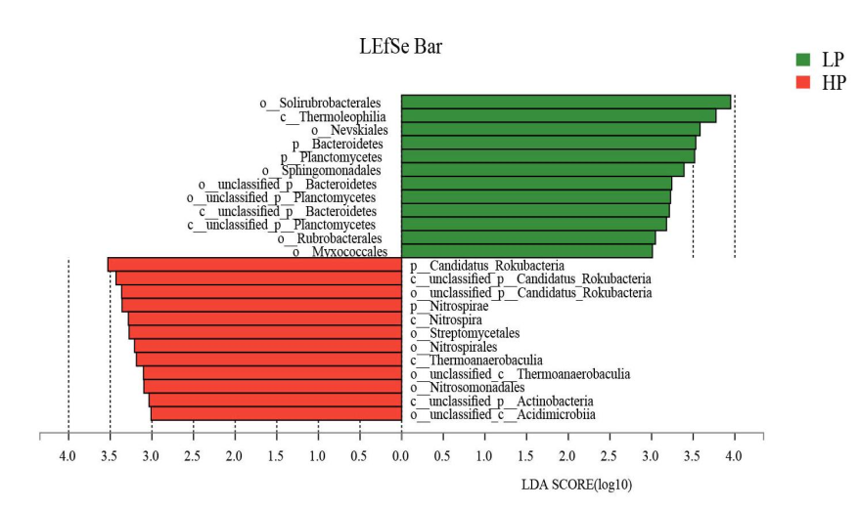Fig. S1 linear discriminant analysis effect size of microbial communities related to different soil phosphorus cycling-related genes. LP: low phosphorus input soil; HP: high phosphorus input soil.

Fig. S2 Functional gene composition of KEGG database for soils with different phosphorus input
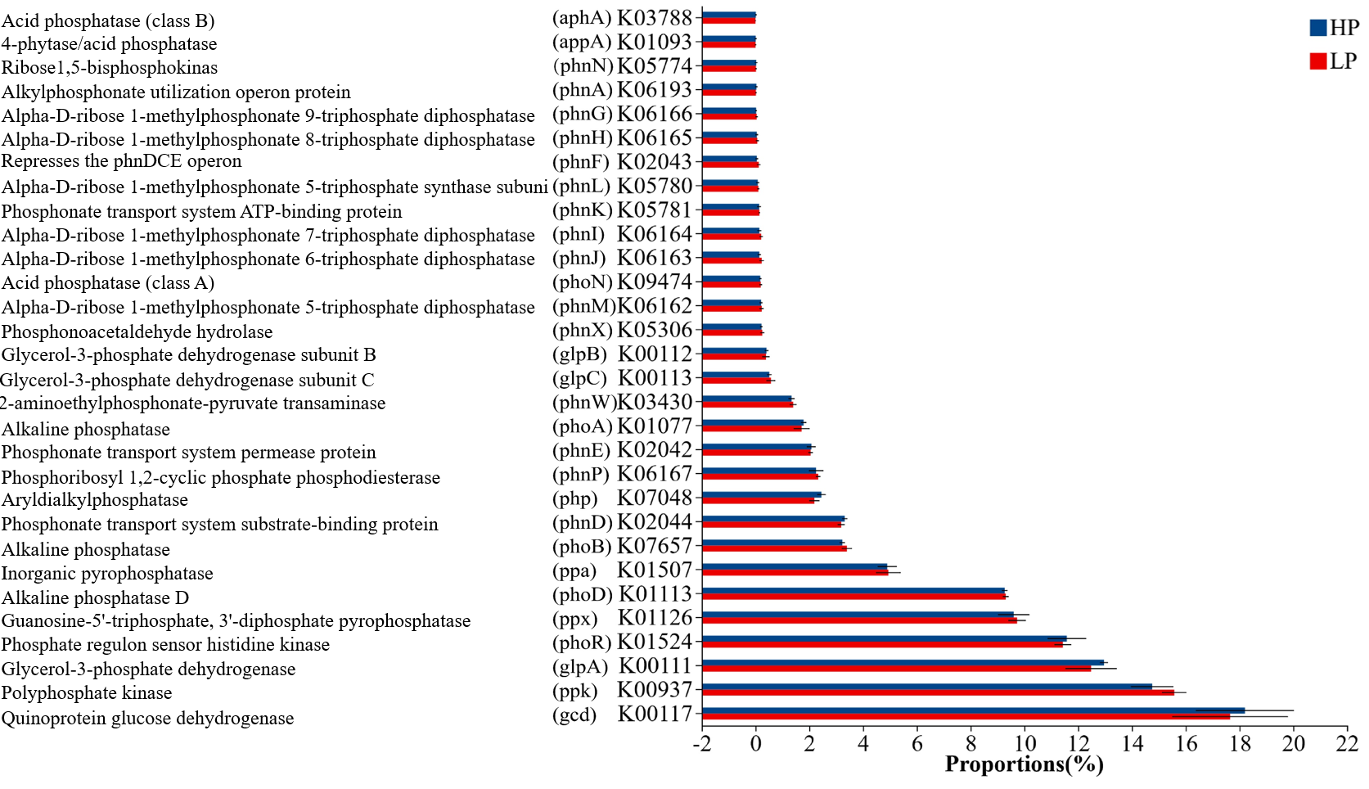Fig. S2 Functional gene composition of KEGG database for soils with different phosphorus input. LP: low phosphorus input soil; HP: high phosphorus input soil.

Figure S3 Species composition at phylum level of NR database for soils with different phosphorus input
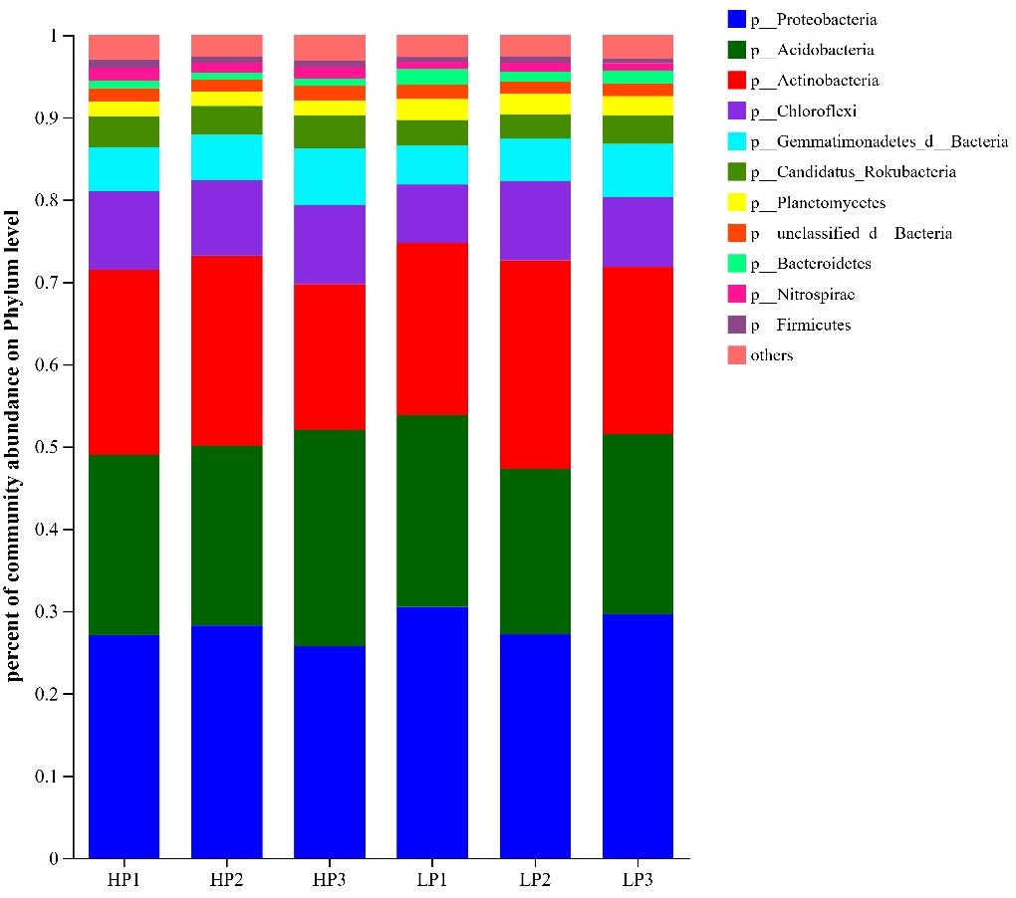Figure S3 Species composition at phylum level of NR database for soils with different phosphorus input. LP: low phosphorus input soil; HP: high phosphorus input soil. The numbers 1, 2, and 3 represent the treatment numbers of the soil samples.

Fig. S4 Shoot biomass and phosphorus content of donor maize (a, b) and faba bean (c, d) (Experiment I)
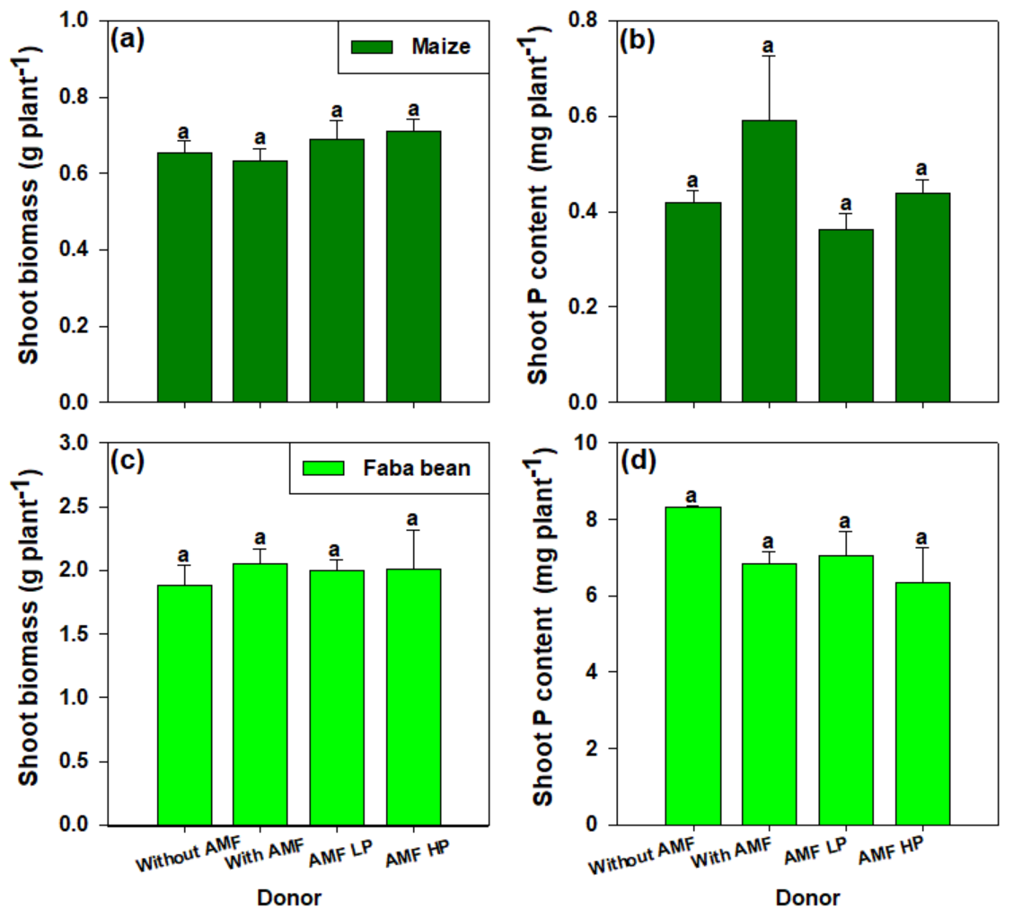Fig. S4 Shoot biomass and phosphorus content of donor maize (a, b) and faba bean (c, d) (Experiment I). P0: application of 0 mg kg⁻¹ Ca(H₂PO₄)₂·H₂O; P100: application of 100 mg kg⁻¹ Ca(H₂PO₄)₂·H₂O; AMF: arbuscular mycorrhizal fungi; LP: low phosphorus input soil; HP: high phosphorus input soil. Bars are means ± standard error (n = 4). Different letters mean the significant differences among treatments (Tukey’s test, P < 0.05).

Fig. S5 Shoot biomass (a) and phosphorus content (b) of donor species (Experiment II)
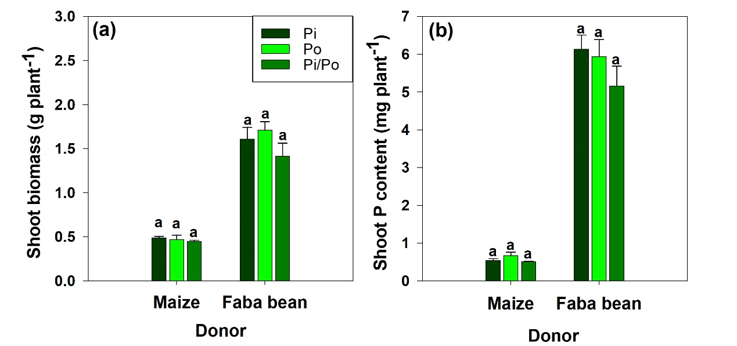
Fig. S5 Shoot biomass (a) and phosphorus content (b) of donor species (Experiment II). Pi: inorganic phosphorus solubilizing bacteria; Po: organic phosphorus mineralization bacteria; Pi/Po: mixture of inorganic phosphorus solubilizing bacteria and organic phosphorus mineralization bacteria. Bars are means ± standard error (n = 4). Different letters mean the significant differences among treatments of the same species (Tukey’s test, P < 0.05).

References
Ben-David, A., & Davidson, C. E. (2014). Estimation method for serial dilution experiments. Journal of Microbiological Methods, 107, 214-221. https://doi.org/10.1016/j.mimet.2014.08.023
Lang, M., Bei, S., Li, X., Kuyper, T. W., & Zhang, J. (2019). Rhizoplane bacteria and plant species co-determine phosphorus-mediated microbial legacy effect. Frontiers in Microbiology, 10, 2856. https://doi.org/10.3389/fmicb.2019.02856
Stockinger, H., Walker, C., & Schüßler, A. (2009). ‘Glomus intraradices DAOM197198’, a model fungus in arbuscular mycorrhiza research, is not Glomus intraradices. New Phytologist, 183(4), 1176-1187. https://doi.org/10.1111/j.1469-8137.2009.02874.x
Thomas, R. L., Sheard, R. W., & Moyer, J. R. (1967). Comparison of conventional and automated procedures for nitrogen, phosphorus, and potassium analysis of plant material using a single digestion. Agronomy Journal, 59(3), 240-243. https://doi.org/10.2134/agronj1967.00021962005900030010x

