Impact of Physical Activity Intensity on Stroke Risk in Middle-aged and Older Adults
Zetai Bai, MD; Mei Li, PhD; Liying Meng, PhD; Chen Zhang, MD; Zheyi Wang, PhD; Deyuan Kong, MD; Guanzhao Wu, PhD

Table S1. Mediation Analysis of the Association Between Highly active Physical Activity and Risk of First Stroke via Cardiovascular Markers
Abbreviations: BP, Blood Pressure; HDL, High-Density Lipoprotein; TyG-BM, Triglyceride-Glucose-Body Mass Index; TC, Total Cholesterol; BMI, Body Mass Index; TyG, Triglyceride-Glucose Index. Adjustments were made for age, gender, marital status, educational background, place of residence, alcohol consumption history, smoking status, and history of diabetes.

Figure S1. Relationship between first stroke and active physical activity (aPA): Subgroup Analysis by Baseline Characteristics
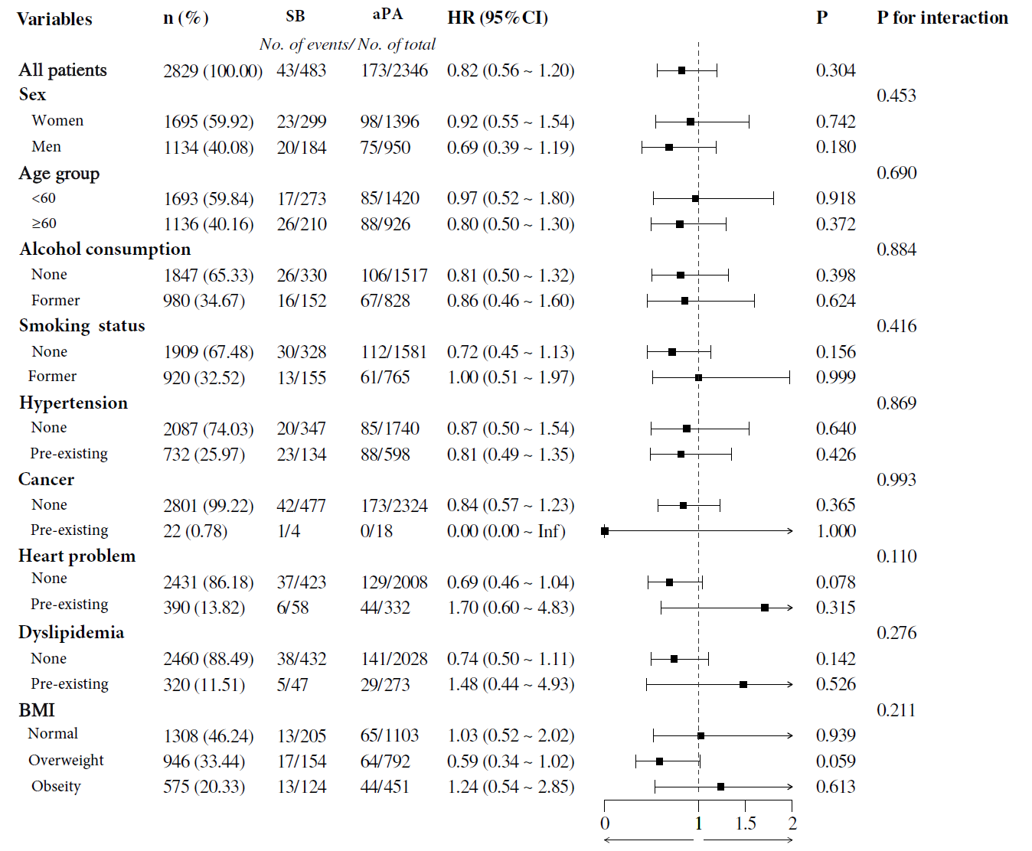
Hazard ratios (HRs) and 95% CIs for very active versus sedentary physical activity were estimated after adjusting for place of residence, marital status, diabetes, and lipids.
after adjusting for sex, age, smoking, alcohol consumption, body mass index, total
smoking, alcohol consumption, hypertension, cancer, heart disease, dyslipidemia and body mass index were analyzed in subgroups. Interactions were compared by likelihood ratio tests comparing active physical activity with a model with a sedentary (continuous) multiplicative interaction term.

Table S2. Factors Influencing Stroke Risk in 2015: Univariate and Multivariate Regression Analyses

Abbreviations: SB,Sedentary behavior; aPA, active physical activity; haPA, highly active physical activity; OR, Odds Ratio; CI, Confidence Interval;

Table S3. Factors Influencing Stroke Risk in 2018: Univariate and Multivariate Regression Analyses
Abbreviations: SB, Sedentary behavior; aPA, active physical activity; haPA, highly active physical activity; OR, Odds Ratio; CI, Confidence Interval.

Table S4. Association of physical activity intensity with first stroke in participants with chronic disease: multi-model cox risk regression
Abbreviations: SB, Sedentary behavior; aPA, active physical activity; haPA, highly active physical activity; HR, Hazard Ratio; CI, Confidence Interval.
Model1: crude.
Model2: adjusted for age, sex.
Model3: adjusted for age, sex, marry status, alcohol consumption, smoking status,education level.

Table S5. Association between different types of physical activity and risk of first stroke in people with a history of different illnesses.
Abbreviations: SB, Sedentary behavior; haPA, highly active physical activity; HR, Hazard Ratio; CI, Confidence Interval.

