Table 1. Composition of cellulose catalytic pyrolysis products.
Organic components | Compound name | Molecular formula | Peak area (%)
Furans | 2-methylfuran | 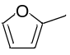 |  | 5.46
Furans | 2,5-dimethyloxolane-3,4-dione | 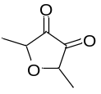 |  | 5.3
Furans | 2-formaldehyde furan | 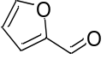 |  | 12.81
Furans | 5-methylfuran-2-carbaldehyde | 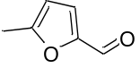 |  | 6.03
Furans | 5-methyl-3H-furan-2-one | 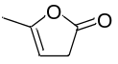 |  | 1.03
Carbohydrates | L-glucan | 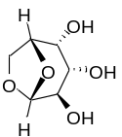 |  | 11.74
Carbohydrates | D-Glucose | 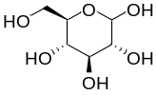 |  | 2.11
Nitrogen-containing substances | 3,5-Dimethylpyrazole | 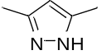 |  | 3.05
Nitrogen-containing substances | 2,2-diethyl-3-methyloxazolidine | 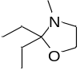 |  | 11.49
Nitrogen-containing substances | 2-methoxyphenyl-methylpropane-amine | 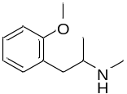 |  | 0.43
Aromatic hydrocarbons | Benzene | 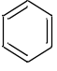 |  | 13.04
Aromatic hydrocarbons | Toluene | 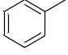 |  | 2.44
Aromatic hydrocarbons | Paraxylene | 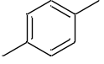 |  | 2.61
Aldehydes /ketones | Methyl vinyl ketone | 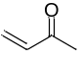 |  | 3.37
Aldehydes /ketones | Dihydro-4-hydroxy-2(3H)-furanone | 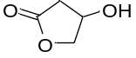 |  | 2.46
Hydrocarbons | 1,2-Cyclopentanedione | 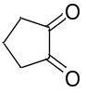 |  | 2.01
Hydrocarbons | 3,5-dihydroxy-6-methyl-2,3-dihydropyran-4-one | 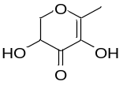 |  | 0.7
Acids and derivates | D-serine | 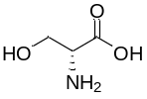 |  | 1.15
Acids and derivates | Cyclopropanecarboxylic acid, 4-methoxy-2-methylbutyl ester | 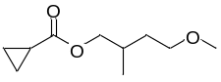 |  | 13.39

Table 2. Optimal configuration of transition states in the non-catalytic pyrolysis path of cellulose.
Optimal configuration of transition state
TS₁ | TS₂ | TS₃ | TS₄
TS₅ | TS₆ | TS₇ | TS₈
TS₉ | TS₁₀ | TS₁₁ | TS₁₂
TS₁₃ | TS₁₄ | TS₁₅ | TS₁₆
TS₁₇ | TS₁₈

Table 3. The yield of typical products in the pyrolysis reaction.
Organic components | Compound name | Molecular formula | Peak area (%)
Organic components | Compound name | Molecular formula | Non-catalytic | Catalytic
Furan | 2-formaldehyde furan |  | 25.34 | 12.81
Aromatic hydrocarbons | Benzene |  | / | 13.04
Aromatic hydrocarbons | Toluene |  | / | 2.44
Aromatic hydrocarbons | Paraxylene |  | / | 2.61

Table 5. Optimal configuration of transition states in the catalytic pyrolysis path of cellulose molecule.
Optimal configuration of the transition state
C_TS₁ | C_TS₂ | C_TS₃ | C_TS₄
C_TS₅ | C_TS₆ | C_TS₇ | C_TS₈
C_TS₉ | C_TS₁₀ | C_TS₁₁ | C_TS₁₂
C_TS₁₃

