Supplementary Material
Paper battery powered iontophoresis microneedles patch for hypertrophic scar treatment
Jie Gao¹, Fuqian Chen¹, Chen Wang¹, Jingbo Yang ¹, Ying Zheng¹, Bin Liu¹, Gang Nie², Linyu Zhu^{2, *}, Shuo Wu^{1,3, *}, Xi Xie⁴, Lelun Jiang^{1, *}
¹ Guangdong Provincial Key Laboratory of Sensor Technology and Biomedical Instrument, School of Biomedical Engineering, Shenzhen Campus of Sun Yat-Sen University, Shenzhen, 518107 PR China.
² Department of Dermatovenereology, The Seventh Affiliated Hospital, Sun Yat-sen University, Shenzhen, 518107 PR China.
³ Department of Otolaryngology, The Third Affiliated Hospital, Sun Yat-Sen University, Guangzhou, 510630 PR China.
⁴ State Key Laboratory of Optoelectronic Materials and Technologies, School of Electronics and Information Technology, Sun Yat-sen University, Guangzhou 510006, China
* The corresponding authors, Tel: +86 20-39332153 E-mail: jianglel@mail.sysu.edu.cn; wush68@mail.sysu.edu.cn; zhulinyu@sysush.com;

1. Phase transformation performance of gelatin
The storage and release of TA in PBIMNP was achieved through the phase transformation of gelatin. Figure S1 illustrates the dynamic process of gelatin blocks placed on the radial side of human forearm at physiological temperature, where human body temperature-initiated phase transformation at 120 s, followed by gradual deepening until complete transition occurred at 170 s with increasing fluidity observed thereafter (200 s). Video S1 further demonstrates rapid phase transformation of gelatin under physiological conditions (~2-3 min), enabling efficient drug delivery.
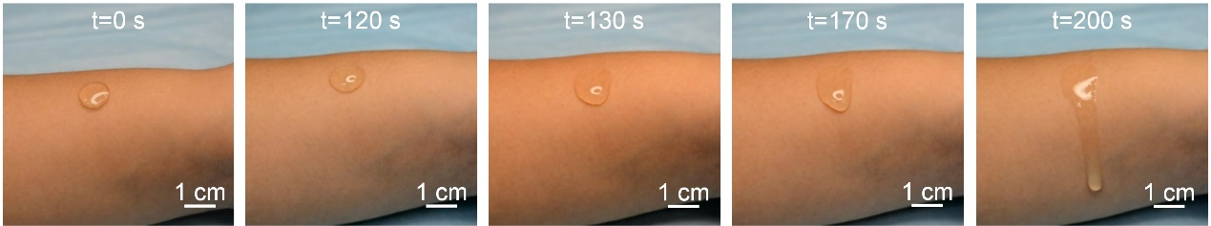
Figure S1 Phase transformation of gelatin on human forearm at 0 s, 120 s, 130 s, 170 s and 200 s, respectively.
2. Characterization of PBIMNP
Figure S2a is the SEM image of the gelatin. Homogeneous pores can be observed in gelatin which could be used for drug storage. Figure S2b is the optical image of the MN, which owns a sharp tip. Figure S2c is the ultra-depth three-dimensional (3D) image of the MN. The height of a needle is approximately 1000 μm.
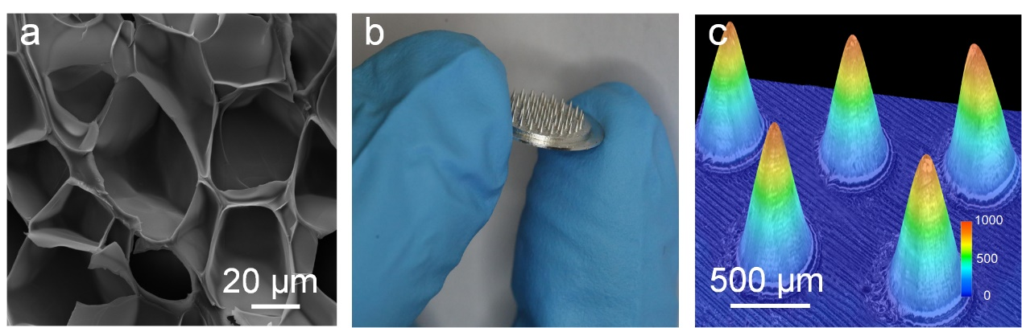
Figure S2 Characterization of PBIMNP: (a) the SEM image of the gelatin, (b) the optical image of MN, and (c) the ultra-depth 3D image of MN.
3. Electrical performance of paper battery
The impedance of human skin in dry, sweat and wound is approximately 2000 Ω, 1000 Ω and 800 Ω, respectively. The current and voltage output performance of the paper battery were investigated at a dry skin impedance of approximately 2000 Ω, as shown in Figure S3. The paper battery output a stable current and voltage for 60 min (Figure 3a), indicating the reliability of voltage source for iontophoresis. The paper battery output performance of the paper battery under various resistances (500 Ω, 1000 Ω, 1500 Ω, 2000 Ω, 2500 Ω, and 3000 Ω) were further investigated during gelatin phase transformation (Figure S3b). As the resistances increased from 500 Ω to 3000 Ω, the current gradient of the paper battery decreased, while the voltage remained stable, and vice versa. It indicated that the output of the paper battery remained stable even under changing resistances, providing a stable output for the iontophoresis of PBIMNP.
Figure S3 Output performance of the paper battery. (a) Current and voltage performance of paper battery over 60 min at an impedance of 2000 Ω. (b) Current and voltage output performance of paper battery loaded with various resistances.
4. Characteristic of triamcinolone acetonide
The drugs are delivered to HS tissues via passive diffusion and active iontophoresis. The efficiency of passive diffusion and active iontophoresis is greatly affected by the microchannels created by PBIMNP and the applied potential, repectivley. Thus, the particle size and Zeta potential of TA were tested, as shown in Figure S4. It was observed that TA particles with an average diameterless than 75 μm accounted for 94.93%, while those less than 187.5 μm constituted 100% (Figure S4a). Notably, the diameter of TA particles was significantly smaller than the microchannel created by PBIMNP (300 μm), suggesting that drug delivery to HS tissues via microchannels was feasible. Figure S4b shows the Zeta potential of TA particles was 3.76 ± 0.25 mV.
Figure S4 Characterization of TA particles: (a) the diameter distribution of TA particles, and (b) the Zeta potential distribution of TA particles.

5. Long-term Stability of PBIMNP
Figure S5 shows the efficiency of gelatin-wrapped TA after 28 days of storage at 4°C. The efficiency of TA in gelatin was 93.52 ± 1.47% on day 7 and remained at 90.07 ± 2.39% on day 28. It demonstrated that the gelatin-wrapped TA had excellent long-term stability at low temperatures and can be used for HS treatment.
Figure S5 Long-term stability of PBIMNP for 28 days.

6. Mechanical performance of PBIMNP
Figures S6a&b show the OCT and HE images of HS tissue after PBIMNP puncture. The depth and diameter of the microchannels were approximately 600 μm and 300 μm, respectively. It indicates that PBIMNP could effectively penetrate dense tissue on HS skin and form uniform microchannels for drug delivery. Due to its high density and hardness, HS puncture required a larger force. The fracture performance of PBIMNP during usage was further investigated to ensure its safety. Figure S6c shows the mechanical performance of PBIMNP when punctured on a steel plate. The load force gradually increased with displacement. The load force reached 3.1 N/needle, which significantly exceeded the penetration force required for HS (1.7 N/needle). It demonstrates that PBIMNP can effectively penetrate the dense HS tissue without fracture, thereby ensuring its safety.
Figure S6 Mechanical performance of PBIMNP. (a) OCT images of HS tissue after PBIMNP puncture. (b) HE images of HS tissue after PBIMNP puncture. (c) Mechanical resistance of PBIMNP when punctured on a steel plate.

7. Puncture performance of PBIMNP
Figure S7 shows the microchannels recovery after PBIMNP puncture in HS and normal skin. The microchannels created on HS skin remained visible even after 60 min of recovery, and it took approximately 420 min for complete healing (Figure S7a). In contrast, microchannels in normal skin completely healed within 30 min (Figure S7b). The longer recovery of microchannels in HS tissue may be attributed to its skin tension. The persistent opening of microchannels in HS skin holds promising implications for long-term iontophoresis-driven drug delivery, offering high potential for HS treatment.
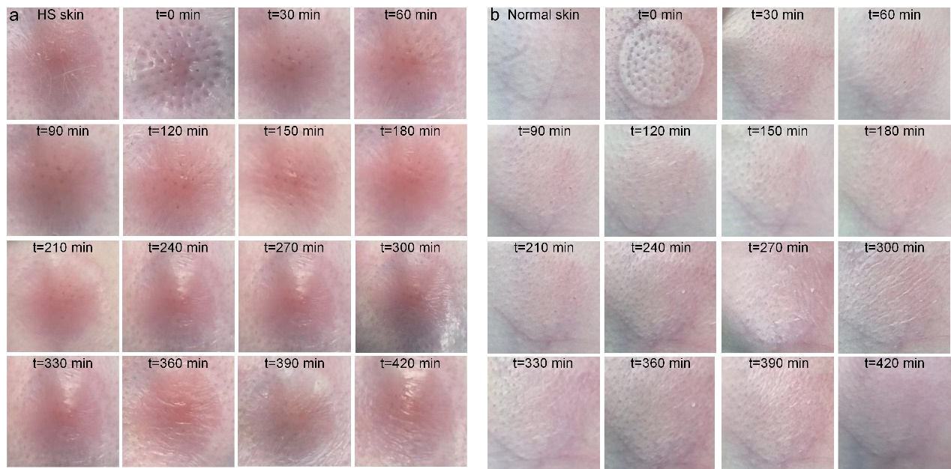
Figure S7 Puncture performance of PBIMNP: (a) The recovery process of HS skin before and after puncture. (b) The recovery process of normal skin before and after puncture.

8. Simulation of PBIMNP
Figure S8 shows the 2D simulation results of the four administration strategies (Cream, MNP, PBIMNP and Injection) on HS skin. The permeability of drug into the cross-section of HS was simulated. The drug permeability did not show significant differences in Cream group for 60 min. In contrast, the permeability in MNP group gradually increased due to the existence of created microchannels. PBIMNP exhibited superior permeability compared to MNP since it facilitated passive diffusion through microchannels created by MN puncture and simultaneous iontophoresis-driven drug delivery. The Injection showed the highest permeability due to the direct administration of the drug into HS skin (Figure 8a). Figure S8b&c depict the calculated cumulative amount of the four administration strategies at 24 h and 1 h, respectively, which were consistent with the 3D simulation results and in vitro experiments.
Figure S8 The 2D simulation of drug delivery process of PBIMNP. (a) The calculated transdermal delivery process administrated with four administration strategies. (b) The calculated cumulative amount administrated with different strategies at 24 h. (c) The calculated cumulative amount administrated with different strategies at 1 h.

9. In vivo experiments of PBIMNP
Figure S9 shows the morphology of HS skin before and after administration. A uniform wound was created on the skin of the rabbit ear through surgical (day 1), leading to a formation of HS after 30 days due to the self-repair of the skin. The skin surface exhibited a raised and dark red color, which is indicative of HS formation. After 3 administrations, the scar swelling and raised were significantly subsided in the MNP, PBIMNP, and Injection group. In contrast, the HS and Cream group still exhibited tightness, darkness in coloration, and raised condition. Furthermore, compared with the HIIIMNP group, the Injection group had a concave-convex surface, potentially attributed to the uneven distribution of drugs in HS tissue caused by injection. It suggests that PBIMNP enables painless and uniform drug delivery in HS tissue, offering a promising therapeutic approach for HS.
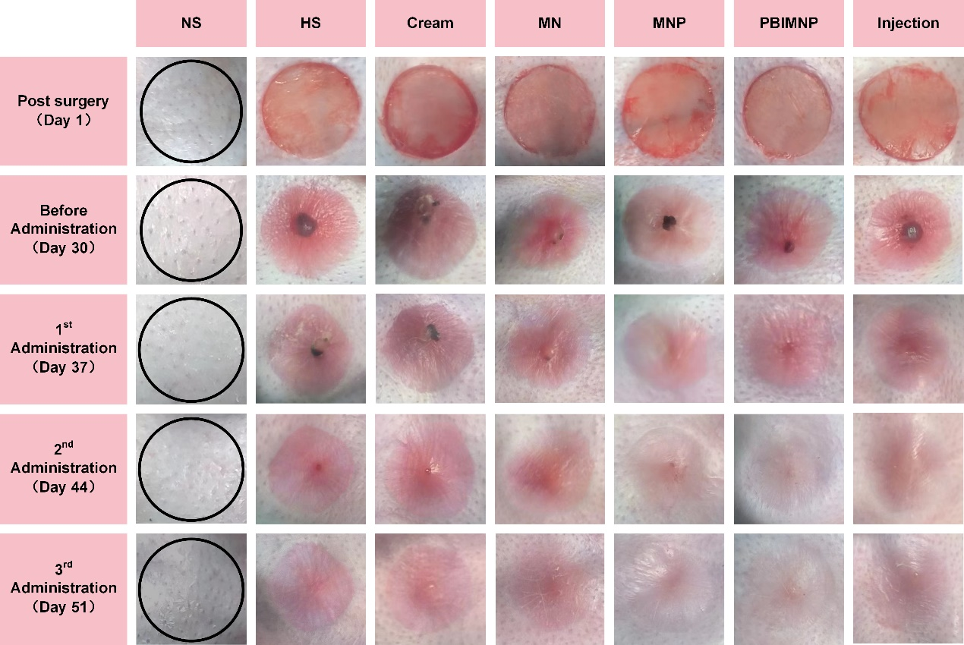
Figure S9 Morphology images of HS skin before and after administration.

10. Histological Study
Figure S10a shows HE images of HS skin before and after administration. On day 30, the normal tissue exhibited regular arrangement and uniform tissue spacing. In contrast, other groups displayed a dense and disordered tissue structure, indicating successful establishment of HS model. After 3 administrations, HS and Cream still exhibited a dense tissue, whereas MN group displayed numerous fine fibers arranged evenly with a relatively compact structure. Conversely, MNP, HIIIMNP, and Injection group showed abundant coarse fibers arranged regularly similar to normal tissue with a relatively loose tissue structure. It suggests that PBIMNP can achieve the therapeutic effect on HS by regulating the distribution of collagen fibers in HS tissues. The somatic cell count in HS tissue was further quantified, as shown in Figure S10b. The somatic cell count in HS tissue of PBIMNP group was 1666 ± 23/mm³ on day 30 and 838 ± 30/mm3 on day 51, and the normal tissue was 786 ± 7.94/mm³, indicating a significant reduction.
Figure S10 Histological analysis of HS tissue before and after various administrations. (a) HE images of HS tissue before and after administration. (b) Somatic cell counts of HS tissue after HE staining.

