Table 1. Baseline clinical characteristics

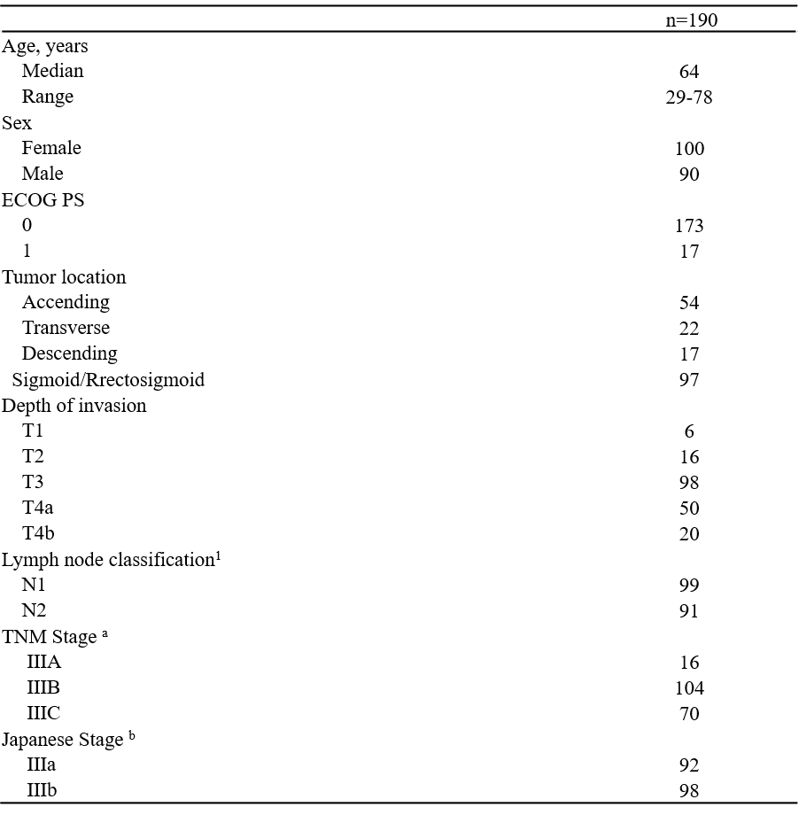

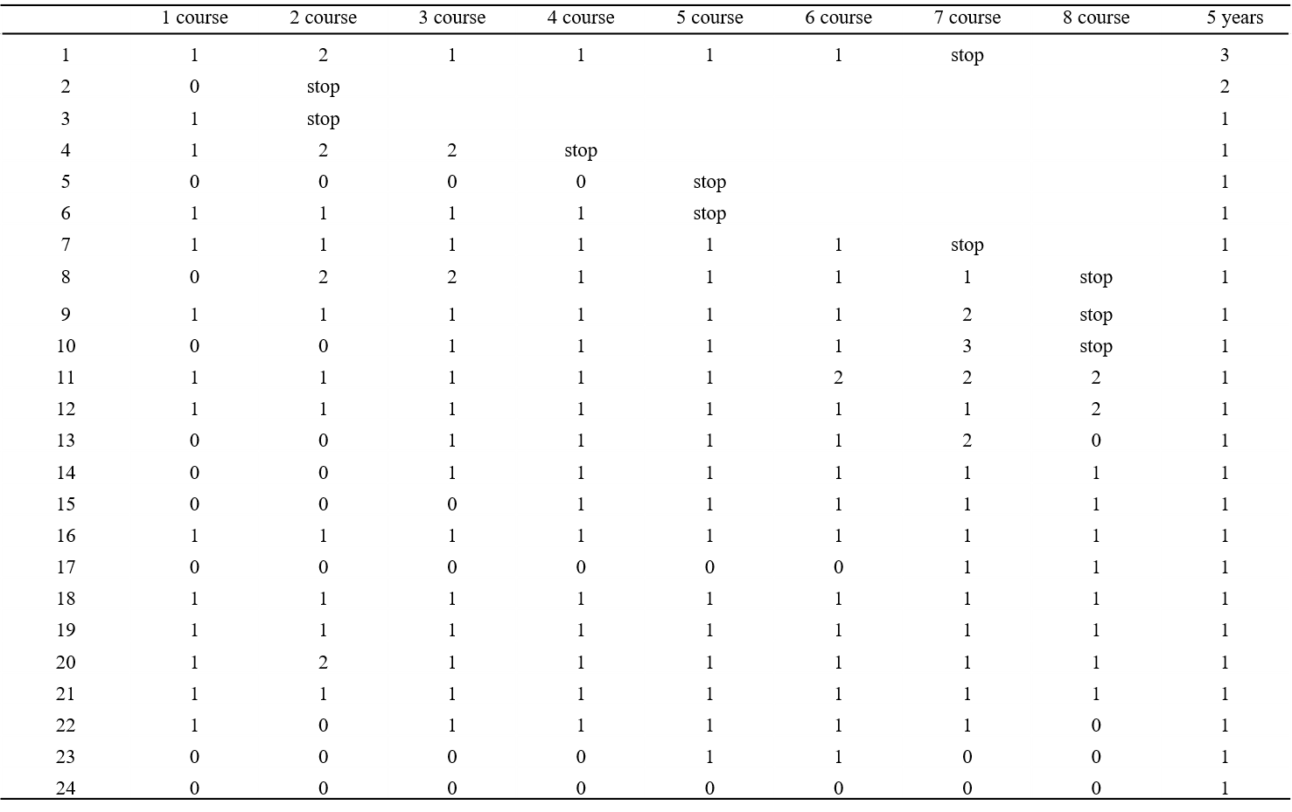
Table 2
Changes in peripheral sensory neuropathy

