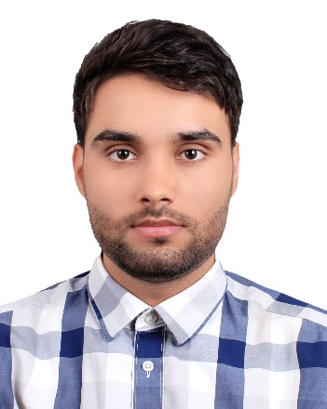
Arif Alkozay holds a Bachelor's degree in Civil Engineering from the Faculty of Engineering in Herat, Afghanistan. With a focus on structural engineering research, he previously served as an assistant professor and research coordinator at the Faculty of Engineering and currently works as a Structural Designer at Sodais Saber Construction Company. He is the founder of the FSDS organization, which offers free services and consultations related to structural design for everyone in Herat province through a collaboration of companies.

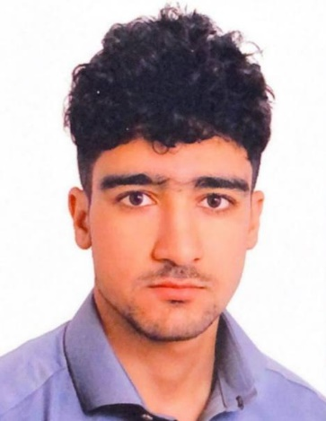
Khalid Ahmad Ahmadi is a senior architecture student at the Faculty of Engineering of Herat University. Currently, he serves as an assistant professor in faculty of engineering. Additionally, he brings nearly two years of experience as a part-time site engineer at Ehdas Khorasan Road and Construction Company.

