Supplementary Materials for

An ecological mechanism determining the direction of species evolution
Haoyuan Wu, Yonghua Wu

Yonghua Wu: wuyh442@nenu.edu.cn

The PDF file includes:

Materials and Methods
Figs. S1 to S4
Tables S1 to S9
References

Materials and methods
Bacterial strain
The E. coli strain used in this experiment is E. coli K-12 GM4792. This strain is asexual and its genome has been publicly disclosed, making it suitable for experimental evolution studies (16). E. coli K-12 GM4792 differs from other closely related strains in that it has a continuous 212bp deletion in its lactose operon region, and its lacI and lacZ fusion genes has a frameshift mutation caused by a single base insertion, rendering it unable to utilize lactose (lac-). However, previous studies have shown that when cultured in a medium where lactose is the sole carbon source, this strain undergoes revertant mutations, resulting in the emergence of lactose-utilizing mutants, lac+ (15, 16). The presence of lac+ and lac- can be easily distinguished through blue-white screening.

Culture conditions
We retrieved E. coli K-12 GM4792 from the -80°C freezer and allowed it to thaw at room temperature. Subsequently, we conducted three consecutive liquid cultures and streak plate cultures on LB agar, selecting a single clone each time. The culture from the third picking was designated as the ancestral strain (Lac- (ancestor)) for the experiment, and we stored multiple backups in glycerol at -80°C. During blue-white screening, the ancestral strain displayed white colonies, indicating its inability to metabolize lactose. Furthermore, partial gene sequencing of the ancestral strain identified a 212 bp deletion, confirming its consistency with the strain utilized in the experiment.

The ancestral strain was cultured in two distinct media types (L and G) for the experimental evolution, with 5 replicates for each medium, totaling 10 experimental populations (L1-5, G1-5). The composition of 1 liter of L medium comprised basic M9 salts (Na₂HPO₄ 6.8 g, KH₂PO₄ 3.0 g, NaCl 0.5 g, NH₄Cl 1.0 g), supplemented with 2 ml of 1.0 M MgSO₄ solution, 0.1 ml of 1.0 M CaCl₂ solution, 10 g sodium acetate, and 20 g lactose. The G medium mirrored the L medium but substituted 10 g sodium acetate with 50 g glucose. All reagents were sourced from Sangon Biotech, Shanghai. In the L medium, sodium acetate and lactose functioned as carbon sources, whereas in the G medium, lactose and glucose served as the carbon sources.

Every 24 hours, 100 µl of culture from each population was transferred to 9.9 ml of fresh corresponding medium in 50 ml plastic tubes and then placed in an incubator at 37°C with shaking at 220 rpm. Blue-white screening was conducted on the cultures every 5 days, with a tally of the blue and white colonies (each population was spread on two plates). Subsequently, a 4 ml aliquot of culture mixed with an equal volume of 50% glycerol was stored at -80°C every 5 days for preservation purposes.

Gene sequencing
We conducted colony PCR amplification and sequencing on various segments of the lactose operon to identify target strains or analyze sequence evolution. For strain identification, we utilized two sets of primers at different experimental stages. The first primer set was employed to determine if the target bacterial culture harbored a 212bp deletion of E. coli K-12 GM4792. The PCR amplification primers used were LacIF1: TATCCCGCCGTTAACCACCATCAAAC and LaczR1: CTTCCTGTAGCCAGCTTTCATCAACAT. The amplification setup consisted of a 25 μl reaction volume, comprising 12.5 μl of PrimeSTAR Max premix (Takara, Beijing), 0.75 μl of each primer, 1 μl of template (colony), and 10 μl of sterile water. The PCR amplification process involved an initial denaturation at 98°C for 60 seconds, followed by 35 cycles of denaturation at 98°C for 10 seconds, annealing at 60°C for 15 seconds, extension at 72°C for 5 seconds, and a final extension at 72°C for 2 minutes. Subsequently, the PCR products were detected by 1% agarose gel electrophoresis and were sent for sequencing (ABI3730, GENEWIZ) using the same primers as the PCR amplification. The second primer set was utilized to assess whether the target bacterial strain carried the 212bp deletion and mutation region of E. coli K-12 GM4792. The PCR amplification primers used were LacIF2: CATCTGGTCGCATTGGGTCA and LaczR2: CCAGTTTGAGGGGACGACGACAGT. The amplification system and conditions were akin to the first set, except that the annealing temperature during the 35 cycles was set at 55°C, and the extension time was 10 seconds.

Genome sequencing
We conducted whole-genome sequencing on the ancestral strain used in this study, as well as on single clones from 10 populations that had undergone experimental evolution for 25 days. For the ancestral strain, we performed both second- and third-generation sequencing and de novo assembly of its genome, resulting in a complete genome. For the single clones from the 10 experimental evolution populations, we conducted second-generation genome resequencing.

We conducted overnight plate cultures of the ancestral strain and the 10 populations from day 25 of experimental evolution. The following day, a single clone was randomly selected from the ancestral strain plate, and two single clones were picked from each of the 10 population plates, resulting in a total of 21 samples, which were then placed in G medium for overnight culture. PCR amplification sequencing was performed on these samples to confirm the presence of a 212bp deletion, indicating that they belonged to the strains used in this study. Subsequently, 5 milliliters of each of the 21 samples were used for DNA extraction using the Bacteria Genomic DNA Extraction Kit (TaKaRa, Beijing) following the provided instructions.

We conducted second-generation genome sequencing on 21 samples using the DNBSEQ platform (BGI, Shenzhen). Initially, we randomly fragmented the genomic DNA of the samples, recovered the necessary DNA fragments through electrophoresis, added adapters for cluster preparation, and finally sequenced them using the MGISEQ-2000 platform. We utilized the SOAPnuke software (38) to filter raw reads (150 bp) and generate high-quality clean reads, which excluded low-quality sequences and adapter sequences.

For our ancestral strain, in addition to second-generation sequencing, we also performed third-generation genome sequencing using the PacBio sequencing platform (BGI, Shenzhen). We processed its DNA into appropriately-sized fragments (20-40K) using g-TUBE, followed by fragment damage repair and end repair. Adapters with hairpin structures were attached to both ends of the DNA fragments to form a dumbbell structure known as SMRTbell. The annealed smrtbell and the polymerase at the bottom of the ZWM were mixed and used for the final sequencing (PacBio Sequel II). Due to the presence of low-quality sequences and adapter sequences in the original sequencing data, it was necessary to filter out these impurities to obtain reliable subreads. Multiple subreads from a single pore were used to obtain a circular consensus sequencing (CCS) data. We utilized the FalconConsensus (39) and Proovread (40) software to generate corrected reads, which were then used for sequence assembly using the Canu software (41). Finally, we employed the GATK software (42, 43) for single nucleotide correction using second-generation sequencing short sequences to obtain reliable assembled genome sequences.

SNP, indel analyses and phylogenetic relationships construction
We detected SNPs and indels by aligning the short reads of 20 single clone samples from evolving populations with the complete genome sequence of the ancestral strain, used as a reference. We employed the Burrows-Wheeler Aligner (44, 45) to align the clean data of each sample to the reference genome, resulting in initial alignment results in BAM format. To ensure accurate variant detection, we followed the optimal variant detection analysis workflow recommended by the official GATK website (Genome Analysis Toolkit, GATK). Following alignment, Picard tools (http://broadinstitute.github.io/picard/) were used to remove duplicate reads, and the software GATK (42, 43) was employed for local realignment and base quality recalibration. Evaluation metrics such as sequencing depth, coverage, and alignment rate were statistically analyzed based on the alignment results for each sample.

The genome-level SNP and indel matrix of the 21 samples was then used to construct a neighbor-joining (NJ) tree using MEGA X (46), with the Jukes-Cantor model selected as the best-fit model and bootstrap values set to 1000. Additionally, we reconstructed a maximum likelihood (ML) tree using IQ-TREE (47) based on the genome-level SNP data, selecting K2P+ASC as the best-fit model. The ML tree exhibited high similarity to the NJ tree, and only the NJ tree was presented.

Fitness assay in L culture medium
We compared the relative fitness differences between lac- and lac+ in L medium. Considering the changes in blue-white clone ratios over time in L1-5, we selected samples with both blue and white clones at specific time points for the experiment. Specifically, frozen glycerol bacteria saved on day 15 were chosen for L1 and L4, while those saved on day 10 were selected for L2, L3, and L5. After thawing the frozen glycerol bacteria at room temperature, a certain amount of bacterial solution was diluted and subjected to blue-white screening. Two blue single clones and two white single clones were selected from each of L1-5, totaling 20 single clones. Each single clone was then placed in 10 ml of L medium for liquid culture at 37°C and 220 rpm for 24 hours to achieve a similar physiological state. After 24 hours, the OD values of these 20 subpopulations were measured three times. Based on the OD values and following a blue: white ratio of 10 : 1 and 1 : 10, two blues and two whites from the same experimental population were paired into competition pairs, resulting in a total of 20 pairs. The paired blue-white bacterial solutions were mixed and prepared as 100 μl bacterial solutions added to 9.9 ml of L medium in 50 ml plastic tubes. Immediately after mixing, bacterial solutions were diluted and plated (3 plates per competition pair), totaling 60 plates. After incubation at 37°C for 24 hours, blue-white screening was performed to count the number of blue and white colonies, calculating the density of blue-white colonies before competition. After 24 hours of competition, the same method was used to calculate the density of blue-white colonies after competition. Based on the densities of blue and white colonies before and after competition, the selection rate constant $r_{ij}$was calculated, which is given by
$$r_{ij}=\frac{ln⁡[N_{i}(1)/N_{i}(0)]-ln⁡[N_{j}(1)/N_{j}(0)]}{1 day}$$
where $N_{i}(0)$ and $N_{j}(0)$ are the initial densities of lac+ and lac-, respectively, and $N_{i}(1)$ and $N_{j}(1)$ are their densities after 24 hours (20).

Fitness assay in G culture medium
We conducted an analysis of relative fitness differences between lac- and lac+ in G medium. Since no lac+ (blue clones) were found in the G-populations during the 25-day experimental evolution period, we compared the relative fitness differences between lac- in the G-populations and lac+ from the L-populations. Blue-white screening was performed on the frozen glycerol bacteria from the G and L-populations on the 25th day. Two white single clones were selected from each of the five G-populations, and two blue single clones were selected from each L-population, resulting in a total of 20 single clones. These clones were individually placed in 10 ml of G medium and cultured at 37°C and 220 rpm for 24 hours to achieve similar physiological states. After 24 hours, the OD values of these 20 subpopulations were measured three times each. We adjusted the OD values to set the blue-white colony ratio of the competitive pairs at 10 : 1 and 1 : 10. We paired 10 lac- and 10 lac+ into 10 competition pairs, totaling 20 pairs. Each competition pair was mixed and prepared as 100 μl of bacterial solution added to 9.9 ml of fresh G medium in 50 ml plastic tubes. The tubes were then cultured at 37°C and 220 rpm for 24 hours. Immediately after mixing, bacterial solutions were diluted and plated (3 plates per competition pair), followed by incubation at 37°C for 24 hours and subsequent blue-white screening to count the number of blue and white colonies for density calculation. After 24 hours of competition, the density of blue and white colonies was calculated using the same method. The selection rate constant, r_{ij}, was calculated in the same manner as described above, with $N_{i}$ and $N_{j }$representing lac- and lac+, respectively.

Inter-directional selection experiment
To investigate inter-directional selection, we conducted competition experiments between lac- and lac+ under varied experimental conditions. From each of the 5 L-populations, two white clones (lac-) and two blue clones (lac+) were selected, resulting in a total of 10 white clones and 10 blue clones. Among these, samples preserved in glycerol on the 15th day were chosen for L1 and L4, while samples preserved on the 10th day were selected for L2, L3, and L5 for the experiment. These 20 clones were cultured in L medium at 37°C and 220 rpm for 24 hours. Subsequently, two blue and two white clones from the same population were paired to create 10 competition pairs (10 replicates). In each pair, lac- and lac+ were mixed in a 1 : 1 ratio (50 μl : 50 μl) by volume, generating 4 parallel subpopulations for each competition pair, totaling 40 subpopulations. These four sets were then subjected to competition experiments under four distinct conditions.

The first group (Group C) was cultured under the same conditions as the experimental evolution culture conditions used in this study, with each competition pair placed in 10 ml of L medium at 37°C and 220 rpm for shaking incubation. The second group (Group J) had similar conditions to Group C, except that the cultures were kept stationary. The third group (Group L) maintained the same conditions as Group C, except that the amount of sodium acetate was reduced from 10g to 1g. The fourth group had conditions akin to Group C, but with the mass of other nutrients tripled while keeping the masses of sodium acetate and lactose constant. The final culture volume was increased from 10 ml to 30 ml, with shaking incubation at 37°C and 220 rpm. Every 24 hours for each of these four experimental groups, 100 μl of the culture was sampled and transferred into fresh medium (9.9 ml for Groups C, J, L, and 29.9 ml for Group H) for subsequent generations. For the 40 experimental subpopulations, samples were taken before competition and every 24 hours thereafter, and subjected to blue-white screening to count the number of blue and white colonies until no white colonies appeared on two consecutive plating rounds.

Carbon source consumption measurement
We evaluated the consumption of carbon sources by lac- and lac+ in L and G media. The frozen glycerol bacteria from the 15th day were used for the experiment. Through blue-white screening, we selected one blue clone (L3-B) and one white clone (L3-W) from the L3 population, and one white clone (G3-W) from the G3 population, making a total of three single clones for the experiment. Initially, these three single clones were cultured overnight in LB liquid medium. The next day, 0.1 ml of overnight cultures of L3-W and L3-B were each added to 9.9 ml of fresh L medium for cultivation, while 0.1 ml of overnight cultures of L3-B and G3-W were added to 9.9 ml of fresh G medium for cultivation, resulting in a total of four experimental populations cultured for 24 hours. On the third day, bacterial cultures from these four experimental populations were streaked, single clones were picked again, and placed in their respective 10 ml fresh culture medium for another 24 hours of cultivation. This 48-hour physiological conditioning ensured that lac- and lac+ reached similar physiological states in their respective culture media. For the formal experiment, after the 48-hour conditioning period, 100 μl of bacterial culture from each of the four experimental populations was added to the corresponding 9.9 ml culture medium, with five replicates for each population, and cultivated at 37°C and 220 rpm for 24 hours. At intervals of 3, 6, 9, 12, and 24 hours, we alternated in extracting 1 ml samples from one of the five replicates, stored at -20°C, and sent for liquid chromatography detection the following day. To ensure result reliability, PCR amplification sequencing was conducted on the three single clone bacterial cultures used in this experiment before starting to confirm a 212 bp deletion, validating the intended strains for the study. Additionally, to prevent potential cross-contamination between lac+ and lac-, blue-white screening tests were carried out on the bacterial cultures before and after the 24-hour experiment to verify the absence of any cross-contamination among the four experimental populations. No mixed contamination was found among the total of 6483 colonies observed, eliminating the possibility of cross-contamination and evolutionary shift from lac- to lac+.

For the measurement of acetate content, detection was carried out using a high-performance liquid chromatography system (Agilent 1200) with a Welch Ultimate AQ C18 column (5μm, 250 mm × 4.6 mm). The samples were diluted 50 times with pure water and directly tested on the machine. The mobile phase used was potassium dihydrogen phosphate: methanol = 99 : 1, with a column temperature of 40°C, flow rate of 0.5 ml/min, detection wavelength of 210 nm, and an injection volume of 10 μl.

For the measurement of lactose and glucose, detection was performed using a high-performance liquid chromatography system (Agilent 1200) equipped with a differential refractive index detector and an Agilent ZORBAX NH2 column (5μm, 250 mm × 4.6 mm). The sample solution was diluted 20 times with pure water and directly tested on the machine. The mobile phase used was water: acetonitrile = 30 : 70, with a column temperature of 40°C, flow rate of 1 ml/min, and an injection volume of 20 μl.

Growth curve measurement
We measured the growth of lac- and lac+ in L medium. One white clone (lac-) and one blue clone (lac+) were selected from each of the five L-populations, resulting in a total of 5 white clones and 5 blue clones for the experiment. For populations L1 and L4, frozen glycerol bacteria saved on the 15th day were chosen, while for populations L2, L3, and L5, frozen glycerol bacteria saved on the 10th day were used. The 10 clones were each cultured with shaking at 37°C and 220rpm in L medium for 24 hours to achieve a similar physiological state. The OD values of these 10 clone cultures were measured three times each, and based on the OD values, the initial OD values of the 10 clone cultures were adjusted to be the same. Subsequently, 350 μl of bacterial culture was taken from each of the 10 clone cultures and added to 10 tubes of L medium, making up to 35 ml, and then incubated with shaking at 37°C and 220rpm for 24 hours. Every 2 hours, 1 ml was transferred from each tube to a sterile 1.5 ml centrifuge tube and stored in a refrigerator at 4°C. Once all samples were collected, the OD600 of each sample was measured sequentially using a UV-visible spectrophotometer (Shimadzu UV-1240) in triplicate, with consistent results for each measurement.

Statistical analyses
We conducted data analysis using the R statistical software. We employed a one-sample t-test to examine the two-tailed probability of potential deviation of the selection rate constant (r_{ij}) from the null hypothesis that the selection rate constant is zero, indicating equal fitness for lac+ and lac-. For the growth rate analysis of lac- and lac+ in L medium, as well as the competition experiment results of lac- and lac+ under four different conditions, we utilized repeated measures ANOVA to assess the statistical significance of corresponding variables at various time points. Prior to the analysis, we performed a normality test on the samples, which indicated a normal or near-normal distribution for all cases. Furthermore, the homogeneity of variance test (p > 0.05) was conducted, and pairwise comparisons were adjusted using the Holm method for p values.

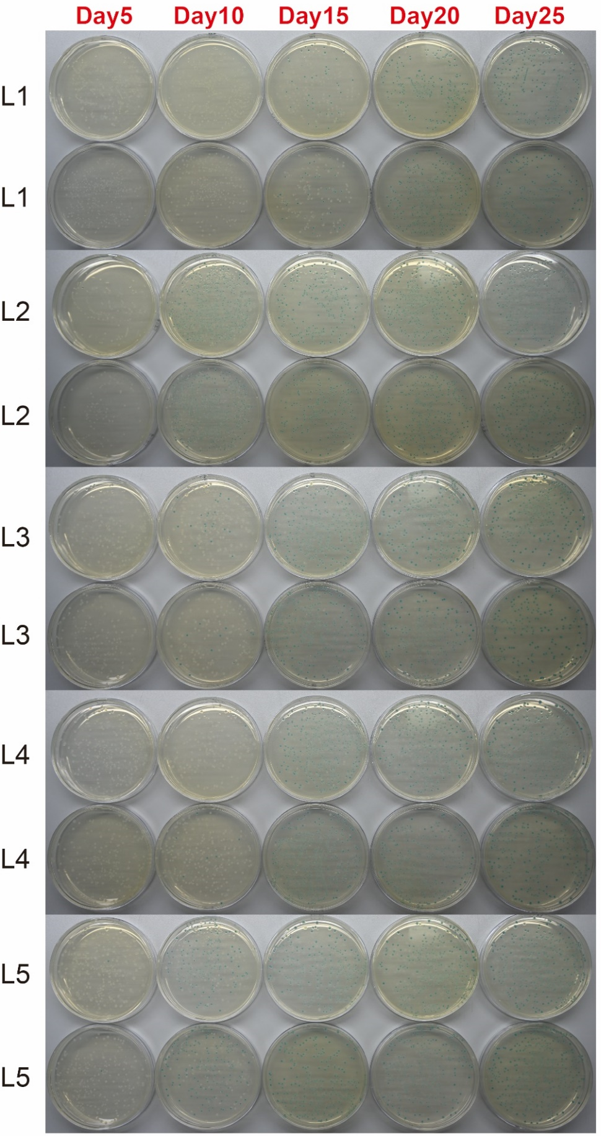

Fig. S1. Plating glycerol stocks of five L-populations at different time points. At each time point, each L-population was spread on two LB agar plates containing IPTG and X-gal.

Fig. S2. Neighbor-joining tree constructed using genome-level SNP and indel data from the 21 clones obtained through genome sequencing. The Jukes-Cantor model was employed as the best-fit model, and bootstrap support greater than 60% is displayed.

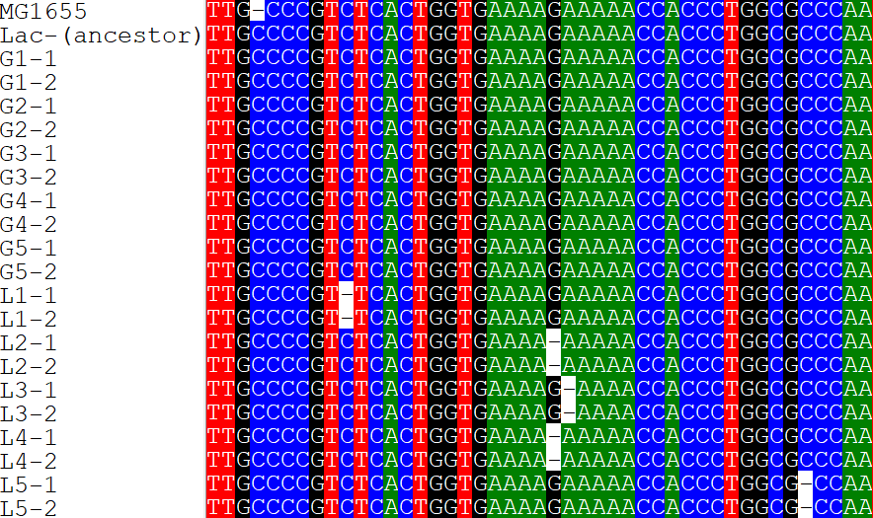
Fig. S3. Single-base deletion found in the 10 clones from the five L-populations. The sequences of ancestral strain, the 10 clones of five G-populations, and E. coli K-12 MG1655 are also included.

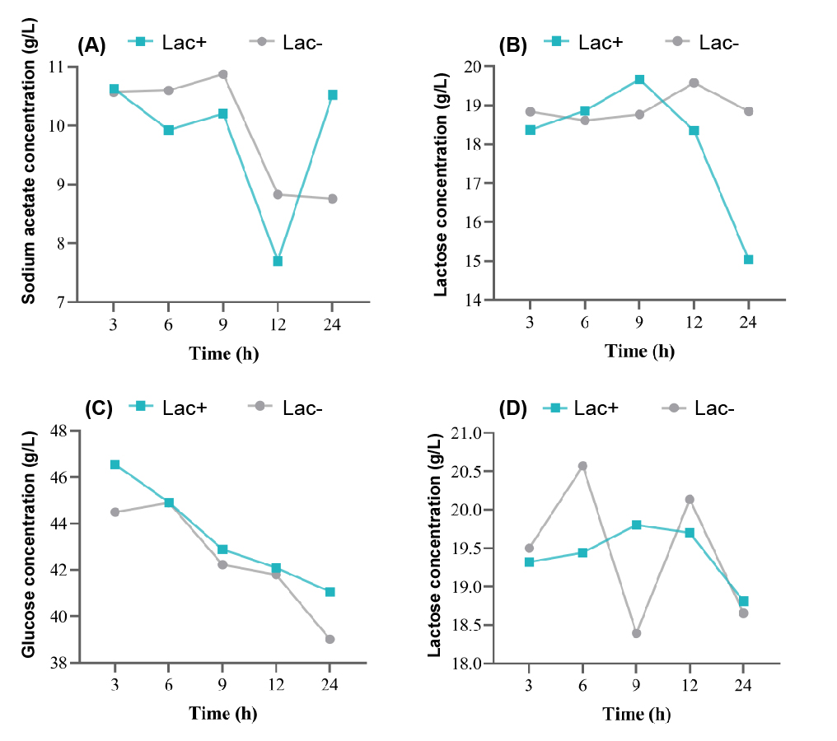
Fig. S4. The consumption of different carbon sources by lac+ and lac- within 24 hours. In L medium, the consumption of sodium acetate (A) and lactose (B) by lac+ and lac- is shown. In G medium, the consumption of glucose (C) and lactose (D) by lac+ and lac- is shown.

Table S1. Sequencing primers for the lactose operon.
Primer name | Sequence | Temperature
LacI | CCTCATTCAGCATTTGCATGGTTT | 59℃
LacZ1 | CCAGTTTGAGGGGACGACGACAGT | 64℃
LacZ2 | AACCGACATCGCAGGCTTCTGCTT | 66℃
LacZ3 | GATCCACCCAGTCCCAGACGAAG | 63℃
LacZ4 | GCCGCCTTCCAGCGTTCGACC | 66℃
LacY1 | AAAAGAATAAACCGAACATCCAAAAG | 56℃
LacY2 | TACAGTGACAAAAACCACAGTTTT | 54℃
LacA1 | ATTGGCATGTTCATTGCGATCATT | 59℃
LacA2 | TGCCGGATGCGGCTAATGTAGATC | 61℃

Table S2. Third-generation sequencing data of the ancestral strain (Lac-(ancestor)).
Valid ZWM  number | Subreads  number | Subreads total  bases (bp) | Subreads mean  length (bp) | Subreads  N50 (bp) | Subreads  N90 (bp) | Genome size  (bp) | Gene number
108,587 | 1,274,176 | 12,205,877,355 | 9,579 | 10,079 | 6,747 | 4,625,273 | 4,368

Table S3. Second-generation sequencing data of 21 clones.
Sample  name | Reads  length (bp) | Raw  data  (Mb) | Adapter  (%) | Duplication  (%) | Total  reads | Filtered  reads (%) | Low quality  filtered reads (%) | Clean  data (Mb)
Ancestor | 150 | 1,537 | 1.12 | 0.17 | 10,248,826 | 1.87 | 0 | 1,508
G1-1 | 150 | 2,621 | 1.40 | 0.52 | 17,476,260 | 5.09 | 0 | 2,487
G1-2 | 150 | 2,621 | 1.28 | 0.56 | 17,476,260 | 5.80 | 0 | 2,469
G2-1 | 150 | 2,621 | 1.03 | 0.51 | 17,476,260 | 4.99 | 0 | 2,490
G2-2 | 150 | 2,621 | 1.45 | 0.54 | 17,476,260 | 5.98 | 0 | 2,464
G3-1 | 150 | 2,621 | 1.33 | 0.63 | 17,476,260 | 5.40 | 0 | 2,479
G3-2 | 150 | 2,621 | 1.23 | 0.57 | 17,476,260 | 5.67 | 0 | 2,472
G4-1 | 150 | 2,621 | 1.02 | 0.60 | 17,476,260 | 5.58 | 0 | 2,474
G4-2 | 150 | 2,621 | 1.27 | 0.57 | 17,476,260 | 5.94 | 0 | 2,465
G5-1 | 150 | 2,357 | 0.88 | 0.48 | 15,717,588 | 4.47 | 0 | 2,252
G5-2 | 150 | 2,621 | 0.90 | 0.52 | 17,476,260 | 4.76 | 0 | 2,496
L1-1 | 150 | 2,489 | 0.80 | 0.52 | 16,597,642 | 4.46 | 0 | 2,378
L1-2 | 150 | 2,621 | 1.12 | 0.56 | 17,476,260 | 5.30 | 0 | 2,482
L2-1 | 150 | 3,145 | 18.98 | 0.80 | 20,971,512 | 23.15 | 0 | 2,417
L2-2 | 150 | 2,621 | 1.22 | 0.54 | 17,476,260 | 5.26 | 0 | 2,483
L3-1 | 150 | 2,621 | 1.19 | 0.57 | 17,476,260 | 4.99 | 0 | 2,490
L3-2 | 150 | 2,169 | 0.88 | 0.50 | 14,461,272 | 4.48 | 0 | 2,071
L4-1 | 150 | 2,621 | 1.22 | 0.57 | 17,476,260 | 5.62 | 0 | 2,473
L4-2 | 150 | 2,621 | 1.83 | 0.55 | 17,476,260 | 6.24 | 0 | 2,457
L5-1 | 150 | 2,621 | 1.04 | 0.55 | 17,476,260 | 5.09 | 0 | 2,487
L5-2 | 150 | 2,621 | 1.09 | 0.57 | 17,476,260 | 5.59 | 0 | 2,474

Table S4. Mapping of reads from the 20 clones in the experimental populations to the complete genome of the ancestral strain (Lac-(ancestor)).
Sample Name | Clean reads | Clean bases(bp) | Mapping rate | Unique rate | Duplicate rate | Mismatch rate | Coverage | Average sequencing depth(X)
G1-1 | 3,083,518 | 462,527,700 | 99.34 | 98.16 | 0.00 | 0.11 | 100.00% | 99.17
G1-2 | 3,083,518 | 462,527,700 | 99.41 | 98.16 | 0.00 | 0.11 | 100.00% | 99.24
G2-1 | 3,083,518 | 462,527,700 | 99.50 | 98.20 | 0.00 | 0.11 | 100.00% | 99.34
G2-2 | 3,083,518 | 462,527,700 | 99.36 | 98.17 | 0.00 | 0.11 | 100.00% | 99.19
G3-1 | 3,083,518 | 462,527,700 | 99.37 | 98.15 | 0.00 | 0.11 | 100.00% | 99.18
G3-2 | 3,083,518 | 462,527,700 | 99.40 | 98.18 | 0.00 | 0.11 | 100.00% | 99.21
G4-1 | 3,083,518 | 462,527,700 | 99.39 | 98.23 | 0.00 | 0.11 | 100.00% | 99.20
G4-2 | 3,083,518 | 462,527,700 | 99.36 | 98.16 | 0.00 | 0.11 | 100.00% | 99.18
G5-1 | 3,083,518 | 462,527,700 | 99.54 | 98.13 | 0.00 | 0.11 | 100.00% | 99.40
G5-2 | 3,083,518 | 462,527,700 | 99.56 | 98.18 | 0.00 | 0.12 | 100.00% | 99.42
L1-1 | 3,083,518 | 462,527,700 | 99.54 | 98.18 | 0.00 | 0.11 | 100.00% | 99.37
L1-2 | 3,083,518 | 462,527,700 | 99.52 | 98.13 | 0.00 | 0.11 | 100.00% | 99.38
L2-1 | 3,083,518 | 462,527,700 | 94.53 | 98.02 | 0.00 | 0.22 | 100.00% | 94.30
L2-2 | 3,083,518 | 462,527,700 | 99.42 | 98.16 | 0.00 | 0.11 | 100.00% | 99.24
L3-1 | 3,083,518 | 462,527,700 | 99.48 | 98.12 | 0.00 | 0.11 | 100.00% | 99.32
L3-2 | 3,083,518 | 462,527,700 | 99.55 | 98.16 | 0.00 | 0.11 | 100.00% | 99.40
L4-1 | 3,083,518 | 462,527,700 | 99.35 | 98.18 | 0.00 | 0.11 | 100.00% | 99.16
L4-2 | 3,083,518 | 462,527,700 | 99.20 | 98.14 | 0.00 | 0.11 | 100.00% | 99.01
L5-1 | 3,083,518 | 462,527,700 | 99.49 | 98.16 | 0.00 | 0.11 | 100.00% | 99.33
L5-2 | 3,083,518 | 462,527,700 | 99.44 | 98.18 | 0.00 | 0.11 | 100.00% | 99.28

Table S5. Genome-level SNPs and indels identified in the 20 clones from 10 experimental populations compared to the ancestral strain (Lac-(ancestor)). A slash (/) indicates no SNPs or indels were found.
Sample name | BGISEQ data (Mb) | SNP number | InDel number
G1-1 | 2,487 | / | /
G1-2 | 2,469 | 1 | /
G2-1 | 2,490 | 2 | /
G2-2 | 2,464 | / | /
G3-1 | 2,479 | 1 | /
G3-2 | 2,472 | 2 | /
G4-1 | 2,474 | 1 | /
G4-2 | 2,465 | 2 | /
G5-1 | 2,252 | 1 | /
G5-2 | 2,496 | / | /
L1-1 | 2,378 | 1 | 1
L1-2 | 2,482 | 1 | 1
L2-1 | 2,417 | 2 | 1
L2-2 | 2,483 | 2 | 1
L3-1 | 2,490 | 2 | 1
L3-2 | 2,071 | 3 | 1
L4-1 | 2,473 | 2 | 1
L4-2 | 2,457 | 2 | 1
L5-1 | 2,487 | 1 | 1
L5-2 | 2,474 | 1 | 1

Table S6. 27 SNPs identified in the 20 clones from 10 experimental populations compared to the ancestral strain (Lac-(ancestor)). A slash (/) indicates either no SNPs were found or no data is available.
Sample | Position | Base change | Codon change | Amino change | Gene
G1-1 | / | / | / | / | /
G1-2 | 1,073,951 | C->G | AGC->AGG | S->R | gshA
G2-1 | 191,515 | A->T | / | / | intergenic
 | 3,715,616 | A->G | GAT->GGT | D->G | staF
G2-2 | / | / | / | / | /
G3-1 | 1,070,388 | C->A | / | / | intergenic
G3-2 | 1,070,388 | C->A | / | / | intergenic
 | 3,900,309 | A->C | ATC->AGC | I->S | holD
G4-1 | 191,515 | A->T | / | / | intergenic
G4-2 | 191,515 | A->T | / | / | intergenic
 | 2,009,031 | C->T | CGT->TGT | R->C | nimR
G5-1 | 3,255,096 | T->C | / | / | intergenic
G5-2 | / | / | / | / | /
L1-1 | 3,758,357 | G->A | ACC->ACT | T->T | secA
L1-2 | 3,758,357 | G->A | ACC->ACT | T->T | secA
L2-1 | 2,138,685 | G->A | CGC->CAC | R->H | Uncharacterized protein
 | 3,715,616 | A->G | GAT->GGT | D->G | staF
L2-2 | 2,138,685 | G->A | CGC->CAC | R->H | Uncharacterized protein
 | 3,715,616 | A->G | GAT->GGT | D->G | staF
L3-1 | 250,632 | A->G | ACC->GCC | T->A | Uncharacterized protein
 | 3,630,350 | A->G | ATT->ATC | I->I | dnaQ
L3-2 | 250,632 | A->G | ACC->GCC | T->A | Uncharacterized protein
 | 3,630,350 | A->G | ATT->ATC | I->I | dnaQ
 | 4,023,873 | G->C | CGC->CCC | R->P | pepA
L4-1 | 2,138,685 | G->A | CGC->CAC | R->H | Uncharacterized protein
 | 3,715,616 | A->G | GAT->GGT | D->G | staF
L4-2 | 2,138,685 | G->A | CGC->CAC | R->H | Uncharacterized protein
 | 3,715,616 | A->G | GAT->GGT | D->G | staF
L5-1 | 3,630,350 | A->G | ATT->ATC | I->I | dnaQ
L5-2 | 3,630,350 | A->G | ATT->ATC | I->I | dnaQ

Table S7. Single base deletion found in the 10 clones from five L-populations.
Sample | Position | Deletion
L1-1 | 3,501,218 | TC->T
L1-2 | 3,501,218 | TC->T
L2-1 | 3,501,232 | AG->A
L2-2 | 3,501,232 | AG->A
L3-1 | 3,501,233 | GA->G
L3-2 | 3,501,233 | GA->G
L4-1 | 3,501,232 | AG->A
L4-2 | 3,501,232 | AG->A
L5-1 | 3,501,249 | GC->G
L5-2 | 3,501,249 | GC->G

Table S8. Statistical analyses of growth difference between lac- and lac+. Repeated measures ANOVA was used to determine the statistical significance. Mean(±SD) based on 5 replicate assays is presented.
Time | Lac+ | Lac- | Difference | t | df | p
0 | 0.019±0.002 | 0.020±0.001 | 0.000 | 0.348 | 8 | 0.736
2 | 0.031±0.001 | 0.029±0.001 | 0.002 | 3.154 | 8 | 0.014
4 | 0.061±0.006 | 0.052±0.004 | 0.009 | 2.891 | 8 | 0.020
6 | 0.123±0.024 | 0.075±0.006 | 0.048 | 4.265 | 8 | 0.003
8 | 0.236±0.059 | 0.120±0.010 | 0.116 | 4.355 | 8 | 0.002
10 | 0.372±0.092 | 0.216±0.017 | 0.156 | 3.725 | 8 | 0.006
12 | 0.530±0.117 | 0.348±0.048 | 0.182 | 3.211 | 8 | 0.012
14 | 0.729±0.076 | 0.423±0.068 | 0.307 | 6.763 | 8 | <0.001
16 | 0.917±0.071 | 0.505±0.107 | 0.412 | 7.168 | 8 | <0.001
18 | 1.093±0.070 | 0.629±0.123 | 0.464 | 7.308 | 8 | <0.001
20 | 1.219±0.061 | 0.738±0.130 | 0.481 | 7.487 | 8 | <0.001
22 | 1.316±0.073 | 0.884±0.161 | 0.432 | 5.455 | 8 | 0.001
24 | 1.439±0.058 | 0.973±0.169 | 0.466 | 5.836 | 8 | <0.001

Table S9. Statistical difference in white clone proportion among four groups (C, J, L, and H). Repeated measures ANOVA was utilized to determine the statistical significance. The mean difference between groups, based on 10 replicate assays, is presented. Results from 24 hours to 120 hours were included in the analysis.
Time | Group(A) | Group(B) | Difference(A-B) | t | df | p
24 | C | J | 0.010 | 1.462 | 36 | 0.609
 |  | L | 0.008 | 2.585 | 36 | 0.084
 |  | H | 0.000 | 0.769 | 36 | 0.894
 | J | L | 0.000 | 1.122 | 36 | 0.807
 |  | H | 0.000 | 0.693 | 36 | 0.894
 | L | H | -0.010 | 1.816 | 36 | 0.389
48 | C | J | 0.000 | 1.012 | 36 | 0.637
 |  | L | 0.004 | 2.934 | 36 | 0.035
 |  | H | 0.000 | 1.497 | 36 | 0.573
 | J | L | 0.000 | 1.923 | 36 | 0.312
 |  | H | 0.000 | 0.485 | 36 | 0.637
 | L | H | 0.000 | 1.438 | 36 | 0.573
72 | C | J | 0.000 | 1.958 | 36 | 0.348
 |  | L | 0.000 | 1.795 | 36 | 0.405
 |  | H | 0.000 | 0.658 | 36 | 1
 | J | L | 0.000 | 0.163 | 36 | 1
 |  | H | 0.000 | 1.300 | 36 | 0.807
 | L | H | 0.000 | 1.137 | 36 | 0.807
96 | C | J | 0.001 | 2.121 | 36 | 0.245
 |  | L | 0.001 | 2.121 | 36 | 0.245
 |  | H | 0.001 | 2.121 | 36 | 0.245
 | J | L | 0.000 | 0 | 36 | 1
 |  | H | 0.000 | 0 | 36 | 1
 | L | H | 0.000 | 0 | 36 | 1
 | H | L | 0.000 | 1.414 | 36 | 0.995
120 | C | J | 0.000 | 1.414 | 36 | 0.995
 |  | L | 0.000 | 1.414 | 36 | 0.995
 |  | H | 0.000 | 0 | 36 | 1
 |  | C | 0.000 | 0 | 36 | 1
 | J | L | 0.000 | 0 | 36 | 1
 |  | H | 0.000 | 0 | 36 | 1
 | L | H | 0.000 | 0 | 36 | 1

