Appendix A. Output of Bayesian mixed-effects models for each setting and experimental manipulation
Table A1. Output of mixed-effects model, lab data, semantic manipulation
term | estimate | conf.low | conf.high
Intercept | 930.84 | 892.68 | 970.55
Relatedness | -59.59 | -77.57 | -41.25
by-item random intercept | 77.87 | 66.68 | 91.96
by-item random slope | 55.38 | 40.24 | 72.07
by-participant random intercept | 116.60 | 95.87 | 144.65
by-participant random slope | 30.20 | 16.80 | 46.16
by-item correlation | -0.22 | -0.49 | 0.07
by-participant correlation | -0.73 | -0.94 | -0.36
Residual error | 236.92 | 233.10 | 240.82

Table A2. Output of mixed-effects model, lab data, phonological manipulation
term | estimate | conf.low | conf.high
Intercept | 884.01 | 848.72 | 920.41
Relatedness | 30.85 | 11.94 | 49.76
by-item random intercept | 76.07 | 65.21 | 90.12
by-item random slope | 64.28 | 50.24 | 80.74
by-participant random intercept | 112.42 | 91.79 | 140.93
by-participant random slope | 28.43 | 8.11 | 45.09
by-item correlation | -0.07 | -0.32 | 0.20
by-participant correlation | -0.11 | -0.55 | 0.34
Residual error | 223.56 | 220.01 | 227.24

Table A3. Output of mixed-effects model, on-line data, semantic manipulation
term | estimate | conf.low | conf.high
Intercept | 1,193.20 | 1,144.40 | 1,239.78
Relatedness | 34.37 | 16.84 | 51.78
by-item random intercept | 76.45 | 63.03 | 92.91
by-item random slope | 53.11 | 34.85 | 71.86
by-participant random intercept | 150.69 | 124.17 | 186.70
by-participant random slope | 11.88 | 0.60 | 34.07
by-item correlation | -0.44 | -0.67 | -0.13
by-participant correlation | 0.02 | -0.69 | 0.74
Residual error | 272.85 | 268.43 | 277.36

Table A4. Output of mixed-effects model, on-line data, phonological manipulation
term | estimate | conf.low | conf.high
Intercept | 1,177.61 | 1,130.76 | 1,221.87
Relatedness | -21.50 | -40.11 | -2.47
by-item random intercept | 74.64 | 61.95 | 90.29
by-item random slope | 62.33 | 46.46 | 80.14
by-participant random intercept | 145.71 | 119.86 | 182.65
by-participant random slope | 20.84 | 1.61 | 40.98
by-item correlation | -0.34 | -0.58 | -0.04
by-participant correlation | 0.21 | -0.41 | 0.78
Residual error | 264.69 | 260.43 | 269.03

Appendix B. Power simulations using descriptive standard deviations of between-participant differences in effect sizes
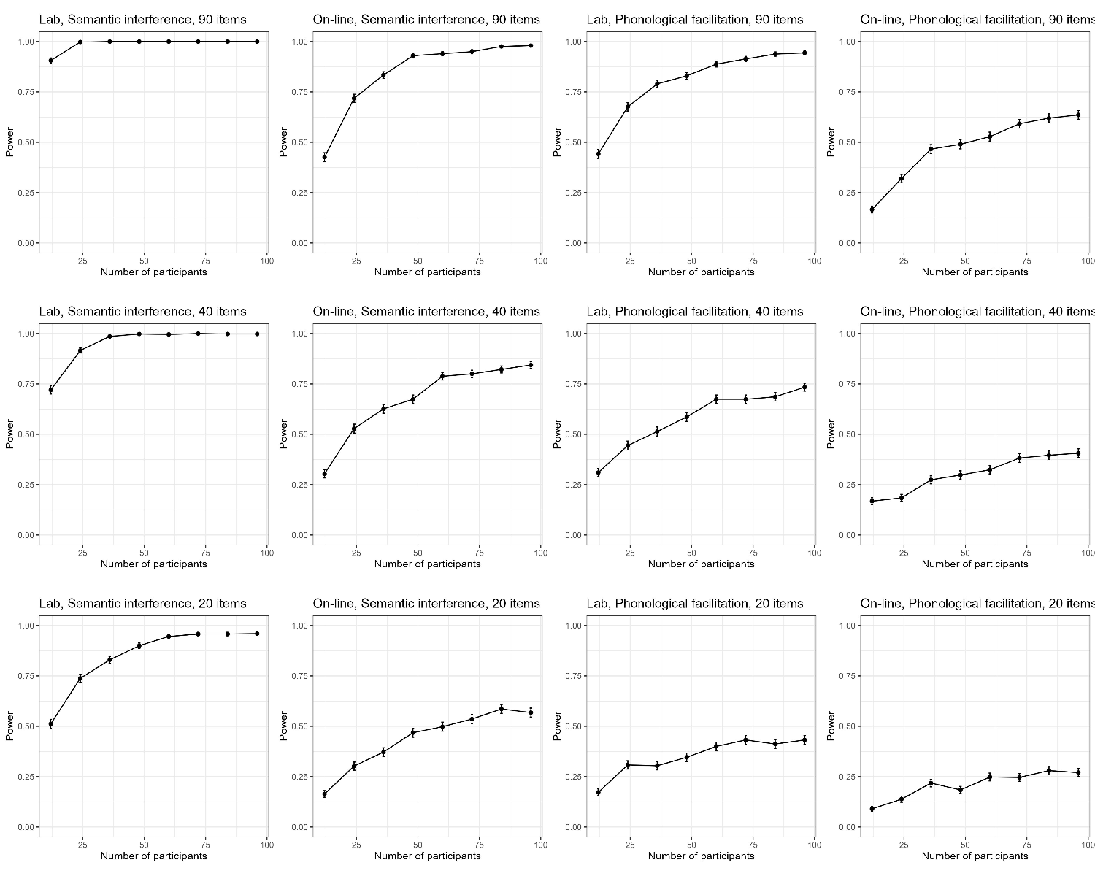
Figure B1: Power to detect the semantic interference and phonological facilitation effects as a function of number of participants for 90 items, 40, and 20 items in lab and on-line data

For each setting and experimental manipulation, simulations were based on the estimates from the corresponding Bayesian statistical models for all fixed effects and variance components except for the standard deviation of the by-participant random slope. For this parameter, we used the descriptive estimate. For each participant, we first computed the mean difference between the related and unrelated conditions. We then computed the grand average of this difference and its standard deviation. The value of the standard deviation was used for the simulations.

