Supplementary Materials for

Listening to ultrasound from plants reveals xylem vessel anatomy

Satadal Dutta,^{1*} Elias Kaiser,² Priscila Malcolm Matamoros,² Peter G. Steeneken,¹ Gerard J. Verbiest^{1*}
*Corresponding authors. Email: s.dutta-1@tudelft.nl, g.j.verbiest@tudelft.nl

This PDF file includes:

Figs. S1 to S7
Tables S1 to S2

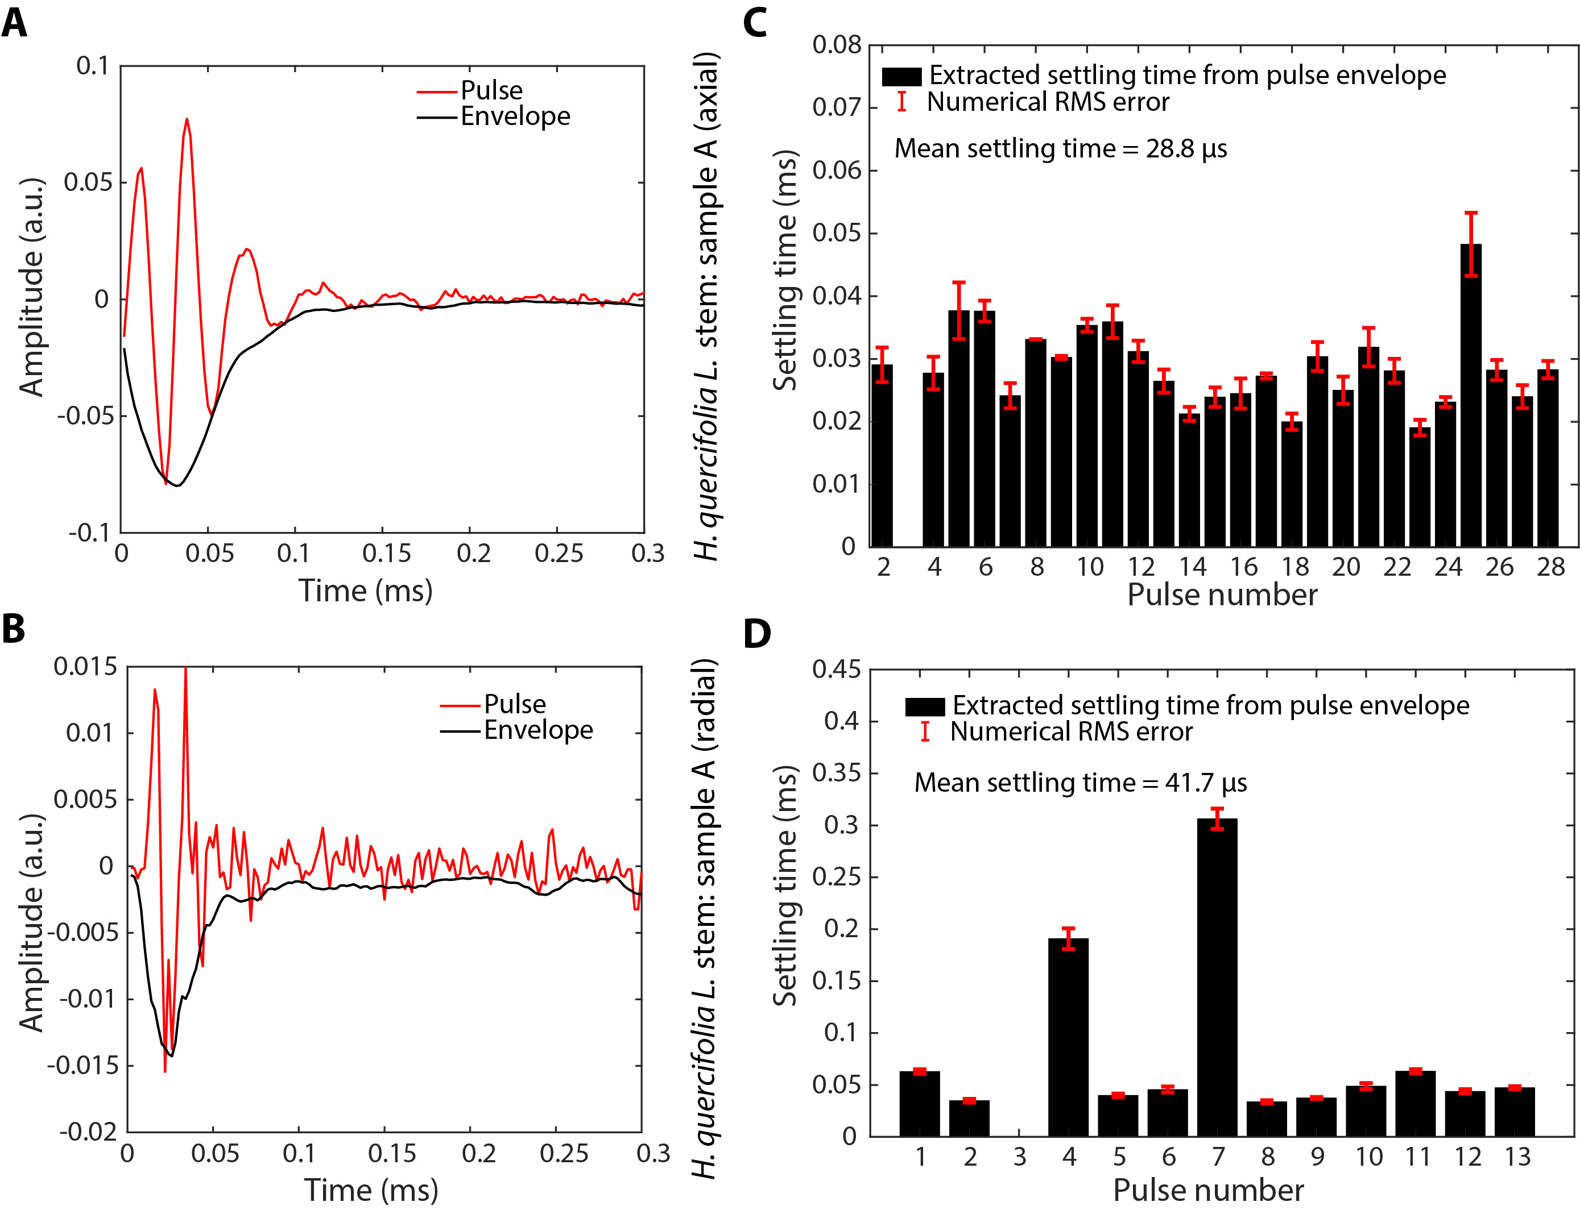
Fig. S1.
Ultrasound pulses (Sample A). (A), (B) Zoomed-in time-domain example ultrasound pulses from stem sample A recorded axially and radially respectively for Hydrangea quercifolia (Fig. 1A). The recording is done with a M500-USB microphone from Pettersson Elektronik AB. Black curves represent the amplitude envelope. (C), (D) Bar plot of the extracted amplitude settling times (τ_{s}) for the ultrasound pulses recorded from sample A in the axial and radial directions, respectively. Settling time is obtained with an exponential fit of the pulse envelope (Fig. 1C, 1D, see Materials and Methods). The red bars indicate the error margin in the numerical fit routine.

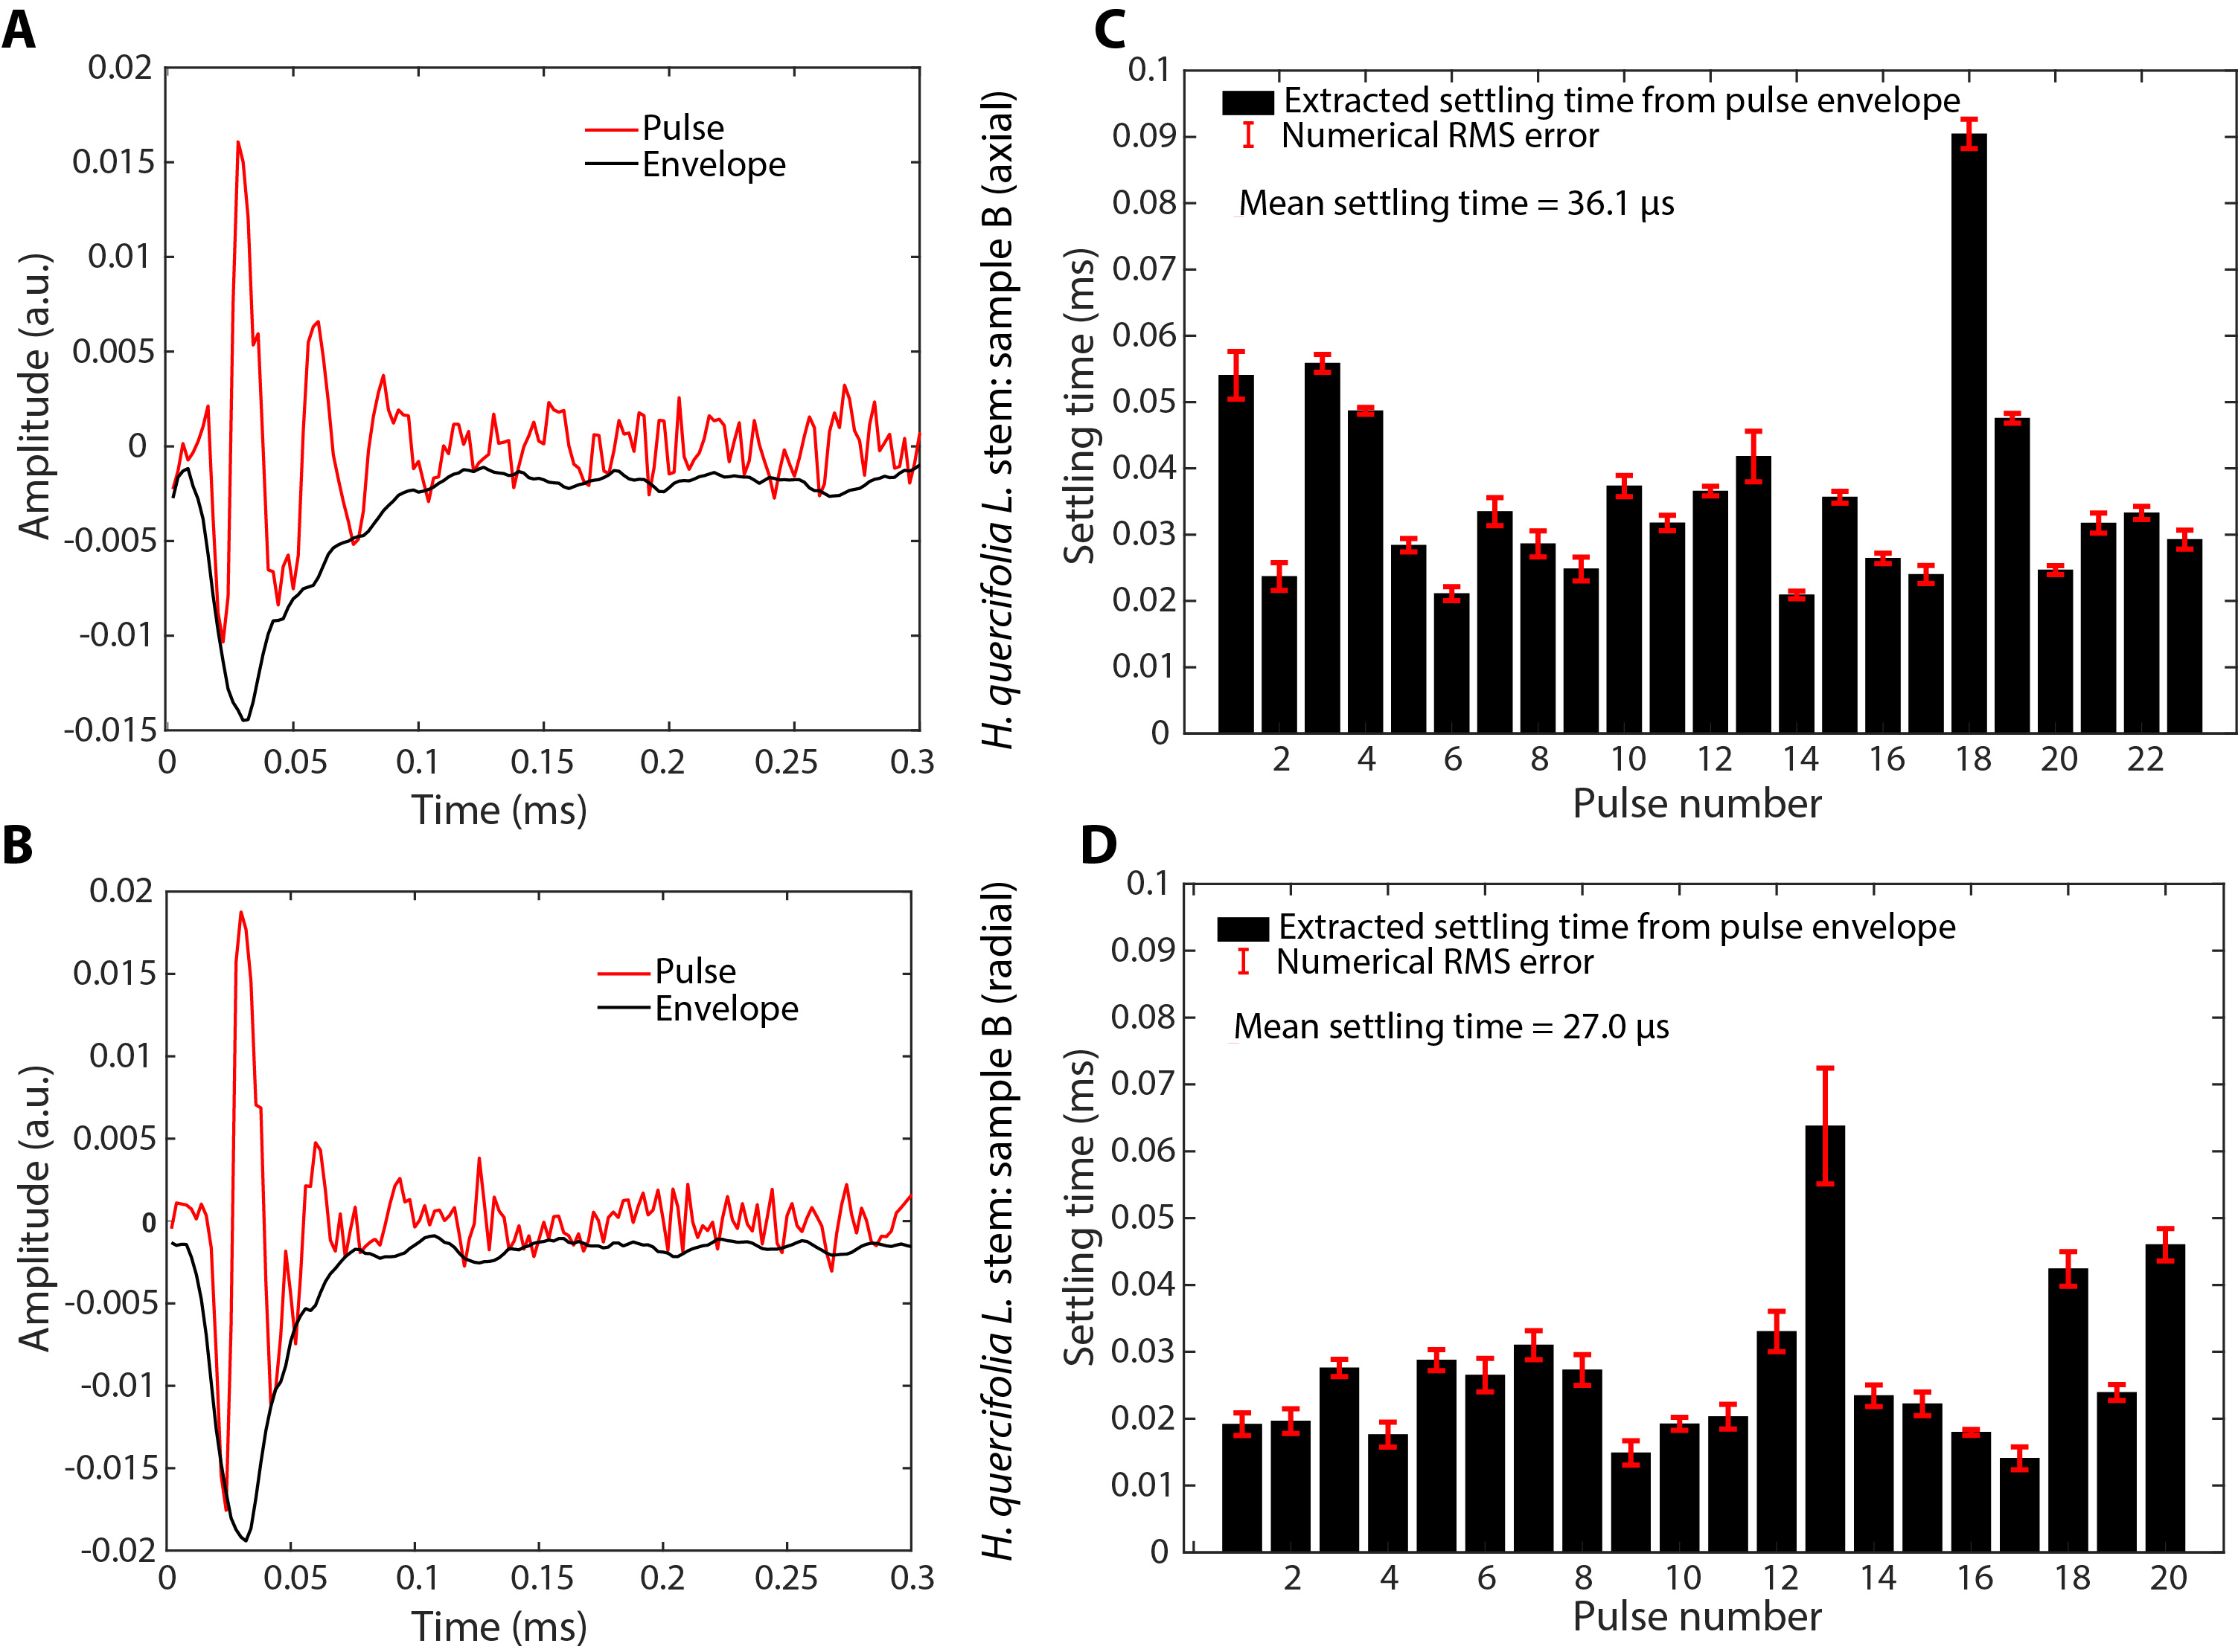
Fig. S2.
Ultrasound pulses (Sample B). (A), (B) Zoomed-in time-domain example ultrasound pulses from stem sample B recorded axially and radially respectively for Hydrangea quercifolia (Fig. 1A). The recording is done with a M500-USB microphone from Pettersson Elektronik AB. Black curves represent the amplitude envelope. (C), (D) Bar plot of the extracted amplitude settling times (τ_{s}) for the ultrasound pulses recorded from sample B in the axial and radial directions, respectively. Settling time is obtained with an exponential fit of the pulse envelope (Fig. 1C, 1D, see Materials and Methods). The red bars indicate the error margin in the numerical fit routine.

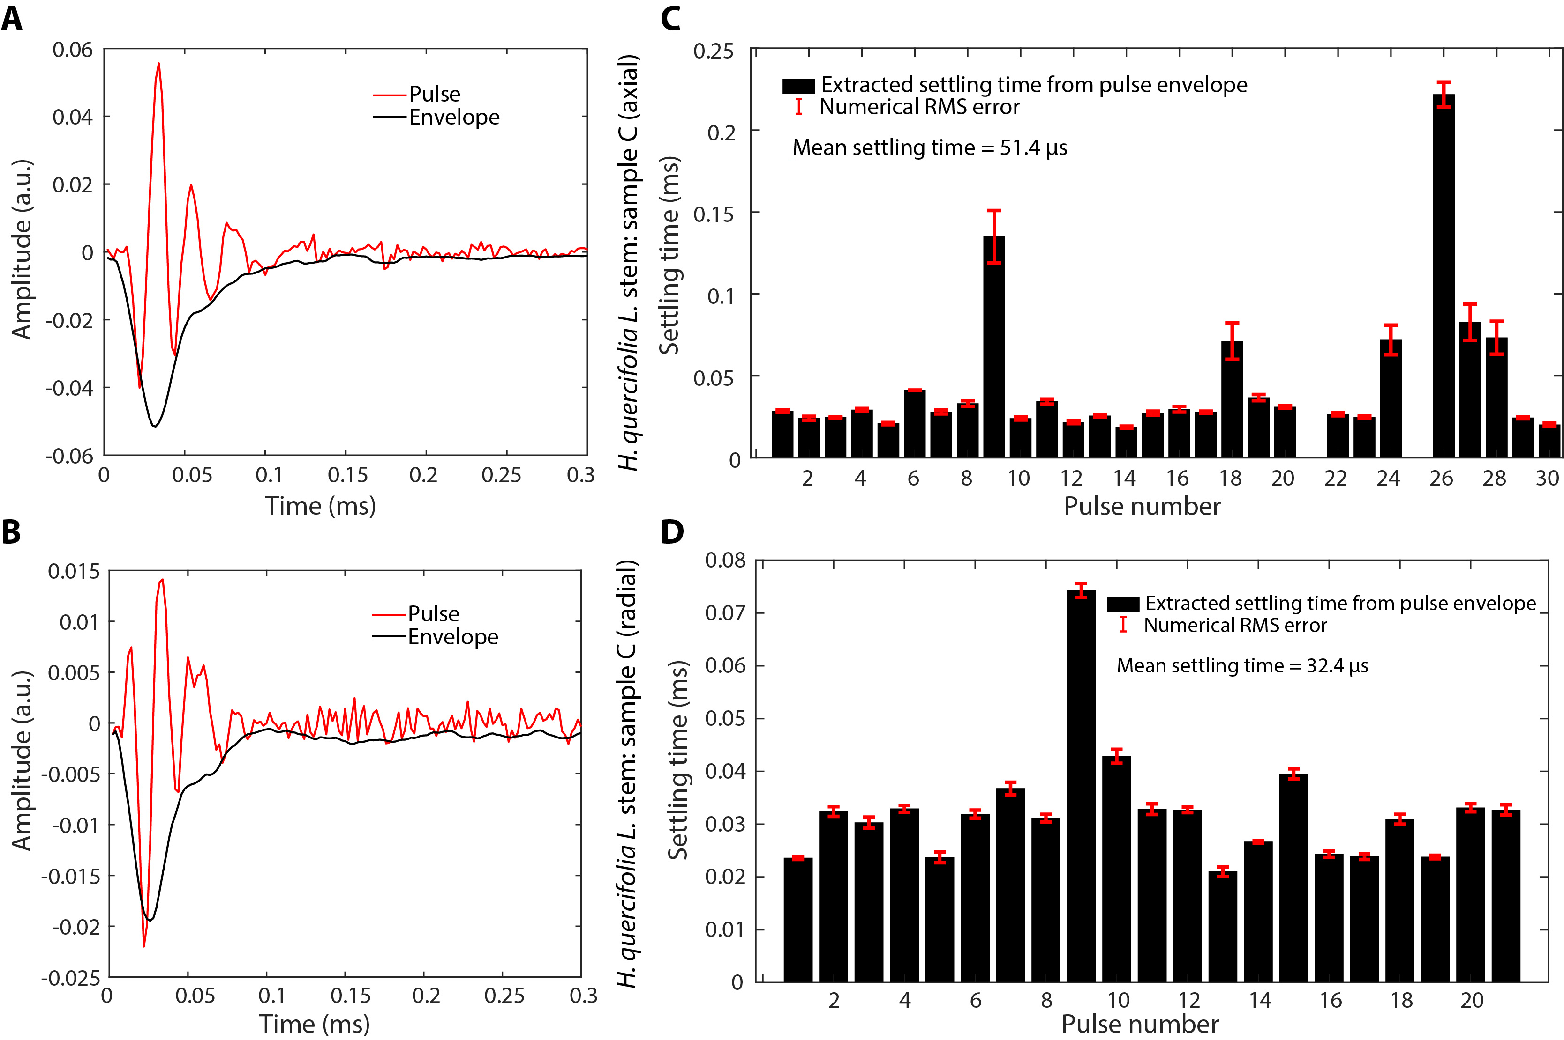
Fig. S3.
Ultrasound pulses (Sample C). (A), (B) Zoomed-in time-domain example ultrasound pulses from stem sample C recorded axially and radially respectively for Hydrangea quercifolia (Fig. 1A). The recording is done with a M500-USB microphone from Pettersson Elektronik AB. Black curves represent the amplitude envelope. (C), (D) Bar plot of the extracted amplitude settling times (τ_{s}) for the ultrasound pulses recorded from sample C in the axial and radial directions, respectively. Settling time is obtained with an exponential fit of the pulse envelope (Fig. 1C, 1D, see Materials and Methods). The red bars indicate the error margin in the numerical fit routine.

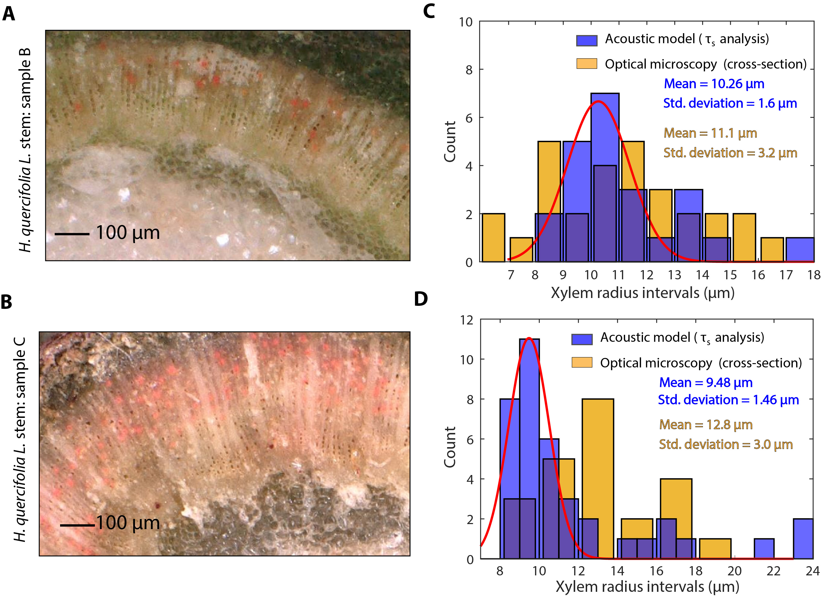
Fig. S4.
Xylem vessel radius: optical microscopy versus acoustic modelling. (A), (B) Optical micrographs (200X) of the transverse cross-sections of the of H. quercifolia. stem samples B and C respectively, cut at 5 mm distance from the paint-infusion end (see Fig. S6). The paint-filled vessels can be seen in fluorescent red colour. (C),(D) Histogram showing the distribution of the model-extracted xylem radii (in blue), and that of the observed xylem radii (in yellow) via latex-staining and optical microscopy for stem sample B and C respectively. The red curve represents a unimodal Gaussian fit.

Fig. S5.
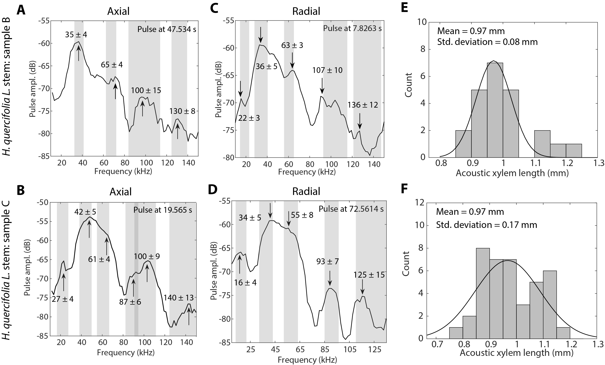
Ultrasound frequency spectra, and acoustic length of xylem vessel element. (A), (B) Observed characteristic peak-frequencies in the example Fourier transform of the ultrasound pulses recorded axially in samples B and C of H. quercifolia, respectively. The black curve represents the spectrum of a representative pulse with the indicated timestamp of the recording. The grey shaded regions indicate the variation in the peak frequencies among the individual pulses (mean± standard deviation). (C), (D) Observed characteristic peak-frequencies in the example Fourier transform of the ultrasound pulses recorded radially in samples B and C, respectively. (E), (F) Histogram showing the extracted xylem vessel element lengths in stem samples B and C via the acoustic model. The black curve represents a unimodal Gaussian fit.

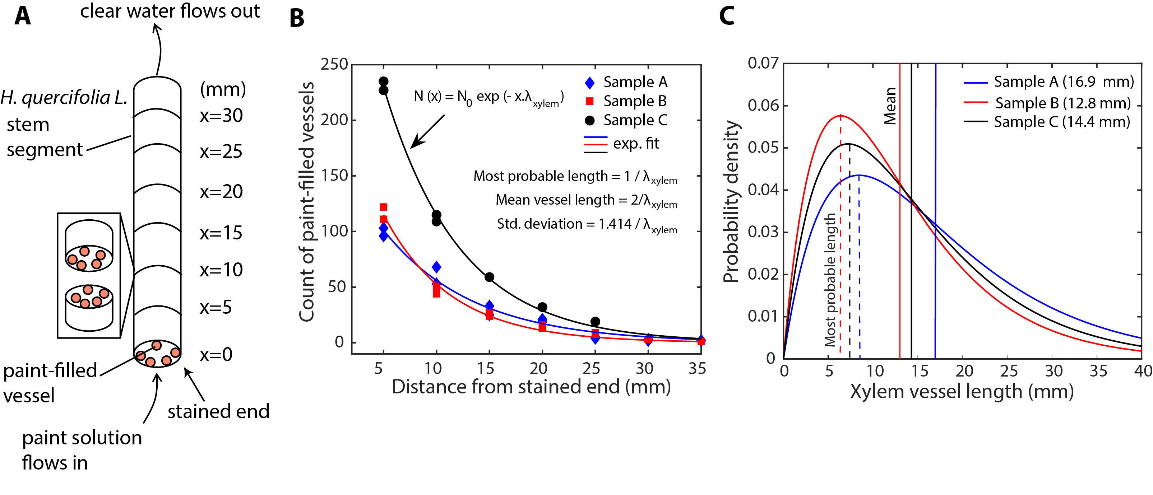
Fig. S6.
Latex paint-infusion method for vessel staining and counting. (A) Schematic illustration of the latex paint-infusion method. The paint solution is sucked in from the bottom end. Water passes through the perforation plates and border pits on the walls of xylem vessels and emerges out from the top end. The paint molecules fill up all the vessel elements inside a single xylem vessel and gets blocked by its fused ends. The infused stem sample is sectioned at 5 mm intervals along the length from the paint-infiltration end. (B) Number of paint-filled vessels as a function of position x along the stem (symbols). The solid curves represent the exponential fits. The characteristic length λ_{xylem} is the reciprocal of the most probable vessel length. (C) The calculated probability distribution functions (see Materials and Methods; equation (10)) for the length of the entire xylem vessel using the extracted values of λ_{xylem} for samples A,B, and C from the pant-infusion and vessel counting technique.

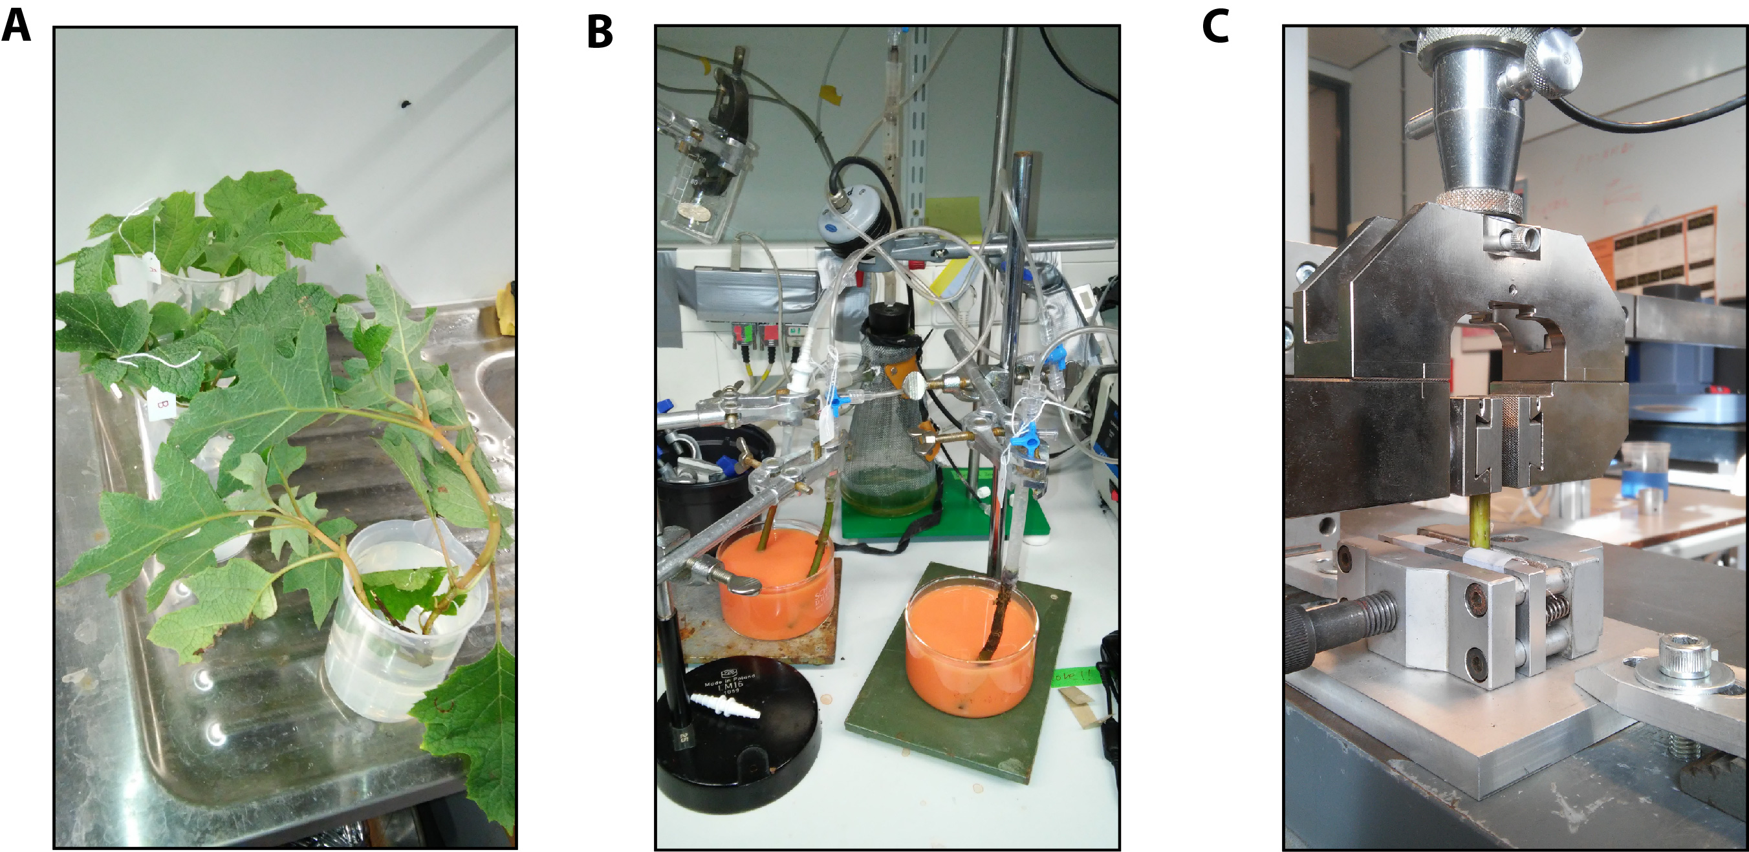

Fig. S7.
Photographs from experiments. (A) A shoot of H. quercifolia placed in water immediately after cutting it from the main plant under water. The shoot is then used for ultrasound recording and a cut-out stem segment from the same is used for latex paint-staining experiment. (B) Set-up of the latex paint-staining apparatus with the stem segments from samples A, B, and C mounted vertically over the paint vessels. (C) Set-up of the Zwick/Roell uniaxial tensile testing machine with the stem segment mounted vertically between the clamps.

Table S1.
Observed and calculated peak frequencies in the axially recorded ultrasound. Note: m denotes order of the resonant mode. The calculated frequencies for m > 1, are integer multiples of the observed frequency at m = 1 in the representative pulse shown in Fig. 3A and Fig. S5A-B.
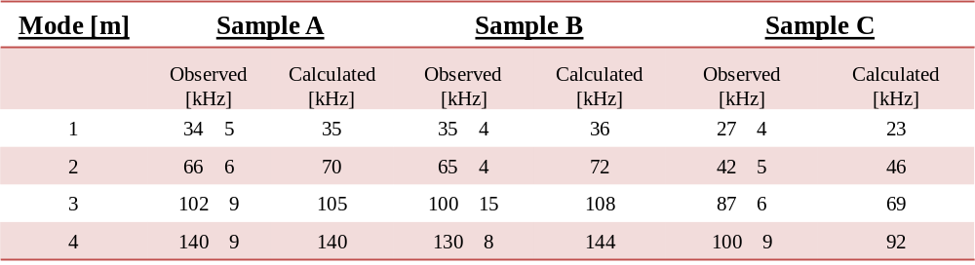

Table S2.
Observed and calculated peak frequencies in the radially recorded ultrasound. The calculated frequencies for m > 1, are integer multiples of the observed frequency at m = 1 in the representative pulse shown in Fig. 3B and Fig. S5C-D.
