Supplementary Material

Microarray pre-processing and quality control
Genomic DNA was extracted from saliva samples using a high salt extraction method (1). Briefly, 20 µL of 20 mg/mL proteinase K (Promega, Madison, WI, USA) was added to each 400 µL saliva sample. Samples were then vortexed to mix and centrifuged briefly, and placed in incubation overnight at 55 °C. Following incubation, 400 µL of 5M NaCl (Sigma-Aldrich, NSW, Australia) was added to each tube. Tubes were vortexed and centrifuged at 9, 000 X g force for 15 min at 4°C. Supernatants were then transferred to fresh 1.5 mL microcentrifuge tube (Eppendorf South Pacific) and the pellet was discarded. To each tube, 1 mL of 100% ethanol was added, and the tube mixed by inversion six times and centrifuged at 18, 000 X g force for 5 min at room temperature. The supernatant was discarded, wash step repeated, and the pellet left to air dry at room temperature. Pellets were resuspended 40 µL 1 x TE (Astral Scientific, NSW, Australia). DNA concentration and quality was measured by fluorometer (Qubit, Thermo Fisher Scientific, VIC, Australia) and spectrophotometry (Nanodrop, Wilmington, DE, USA)
Extracted genomic DNA samples were bisulphite treated and hybridised to Infinium MethylationEPIC arrays (EPIC; Illumina, San Diego, CA, USA) at NTX-Dx (Diagenode, Ghent, Belgium). These arrays generate data from over 850,000 CpGs throughout the human genome. Raw intensity data was imported into R (3.6.3, http://cran.r-project.org/). Data underwent subset-quantile normalisation (SQN) (2), followed by data quality assessment using the minfi (v1.34.0) Bioconductor package (3). EPIC probes (n= 865,859) were filtered by removing those with a poor signal to noise ratio (mean detection p-value of > 0.01, n = 113,011), containing a single nucleotide polymorphism at the CpG site (n = 26,455), mapping to sex chromosomes (n = 16,776), or cross-reactivity to multiple genomic locations (n = 34,471) (4).
DNA methylation levels were reported as beta (β) values (proportion of methylated intensity over total intensity values). Beta values were converted to M-values (log₂ ratio of the methylated intensity divided unmethylated intensity) for statistical regression analyses (5).

Medication Status
Children in the ADHD cohort were categorised as either ‘yes’ (1) or ‘no’ (0) for medication status. Children were categorised as ‘yes’ is they were taking medication for their ADHD at the time of sample collection. Medications include methylphenidate, dexamphetamine, atomoxetine, clonidine, risperidone and melatonin. Medication was not found to be a significant covariate and was thus excluded from the analysis.

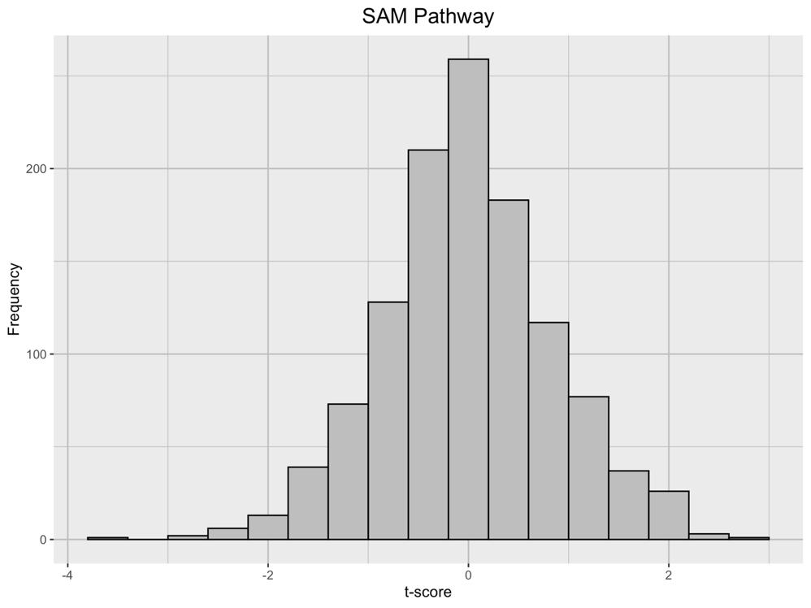
Figure S1. Distribution of t-scores for SAM pathway from diagnostic status regression

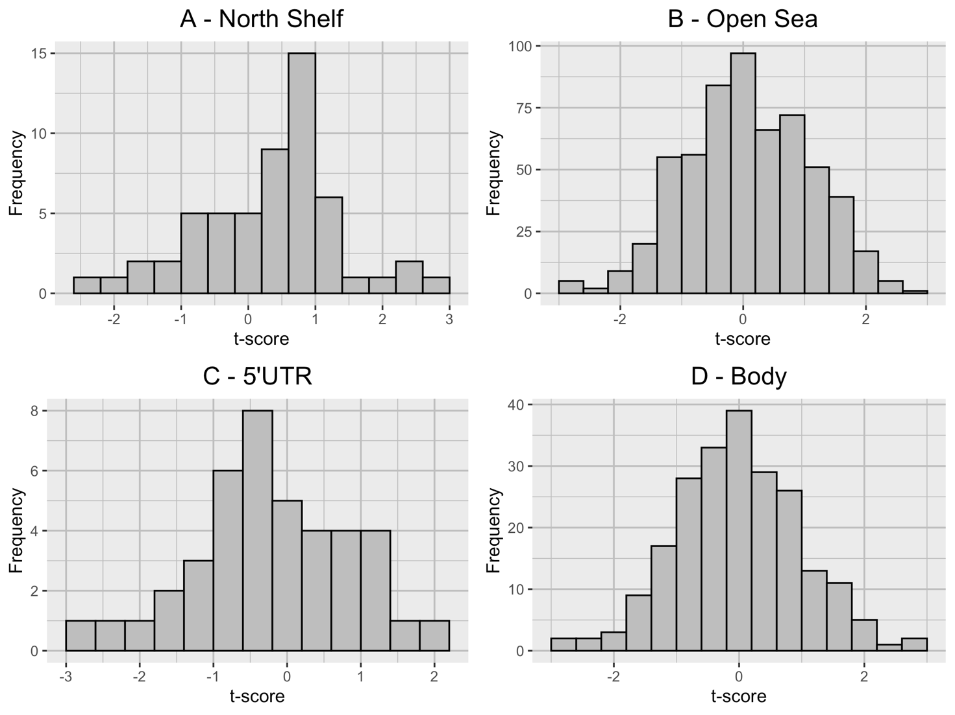
Figure S2. Distribution of t-scores for gene elements from diagnostic status regression.

Table S1. Summary Differentially Methylated Probes from Symptom Regression Modelling (uncorrected p<0.05)
Rank | Probe | Gene | Chr | Position | Rel 1 | Rel 2 | t | p | p_{FDR} | Δβ
1 | cg15019810 | ST6GAL1 | 3 | 186648242 | TSS200 | Island | -2.950 | 0.004 | 0.794 | -0.014
2 | cg09479134 | NANP | 20 | 25604757 | TSS200 | Island | -2.871 | 0.005 | 0.794 | 0.006
3 | cg16966815 | ST6GALNAC5 | 1 | 77333122 | TSS200 | Island | 2.832 | 0.005 | 0.794 | 0.010
4 | cg12987059 | GLB1 | 3 | 33067108 | Body | Open Sea | 2.831 | 0.005 | 0.794 | -0.005
5 | cg27169166* | SLC35A1 | 6 | 88182413 | TSS1500 | Island | -2.807 | 0.006 | 0.794 | -0.002
6 | cg23928920 | ST8SIA2 | 15 | 92944756 | Body | Open Sea | -2.806 | 0.006 | 0.794 | -0.004
7 | cg24050613 | ST6GAL1 | 3 | 186648279 | TSS1500 | Island | -2.678 | 0.008 | 0.794 | 0.004
8 | cg08892099 | ST3GAL4 | 11 | 126225356 | TSS1500;TSS200;Body | Island | 2.669 | 0.008 | 0.794 | 0.002
9 | cg23798064 | ST3GAL4 | 11 | 126283076 | Body | N Shelf | 2.662 | 0.009 | 0.794 | 0.002
10 | cg25630069* | ST3GAL3 | 1 | 44385621 | 3'UTR | Open Sea | 2.620 | 0.010 | 0.794 | 0.002
11 | cg23850243 | NPL | 1 | 182758118 | TSS1500 | N Shore | -2.605 | 0.010 | 0.794 | -0.012
12 | cg01298990 | NANS | 9 | 100818423 | TSS1500 | N Shore | -2.603 | 0.010 | 0.794 | -0.006
13 | cg10958432 | ST6GALNAC3 | 1 | 76802689 | Body | Open Sea | -2.585 | 0.011 | 0.794 | 0.003
14 | cg05634734 | ST6GALNAC6 | 9 | 130652509 | Body | N Shore | -2.545 | 0.012 | 0.794 | -0.006
15 | cg04571163 | ST6GAL2 | 2 | 107502354 | 5'UTR | Island | -2.529 | 0.012 | 0.794 | 0.004
16 | cg04571056 | ST6GALNAC5 | 1 | 77497162 | Body | Open Sea | -2.515 | 0.013 | 0.794 | 0.005
17 | cg14077073 | ST8SIA6 | 10 | 17368619 | Body | Open Sea | -2.495 | 0.014 | 0.794 | 0.007
18 | cg19008371 | ST3GAL4 | 11 | 126226766 | 5'UTR | S Shore | -2.487 | 0.014 | 0.794 | -0.005
19 | cg13153065* | ST6GALNAC4 | 9 | 130674860 | Body | Island | 2.486 | 0.014 | 0.794 | -0.010
20 | cg10874168 | ST3GAL3 | 1 | 44298113 | Body | Open Sea | -2.472 | 0.015 | 0.794 | 0.002
21 | cg10833299 | NEU4 | 2 | 242749776 | TSS1500 | Open Sea | 2.440 | 0.016 | 0.794 | -0.006
22 | cg08159742 | ST3GAL4 | 11 | 126275628 | 5'UTR | Open Sea | -2.431 | 0.016 | 0.794 | 0.004
23 | cg02793739 | NEU3 | 11 | 74699647 | TSS1500 | N Shore | 2.428 | 0.016 | 0.794 | 0.005
24 | cg26708476 | NEU1 | 6 | 31829177 | Body | N Shore | 2.427 | 0.016 | 0.794 | 0.007
25 | cg06176087 | ST3GAL3 | 1 | 44182086 | 5'UTR;Body | Open Sea | 2.406 | 0.017 | 0.794 | -0.016
26 | cg07952850 | NEU3 | 11 | 74699053 | TSS1500 | N Shore | 2.388 | 0.018 | 0.794 | -0.001
27 | cg14177779 | ST3GAL5 | 2 | 86076806 | Body | Open Sea | 2.384 | 0.018 | 0.794 | 0.002
28 | cg16457662 | NEU3 | 11 | 74701311 | Body | S Shore | -2.355 | 0.020 | 0.794 | -0.004
29 | cg23168671 | NEU3 | 11 | 74698584 | TSS1500 | N Shore | 2.352 | 0.020 | 0.794 | 0.011
30 | cg25833695 | ST8SIA6 | 10 | 17468706 | Body | Open Sea | 2.351 | 0.020 | 0.794 | 0.001
31 | cg22223530 | ST8SIA2 | 15 | 92977495 | ExonBnd;Body | Open Sea | 2.271 | 0.025 | 0.920 | -0.001
32 | cg12406941 | ST3GAL2 | 16 | 70472589 | 5'UTR | Island | -2.261 | 0.025 | 0.920 | 0.007
33 | cg15026574* | ST6GAL1 | 3 | 186683429 | 5'UTR | Open Sea | -2.250 | 0.026 | 0.920 | 0.007
34 | cg02915215 | ST3GAL1 | 8 | 134467165 | 3'UTR | Open Sea | -2.239 | 0.027 | 0.920 | 0.003
35 | cg16263653 | GLB1 | 3 | 33116782 | Body;5'UTR | Open Sea | -2.224 | 0.028 | 0.920 | -0.020
36 | cg13005014 | ST6GAL2 | 2 | 107485080 | 5'UTR | Open Sea | -2.199 | 0.029 | 0.920 | 0.000
37 | cg04006397 | NEU1 | 6 | 31827926 | Body | N Shelf | 2.185 | 0.030 | 0.920 | 0.005
38 | cg15313810 | ST6GALNAC4 | 9 | 130674654 | Body | Island | -2.183 | 0.031 | 0.920 | -0.005
39 | cg00579505* | ST3GAL1 | 8 | 134477188 | ExonBnd;Body | Open Sea | 2.159 | 0.032 | 0.920 | -0.006
40 | cg27347290 | NEU1 | 6 | 31831439 | TSS1500;Body | S Shore | 2.130 | 0.035 | 0.920 | 0.010
41 | cg10005894 | ST6GAL1 | 3 | 186649165 | 5'UTR | S Shore | 2.129 | 0.035 | 0.920 | 0.008
42 | cg26551303 | NPL | 1 | 182781404 | Body | Open Sea | 2.126 | 0.035 | 0.920 | -0.005
43 | cg23374902 | ST6GALNAC3 | 1 | 76696881 | Bod | Open Sea | -2.125 | 0.035 | 0.920 | -0.010
44 | cg12809499 | CTSA | 20 | 44519146 | TSS1500;1stExon | Island | -2.102 | 0.037 | 0.920 | 0.011
45 | cg24976808 | ST6GAL2 | 2 | 107441509 | Body | Open Sea | 2.083 | 0.039 | 0.920 | 0.001
46 | cg17005110 | ST8SIA5 | 18 | 44280817 | Body | Open Sea | 2.079 | 0.039 | 0.920 | -0.004
47 | cg10549480 | ST8SIA2 | 15 | 92944717 | Body | Open Sea | 2.062 | 0.041 | 0.920 | -0.001
48 | cg19825856 | ST6GAL2 | 2 | 107501733 | 5'UTR | N Shore | -2.060 | 0.041 | 0.920 | -0.009
49 | cg01234063 | ST3GAL4 | 11 | 126226007 | TSS200 | Island | -2.055 | 0.042 | 0.920 | -0.011
50 | cg08260891 | CTSA | 20 | 44518802 | TSS1500;Body | N Shore | -2.051 | 0.042 | 0.920 | -0.013
51 | cg05065226* | ST6GALNAC1 | 17 | 74636203 | Body; 5'UTR | Open Sea | 2.045 | 0.043 | 0.920 | -0.017
52 | cg12801256 | ST6GAL2 | 2 | 107459860 | Body | Island | 2.044 | 0.043 | 0.920 | -0.003
53 | cg21947295 | ST6GALNAC3 | 1 | 76877547 | Body | Open Sea | -2.039 | 0.043 | 0.920 | 0.002
54 | cg19369529 | ST6GALNAC5 | 1 | 77529073 | 3'UTR | Open Sea | 2.025 | 0.045 | 0.920 | 0.002
55 | cg12512564 | ST6GAL1 | 3 | 186760374 | 5'UTR | Open Sea | 2.022 | 0.045 | 0.920 | 0.007
56 | cg27158141 | ST6GALNAC3 | 1 | 76540229 | TSS200 | Island | -2.021 | 0.045 | 0.920 | -0.006
57 | cg22397365 | ST3GAL3 | 1 | 44396475 | 3'UTR | N Shelf | -2.017 | 0.045 | 0.920 | -0.008
58 | cg06675273 | ST8SIA2 | 15 | 92936465 | TSS1500 | N Shore | 2.015 | 0.046 | 0.920 | -0.004
59 | cg27276190 | GLB1 | 3 | 33134921 | 5'UTR;Body | N Shelf | 2.010 | 0.046 | 0.920 | 0.007
60 | cg09023643* | ST6GAL1 | 3 | 186646931 | TSS1500 | N Shore | -2.008 | 0.046 | 0.920 | 0.004
61 | cg06000825 | ST8SIA4 | 5 | 100236649 | Body | Island | 1.999 | 0.047 | 0.923 | -0.005
62 | cg13956924 | ST3GAL4 | 11 | 126222227 |  | N Shelf | 1.980 | 0.050 | 0.923 | -0.002
63 | cg12672379 | ST3GAL5 | 2 | 86117869 | Body | S Shore | -1.979 | 0.050 | 0.923 | 0.000
Note: Chr = Chromosome; Position = Chromosomal coordinate of the CpG (Build 37); Rel 1 = Gene region feature category ; Rel 2 = Location of CpG relative to CpG Island; t = t-statistic, p = uncorrected p-value; p_{FDR} = FDR corrected p-value, Coeff = Standardised Regression Coefficient; Δβ = Delta Beta; *Probes also associated with diagnostic status at an uncorrected level.

References
1. Ollikainen M, Smith KR, Joo EJ-H, Ng HK, Andronikos R, Novakovic B, et al. DNA methylation analysis of multiple tissues from newborn twins reveals both genetic and intrauterine components to variation in the human neonatal epigenome. Hum Mol Genet. 2010;19(21):4176-88.
2. Touleimat N, Tost J. Complete pipeline for Infinium(®) Human Methylation 450K BeadChip data processing using subset quantile normalization for accurate DNA methylation estimation. Epigenomics. 2012;4(3):325-41.
3. Aryee MJ, Jaffe AE, Corrada-Bravo H, Ladd-Acosta C, Feinberg AP, Hansen KD, et al. Minfi: a flexible and comprehensive Bioconductor package for the analysis of Infinium DNA methylation microarrays. Bioinformatics. 2014;30(10):1363-9.
4. Chen YA, Lemire M, Choufani S, Butcher DT, Grafodatskaya D, Zanke BW, et al. Discovery of cross-reactive probes and polymorphic CpGs in the Illumina Infinium HumanMethylation450 microarray. Epigenetics. 2013;8(2):203-9.
5. Maksimovic J, Phipson B, Oshlack A. A cross-package Bioconductor workflow for analysing methylation array data. F1000Research. 2016;5:1281.

