Appendixes:
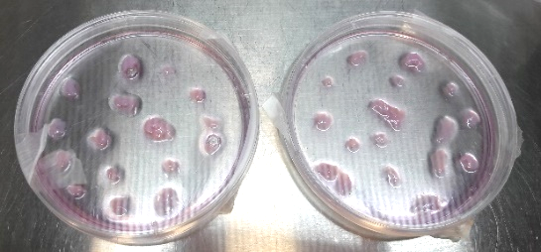
1-Warton’s Jelly pieces culturing in 3.5-cm Petri dishes coated with 0.1% collagen:

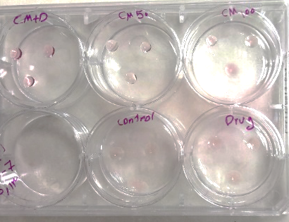
2- Hanging drops on the lids placed on top of the wells:

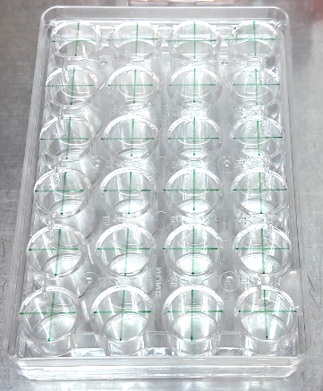
3- Vertical and horizontal lines crossing on behind of the 24-well plate floors:

4-The Image j analysis pathway:
- Image Type 8-bit
- ProcessFind Edges.
- ProcessSharpen.
- Process Binary Make Binary
- ImageAdjustThreshold. ‘Default’ and ‘B&W’ and tick ‘Dark background’, and untick the ‘Stack histogram’ boxes. Move the upper bar to the left(0) and the lower bar until the best clarity and contrast is achieved for the imageApply.
- ProcessFind Edges.
- ImageLookup Tables>Invert LUT.
- AnalyzeAnalyze Particles. Size:100/100000-infinity
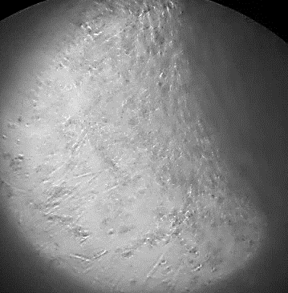
5-Spindle-shaped plastic-adherent cells sprouted from Wharton’s jelly pieces after 14 days of initial primary explant culture. Image was photographed by an inverted light microscope. Magnification: ×20 objective lens.
6-IC50 analysis result with Graph Pad Prism6 software:
log(inhibitor) vs. response -- Variable slope (four parameters)
Best-fit values
Bottom | -1.571
Top | 31.61
LogIC50 | 1.265
HillSlope | 2.421
IC50 | 18.41
Span | 33.18
Std. Error
Bottom | 6.039
Top | 8.356
LogIC50 | 0.1101
HillSlope | 1.755
Span | 12.85
95% Confidence Intervals
Bottom | -20.79 to 17.64
Top | 5.025 to 58.20
LogIC50 | 0.9147 to 1.615
HillSlope | -3.163 to 8.005
IC50 | 8.217 to 41.24
Span | -7.707 to 74.07
Goodness of Fit
Degrees of Freedom | 3
R square | 0.9506
Absolute Sum of Squares | 40.10
Sy.x | 3.656
Number of points
Analyzed | 7

