Purpose |  | Primer name |  | Primer sequence (5'-3')
Targeted deep sequencing | 1st PCR | NbXylT1 | XYLT1 MS F1 | ACGTTGTTTAACCCTCTGTAGTCTAC
Targeted deep sequencing | 1st PCR | NbXylT1 | XYLT1 MS R1 | GGAAAGCTCCATTTTTGAACATG
Targeted deep sequencing | 1st PCR | NbXylT2 | XYLT2 MS F1 | TCCCACCCTGATCACTCTC
Targeted deep sequencing | 1st PCR | NbXylT2 | XYLT2 MS R1 | GAAAAGCTCCAGTTTTGAACGCG
Targeted deep sequencing | 1st PCR | NbFucT1 | FUCT1 MS F1 | TTAGTGATTCGAATTTATGCTAGTCTT
Targeted deep sequencing | 1st PCR | NbFucT1 | FUCT1 MS R1 | GTCTAGATTCAAACCATTGTTGGA
Targeted deep sequencing | 1st PCR | NbFucT2 | FUCT2 MS F1 | GTGATTCGAATTTATGCTAGTCCAATGAT
Targeted deep sequencing | 1st PCR | NbFucT2 | FUCT2 MS R1 | GTCTAGATCCAAACCATCGTAGAA
Targeted deep sequencing | 1st PCR | NbFucT3 | FUCT3 MS F1 | GTAGAATATGCATGCATGTGGTTAAAC
Targeted deep sequencing | 1st PCR | NbFucT3 | FUCT3 MS R1 | GAGCAGAGCATATTTGTGAACC
Targeted deep sequencing | 1st PCR | NbFucT4 | FUCT4 MS F1 | GTAGAATATGCATGCCTGTCGTTTGAC
Targeted deep sequencing | 1st PCR | NbFucT4 | FUCT4 MS R1 | TAGAGCAGAGCATATTTGTACGTCG
Targeted deep sequencing | 1st PCR | NbFucT5 | FUCT5 MS F1 | GTTGATCGGAATTTGGCAACT
Targeted deep sequencing | 1st PCR | NbFucT5 | FUCT5 MS R1 | CTCCAATGACAAATTAGATGACCTTAG
Targeted deep sequencing | 2nd PCR | NnFucT1&2 | NbFUT 1&2 F2 | ACACTCTTTCCCTACACGACGCTCTTCCGATCTTGGTTTCTGTTCTCAATTTG
Targeted deep sequencing | 2nd PCR | NnFucT1&2 | NbFUT 1&2 R2 | GTGACTGGAGTTCAGACGTGTGCTCTTCCGATCTCAATTCTGAAAATCCAAGTC
Targeted deep sequencing | 2nd PCR | NbFucT3 or 4 | NbFUT 3&4 F2 | ACACTCTTTCCCTACACGACGCTCTTCCGATCTCTTGTCATCTTGTTCTCAA
Targeted deep sequencing | 2nd PCR | NbFucT3 or 4 | NbFUT 3 R2 | GTGACTGGAGTTCAGACGTGTGCTCTTCCGATCTAGTGTAAAGAGCAGAACC
Targeted deep sequencing | 2nd PCR | NbFucT3 or 4 | NbFUT 4 R2 | GTGACTGGAGTTCAGACGTGTGCTCTTCCGATCTAGTGTAAAATGCAGAACC
Targeted deep sequencing | 2nd PCR | NbFucT5 | NbFUT 5 F2 | ACACTCTTTCCCTACACGACGCTCTTCCGATCTCTAATTGTGGTGCTCGTAA
Targeted deep sequencing | 2nd PCR | NbFucT5 | NbFUT 5 R2 | GTGACTGGAGTTCAGACGTGTGCTCTTCCGATCTCAGCTACTAAAGACTGGAA
Targeted deep sequencing | 2nd PCR | NbFucT5 | NbFUT 5 F2 -2 | ACACTCTTTCCCTACACGACGCTCTTCCGATCTCTTCCGGTTGCAAGCTCTTGAA
Targeted deep sequencing | 2nd PCR | NbFucT5 | NbFUT 5 R2-2 | GTGACTGGAGTTCAGACGTGTGCTCTTCCGATCTAGCACCAATCACCACGGGGACT
Targeted deep sequencing | 2nd PCR | NbXylT1&2 | NbXYylT 1&2 F2 | ACACTCTTTCCCTACACGACGCTCTTCCGATCTCAACTCAATCACTCTCTATC
Targeted deep sequencing | 2nd PCR | NbXylT1&2 | NbXylT 1&2 R2 | GTGACTGGAGTTCAGACGTGTGCTCTTCCGATCTATTACCGAAGTAACCCT
Transgene-free, Cas9 free selection |  | NF1 |  | TGTCCCAGGATTAGAATGATTAGGC
Transgene-free, Cas9 free selection |  | X6 R |  | GACGTAAGGGATGACGCACA
Transgene-free, Cas9 free selection |  | Cas9-F1 |  | GTTCATCAAGCCGATTCTGG
Transgene-free, Cas9 free selection |  | Cas9-R1 |  | GCTTCCTGCTCAGCCTCCC
Transgene-free, Cas9 free selection |  | Cas9-F2 |  | CCCACCATCTACCATCTGCG
Transgene-free, Cas9 free selection |  | Cas9-R |  | ATGTCCTCGTTCTCCTCGTTGT
Supplementary tables and figures
Table S1. List of primers used in the study.

Table S2. Inheritance of targeted mutations and Cas9 in T₁ transformants. (*Cas9 free plants)
Mutant plants |  |  | CRISPR/Cas9-induced mutations
Generation | Plant ID |  | NbFUCT1 | NbFUCT2 | NbFUCT3 | NbFUCT4 | NbFUCT5 | NbXYLT1 | NbXYLT2
T₀ | HL40 | Mutation | +1/+1 | +1/-5 | WT/-1 | WT/+1 | -1/-5 | +1/-8 | +1/-3
T₀ | HL40 | Zygosity | Bi-allele | Bi-allele | Heterozygote | Heterozygote | Bi-allele | Bi-allele | Bi-allele
T₁ | HL40-4 | Mutation | +1 | +1 | -1 | +1 | -1/-5 | +1/-8 | +1/-3
T₁ | HL40-4 | Zygosity | Homozygote | Homozygote | Homozygote | Homozygote | Bi-allele | Bi-allele | Bi-allele
T₁ | HL40-11 | Mutation | +1/+1 | +1/-5 | WT/-1 | WT/chi | -1/-5 | +1/-8 | +1
T₁ | HL40-11 | Zygosity | Bi-allele | Bi-allele | Heterozygote | Chimera | Bi-allele | Bi-allele | Homozygote
T₁ | HL40-14 | Mutation | +1/+1 | +1 | WT/-1 | WT/chi | -5 | -8 | +1
T₁ | HL40-14 | Zygosity | Bi-allele | Homozygote | Heterozygote | Chimera | Homozygote | Homozygote | Homozygote
T₁ | HL40-18 | Mutation | +1 | +1/-5 | WT/chi | WT/+1 | -1 | +1/-8 | +1
T₁ | HL40-18 | Zygosity | Homozygote | Bi-allele | Chimera | Heterozygote | Homozygote | Bi-allele | Homozygote
T₁ | HL40-20* | Mutation | +1 | +1 | WT | +1 | -1 | +1/-8 | +1
T₁ | HL40-20* | Zygosity | Homozygote | Homozygote | Wild | Homozygote | Homozygote | Bi-allele | Homozygote
T₁ | HL40-48* | Mutation | +1 | -+1/-5 | -1 | +1 | -5 | -8 | +1
T₁ | HL40-48* | Zygosity | Homozygote | Bi-allele | Homozygote | Homozygote | Homozygote | Homozygote | Homozygote
T₁ | HL40-219* | Mutation | +1 | -5 | -1 | +1 | -1/-5 | +1 | +1
T₁ | HL40-219* | Zygosity | Homozygote | Homozygote | Homozygote | Homozygote | Bi-allele | Homozygote | Homozygote
T₁ | HL40-379* | Mutation | +1/+1 | +1/-5 | -1 | +1 | -5 | -8 | +1
T₁ | HL40-379* | Zygosity | Bi-allele | Bi-allele | Homozygote | Homozygote | Homozygote | Homozygote | Homozygote
T₁ | HL40-591* | Mutation | +1/+1 | +1/-5 | -1 | +1 | -1/-5 | +1/-8 | +1
T₁ | HL40-591* | Zygosity | Bi-allele | Bi-allele | Homozygote | Homozygote | Bi-allele | Bi-allele | Homozygote
T₀ | HL64 | Mutation | -1/-2 | +1/-5 | WT/+1 | WT/+1 | -26 | -7/-14 | -5/-9
T₀ | HL64 | Zygosity | Bi-allele | Bi-allele | Heterozygote | Heterozygote | Homozygote | Bi-allele | Bi-allele
T₁ | HL64-15 | Mutation | -1/-2 | -5 | WT | WT/+1 | -26/Chi | -7/-14 | -5
T₁ | HL64-15 | Zygosity | Bi-allele | Homozygote | Wild | Heterozygote | Chimera | Bi-allele | Homozygote
T₁ | HL64-17 | Mutation | -2 | +1/-5 | WT | WT | -26 | -14 | -5/-9
T₁ | HL64-17 | Zygosity | Homozygote | Bi-allele | Wild | Wild | Homozygote | Homozygote | Bi-allele
T₁ | HL64-19 | Mutation | -1/-2 | +1 | +1 | +1 | -26 | -7/-14 | -5
T₁ | HL64-19 | Zygosity | Bi-allele | Homozygote | Homozygote | Homozygote | Homozygote | Bi-allele | Homozygote
T₁ | HL64-512* | Mutation | -1/-2 | +1 | +1 | +1 | -26 | -7/-14 | -5
T₁ | HL64-512* | Zygosity | Bi-allele | Homozygote | Homozygote | Homozygote | Homozygote | Bi-allele | Homozygote

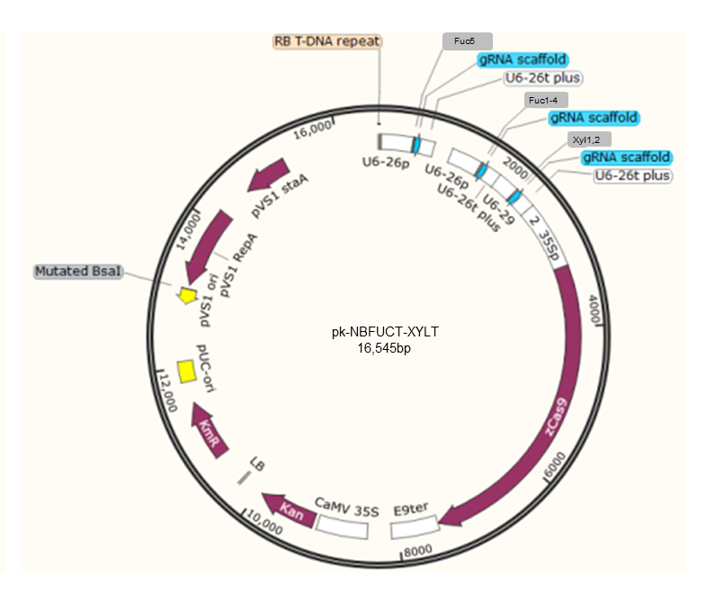
Figure S1. Nicotiana benthamiana pk-NbFUCT-XYLT plasmid construct containing three sgRNAs targeting two NbXylT and five NbFucT genes.
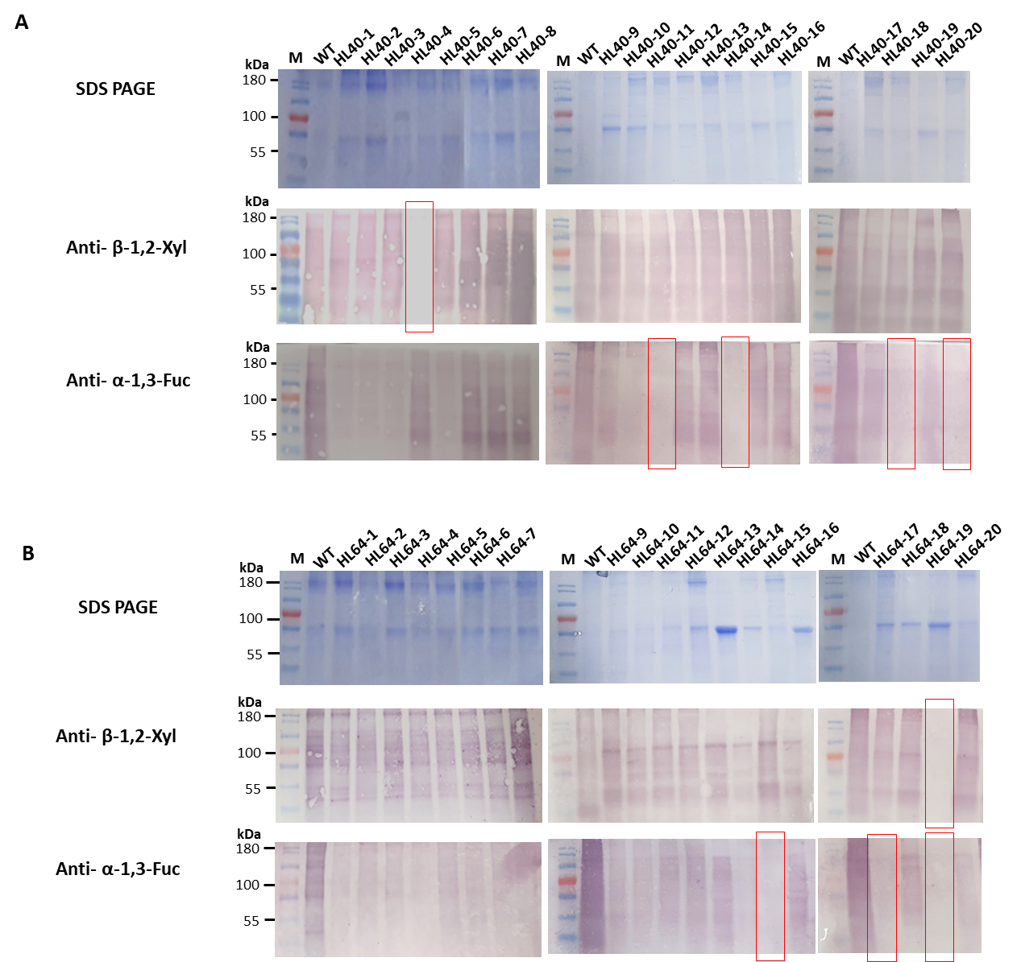
Figure S2 . Western blot analysis of the (A) HL40 and (B) HL64 F-KO and X-KO T₁ transformants. Western blotting was performed using anti- β-1,2-xylose, and anti- α-1,3-fucose antibodies. The size of protein markers are indicated by kDa on the left side.

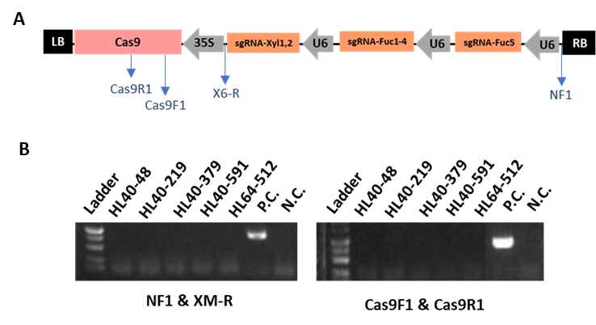
Figure S3 . PCR-based genotyping to check the absence of Cas9 gene in the T₁ transformants (A) Schematic diagram of the Cas9-sgRNA construct and the position of primer set (Cas9 F1 x Cas9 R1). (B) Confirmation of the absence of Cas9 in T₁ plants. Wild type N. benthamiana was used as negative control (N.C). The T₁ line HL-64-19 was used as a positive control (P.C).

