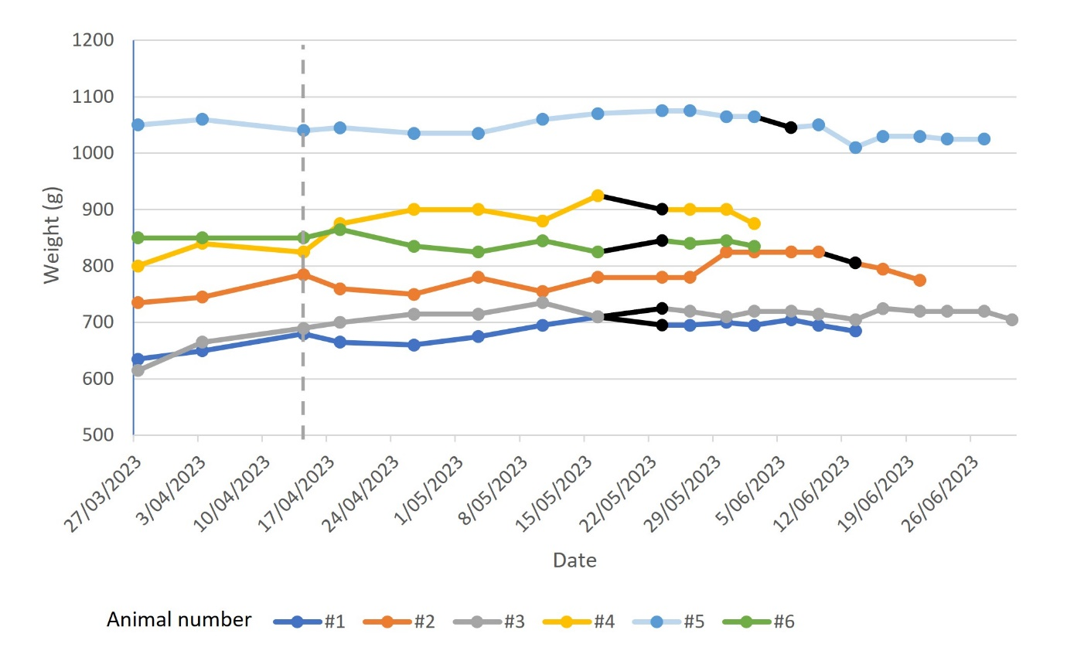
Supplemental Figure 1: Weight changes by animal, with challenge date denoted by a dashed grey vertical line and date of onset of lesion development shown in black.

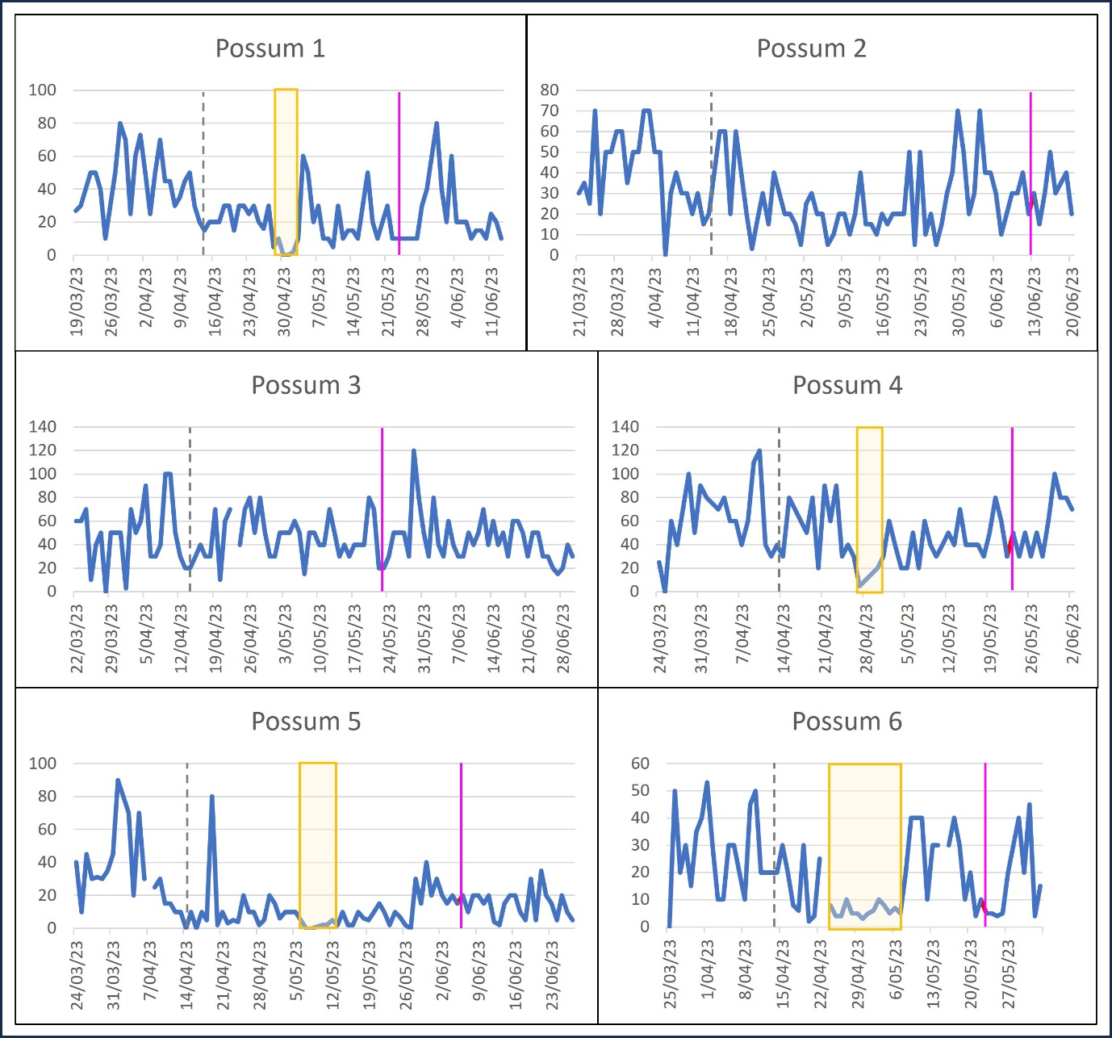
Supplemental Figure 2: Daily faecal production by animal with number of faecal pellets produced on the Y axis and date on the X axis. Challenge date is denoted by a dashed grey vertical line and date of onset of lesion development by a solid magenta vertical line. The periods of possible reduced faecal production are highlighted by a yellow box.

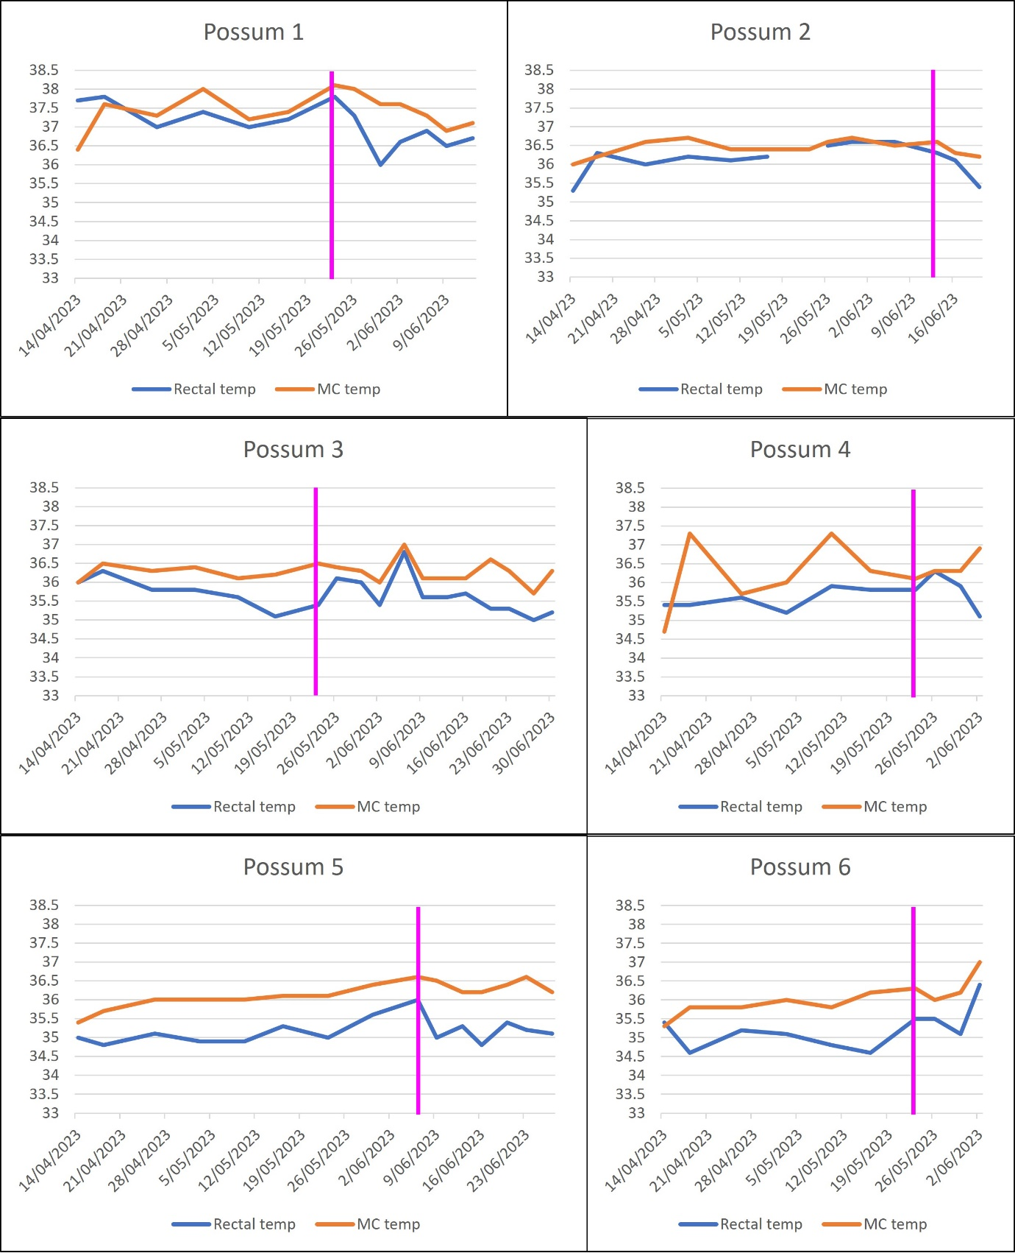
Supplemental Figure 3: Rectal temperatures (blue) and microchip (MC, orange) temperatures by animal from the date of challenge, with degrees Celsius on the Y axis and date on the X axis. The date of onset of lesion development is denoted by a solid magenta vertical line.

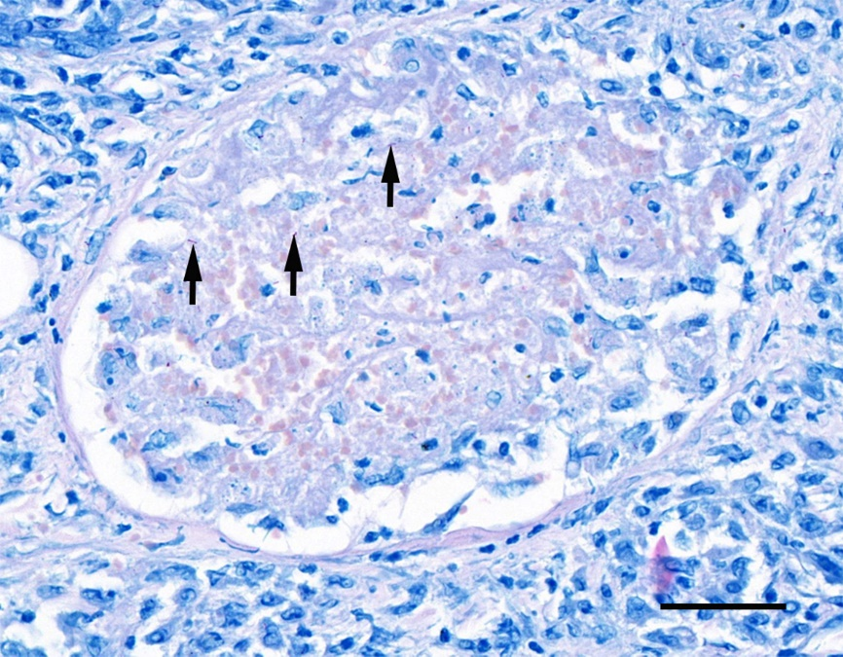
Supplemental Figure 4. Histology of a cross section of an inflamed blood vessel previously highlighted in Figure 4. Amidst the intra-luminal accumulation of necrotic debris and erythrocytes are scattered, extracellular, magenta-staining, individual acid-fast bacilli (arrows). Wade-Fite modification of Ziehl-Neelsen stain. Scale = 50µm.

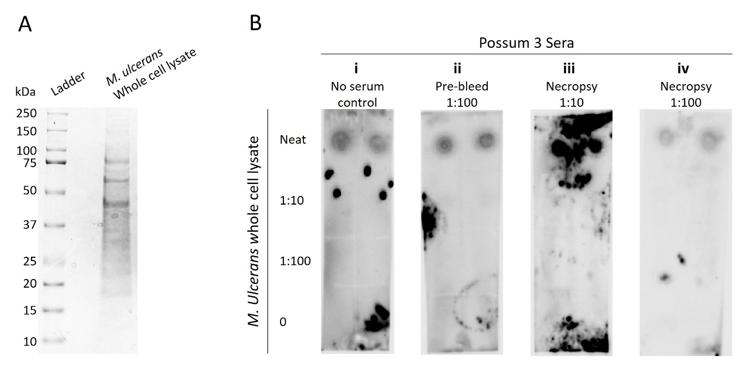
Supplemental Figure 5. (A) SDS-PAGE of M. ulcerans whole cell lysate. (B) Dot Blot to detect seroconversion of Possum 3 to MU. Bacterial whole cell lysate was used at neat, 1:10 and 1:100 dilutions, and no bacteria control, and probed with (i) no serum control, (ii) pre-infection bleed sera diluted 1:100, (iii) necropsy bleed sera diluted 1:10, and (iv) necropsy sera diluted 1:100. Blots were visualised using Pierce ECL Western Blot substrate and ChemiDoc visualisation system.

